Cutter v6.1
G-Code to 4 Axis
Wing Cutter

This software is available at:
https://github.com/rbp28668/Aerofoils

By R Bruce Porteous
(c) 2020

Table of Contents
Introduction 3
Overall Screen Layout 4
Communications 5
G-Code Page 6
Direct G-Code Commands 6
Custom Buttons 8
G-Code Status 8
G-Code Program 9
Hardware Page 10
Sending Line Command 11
Single Step Command 11
Miscellaneous Direct Commands 11
Configuration Page 12
Setting Cutter Geometry 12
Setting Motor Parameters 13
Setting Default Communications Options 14
Defining Custom Buttons 14
Saving Configuration 15
G-Code 16
G-Commands 16
M-Commands 16
Axes and Parameters 16
Writing G-Code 17
Controller Protocol 18
Using PuTTY for Debugging 18

Introduction

The Cutter program is the companion program to Aerofoil. Whereas Aerofoil is used to design wings and create G-Code, Cutter interprets the G-Code to drive a CNC 4-axis foam cutter. Whilst Cutter is designed to work in parallel with Aerofoil, it can accept G-Code from other sources. To this end it has a degree of flexibility in axis naming and implements several extra G-Code commands.

The core component in Cutter is the G-Code interpreter. It knows how to execute individual or a sequence of G-Code commands. Some of these change the state of the interpreter (such as changing the units from mm to inch), others such as G0 (move) and G1 (cut), send commands to the CNC hardware.

In normal operation you
- Connect to the hardware (see Communications)
- Configure the cutter, especially the block size (see Configuration Page)
- Control the cutter via the G-Code screen (see G-Code Page)
The G-Code screen provides options to directly control the cutter as well as run G-Code programs. These programs can be read from disk or sent directly over the network from Aerofoil.

Overall Screen Layout

The Cutter screens are divided into 3 main sections. There’s a common communications section that deals with communications from the Aerofoil program and to the cutter hardware

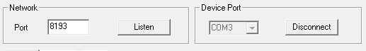
There’s a central page controlled by tabs. The default page is where you use G-Code to control the cutter. There is a Hardware page for lower level access to the controller and a Config page to set up Cutter’s configuration.

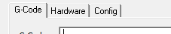
And at the bottom there’s a status area that shows the status of the cutter.

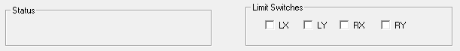

Communications
The communications section controls 2 sets of communications:
- The network port that Cutter listens on to receive G-Code files from Aerofoil.
- The serial port (USB) that has the cutter hardware connected to.

In Network, when you click Listen the Cutter program is ready to receive G-Code from Aerofoil and the Listen button changes to read Stop Listening. The port is arbitrary but both Aerofoil and Cutter need to be configured with the same port. Note that in the Config page it is possible to define a Default listen port and select Listen automatically in which case Cutter will start to listen for data automatically when it starts up.

In Device Port the system will display all the available serial ports. You need to pick the serial port the cutter hardware is connected to and click on Connect. When connected the dropdown list of ports is greyed out and the button changes to Disconnect as shown above. Note that in the Config page it is possible to define a Default COM Port and select Connect automatically in which case Cutter will connect automatically when it starts up.

Tip: Make sure that Cutter is connected to the hardware before doing anything else. You can tell it’s connected as the COM port dropdown is greyed and the button now reads Disconnect.

G-Code Page
When the program starts up the G-Code page is the default as shown below. Selecting the G-Code tab will bring you back to this page from either the Hardware or Config pages. This is the main page to drive the cutter from – it allows you to send commands to the cutter immediately, shows you the status of the cutter after executing the G-code commands and allows you to load and run a complete G-Code program.
The individual sections are discussed further below.

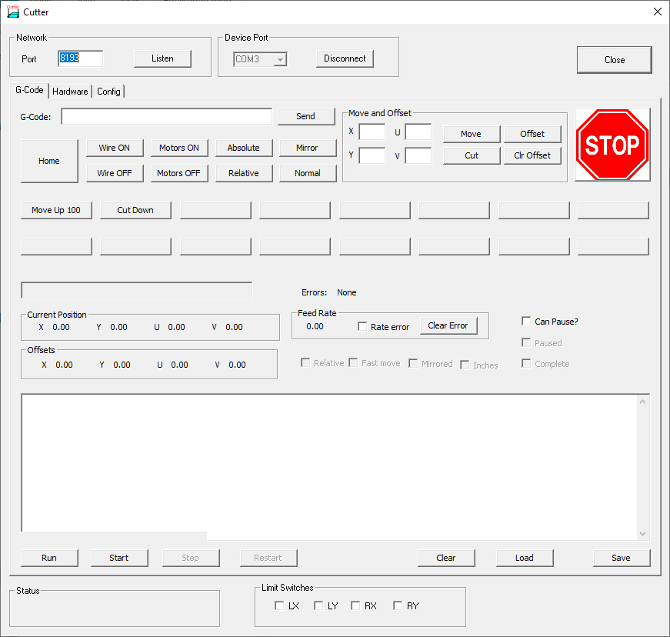

Direct G-Code Commands
This section allows you to send commands directly to the cutter.
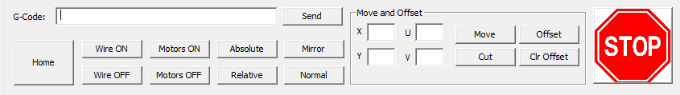
The G-Code edit box allows you to send a line of arbitrary G-Code to the cutter. Pressing Send sends whatever you have typed to the G-Code interpreter. If the command directly affects the cutter the appropriate command will be sent to the cutter, other commands just change the state of the interpreter.
In the Move and Offset box the entries are:
- X,Y ,U,V allow you to specify distances to move in the current units (mm by default).
- Move sends these as a fast move (G0)
- Cut sends these as a slow, feed-rate move (G1)
- Offset sets the offset to the given position. This moves the whole
- Clr Offset clears the offset
The other buttons are:
- Home which tells the cutter to run the home command and move to, and off its limit switches.
- Wire On turns on the hot wire.
- Wire Off turns off the hot wire.
- Motors On enables the motors.
- Motors Off disables the motors.
- Absolute sets absolute positioning – the X,Y,U,V coordinates will be treated as a location to drive to (in the current units).
- Relative sets relative positioning – the X,Y,U,V coordinates will be treated as the amount to move in the current units.
- Mirror mirrors the cut left to right.
- Normal cancels mirroring.
And of course the big red STOP button which should send an immediate stop to the controller (emptying any queues) and stop the interpreter.

Tip: Make sure the motors are enabled before starting a G-Code program. It may be that the program has an M17 command to enable the motors but it may not have.

Custom Buttons
In the Config page it’s possible to configure up to 16 buttons. Each button is given a label and a sequence of G-Code to execute when that button is pressed. Initially these are undefined and in the screenshot below only 2 are configured – one to move the cutter up 100mm and one to Cut down to zero again for trimming foam blocks.
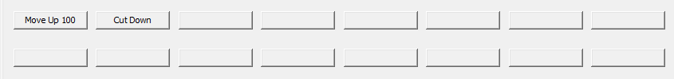
The ability to have small “programs” available from individual buttons is invaluable when trimming foam blocks for example. What each button does is entirely up to you.

G-Code Status
The next part of the screen is all about reporting the status of the G-Code interpreter. Note that this is the status of the interpreter – it’s not necessarily the status of the cutter hardware due to the buffering on the cutter. Usually the interpreter is well ahead of the cutter which has a long list of commands to run.
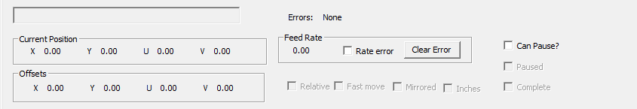
The fields in the status area are as follows:
The unlabled, greyed edit box displays the last command to be executed by the interpreter. Next to it is the error display. When there is an error it will be shown here.
Current Position shows the position of the 4 axes.
Offsets show any current offsets that have been set.
Feed Rate shows the current feed rate, whether there has been a rate error (i.e. the G-Code has asked for a rate the cutter can’t match), and a button to clear feed rate errors.
There are 4 check boxes which show state information from the interpreter. These are:
- Relative – if set shows relative moves are in force, if clear then absolute.
- Fast move – if set shows G0 is in force, if clear G1
- Mirrored – set if the cut is being mirrored left to right, clear if not.
- Inches – set if the current units are inches, clear if mm (the default).
The last 3 check boxes control program operation
- Can Pause enables M01, optional pause.
- Paused is set if the program is paused.
- Complete is set if the program has finished executing.

G-Code Program
This is where you can load, run, modify and save a G-Code program.
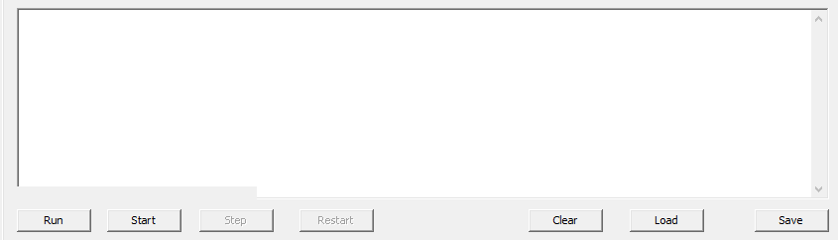
The buttons are as follows:
- Run runs the current G-Code program from the start. If Run is relabled as Continue then it continues running a program at full speed rather than single stepping through it.
- Start starts the program but doesn’t run it. When you click on start the Run button becomes Continue and the Step button is enabled. This allows you to single step through the G-Code.
- Step executes the next line of G-Code when single stepping.
- Restart resets the program to the beginning again so that Run or Start can be used. Note that Restart is only available when the program has completed.
- Clear clears/erases the current program.
- Load pops up a file open dialog to load a new G-Code program from disk.
- Save saves the current G-Code program to disk. It will pop up a file save dialog

Usual operation is to load the program from disk (or send it from Aerofoil) then just press Run, sit back and watch!
Single stepping with Start, Step (and possibly Continue) is useful for debugging G-Code to execute it one line at a time.

Hardware Page
It’s rare that you will need to use this page except when you’re debugging hardware or checking operation of the cutter firmware. The buttons on this page send low level commands directly to the hardware without going via the G-Code interpreter. As such the buttons on this page are a direct one to one match for the commands in the Controller Protocol section on page 18.
Note that the axis names of X,Y, U and V are a concern of the G-Code interpreter and are not used here. Instead the axes are labelled LX (left X or horizontal), LY (left Y or vertical), RX (right X or horizontal) and RY (right Y or vertical).
Note: Be wary of moving the axes with this page when you’re also using G-Code. The G-Code interpreter will be blissfully unaware that you’ve moved the axes behind its back. Usually the only safe option after doing this is to use G-Code to home the axes.

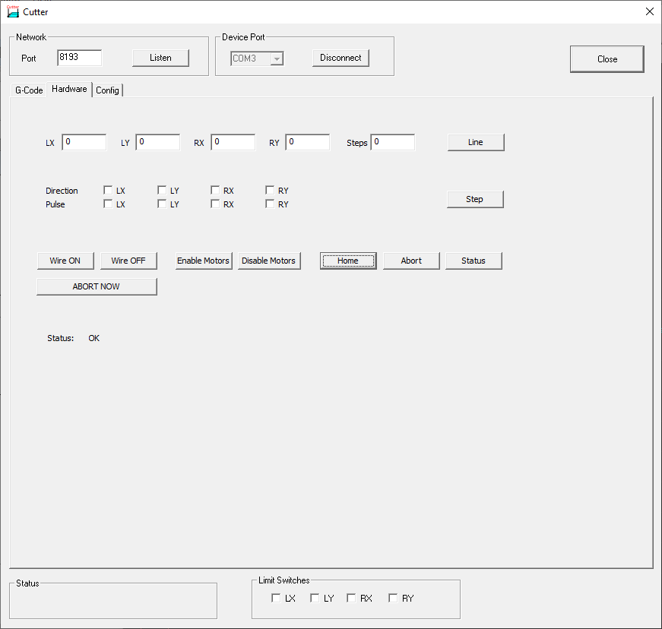

Sending Line Command
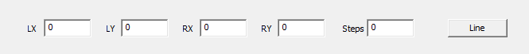
This uses the values of LX, LY, RX, RY and Steps to send a line command to the hardware.
Note that LX,LY,RX and RY are all integer numbers of steps, not mm. Also note that these are inherently relative moves and may be negative.
Steps must be greater than the largest absolute value of LX,LY,RX or RY. Steps determines the total time for the cut in hardware “ticks” (typically multiples of a few hundred microseconds). The current values of LX, LY, RX, RY and Steps are sent to the controller when you click on the Line button.

Single Step Command
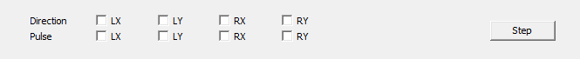
Step sends a command for a single step. Which motor(s) are moved and in which direction is controlled by the direction and pulse check-boxes for the respective axes.

Miscellaneous Direct Commands
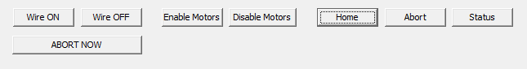
The buttons are used as follows:
- Wire ON turns the hot-wire on.
- Wire OFF turns the hot-wire off.
- Enable Motors enables the stepper motors.
- Disable Motors disables the stepper motors.
- Home runs the cutter’s homing sequence
- Abort disables the steppers, clears the stepper FIFO, clears the command queue and stops any current operation. Note though that this is a queued command so only stops operation when the cutter reaches this command in its buffer.
- Status polls the status of the cutter. It will show if the command queue is full or empty and the status of the limit switches. Status is an immediate command – it’s not queued.
- Abort Now sends an abort now command to the cutter. This clears the command queues, stops the current operation and clears the cutter’s FIFO buffer. This is an immediate command and is not queued so takes affect immediately.

Configuration Page
The configuration page controls the cutter’s view of the hardware, its characteristics and geometry. It also allows you to set default communications and set up the configurable buttons on the G-Code page. The overall Config page is shown below.
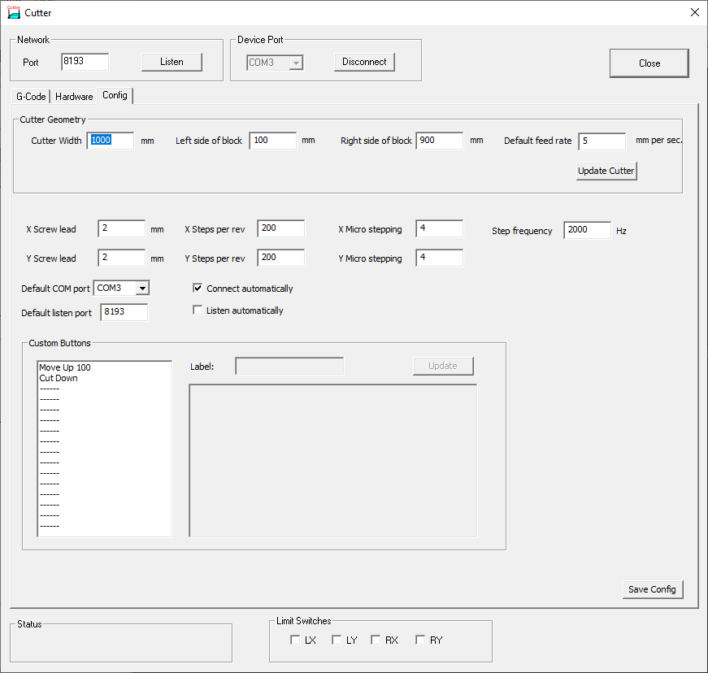

Setting Cutter Geometry
Setting the cutter geometry is important when cutting tapered components as the software can compensate for the edges of the block not being where the wire is supported. Typically the axes have to move further than the dimensions on the block edge or possibly move in the opposite direction to keep one end stationary whilst the other end moves.

Tip: If the G-Code has already been corrected for tapers then set Left side of block to 0 and set Right side of block to equal Cutter Width. Otherwise you will end up with the correction being applied twice – once by the program creating the G-Code, once by Cutter.

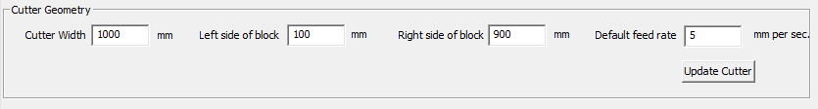
Enter the Cutter Width, the Left side of block and the Right side of block to determine the cutter geometry. All dimensions are in mm and the block positions should be measured from the point where the wire is supported on the left hand side of the cutter as shown in the sketch below.

Drawing 1: Measuring block position
Left
Right

Don’t forget to click on Update Cutter after changing these values.

Setting Motor Parameters
The motor parameters are critical for allowing Cutter to calculate the number of steps for a given distance and feed rate.
The parameters are as follows:
- X Screw lead is the number of mm the carriage moves horizontally for a single turn of the motor.
- Y Screw lead is the number of mm the carriage moves vertically for a single turn of the motor.
- X Steps per rev is the number of steps the horizontal axis motor takes to do a single rotation. For a 1.8 degree stepper this will be 200.
- Y Steps per rev is the same value for the vertical axis.
- X Micro stepping is the number of microsteps for 1 full step of the horizontal axis motor. This is usually a power of two i.e. 2, 4, 8 etc. With a microstepping driver the driver will need steps per rev times micro stepping factor pulses to make a single rotation.
- Ymicro stepping is the same for the vertical axis
- Step frequency is the frequency, in Hz, that the data that’s sent to the steppers is clocked out of the controller FIFO buffer. It’s the reciprocal of the clock period set up in cutter.ino in the driver.
The step frequency is set by this line in cutter.ino:
tickTimer.begin(timerTick, 400);
The numeric value is the time between interrupts in microseconds. 400 microseconds corresponds to a 2500Hz step frequency, 500 microseconds to 2000Hz and so on.

Setting Default Communications Options
Default communication options allow the software to connect to the cutter hardware and to listen for G-Code data automatically.
To automatically connect to the cutter hardware on a given COM port select the appropriate Default COM port value and select Connect automatically.
To automatically listen on a given TCP port enter the port number in Default listen port and select Listen automatically.
Note that if something else (possibly another instance of Cutter) is already connected to the selected COM port or listening on the selected TCP port then Cutter will not start up.

Defining Custom Buttons
The 16 configurable buttons on the G-Code page can be configured using the Custom Buttons group shown below.
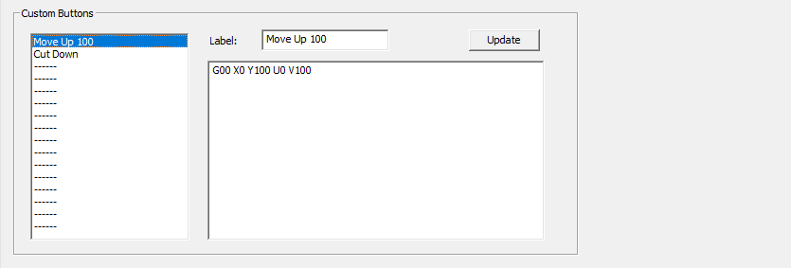
Configuring these are simple. Select one of the 16 values, enter a new Label, type (or paste) the G-Code into the edit box and click on Update. Unused entries are labelled with ----- .

Saving Configuration
After making any changes to the configuration click on the Save Config button. The cutter configuration will be written to a file cutter_config.xml in the current directory. On startup the software will read and initialise itself from this file.

G-Code

The G-Code interpreter is a key part of the Cutter software. The commands it implements are described below.

Note that axes for wing cutter are X,Y (left hand side) and U,V (right hand side). A,Z can be used as aliases for U and V respectively.

G-Commands
G00 - straight line as fast as possible (interpolated)
G01 - straight line at given or active feed rate.
G04 - dwell/pause for given time (P mS or S seconds)
G17 - plane XY: accepted but ignored.
G20 - program coordinates are in inches
G21 - program coordinates are in mm
G28 - return to home position
G38 - mirror imaging “on”
G39 - mirror imaging “off”
G40 - set cutter compensation off: accepted but ignored
G49 - clear existing toolset offset: accepted but ignored
G52 - set local workshift (offsets)
G53 - cancel local workshift
G90 - Absolute programming
G91 - Incremental programming
G94 - Feed rate is units (mm or inch) per minute.

M-Commands
M00 - program stop (restartable)
M01 - optional program stop (restartable)
M02 - end of program
M03 - wire on
M05 - wire off
M17 - Enable/Power all stepper motors
M18 - Disable all stepper motors
M30 - End program and reset to beginning

Axes and Parameters
F - feedrate
X - Left X position
Y - Left Y position
U - Right X position
V - Right Y position
A - Alternative Right X Position
Z - Alternative Right Y Position
N - line number
P - dwell time in mS
S - dwell time in S

Writing G-Code
G-Code has one or more commands per line. Movement commands are modal, for example, say a code begins with a linear rapid move at X1 Y1 (G00 X1 Y1). If the next function is another linear rapid move, it is not necessary to write G00 again. All that is needed on the next line of code is the new position (say, X2 Y2) because the modal condition is the same. Then, to change the function to a linear feed (G01), programming G01 on the following line would deactivate the linear rapid move and activate the linear feed.

Comments can be placed in parentheses i.e. ( this is a comment ).

Controller Protocol

The commands implemented by the stepper controller are shown below. Note that the number of digits in each (hex) number is important – where SSSSSSSS is specified that means exactly 8 hex digits. Line takes 2s complement numbers so minus numbers will typically start F….

The commands are as follows:

? - show this message
P - ping, show queue state
A - abort now and clear queues
Z - Abort current operation and clear queues
S - Single step - DB where D is 4 bits of direction, P are pulse bits (1 to pulse), both hex digits
L - Line in 4 dimensions SSSSSSSSAAAAAAAABBBBBBBBCCCCCCCCDDDDDDDD where S gives total number of steps and A-D are axes. All in hex, 2s complement
H - Drives the steppers to their home positions
E - Enable motors
D - Disable motors
W - Turn on hot wire
X - Turn off hot wire

After each command it returns a 4 byte status:

Y or N which says if the command was interpreted correctly (Y) or not (N).
F or - has F if the command queue is full.
E or - has E if the command queue is empty.
a hex digit that encodes the status of all 4 limit switches.

Using PuTTY for Debugging
If you connect a serial terminal (such as by using the PuTTY program) it should be possible to drive the controller using the commands shown above. For the line a calculator capable of converting decimal to 8 digit HEX values in invaluable! This can sometimes be useful for debugging purposes if you’re not sure that the correct commands are reaching the controller. At the very least, entering “?” and getting back the description of the allowable commands tells you the cutter hardware is connected to the port you think it is!

