EATool
User Guide
Version 0.5

Table of Contents
Introduction 6
Principles 7
Meta model 7
Model 7
Identity 8
Display Hints 8
Inheritance 9
Diagrams 9
Building the Metamodel 10
Starting From Scratch 10
Creating Meta-Entities 10
Adding Relationships 15
Changing the Meta-model 18
Additions 18
Meta-Entities 18
Meta-Relationships 18
Meta-Properties 18
Changes 19
Meta-Entities 19
Meta-Relationships 19
Meta-Properties 19
Deletions 19
Meta-Entities 19
Meta-Relationships 19
Meta-Properties 19
Building the Model 21
Adding Entities 21
Adding Relationships 23
Loading and Saving 26
New 26
Open 26
Save As 26
Merge 27
Import 27
Export 27
Properties 28
Exit 28
Importing Data 29
XML 29
Entity 30
Relationship 30
Import Translations 30
CSV 34
CSV Hierarchy 35
Exporting Data 39
Working with Diagrams 41
Creating Diagram Types 41
Creating Diagrams 45
Editing Diagrams 46
Entities and Symbols 46
Relationships and Connectors 47
Zoom 48
Layout 48
Browsing the Model 55
Search 57
Matrices 59
Exporting to a Web Site 61
Scripts 62
Creating a Script 62
Predefined Objects 64
Collections 64
Diagram Event Handlers 64
Function Help 65
Event Mappings 65
Application Level Events 65
Diagram Events 66
Configuration 67
Look and Feel 67
Help 69
Customisation 70
Menus 70
Types 70
Import 70
Export 70
Background 70
Errors 71
Appendix – Sample Export Stylesheet 72
Appendix – Specifying Searches 74
Fields 74
Term Modifiers 74
Wildcard Searches 74
Fuzzy Searches 75
Proximity Searches 75
Range Searches 75
Boosting a Term 76
Boolean operators 76
OR 76
AND 76
+ 77
NOT 77
- 77
Grouping 77
Field Grouping 77
Escaping Special Characters 78
Appendix – Scripting Objects 79
Appendix – Action Names 80
Main Application 80
Diagram Viewer 81
Appendix – Sample Scripts 83

List of Figures
Figure 1: Meta model classes and their relationships 7
Figure 2: Model classes and their relationships 8
Figure 3: An example of inheritance in the meta-model 9
Figure 4: Initial view of MetaModel Explorer 10
Figure 5: Meta Model Explorer showing Meta-Entities and Meta-Relationships 11
Figure 6: Empty Edit Meta-Entity Dialogue 11
Figure 7: Edit Meta-Property Dialogue 12
Figure 8: Edited Meta-Entity Definition 13
Figure 9: Explorer with single meta-entity added 13
Figure 10: Edit Display Hint Dialog 14
Figure 11: Popup for Meta-Relationships 15
Figure 12: Blank edit Meta-Relationship dialog. 15
Figure 13: Completed Edit Meta-Relationship dialogue. 17
Figure 14: Meta-Model Explorer with a meta-relationship added. 18
Figure 15: Blank Model Explorer 21
Figure 16: Selecting an entity type 21
Figure 17: Edit Entity Dialogue 22
Figure 18: Model Explorer with a single Entity defined. 22
Figure 19: Edit Entity Relationships with no relationships defined 23
Figure 20: Select Relationship Type Dialogue 23
Figure 21: Select Entity Dialogue 24
Figure 22: Completed Relationships Tab 24
Figure 23: Model Explorer with relationships added. 25
Figure 24: Edit Relationship Dialogue 25
Figure 25: File menu 26
Figure 26: Loading progress bar 26
Figure 27: Select imput translation dialogue 27
Figure 28: Select Export Translation Dialogue 28
Figure 29: Edit Repository Properties dialogue 28
Figure 30: Exit Application Dialogue 28
Figure 31: Sample XML import file 29
Figure 32: Empty Import Mappings Explorer 30
Figure 33: New Import Mapping Dialogue 31
Figure 34: Import Mapping Explorer with empty mapping 31
Figure 35: New Entity Mapping dialogue 31
Figure 36: New Entity Mapping dialogue mapping Process to Business Process 32
Figure 37: Import Mapping Explorer showing entity mapping pop-up menu 32
Figure 38: New Property Mapping dialogue 32
Figure 39: New Relationship Mapping dialogue 33
Figure 40: Mapping the sample relationship 33
Figure 41: Import Mapping Explorer with relationship mapping defined. 33
Figure 42: New Property Mapping dialogue 34
Figure 43: Import Mappings Explorer with entity and relationship mappings 34
Figure 44: Import Mapping dialogue 35
Figure 45: Example import hierarchy 35
Figure 46: Target Meta-Model for Import 36
Figure 47: Import Mapping Dialog 37
Figure 48: Entity Mapping Dialog 37
Figure 49: Property Mapping Dialog 37
Figure 50: Relationship Mapping Dialog 37
Figure 51: Import Mapping Explorer 38
Figure 52: Export Mapping Explorer 39
Figure 53: Export Mapping Dialogue 40
Figure 54: Empty Diagram Explorer 41
Figure 55: Diagram Type Editor 42
Figure 56: Selecting a Symbol Type to correspond to an Entity Type 42
Figure 57: Selecting a connector type to correspond to a relationship type 43
Figure 58: Configure Symbol Type dialogue 44
Figure 59: Selecting a connector type 45
Figure 60: Pop-up menu for Diagram Type 45
Figure 61: Prompt for Diagram Name 46
Figure 62: Model Viewer with blank diagram 46
Figure 63: Blank Model Viewer 46
Figure 64: Entity Selection Dialogue 47
Figure 65: Select relationship or create new dialogue 48
Figure 66: Process Hierarchy as drawn 49
Figure 67: Grid Layout 50
Figure 68: Grid Connect Layout 51
Figure 69: Spring Layout 52
Figure 70: Hierarchy Layout 52
Figure 71: Circular Hierarchy Layout 53
Figure 72: Complete view of model 54
Figure 73: Browser list of Entity Types 55
Figure 74: Browser list of entities of a given type 56
Figure 75: Browser display of entity 57
Figure 76: Search Dialogue 58
Figure 77: Search results for "Deploy" 58
Figure 78: Department owns process matrix 59
Figure 79: Matrix sorted by similarity 60
Figure 80: Scripts Explorer 62
Figure 81: Edit Script Properties Dialogue 62
Figure 82: Script Editor 63
Figure 83: Scripting Function Help Browser 65
Figure 84: Application Event Map Editor 66
Figure 85: Diagram Type Event Mapping Editor 66
Figure 86: Metal Look and Feel 67
Figure 87: Motif Look and Feel 68
Figure 88: Windows Look and Feel 68
Figure 89: Error Dialogue 72
Figure 90: Expanded Error Dialogue 72

Introduction
This document describes how to use EATool which is an Enterprise Architecture (EA) Tool. EATool was written to explore various concepts around an EA tool and has become a flexible tool in its own right.
There were a number of design aims from the start which were:
- The metamodel, which describes the things that are modelled and their relationships, should be editable by users – or at least by a subset of users. There shouldn't need to be a need to call in a consultant to add a new entity or data field.
- An organisation's information exists in a wide range of forms and locations. A tool should be able to import relevant information, and equally importantly, re-import it to keep it up to date.
- Diagrams provide a powerful mechanism for viewing flows and relationships but can be a nightmare to maintain. As far as possible, diagrams should be automatically generated and laid out.
- Provide a strong concept of identity for entities and relationships so that they can be renamed without losing linkages between entities and so that entities with similar properties can be distinguished easily.
In addition, there are a number of drivers which, while currently out of scope, are on the future roadmap of the tool:
- EA is possibly most critical in large organisations. These are likely to have distributed teams so multiple repositories should be coordinated and there should be the capability of providing a federated view.
- Multi-user repositories using a shared (relational) database rather than a single-user application.
- Web interface, initially to provide viewing but later to provide update facilities as well.
- Integration into enterprise messaging.

Principles

Meta model
The meta model describes the allowable entities and their properties. It also describes the relationships between different types of entities. Before creating any entities or relationships the corresponding meta-entities and meta-relationships must have been created.
Meta-Entities have zero or more meta-properties. Each meta property has a type and a default value. When an entity is created it gets a full set of properties as described by the meta-properties of its corresponding meta-entity.
Relationships are directional. For example if you have an employee hierarchy with a “manager of” relationship it is important to be able to distinguish between who is the manager and who is the subordinate i.e. what roles the connected entities take in the relationship.
Meta-Relationships then each have 2 Meta-roles – a start role and a finish role. Each of these Meta-Roles describes the type of entity (i.e. the meta-entity) which they connect to and the multiplicity of the relationship.
These classes (types of thing) and relationships in the meta-model are shown below in the form of a UML class diagram:
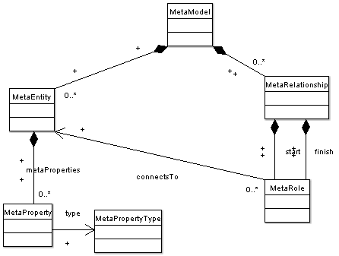Figure 1: Meta model classes and their relationships

The above diagram shows that the meta-model contains meta-entities and meta-relationships. A meta-entity can contain zero to many meta-properties each of which has a given meta-property-type. A meta-relationship contains 2 meta-roles (start and finish) each of which connects to a given meta-entity.

Model
Each class in the model has a corresponding class in the meta model. Given the different things in the meta model and their relationships it should be no great surprise to see that the classes in the model, and their relationships look very similar:
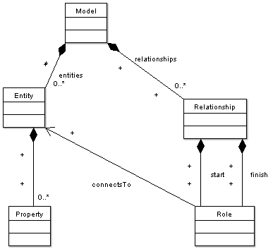Figure 2: Model classes and their relationships
What is not shown is that model connects to meta-model, entity to meta-entity, relationship to meta-relationship and so on. The key concept here is that the model (entities, relationships etc) contain the data you are interested in. The semantics of that data and its relationships are described by the meta-model.

Identity
Everything in the repository has an unchanging unique identifier that gives that thing its identity. The values of properties may change, the names of things in the meta-model may change but the fundamental identity of those things remains unchanged. This is done using “Universally Unique Identifiers, otherwise known as UUIDs. UUIDs (at least the type used here) are created using a network card address (the MAC address which is unique to that network card), a timestamp and a sequence number. When put together these are guaranteed with a very high degree of certainty to produce unique identifiers irrespective on whether they are created at the same or different times or on the same or different computers. This uniqueness not only allows the identity of objects in one repository to be managed but means that repositories can be distributed and merged without risk of accidental over-writes.
When displayed as text UUIDs are shown in a format like
4d3b8f30-e02d-01da-8000-00b93dc5b76a
In effect it's a random string of characters without meaning – but it's a unique random string of characters!

Display Hints
UUIDs are great for establishing an invariant identity for a “thing” but are truly awful method for people to refer to that thing. Implicit in the diagrams of the meta-model and the model above is that no one property is given special treatment as the “name” of the entity. Hence there is the need for a “Display Hint” which describes which properties should be used as the “name” of an entity when that entity is displayed in a list or on a diagram. These display hints are set up in the meta-model and can reference more than one property. For example, a list of services might have a reference number and a short description so number:description might be the best choice for the “name” for those service entities.
The EATool also uses the lack of any display hint to treat a meta-entity (and its corresponding entities) as “second-class citizens” ignoring them during many operations.

Inheritance
When producing a meta-model, you quite often find that you want a number of meta-entities to have a group of similar properties. For example, where much of the data is imported from external sources you might want the date of last update, the source system and the ID of the data in the source system. While you can add these properties to each meta-entity by hand, there is an easier way. This way is to use inheritance.
To use inheritance you define your common sets of properties in a base meta-entity. Then other meta-entities can inherit those properties. These are derived meta-entities. Any existing meta-entity can be used as a base and when the derived meta-entity is created it is marked as extending another meta-entity. There is no limit to the inheritance depth so you may end up with a hierarchy such as:
Figure 3: An example of inheritance in the meta-model
Common
Infrastructure
Component
Server

In the above example, it makes sense to have records that record the servers in use. It probably doesn't make sense to have “Common” records existing on their own. To prevent this meta-entities can be marked as Abstract. Abstract meta-entities cannot be used to create entities- they can only be used as bases for other meta-entities.

Diagrams
In a similar fashion to the way the model is described by the meta-model, diagrams are described by diagram types. Here each diagram type defines which types of entity can be displayed on its diagram, what the symbols should be for each type of entity and how their relationships should be displayed. It also allows you to set the colours and fonts for each type of entity.

Building the Metamodel

Starting From Scratch
Starting a meta-model from scratch is, in some ways, easier than changing one that's already in use as you don't have to consider the impact on an existing model.

Creating Meta-Entities
Most manipulation of the Meta-Model is done using the Meta-Model Explorer. To start this up, select MetaModel, Explore from the main menu. You should see the explorer window that looks something like:
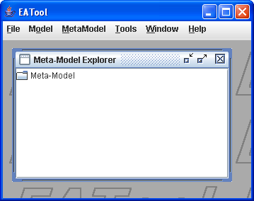Figure 4: Initial view of MetaModel Explorer
EATool represents the meta model as a hierarchy with the Meta-Model entry as the root. Double click on the root Meta-Model folder to show the entries for Meta-Entities and Meta-Relationships. Initially they are displayed as documents as there are no meta entities or meta relationships defined.
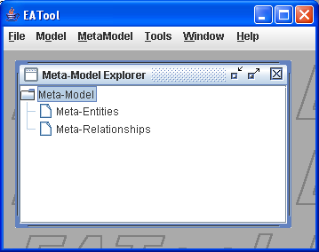Figure 5: Meta Model Explorer showing Meta-Entities and Meta-Relationships
Initially we want to create some Meta Entities. Right click on “Meta-Entities” to produce a pop-up menu. The menu should only have a single entry: New. Click on this and you should see an Edit Meta-Entity dialogue similar to the one shown below:
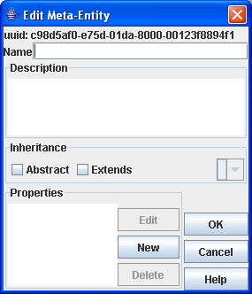Figure 6: Empty Edit Meta-Entity Dialogue
Name is self explanatory although care in naming pays dividends in understanding a model later on. Description allows you to record more detail on the semantics of this meta-entity. It's helpful to record what you created this meta entity for- especially if you are likely to have to maintain the model some months hence.
The Inheritance panel allows you to specify a meta-entity that this inherits from, and/or allows you to specify that this meta-entity is only to be used as a base for other meta-entities.
Abstract allows you to define this meta entity as abstract. If this box is checked you cannot create any entities of this type. Typically this is used for a meta-entity containing common properties that you want to have in a number of meta-entities, or for a marker meta-entity. A marker meta entity is where you want to group a range of meta-entities that have a similar function, e.g. All those that might appear on a process chart for example.
Extends allows you to extend an existing meta-entity and you can choose that base meta-entity using the drop-down list on the right of the extends check box. Any entity created from this meta-entity will also have any properties defined in that base meta-entity (and so on).

The Properties panel allows you to create, edit and delete properties. New and Edit pop up a further dialogue like the one shown below.
Finally the OK and Cancel buttons save or abandon the edit respectively.

The Edit Meta-Property dialogue is shown below. Again, it has a Name and Description. It is worth filling in the Description as it is used as a tooltip (pop up help) when editing an entity.
The Type field determines the data type of the property e.g. whether it's text (a string), numeric, a date or a web address (URL).
The property can be marked as Mandatory – any corresponding entities must have a value for that property set.
The Default value is used to set the initial value of the property when a new entity is created.
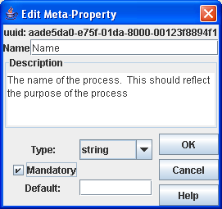Figure 7: Edit Meta-Property Dialogue

Once the meta-property is defined it is shown in the Properties list as shown below.

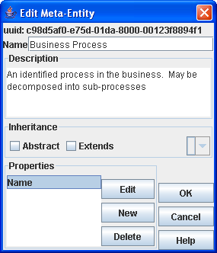Figure 8: Edited Meta-Entity Definition

Once all the required properties have been added and you have clicked on OK, the meta model explorer view is updated with the details of the meta-entity and its properties.

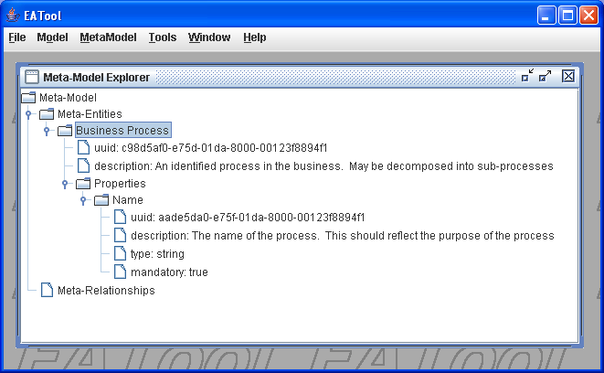Figure 9: Explorer with single meta-entity added
Right-clicking on a Meta Entity will produce a pop up menu for that meta entity (right clicking on most things produces an appropriate pop up menu). Most of the options are obvious – Edit Display Hint is discussed below.
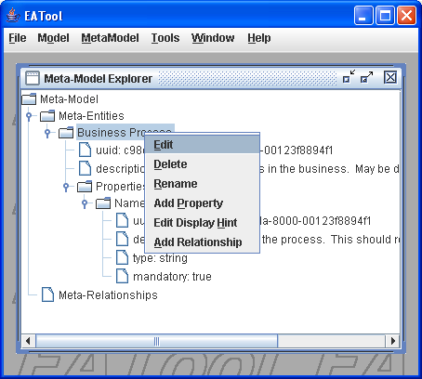Illustration 1: Meta-Model Explorer with Meta-Entity pop up menu.
When you create a new Meta Entity you will probably give it some properties. One (or more) of these properties may provide the “human readable name” of any corresponding entities. Setting the display hint tells EATool which property to use. If no display hint is set, EATool will just display the UUID for an entity. Whilst this is the true identifier for the entity, it's not the most understandable name for that entity. To set the display hint, right click on a Meta-Entity in the Meta-Model Explorer and click on Edit Display Hint. You will see a dialogue similar to the one shown below. Pick the property or properties you want to use for the display hint and use the arrow buttons to move them to the right hand list. If you select more than one, then the entity's “name” will be the selected properties separated by colons.

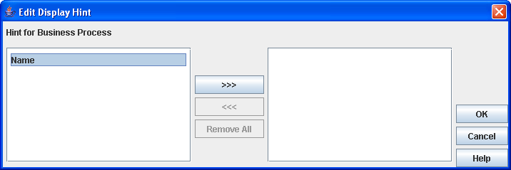Figure 10: Edit Display Hint Dialog

Adding Relationships
To add meta-relationships right click on the Meta-Relationships node in the explorer and click on New as shown below:

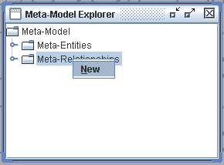Figure 11: Popup for Meta-Relationships
You should then see a blank Edit Meta-Relationship dialogue like the one below.

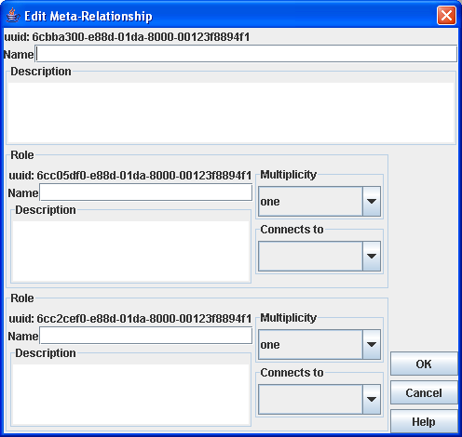Figure 12: Blank edit Meta-Relationship dialog.

Each Meta-Relationship must have a name. Whilst the uuid is unchanging, generally, you will select relationships of this type by its name so that it helps to have a sensible name. For example, “decomposes to” may accurately describe the relationship in a hierarchy – but doesn't help if there are multiple “decomposes to” relationships in the meta-model. Instead, something like “Business Process Hierarchy” is much more descriptive.
Description expands on the purpose of the meta-relationship. Generally, having something sensible will help you remember what your original intention was and will help to communicate the semantics of your model to others.
Note that there are 2 panels for Role. Remember that each relationship has 2 roles – a start and a finish role (while not explicitly named, the start role is the first one). These roles describe what role the connected entities will take in a relationship, what type of entities are connected and the multiplicity of the connected entities.
Name and Description are as before. If you do not explicitly name the Role it will be given the name of the meta-entity it connects to. Usual comments about naming and clarity of the meta-model apply!
Multiplicity describes the number of entities that can connect via that relationship. If the multiplicity includes zero then that relationship is optional. The current multiplicities are:
- One – the connected entity must be connected to exactly one other entity.
- Zero or one – the connected entity may be connected to at most one other entity.
- Zero, one or many- the connected entity may be connected to no, or any number of other entities.
- Many – the connected entity must be connected to 1 or more other entities.
Connects To identifies the meta-entity that this meta-role (and hence meta-relationship) connects to.
An example of a business process hierarchy is shown below. Note the one to zero, one or many multiplicities that give the tree structure – an entity can have zero or more children but can only have one parent.
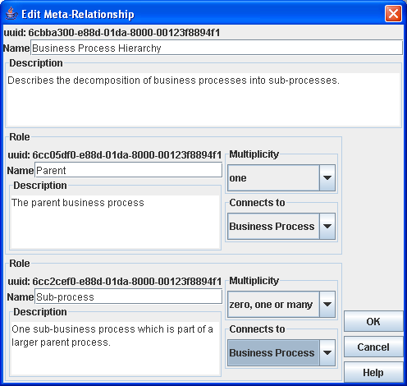Figure 13: Completed Edit Meta-Relationship dialogue.
Once the meta-relationship has been entered, it is added to the explorer tree as shown below. Right clicking on the meta-relationship allows you to edit or delete the meta-relationship. Similarly, you can edit the individual roles by right clicking on them.

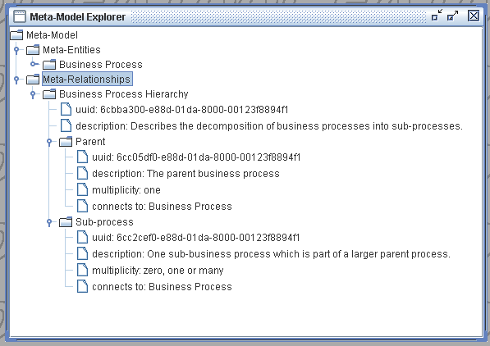Figure 14: Meta-Model Explorer with a meta-relationship added.

Changing the Meta-model
Once the meta-model has been built, you create a model. As you gain experience with the model you may want to modify the meta-model, only now, changes to the meta-model impact the associated model. Depending on the type of change the impact on the model will vary. The impact of various changes are described below.

Additions
Generally, additions to the meta-model have little or no impact on any corresponding model as detailed below.

Meta-Entities
Adding a new meta-entity has no impact on the existing model, diagrams or scripts. Once the new meta-entity is created corresponding entities can be created, used in diagrams, referred to in scripts etc.

Meta-Relationships
Adding a new meta-relationship has no impact on the existing model, diagrams or scripts. Once the new meta-relationship is created corresponding entities can be created, used in diagrams, referred to in scripts etc.

Meta-Properties
Adding a new meta-property to a meta-entity will update all those entities that are described by that meta-entity. These entities will all have a new property, corresponding to the new meta-property, added. These new properties will be initialised to the default value specified in the new meta-property. Note that if you mark the meta-property as mandatory then you should supply a valid default value for the created properties.

Changes
Name changes do not change the model but will appear in reports, dialogs etc. as linking between meta-model and model is done by unique keys rather than names.

Meta-Entities
The only change that can be made to a meta-entity is to rename it or change its description. These do not impact the corresponding model.

Meta-Relationships
Changing the “connects to” fields of any meta-relationship invalidates any corresponding relationships which will then be deleted (as they would no longer connect to the right type of entity). Name and description can be freely changed, as can the names and descriptions of the associated roles. Changing multiplicity must be done with care as this may result in a model that while consistent, is semantically invalid.

Meta-Properties
Changing the name and description has no impact on the model.
Changing the mandatory attribute may invalidate the model in that there may be properties, now marked as mandatory which do not have values.
Changing the default value will only effect properties created after the change.
Changing the type will have a variable effect. All the corresponding properties will be processed and the system will attempt to convert to the new type (through a text representation). If values cannot be converted to the new type then they are replaced by the default value from the meta-property.

Deletions
Deletions generally have a major impact on the corresponding model (and diagrams) as dependent entities, relationships and symbols all have to be deleted as well.

Meta-Entities
Deleting a meta-entity will also delete any attached meta-relationships, any entities or relationships that correspond to those meta-entities and meta-relationships. It also impacts diagrams where corresponding symbols, symbol types, connectors and connector types are deleted.

Meta-Relationships
Deleting a meta-relationship will also delete any corresponding relationships, connectors from diagrams and connector-types.

Meta-Properties
Deleting a meta-property will delete any corresponding properties. It may also invalidate any display hints.

Building the Model
The next step after building the meta-model is to populate the model. Instead of using the Meta-Model Explorer, which you used to build the meta-model, you use the Model Explorer as the main method of building the model. There are however other methods of building the model – by use of diagrams, matrices, and data import which will be discussed in later sections.
To start up the model explorer, select Model, Explore from the main menu. You should then see the Model Explorer window and if you then double click on the Model folder icon it should expand to show the 2 sub categories of Entities and Relationships as shown below.

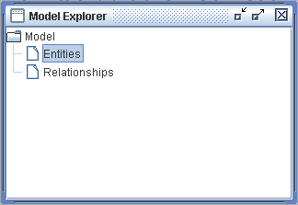Figure 15: Blank Model Explorer

Adding Entities
Right clicking on Entities in the Model Explorer will produce a pop-up menu with a single entry of New. Click on New to create a new Entity. You will then be asked to select the type of entity that you want to create as in the dialogue shown below. The list of available entity types corresponds to the meta-entities you defined in the meta model.

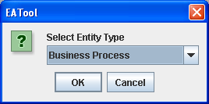Figure 16: Selecting an entity type
Select the entity type you want to create and click on OK. You will then see a dialogue similar to the one shown below to enter details for that entity. There are 2 tabs on the dialogue: Properties and Relationships. At the moment we will only worry about the properties tab.
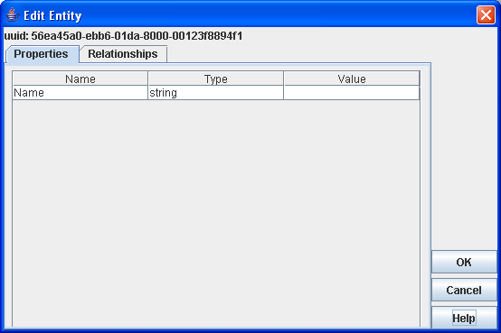Figure 17: Edit Entity Dialogue
In the properties tab there is a table of the entities properties showing the name of each property, its data type, and its current value. The value field is the only one you can edit so click on the value cell in the table and type in an appropriate value. When you move to another cell or click on OK the system will check that the value you have entered is valid for the data type of that value. If not you will see an error message and the cursor will stay in the offending cell.
Note that if you hover the mouse over a row in the table, if you have put a description in for that property in the meta model, then that description will be displayed as a tool-tip. Another good reason for properly documenting the meta-model!
Once you have entered all the values (in the dialogue above there is only one, called Name) click on OK. The Model Explorer will then be updated with the new Entity which can be expanded down by right clicking on each folder node as shown below.

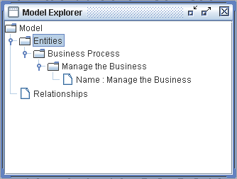Figure 18: Model Explorer with a single Entity defined.

Adding Relationships

As before, create a new entity, or edit an existing one (right click on the entity in the explorer tree and select Edit from the pop-up menu). This time, click on the Relationships tab in the dialogue. The dialogue should then look similar to the one shown below. Currently there are no relationships defined for this entity so the table is empty.

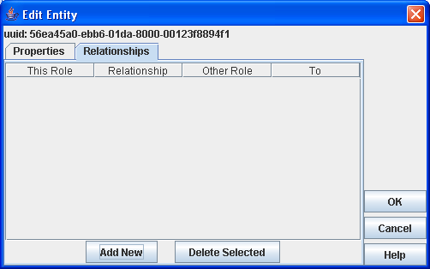Figure 19: Edit Entity Relationships with no relationships defined
Clicking on Add New will pop up another dialogue for you to select the type of relationship you want to create. The list of relationship types will be those set up in the meta-model that connect to the type of entity you are currently editing. Note that if there is only one valid type of entity then it will be assumed and the system won't ask you. Select the type of the relationship you want to create from the dialogue and click on OK:

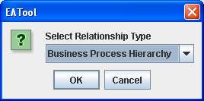Figure 20: Select Relationship Type Dialogue
Next, the system will display a Select Entity dialogue for you to select the entity you want to link to as shown below. Note that these are all the possible entities that could connect to the entity that you're editing. Select the entity you want to connect to and click on OK.

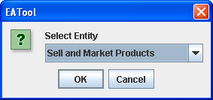Figure 21: Select Entity Dialogue
When you have clicked on OK the relationship will be added to the relationships list of the entity. Repeat the process to add as many relationships as needed. If you incorrectly add a relationship then select it's row (it will be highlighted as in the figure below) and click on Delete Selected. Once you have added a number of relationships then the Relationships tab will look something like the one shown below. Click on OK to close the dialogue.

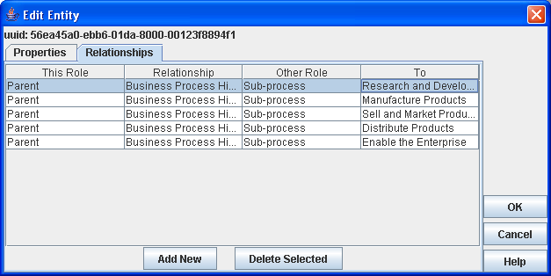Figure 22: Completed Relationships Tab

Once the relationships have been created, they are reflected in the Model Explorer as shown below:

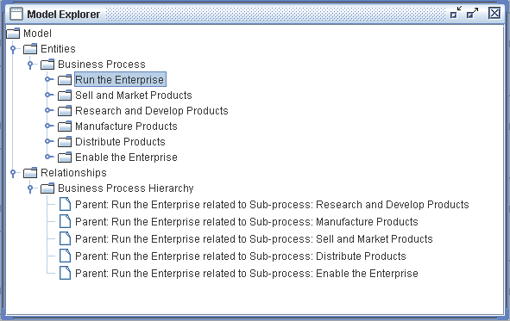Figure 23: Model Explorer with relationships added.
Once you have started to create relationships there are a couple of shortcuts available in the Model Explorer. Right clicking a relationship type node (e.g. Business Process Hierarchy in the figure above) produces a pop-up menu with a single option of New. Clicking on New will show a dialogue that allows you to select entities that connect to both ends of the given type of relationship as shown below.

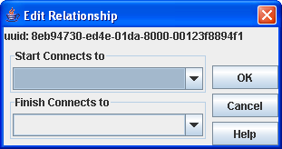Figure 24: Edit Relationship Dialogue
Similarly, right-clicking on a relationship will allow you to edit it (change the entities it connects to ) or to delete it.

Loading and Saving
In this version of EATool, repositories are stored on disk and are read into memory for editing or display. Once edited they need to be saved back to disk. Later versions may be backed by a relational database where incremental changes are written to the database.
Creating a new repository, loading, saving, merging, import and export are all accessed from the File menu.
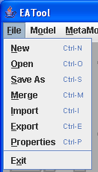Figure 25: File menu

New
To create a new, empty, repository, select File/New. This will clear out any existing repository from memory. Make sure you have saved any existing work first! Note that when you start up EATool it starts with an empty repository until you load an existing one or create one from scratch.

Open
To open an existing repository select File/Open. This will display a standard File Open dialogue. Select the (xml) repository file you wish to load and click on Open. You will see a progress bar similar to the one shown below while the repository is being loaded and indexed.

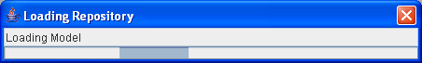Figure 26: Loading progress bar
By default the File Open dialogue will have the repository you last opened selected.

Save As
To save the repository you are working on select File/Save As. This will display a standard File Save dialogue for you to select the file-name and location where you wish to save the repository. Navigate to the directory where you want to save the repository, enter its file-name and click on Save. Note that the File Save dialogue will default to the file that you last used to save a repository in. This may not be the same file that you loaded the repository from.

Merge
Merging repositories is similar to opening a new one except that any repository you currently have in memory is not cleared first. Remember that all the “things” in the repository are identified by UUID, not by their names. Any “thing” in the current repository with a UUID that is matched by a UUID the repository being read from disk will be over-written by the corresponding “thing” from the repository being read. If there is no match then the “thing” read from disk will just be added.
To merge a repository, select File/Merge and select the repository file that you wish to merge into the current repository.

Import
Import is used to import data from an external source (e.g. From other CSV or XML files). Before data can be imported import translations need to be created. This is discussed further on page 29 - Importing Data.
If there are no import translations defined, selecting File/Import will display an error message “No Import Translations Defined”. If there are translations defined you will see s dialogue, similar to the one shown below to select the import translation.
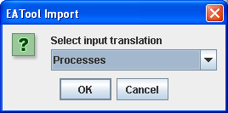Figure 27: Select imput translation dialogue

Select the appropriate translation and click on OK. You will then see a standard File Open dialogue to select the file to import from. Select the file to import and click on OK. The file will be loaded and the data mapped to the appropriate entities and relationships as defined in the import translation.

Export
Export is used to export part of the repository (e.g. Just the meta-model) with an optional XSLT transform which can convert the XML from the repository into other forms of XML or into HTML for display in a web-browser. Note that this is not the recommended way of producing a web-site from a model but is useful for documenting a meta-model.
Before exporting data an export translation needs to be defined. This is discussed further on page 39 - Exporting Data.
If there are no export translations defined then selecting File/Export will display an error message “No Export Translations Defined”. If there are translations defined then you will see a dialogue similar to the one shown below to select the export translation to use.
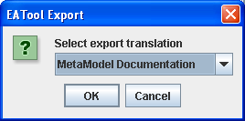Figure 28: Select Export Translation Dialogue
Select the export translation to use, click on OK and then you will see a standard File Save dialogue. Select the file you wish to export to and click on Save.

Properties
There are a couple of properties that can be set for a repository. One is the name of the originator – i.e. The person or group who created the repository. The other is the repository name. To set these properties select File/Properties. The Edit Repository Properties dialogue will be displayed. Enter values for the properties and click on OK.

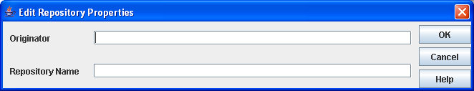Figure 29: Edit Repository Properties dialogue
Note that the Repository Name is used as a title when exporting the repository to a web site.

Exit
File/Exit shuts down the application after first asking for confirmation as shown below.
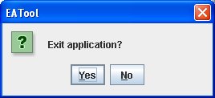Figure 30: Exit Application Dialogue

Importing Data

XML
EATool will import external data in an XML format. An import translation needs to be set up before the data can be imported. This import translation defines the mappings between the external data being imported and the meta-model.
There are a a number of questions that the import translation needs to address:
- What kind of entities are being imported?
- Which properties (of the entities) are present in the import?
- As the imported data won't have UUIDs, how are the entities identified?
- How are the entities related?

To see how the import works it is worth first of all looking at a sample XML import file. A sample XML import file that describes 2 business processes and establishes a relationship between them is shown below.

<?xml version="1.0" encoding="UTF-8"?>
<Import>

<Entity type="Process">
<Property type="name" value="Run the enterprise"/>
<Property type="description" value="Top level process that defines the entire enterprise"/>
</Entity>
<Entity type="Process">
<Property type="name" value="Enable the business"/>
<Property type="description" value="Provide the support needed to enable a functioning enterprise"/>
</Entity>

<Relationship type="Process Decomposition">
<Role type="Parent">
<PropertyKey type="name" value="Run the enterprise"/>
</Role>
<Role type="Child">
<PropertyKey type="name" value="Enable the enterprise"/>
</Role>
</Relationship>

</Import>

Figure 31: Sample XML import file
The key points in this file are:
- It's a well-formed XML file with a top level xml declaration.
- It has a single root element, in this case called <Import>. The name of the root element doesn't actually matter provided it's a valid element name.
- Entities are described by the Entity element and Relationships by the Relationship element.

Entity
The Entity element has a single attribute called type. The import uses the type attribute to identify what type of entity is being imported. The import translation will map this type into a meta-entity. If the type is not recognised then the import will fail with an error message. Hence, while not all the entity translations defined in the import translation need to be in the import file, all the type in the import file must have entity translations defined in the import translation.
The Entity element has one or more Property child elements. The Property elements have both a type and a value. These identify the property and provide its value respectively.

Relationship
A Relationship element also has a single attribute called type. In the same was as for an entity, the import translation uses this type attribute to identify the type of relationship that is being imported. Each relationship has 2 Role child elements. The Role elements have their type attributes also.
A role must connect to an entity- but which entity? The PropertyKey elements identify the entity. They have 2 attributes, type and value which specify the entity that has the property given by type with the specified value. Note that each Role can specify more than one PropertyKey elements if it needs more than one property to uniquely identify an entity.

Import Translations
Import translations are managed using an Import Mapping Explorer (Note that Import Mappings and Import Translations are synonymous). To display the Import Mapping Explorer, select Tools/ Import Mappings from the main menu. Initially the explorer will look similar to the figure below.

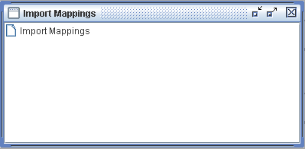Figure 32: Empty Import Mappings Explorer
Right click on the Import Mappings icon in the explorer and select New from the pop-up menu. You will then see a New Import Mapping dialogue similar to the one shown below.
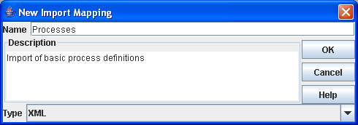Figure 33: New Import Mapping Dialogue
Enter a name for the mapping and an optional description. Leave the type of import as XML and click on OK. This then creates a new empty mapping which is visible in the explorer as shown below.

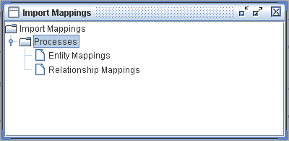Figure 34: Import Mapping Explorer with empty mapping
To create a new Entity Mapping, right click on the Entity Mappings node in the tree and select New from the pop-up menu. You will then see a New Entity Mapping dialogue as shown below.

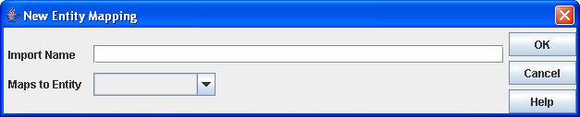Figure 35: New Entity Mapping dialogue
Using the sample XML shown earlier, we want to map import type of “Process” to a Business process. This would be entered as shown below.

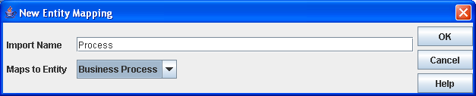Figure 36: New Entity Mapping dialogue mapping Process to Business Process
Once you click on OK, the entity translation will be reflected in the explorer. You still need to enter property translations for the entity so right click the entity mapping to get the pop-up shown below.

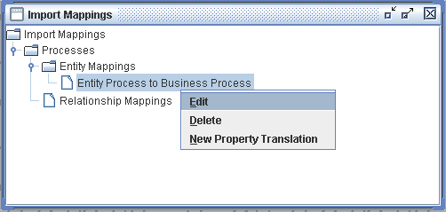Figure 37: Import Mapping Explorer showing entity mapping pop-up menu
Select New Property Translation to display the New Property Mapping dialogue below.

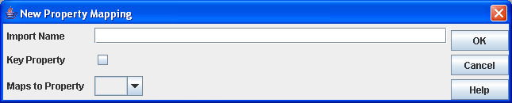Figure 38: New Property Mapping dialogue
Enter the type of the property (as defined by the type attribute in the import file) in the Import Name field and select the property it maps to from the drop-down list. If this is a key property – i.e. one that will be used to identify any existing entity for update, then check the Key Property check-box.
Relationship import mappings are set up in a similar fashion. Right clicking on Relationship Mappings in the explorer and clicking on New will display the New Relationship Mapping dialogue shown below.

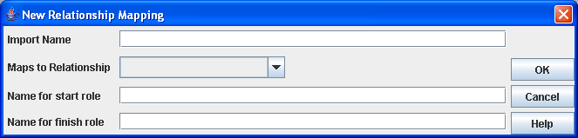Figure 39: New Relationship Mapping dialogue
Enter the values from the type attributes for the relationship and its 2 roles and select the relationship type from the drop down. For mapping the process decomposition relationship in the sample file, the values would be as follows

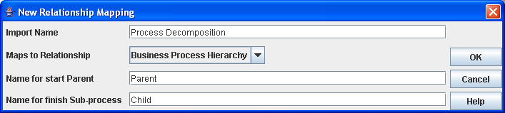Figure 40: Mapping the sample relationship
As usual, the changes are reflected in the explorer as shown below:

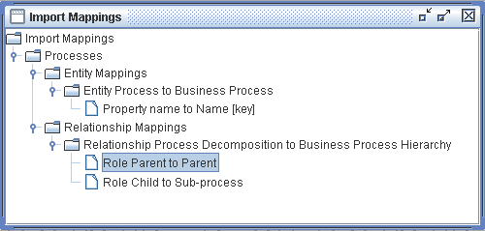Figure 41: Import Mapping Explorer with relationship mapping defined.
The last task is to add property keys to each role to identify which entities the relationships connect to. Right click on each Role and select New Property Translation from the pop-up menu.

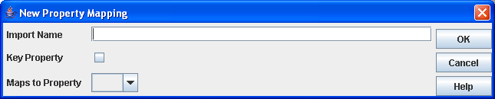Figure 42: New Property Mapping dialogue
Here we want to identify the roles by their name property. This property is identified by a type attribute of name in the sample XML and it is a key property. Enter the values to set up the property key and click on OK. The final explorer view of this mapping is shown below.

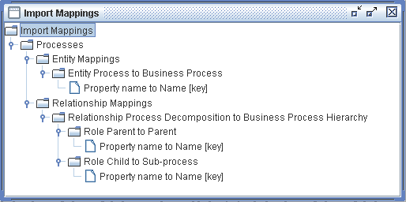Figure 43: Import Mappings Explorer with entity and relationship mappings

CSV
The CSV Import provides a shortcut to importing CSV (“Comma Separated Value”) file by producing an XML import file “on the fly” during the import.
Note that the CSV file should not have a header row.
Each row in the CSV file generates a single Entity in the XML import file. These entities all have a type attribute of “entry”.
Each column in the CSV file generates a Property element in the XML import file. The first property has a type of “value1”, the second “value2” etc.

When setting up the import translation you will need to map the values shown above and also select CSV as the import type in the import mapping dialogue shown below.

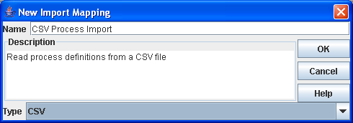Figure 44: Import Mapping dialogue

CSV Hierarchy
Frequently hierarchies (such as organisational trees, classifications etc.) are specified as a table in a spreadsheet. The example below shows such a hierarchy.

A | AA | AAA
A | AA | AAB
A | AB | ABA
A | AC | ACA
B | BA | BAA
B | BA | BAB
B | BB | BBA
C | CA | CAA
C | CA | CAB
C | CB | CBA
C | CC | CCA

Here, what is really wanted is shown below.

Figure 45: Example import hierarchy
AA
AB
AC
BA
BB
CA
CB
CC
AAA
AAB
ABA
ACA
BAA
BAB
BBA
CAA
CAB
CBA
CCA
A
B
C
Root

The first thing that will be apparent is that the proper hierarchy has a root node but the table doesn't. The system will insert a root node (called “root”) when it performs the import.

A Hierarchy import produces both entities and relationships.
The entities are produced with type “entry”. They have a single property of type “name”.
The relationships are produced with type “hierarchy”. Each relationship has 2 Roles with types of “parent” and “child”. Each Role has a single PropertyKey with type “name”.

For this example we have a hierarchy of “HierarchyNode” linked in by a “Hierarchy” relationship with “Parent” and “Child” Roles. The entity and relationship is shown below.
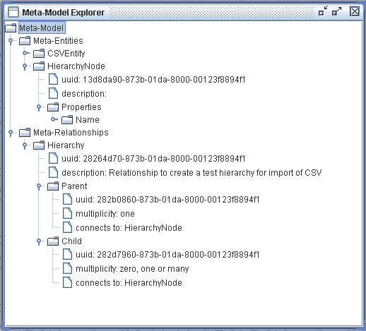Figure 46: Target Meta-Model for Import

The first stage is to create an empty import mapping. Display the Import Mapping Explorer using Tools/Import Mappings. In the explorer right click on Import Mappings and select New. You should see a dialog similar to the one below. Note the selection of the correct type – in this case “CSV Hierarchy”.

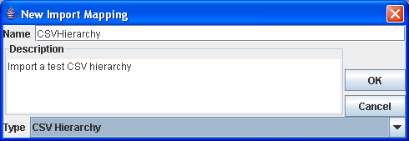Figure 47: Import Mapping Dialog

Within that input mapping create a new entity mapping. Here each entity is given type “entry” by the CSV import. In this example we wish to map the entities in the hierarchy to “HierarchyNode”

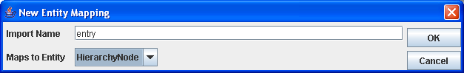Figure 48: Entity Mapping Dialog
Similarly, the CSV import produces a single property for each entity of type “name”. The “HierarchyNode” entity has a single “Name” property so that is what we map this to.

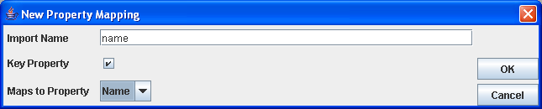Figure 49: Property Mapping Dialog
The next stage is to set up the relationship mappings.

The relationship mapping specifies the linkage between an import name and a relationship and similar mappings for each of the Roles on the relationship. This is entered using the Relationship mapping dialog shown below.
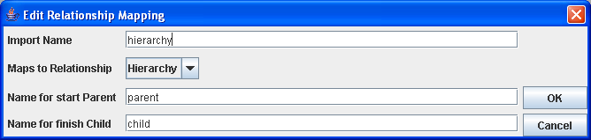Figure 50: Relationship Mapping Dialog
Each Role also needs to have one or more property keys defined which allow the import mapping to select which entities each end of the relationship connect to. Right clicking on a Role Translation node allows a new Property Translation to be added.

The full mapping for the import is then as shown below.
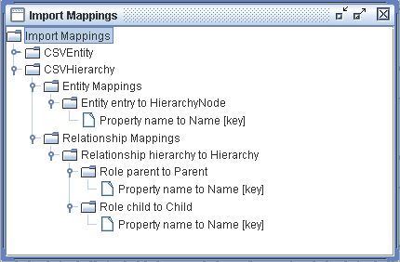Figure 51: Import Mapping Explorer

Exporting Data
Parts of the repository can be exported. This is a fairly coarse-grained export where you specify whether it's the meta-model, the model, diagram types etc that you want exported. However it does allow you to specify a XSLT transform that can translate the exported XML into another flavour of XML or to HTML. A sample export stylesheet for describing the metamodel as HTML is given in Appendix – Sample Export Stylesheet on page 73.

To set up an export mapping first select Tools/Export Mappings from the main menu to bring up the Export Mappings Explorer shown below.

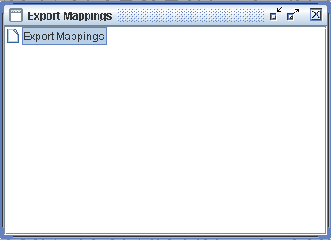Figure 52: Export Mapping Explorer
Currently there are no export mappings defined – right click on the Export Mappings entry and select New from the popup menu. You will then see a New Export Mapping dialogue similar to the one shown below.

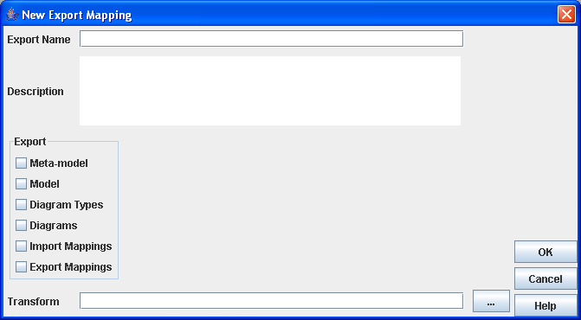Figure 53: Export Mapping Dialogue
As usual, give the mapping a name and description – so you can remember why you set it up a few months hence!
In the Export window check which parts of the repository that you want to export.
You can specify a path to an XSLT transform in the Transform field. This should be the full path to the transform file. If you click on the small button to the right of the Transform field then you can browse for the transform file.
Click on OK and the transform will be saved and will be visible in the explorer where right clicking on it will allow you to edit or delete the transform.

To run the export, select File/Export from the main menu as described in Loading and Saving on page 26.

Note. This manual does not cover writing XSLT. It is a large topic and there are a number of books available. The W3C standard describing XSLT can be found at http://www.w3.org/TR/xslt.

Working with Diagrams
Diagrams are valuable for displaying relationships between entities. Diagrams are managed by a diagram explorer that is accessed by selecting Model/Diagrams from the main menu. Initially, the diagram explorer will be empty as shown below.

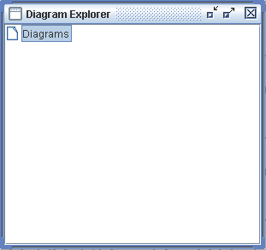Figure 54: Empty Diagram Explorer
Right clicking on Diagrams will produce a pop-up menu. Click on New to define a new diagram type. In the same way as the meta-model describes the entities and their relationships, diagram types describe the symbols and connectors that are used to represent entities and their relationships.

Creating Diagram Types
When you right click on Diagrams and click on New in the diagram explorer you will see a Diagram Type Editor similar to the one shown below. Here there's the usual field for Name so that the diagram type can be given a (meaningful) name. There's also a list of all the meta-entities defined in the meta-model. At this stage, none of them have symbols defined. There is also a table of allowed relationships. As no entity types have been selected, there are no relationships that can appear on the diagram so the relationships table is empty.
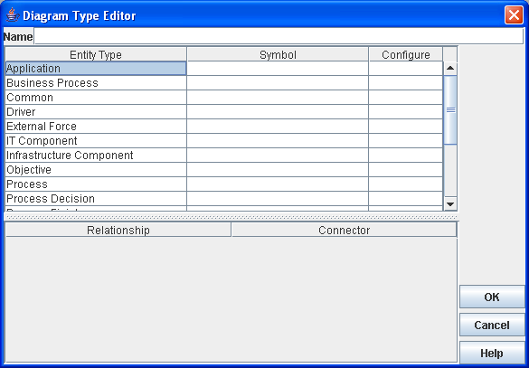Figure 55: Diagram Type Editor
Clicking in the symbol column allows you to select a symbol, from a drop down list, that should be used to display an entity of that type.

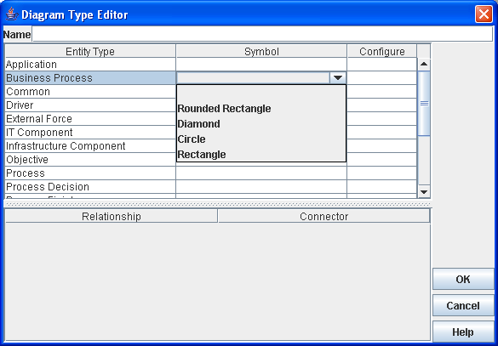Figure 56: Selecting a Symbol Type to correspond to an Entity Type
Once an entity type (or types) has been selected the allowable relationships are displayed. Here, there are 2 types of relationship defined that can connect business processes so they are the only relationships that are added to the relationships table.

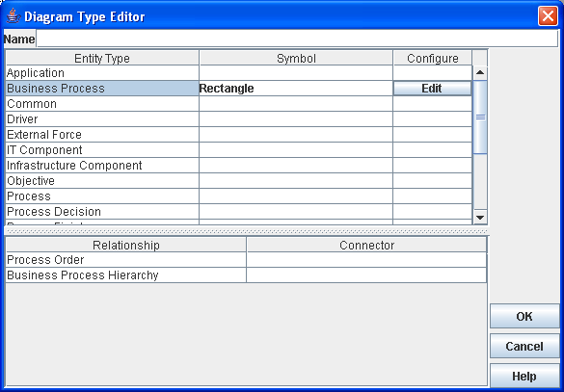Figure 57: Selecting a connector type to correspond to a relationship type
As well as the selecting the type of symbol, clicking on the corresponding Edit button allows you to configure how the symbol is displayed. This pops up a Configure Symbol Type dialogue as shown below.

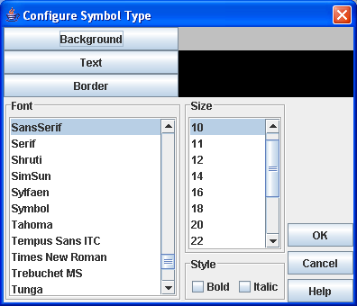Figure 58: Configure Symbol Type dialogue
Here the Background, Text and Border buttons allow you to change the colours of the symbol's background, text and border (we try to keep it simple for architects!). These all pop up a standard colour selection dialogue. The other fields allow you to alter the font, style and size for the text on the symbol.

Connectors are chosen in a similar fashion to symbols. Clicking on the appropriate line in Connectors produces a drop-down list of the available connector types for that relationship as shown below.

Note that only entities and relationships that have symbols and connectors associated with them in the diagram type can be displayed on a diagram of that type.
Inheritance in meta-entities is useful here. Relationships between base types allow any of the derived classes to be connected on a diagram which is useful for diagrams such as process charts where tasks, processes, flow breaks, events, splits and joins all need to be connected by the same type of relationship and connector.

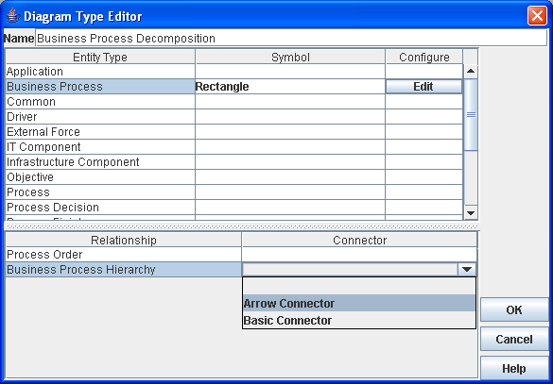Figure 59: Selecting a connector type

Creating Diagrams
Once the diagram type(s) have been created they are reflected in the Diagram Explorer. Right clicking on a diagram type produces a pop-up menu as shown below.

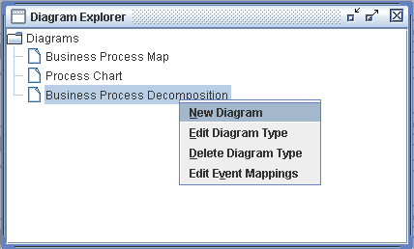Figure 60: Pop-up menu for Diagram Type
To create a new diagram, select New Diagram from the pop-up. The system will prompt for a name for the diagram

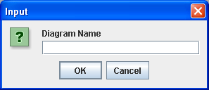Figure 61: Prompt for Diagram Name
Enter the name, click on OK and you will see the Model Viewer with a blank diagram similar to the one below.

Figure 62: Model Viewer with blank diagram
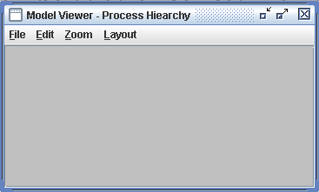Figure 63: Blank Model Viewer

Editing Diagrams
Create a new diagram or right click on an existing diagram in the Diagram Explorer or select Edit from the pop-up menu you get when you right-click an existing diagram. You will then get the Model Viewer window that allows you to edit a diagram.

Entities and Symbols
To add a new entity (that is not already in the model), either select Edit/New Entity from the Model Viewer menu, or right-click on the background of the diagram and select New Entity from the pop-up menu. If the diagram supports more than one entity type you will be asked to select the type of entity to create. You will then see the standard Edit Entity dialogue which will allow you to enter details of the new entity.

To add existing entities (i.e. Those that are already defined in the model) either select Edit/Add Entities from Model from the Model Viewer menu or or right-click on the background of the diagram and select Add Entities from Model from the pop-up menu. A short cut for this is to double-click on the diagram background. You will then see a selection dialogue which has a simple tree of allowable entities.

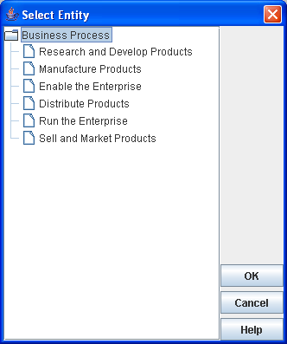Figure 64: Entity Selection Dialogue
Select the entity(s) you wish to add to the diagram and click on OK.

Once the entities are added to the diagram you can move them about by dragging with the mouse. They can also be resized by selecting them with the mouse (single click) and then dragging one of the “handles” that appear round the edges of the symbols.
Right-clicking on an entity allows you to manipulate the entity in a number of ways. From the pop-up menu select:
- Browse Entity to open up this entity in the model browser.
- Edit Entity to edit this entity in the standard entity editor.
- Edit Symbol to change the colours or font of the symbol.
- Remove Entity from Diagram to remove the symbol from the diagram, leaving the underlying entity in the model.
- Delete Entity from Model to delete the symbol and the underlying entity. You will be asked if you really want to delete the entity in this case.

Note that double-clicking on an entity will open up the Edit Entity dialogue and control-clicking will open up the Edit Symbol Display dialogue.

Relationships and Connectors
To add connectors corresponding to existing relationships in the model select Edit/Add Connectors. This will add all the possible connectors to the diagram (depending on which entities are displayed on the diagram and which relationship types have connectors defined in the diagram type).
If you want to be a bit more selective then Edit/Add Selected Connectors allows you to select only connectors of a given type.
You can create new relationships in the diagram. Shift-drag from the start entity to the finish entity. You will be asked if you want to create a new relationship and, if you select yes, then the new relationship will be created and added to the diagram. If there are more than one possible relationship types between the 2 entities you will also be asked to select the type of relationship to create.
If there is already a relationship joining the 2 entities you will see a dialogue similar to the one shown below which allows you to create a new relationship or select an existing one. Either select --New-- from the drop down or select the existing relationship.

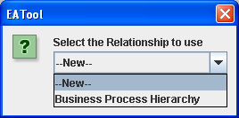Figure 65: Select relationship or create new dialogue
Connectors can (usually) be routed by clicking on the connector and moving the handles. If you want to delete a connector there are 2 options. Right click on the connector to get the pop-up menu and select either Remove Relationship from Diagram or Delete Relationship from Model. Remove Relationship from Diagram just deletes the connector from the diagram but leaves the underlying relationship intact in the model. Delete Relationship from Model on the other hand not only removes the connector from the diagram, but also deletes the underlying relationship from the model. In the latter case, you will be prompted to check that you really do want to delete the relationship.

Zoom
On the Model Viewer menu the Zoom menu allows the diagram to be shown at different magnifications. Zoom In and Out magnify or reduce the diagram by a factor of 1.2 respectively.
The percentage zoom options set the scale factor to the given percentage of full size.
Fit to Window scales the entire diagram to fit within the current size of the window.

Layout
There are a number of options for automatically laying out a diagram. Given the starting point below a hand drawn process hierarchy, the different layouts are discussed in this section.

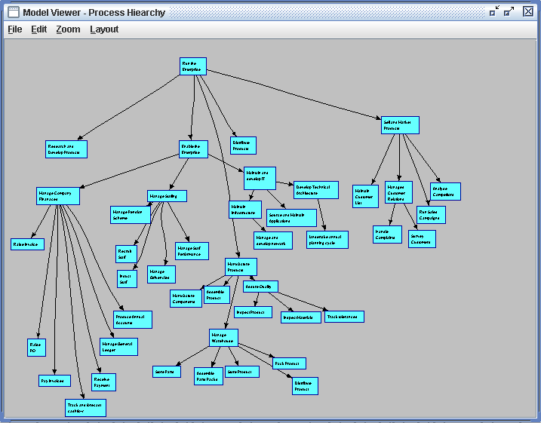Figure 66: Process Hierarchy as drawn
Firstly we have the grid layout. Probably the simplest of the layouts this just puts the symbols on a rectangular grid. Pros are that it's simple, fast and makes good use of screen-space. Cons are that it makes no attempt order the symbols. The grid layout is shown below.
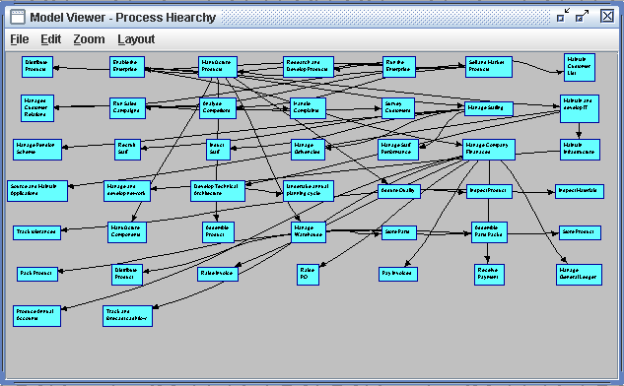Figure 67: Grid Layout
Next is the grid connect layout. Here the symbols are placed on a grid – but the positions on the grid of the symbols are chosen to try to keep connected symbols close together and to minimise connector crossing. It's fairly efficient but doesn't always produce good layouts. The process hierarchy diagram after using grid-connect layout is shown below.
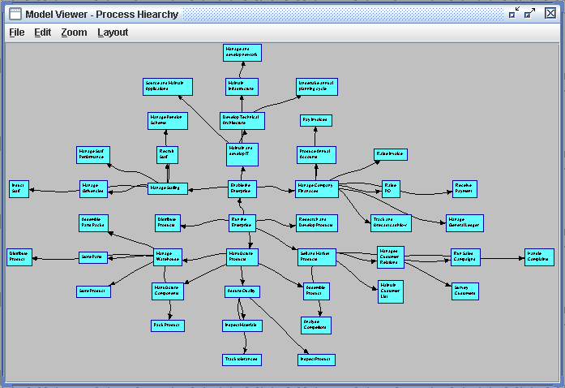Figure 68: Grid Connect Layout
A more general layout than the grid-connect layout is the spring-layout. Here the symbols repel each other but the connectors pull them together. (disconnected islands are processed individually so they don't just fly apart). This is probably the best layout for “random” graphs of entities of the “show me all of this stuff so I can see where the hot-spots are” type of diagram. Beware that for large numbers of symbols this can be slow.

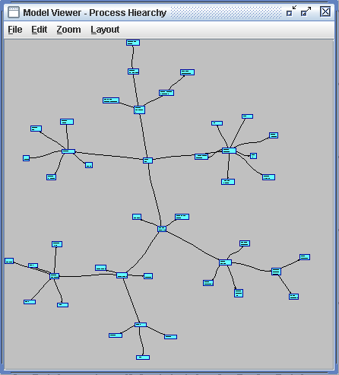Figure 69: Spring Layout

2 special purpose layouts are the Hierarchy and Circular Hierarchy layouts. These only work on true hierarchies where one parent can have zero to many children and a child can only have one parent. If a diagram includes zero or more than 1 hierarchy relationships then both layouts will do nothing as there is either no appropriate relationship or it is ambiguous which relationship to use.

The Hierarchy Layout is shown below. It produces a standard tree shape with the root entity at the top.
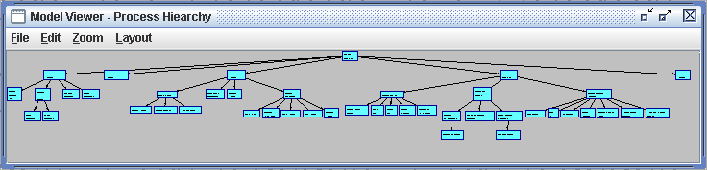Figure 70: Hierarchy Layout
Circular Hierarchy is similar except that the root entity is in the centre of the diagram with successive descendants in rings around the centre. This is shown below.

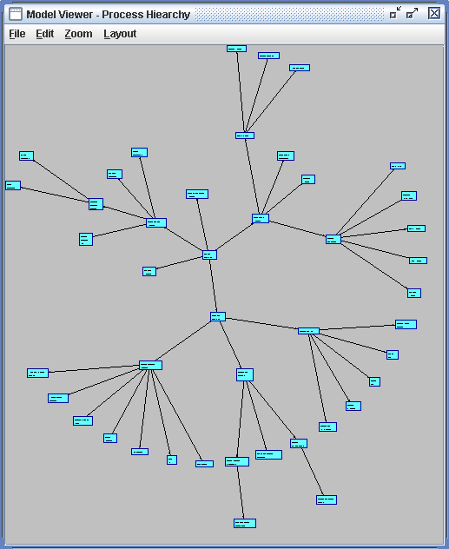Figure 71: Circular Hierarchy Layout
Viewing the model
Selecting Model/View from the main menu will produce a diagram with ALL the entities defined in the model displayed. The entities will be automatically coloured by type. This can be useful for seeing patterns in the model but should be used with care, especially with a big model.

An example is shown below – some diagrams are much more complex!
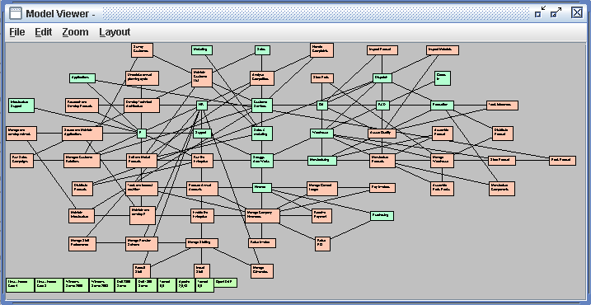Figure 72: Complete view of model

Browsing the Model
As well as displaying the model in diagrams and in tree format (via the Model Explorer) you can also browse the model as a set of linked pages. From the main menu select Model/Browse. You should then see the Model Browser similar to the one shown below.

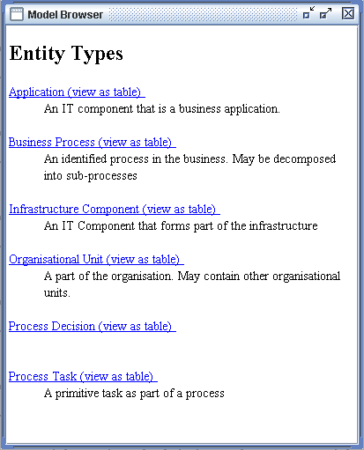Figure 73: Browser list of Entity Types

Here you can see the different entity types from the meta-model arranged in an alphabetical list along with their descriptions. Note that only those meta-entities with display hints set are shown. Each entity type has a hyperlink (shown in underlined blue) to a list of all those entities of that type. The link in the view as table part links through to a tabular display of all the entities.
Clicking on the “Business Process” link in the example above will produce a list of all the corresponding entities (in this case Business Process) as shown below.
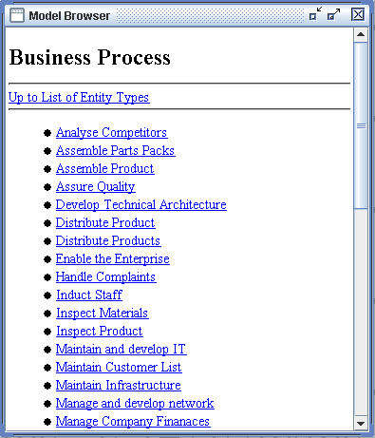Figure 74: Browser list of entities of a given type
Here you can see all the entities of the given type. Again, the entries are hyperlinks that lead to the detail on each entity. The Up to List of Entity Types link at the top of the page allows you to backtrack up to the top level again.
In this example, clicking on “Manage Company Finances” will display the detail for that entity as shown below.
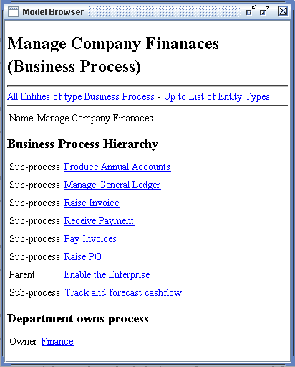Figure 75: Browser display of entity
At the top of the page there's the name of the entity (with the type in parentheses). Next there are links that take you up to the list of all the entities of that type, or up to the top level again. Then there is display of the entity itself, both it's properties (in the figure above there is only one called name) and what this entity is connected to via its different relationships. You can use the related entity links to navigate through the model - clicking on the linked entities will display the details for that entity

Search
As well as browsing the model directly, you can search for an entity using a full-text search. When a model is loaded it is indexed for quick searching. To do this select Model/Search from the main menu. You should then see a dialogue similar to the one shown below to enter your query. Enter the search word(s) you wish to search for and click on OK. Note that queries may be quite complex- see Appendix – Specifying Searches on page 75.

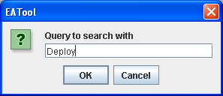Figure 76: Search Dialogue
When you click on OK you will either get a message saying that there are no matches or you should see a dialogue similar to the one shown below. The drop-down list in this dialogue shows all the matches to your search with most relevant match first.

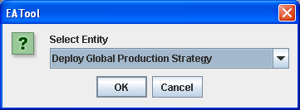Figure 77: Search results for "Deploy"
Select the entity you want and click on OK to open the model browser for the selected entity.

Matrices
A convenient method of representing the relationship between 2 sets of entities is by using a matrix. Here the entities are shown as rows and columns on a grid and where a relationship of the correct type exists between the 2 entities this is shown by a tick on the intersection of the appropriate row and column. By setting or clearing the tick-boxes relationships can be added or removed between entities.
To display a matrix select Model/Matrix from the main menu. You will then be asked to select the relationship that the matrix corresponds to. Select a relationship, click on OK, and you should see a matrix similar to the one shown below.

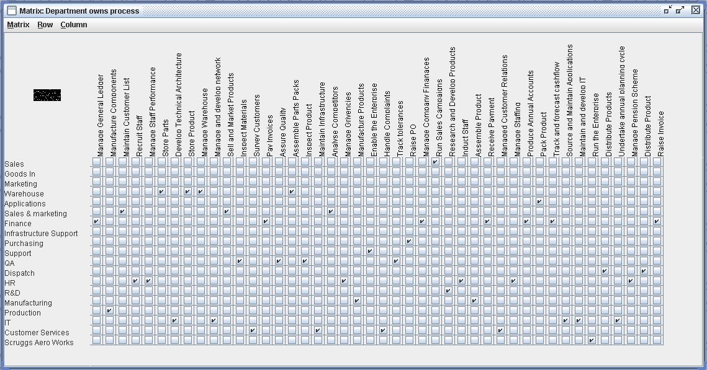Figure 78: Department owns process matrix

The rows and columns can be sorted by one of 3 methods:
- Alphabetically – alphabetically by entity name.
- Density – by number of connections
- Similarity – to group “like” entities together.
If accessed from the Matrix menu then both axes are sorted. The Row and Column menus allow you to sort each axis separately. To show the effect of a similarity sort, the matrix above has been sorted and displayed below.
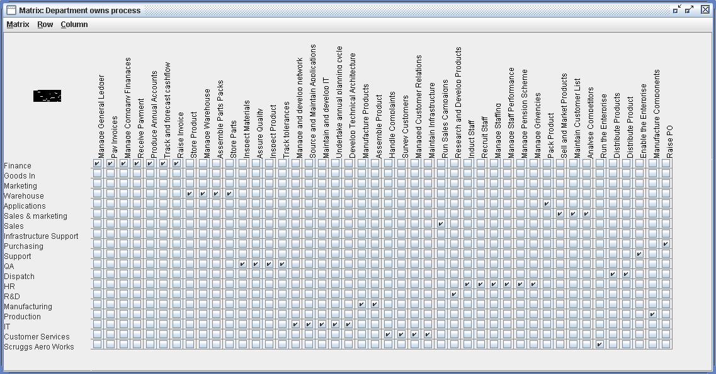Figure 79: Matrix sorted by similarity
Once you have made any changes to the matrix you need to select Matrix/Save and Close from the matrix menu. It is only at this point that the changes you have made get written back into the underlying model. To abandon any changes just select Matrix/Close.

Exporting to a Web Site
EATool will export the model in HTML in a form suitable for displaying on a web-site. To export the model select Tools/Export Web Site from the main menu. You will then be prompted for a folder to export the web site to as shown below. Select the export folder and click on Export.
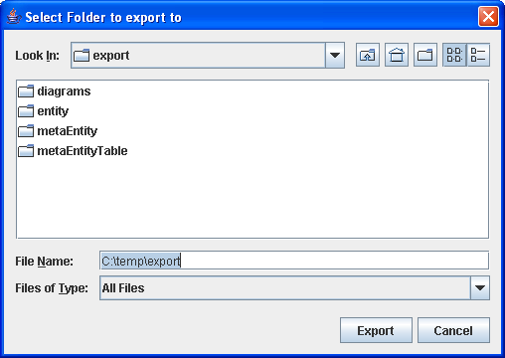

The export process will export the model into the selected folder and will create an index page index.html. Most of the model will be created in sub-folders so ensure that they are copied when publishing the model to the web.

Scripts
The functionality of EATool can be enhanced by writing scripts. Scripts can be written in a number of languages – the 2 supplied as standard are JavaScript and Python. In practice, any “Bean Scripting Framework” compatible Java scripting implementation can be used.
The details of JavaScript and Python are not covered here – there are a number of good books and internet sites that fully cover the languages. What is covered is how the scripts integrate with EATool and how to write and edit them.

Creating a Script
To create a script select Tools/Scripts from the main menu. You should then see the Scripts Explorer similar to that shown below:

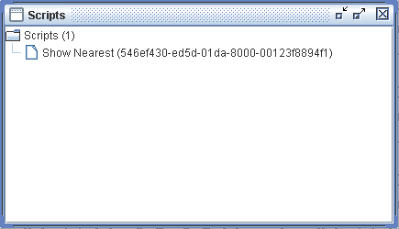Figure 80: Scripts Explorer
Right clicking on the Scripts folder will produce a pop-up menu – select New to create a new script. You should then see an Edit Script Properties dialogue similar to the one shown below.

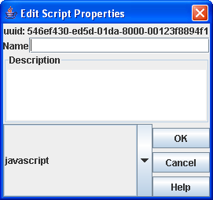Figure 81: Edit Script Properties Dialogue
Like most other things in EATool, scripts have a name and a description and you are encouraged to take care to choose a meaningful name and to document the intent of the script in the Description field.

In the drop-down list you select the language the script is written in. In this case it's JavaScript. Click on OK and you will see a script editor similar to the one shown below.

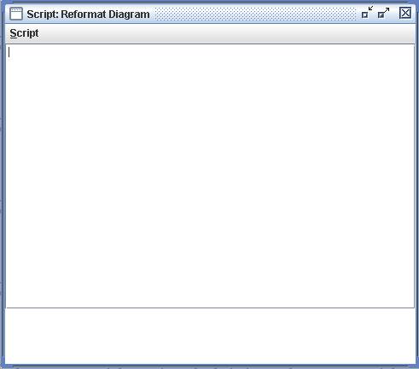Figure 82: Script Editor
There are 2 main areas in the script editor. The top one is where you enter and edit the script, the bottom one is where any errors are shown. The script editor has a single Script menu this is where you with the following options.
- Save and Close which updates the repository with any changes and closes the script editor.
- Edit Properties which allows you to change the script's name and description.
- Close which closes the script editor without updating the repository.
- Run which runs the script
- Object Browser which displays an object browser that shows what the different classes that are available to the scripts are.

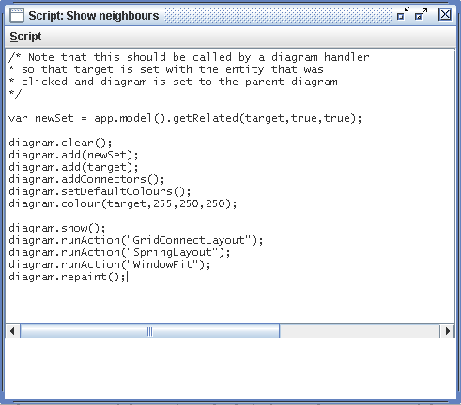

Predefined Objects
Scripting allows you to manipulate EATool pro grammatically. EATool is a complex piece of software however and worse, its internal workings are liable to change over time as the system is developed. To this end, the system provides you with a simplified scripting interface and also sets up an Application object defined called “app” which is available to all scripts.
Note that you are not prevented from accessing the underlying code of EATool outside of the documented scripting classes. This is quite possible but is unsupported and scripts may stop working when the code is updated.
The full set of scripting objects is described in Appendix – Scripting Objects on page80.

Collections
To simplify things many of the scripting objects are in fact sets. Even methods that you would think just have one value will return a set. In this case the set will just contain one item. The collection objects all support an isEmpty() method which allows you to see if it has any items in it.
Generally you do not manipulate individual items in the set but manipulate the complete set as a whole.

Diagram Event Handlers
Scripts called from diagram event-handlers also have 2 other objects defined:
“target” which represents the “thing” that was clicked on the diagram ( which will be an EntitySet or a RelationshipSet depending on the handler called) and “diagram” which is the diagram containing the symbol or connector that was clicked on.

Function Help
Select Script/Object Browser from the script editor menu to display a quick reference screen that describes the methods of EATool's built in scripting objects. An example entry for Application is shown below.
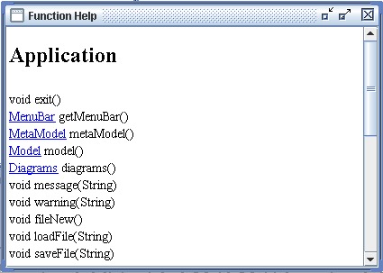Figure 83: Scripting Function Help Browser
As you can see, some entries are hyper-linked. Clicking on these entries will display the quick reference data for the appropriate class.
Note that these quick reference pages are generated directly from the scripting code so they will always be up to date. If, for any reason, these conflict with the HTML scripting reference, then it's the HTML that's wrong.

Event Mappings
Various things in EATool can fire events. These are useful as events can have scripts tied to them. For example an event is fired after a repository is loaded – this can then set up extra menus for example.

Application Level Events
Application level events are accessed by selecting Tools/Event Mappings from the main menu. This will display a dialogue similar to the one shown below.
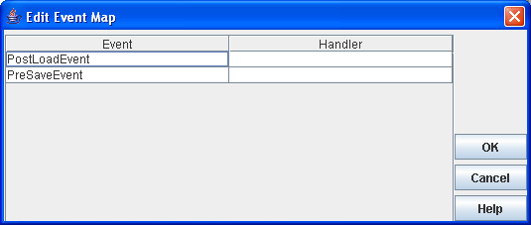Figure 84: Application Event Map Editor
The application has 2 events: Post-load and pre-save. These are called just after a repository is loaded and just before it is saved respectively. To tie a handler (script) to an event, click on the appropriate line in the Handler column of the dialogue. The system will display a drop down list with the currently available scripts. To deselect a script for an event select the --NONE-- option in the list.

Diagram Events
Diagram events are fired when a diagram is displayed or closed. They can also be invoked by shift-clicking a symbol or connector on a diagram. This allows you to set up dynamic diagrams that populate themselves from the model when opened. It also allows you to extend the ways in which you can interact with a diagram – e.g. Shift-clicking a symbol can open another diagram that shows all the entities that are connected to that symbol.

To set up event mappings for a diagram you need to open the Diagram Explorer (from the main menu select Model/Diagrams). Right clicking a diagram type will show a pop-up menu. Select Edit Event Mappings from that menu to edit the mappings for diagrams of that type. The system will display an Edit Diagram Type Event Mapping dialogue similar to the one shown below.

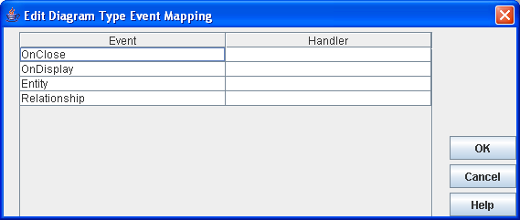Figure 85: Diagram Type Event Mapping Editor
Handlers are set in just the same way as for the application events.

Configuration

Look and Feel

The appearance of the application can be changed from the default “Metal” look to Windows or Motif styles. These choices are under the Window menu:

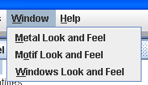
The different views are shown below.

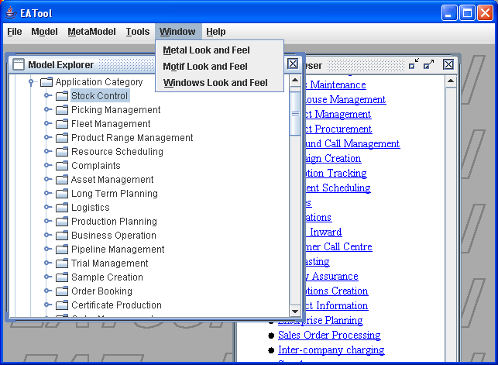Figure 86: Metal Look and Feel

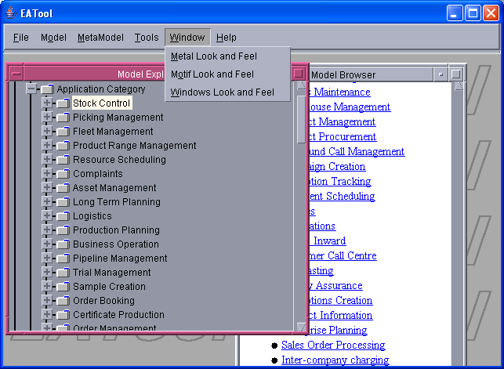Figure 87: Motif Look and Feel

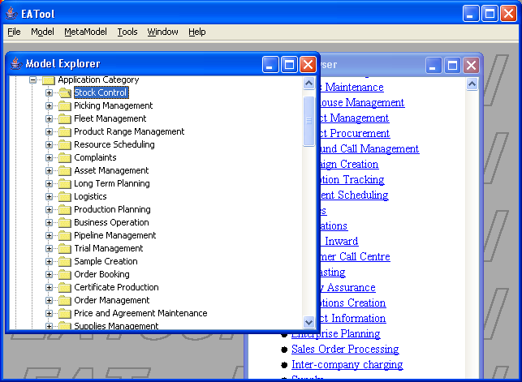Figure 88: Windows Look and Feel

Help
Currently, Help doesn't. Because of the way Java handles modal dialogue boxes help will have to wait for a separate help engine to be implemented.

Customisation
Within the main EATool.jar file there is a configuration file called config.xml. This is an XML file that holds the configuration information for the tool. Other aspects of EATool are controlled by other files within EATool.jar as well. Note that to change config.xml it is necessary to explode the EATool.jar file with the java Jar utility and to re-build it afterwards.

Menus
All the menus are defined in a similar fashion and the structure will quickly become obvious when looking at the original config.xml. The attributes in a menuitem record (below) are not so obvious.
<menuitem action="FileNew"
display="New"
mnemonic="N"
accel="N"
accelmod="CTRL"/>

The action is the name of the action that should be called when the menu item is selected. These are listed in Appendix – Action Names on page 81. Display is the text that should be displayed in the menu. The mnemonic provides a key to navigate through the menu. Accell and accelmod provide a shortcut key (accelerator) for that menu item.
Note that popups are defined in similar fashion. Frequently a popup name is the same as the object that the popup belongs to (e.g. Entity, Relationship).

Types
Property types may be extended by creating a top level element MetaTypes in config.xml.
This should contain MetaType elements, each of which has a single class attribute which provides the fully qualified name of the implementing class for that type.

Import

<!--=============================================================-->
<!-- ImportParsers for importing different types of files. -->
<!--=============================================================-->
<ImportParsers>
<Parser name="XML" class="org.apache.xerces.parsers.SAXParser"/>
<Parser name="CSV" class="alvahouse.eatool.repository.mapping.CSVXMLReader"/>
<Parser name="CSV Hierarchy" class="alvahouse.eatool.repository.mapping.CSVHierarchyXMLReader"/>
</ImportParsers>

Background
The background is created using an image “background.gif” that should be in the package directory alvahouse.eatool.gui.images. This can be replaced by another image if needed but note that a greyed out version of the image is displayed, not the image itself.

Web Site Export
The web site export pages are generated using XSL transform files and cascading style sheets. These can be found in the package directory alvahouse.eatool.webexport.transform. Modifying these will allow the content and style of the exported web site to be changed.

Diagram Symbols
Diagram symbols and the connectors are defined by linking symbol names with the Java class that defines them. This is shown below. Additional symbols can be defined by adding the appropriate classes (which need to be added to the classpath when EATool is run).

<!--=============================================================-->
<!-- DiagramClasses used for setting up diagram types. -->
<!--=============================================================-->
<DiagramClasses>
<Symbols>
<GraphicalElement name="Rectangle" class="alvahouse.eatool.gui.graphical.symbols.RectangularSymbol"/>
<GraphicalElement name="Diamond" class="alvahouse.eatool.gui.graphical.symbols.DiamondSymbol"/>
<GraphicalElement name="Circle" class="alvahouse.eatool.gui.graphical.symbols.CircularSymbol"/>
<GraphicalElement name="Rounded Rectangle" class="alvahouse.eatool.gui.graphical.symbols.RoundedSymbol"/>
</Symbols>
<Connectors>
<GraphicalElement name="Basic Connector" class="alvahouse.eatool.gui.graphical.BasicConnector"/>
<GraphicalElement name="Arrow Connector" class="alvahouse.eatool.gui.graphical.ConnectorArrow"/>
</Connectors>
<ConnectorEnds>
<GraphicalElement name="NullEnd" class="alvahouse.eatool.gui.graphical.NullConnectorEnd"/>
</ConnectorEnds>
</DiagramClasses>

Scripting Languages

<!--=============================================================-->
<!-- Define allowable scripting languages -->
<!--=============================================================-->
<Scripting>
<Language name="javascript" class="org.apache.bsf.engines.javascript.JavaScriptEngine" ext="js"/>
<Language name="jython" class="org.apache.bsf.engines.jython.JythonEngine" ext="py"/>
</Scripting>

Errors
Occasionally bad things happen! Any unexpected errors are trapped and a suitable error dialogue shown. An example is shown below – in this case it is saying that the error type was “Input Exception”, the system was unable to load XML (and where in the XML file it hit the problem) and why what the problem was.

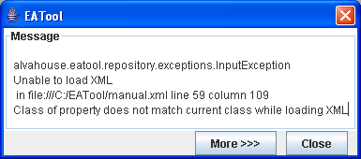Figure 89: Error Dialogue
This is probably all the information that most people need or want! However, clicking on More>>> also displays a program stack trace which shows exactly where in the program code the error occurred. Any requests for help should include this expanded dialogue!

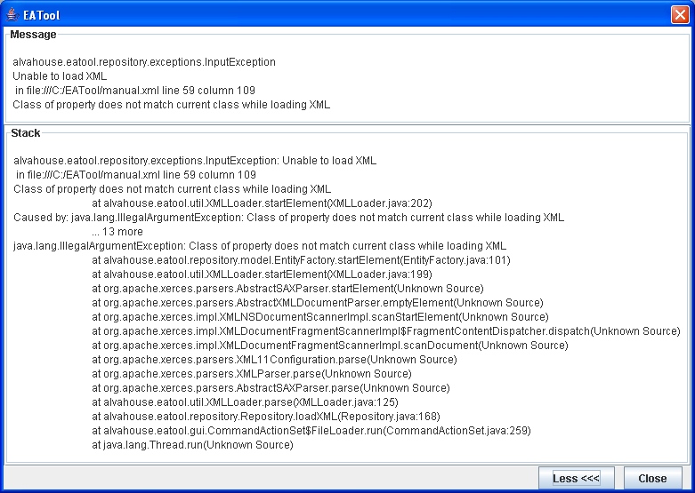Figure 90: Expanded Error Dialogue

Appendix – Sample Export Stylesheet
<?xml version="1.0" encoding="UTF-8"?>
<xsl:stylesheet version="2.0" xmlns:xsl="http://www.w3.org/1999/XSL/Transform" xmlns:xs="http://www.w3.org/2001/XMLSchema" xmlns:fn="http://www.w3.org/2005/02/xpath-functions" xmlns:xdt="http://www.w3.org/2005/02/xpath-datatypes" xmlns:ea="http://rbp28668.co.uk/java/test/repository">
<xsl:output method="html" version="1.0" encoding="UTF-8" indent="yes"/>
<xsl:template match="/ea:Repository">
<html>
<head>
<title>Meta Model Export</title>
</head>
<body>
<h1>Meta Model</h1>
<h2>Entities</h2>
<xsl:apply-templates select="ea:MetaModel/ea:MetaEntity"/>
<h2>Relationships</h2>
<xsl:apply-templates select="ea:MetaModel/ea:MetaRelationship"/>
</body>
</html>
</xsl:template>

<xsl:template match="ea:MetaEntity">
<xsl:call-template name="NamedItem"/>
<xsl:if test="ea:MetaProperty">
<table>
<xsl:for-each select="ea:MetaProperty">
<tr>
<td><xsl:value-of select="@name"/></td>
<td><xsl:value-of select="@type"/></td>
<td><xsl:value-of select="@uuid"/></td>
</tr>
</xsl:for-each>
</table>
</xsl:if>
</xsl:template>

<xsl:template match="ea:MetaRelationship">
<xsl:call-template name="NamedItem"/>
<xsl:apply-templates select="ea:MetaRole"/>
</xsl:template>

<xsl:template match="ea:MetaRole">
<p>Role <xsl:value-of select="@name"/>
(<i><xsl:value-of select="@uuid"/></i>)<br/>
to <xsl:value-of select="@connects"/> with multiplicity <xsl:value-of select="@multiplicity"/>
<xsl:if test="@description"><br/><xsl:value-of select="@description"/></xsl:if>
</p>

</xsl:template>

<xsl:template name="NamedItem">
<h3><xsl:value-of select="@name"/></h3>
<i><xsl:value-of select="@uuid"/></i>
<xsl:if test="@description"><br/><xsl:value-of select="@description"/></xsl:if>
</xsl:template>
</xsl:stylesheet>

Appendix – Specifying Searches

The full text search uses the Lucene search engine. While it is quite possible to type in simple queries, Lucene provides a query parser that is capable of handling much more complex queries. How queries are put together is described below.
A query is broken up into terms and operators. There are two types of terms: Single Terms and Phrases.
A Single Term is a single word such as "test" or "hello".
A Phrase is a group of words surrounded by double quotes such as "hello dolly".
Multiple terms can be combined together with Boolean operators to form a more complex query (see below).

Fields
Lucene supports fielded data. When performing a search you can either specify a field, or use the default field. The field names and default field is implementation specific.
You can search any field by typing the field name followed by a colon ":" and then the term you are looking for.
As an example, let's assume a Lucene index contains two fields, title and text and text is the default field. If you want to find the document entitled "The Right Way" which contains the text "don't go this way", you can enter:
title:"The Right Way" AND text:go
or
title:"Do it right" AND right
Since text is the default field, the field indicator is not required.

Note: The field is only valid for the term that it directly precedes, so the query
title:Do it right
Will only find "Do" in the title field. It will find "it" and "right" in the default field (in this case the text field).

Term Modifiers
Lucene supports modifying query terms to provide a wide range of searching options.

Wildcard Searches
Lucene supports single and multiple character wildcard searches.

To perform a single character wildcard search use the "?" symbol.
To perform a multiple character wildcard search use the "*" symbol.
The single character wildcard search looks for terms that match that with the single character replaced. For example, to search for "text" or "test" you can use the search:
te?t
Multiple character wildcard searches looks for 0 or more characters. For example, to search for test, tests or tester, you can use the search:
test*
You can also use the wildcard searches in the middle of a term.
te*t
Note: You cannot use a * or ? symbol as the first character of a search.

Fuzzy Searches
Lucene supports fuzzy searches based on the Levenshtein Distance, or Edit Distance algorithm. To do a fuzzy search use the tilde, "~", symbol at the end of a Single word Term. For example to search for a term similar in spelling to "roam" use the fuzzy search:
roam~
This search will find terms like foam and roams.

Starting with Lucene 1.9 an additional (optional) parameter can specify the required similarity. The value is between 0 and 1, with a value closer to 1 only terms with a higher similarity will be matched. For example:
roam~0.8
The default that is used if the parameter is not given is 0.5.

Proximity Searches

Lucene supports finding words are a within a specific distance away. To do a proximity search use the tilde, "~", symbol at the end of a Phrase. For example to search for a "apache" and "jakarta" within 10 words of each other in a document use the search:
"jakarta apache"~10

Range Searches
Range Queries allow one to match documents whose field(s) values are between the lower and upper bound specified by the Range Query. Range Queries can be inclusive or exclusive of the upper and lower bounds. Sorting is done lexicographically.
mod_date:[20020101 TO 20030101]
This will find documents whose mod_date fields have values between 20020101 and 20030101, inclusive. Note that Range Queries are not reserved for date fields. You could also use range queries with non-date fields:
title:{Aida TO Carmen}
This will find all documents whose titles are between Aida and Carmen, but not including Aida and Carmen.
Inclusive range queries are denoted by square brackets. Exclusive range queries are denoted by curly brackets.

Boosting a Term
Lucene provides the relevance level of matching documents based on the terms found. To boost a term use the caret, "^", symbol with a boost factor (a number) at the end of the term you are searching. The higher the boost factor, the more relevant the term will be.

Boosting allows you to control the relevance of a document by boosting its term. For example, if you are searching for
jakarta apache
and you want the term "jakarta" to be more relevant boost it using the ^ symbol along with the boost factor next to the term. You would type:
jakarta^4 apache
This will make documents with the term jakarta appear more relevant. You can also boost Phrase Terms as in the example:
"jakarta apache"^4 "Apache Lucene"
By default, the boost factor is 1. Although the boost factor must be positive, it can be less than 1 (e.g. 0.2)

Boolean operators
Boolean operators allow terms to be combined through logic operators. Lucene supports AND, "+", OR, NOT and "-" as Boolean operators(Note: Boolean operators must be ALL CAPS).

OR
The OR operator is the default conjunction operator. This means that if there is no Boolean operator between two terms, the OR operator is used. The OR operator links two terms and finds a matching document if either of the terms exist in a document. This is equivalent to a union using sets. The symbol || can be used in place of the word OR.

To search for documents that contain either "jakarta apache" or just "jakarta" use the query:
"jakarta apache" jakarta
or
"jakarta apache" OR jakarta

AND
The AND operator matches documents where both terms exist anywhere in the text of a single document. This is equivalent to an intersection using sets. The symbol && can be used in place of the word AND.
To search for documents that contain "jakarta apache" and "Apache Lucene" use the query:
"jakarta apache" AND "Apache Lucene"

+
The "+" or required operator requires that the term after the "+" symbol exist somewhere in a the field of a single document.
To search for documents that must contain "jakarta" and may contain "lucene" use the query:
+jakarta apache

NOT
The NOT operator excludes documents that contain the term after NOT. This is equivalent to a difference using sets. The symbol ! can be used in place of the word NOT.
To search for documents that contain "jakarta apache" but not "Apache Lucene" use the query:
"jakarta apache" NOT "Apache Lucene"
Note: The NOT operator cannot be used with just one term. For example, the following search will return no results:
NOT "jakarta apache"

-
The "-" or prohibit operator excludes documents that contain the term after the "-" symbol.
To search for documents that contain "jakarta apache" but not "Apache Lucene" use the query:
"jakarta apache" -"Apache Lucene"

Grouping
Lucene supports using parentheses to group clauses to form sub queries. This can be very useful if you want to control the boolean logic for a query.
To search for either "jakarta" or "apache" and "website" use the query:
(jakarta OR apache) AND website
This eliminates any confusion and makes sure you that website must exist and either term jakarta or apache may exist.

Field Grouping
Lucene supports using parentheses to group multiple clauses to a single field.
To search for a title that contains both the word "return" and the phrase "pink panther" use the query:
title:(+return +"pink panther")

Escaping Special Characters
Lucene supports escaping special characters that are part of the query syntax. The current list special characters are
+ - && || ! ( ) { } [ ] ^ " ~ * ? : \
To escape these character use the \ before the character. For example to search for (1+1):2 use the query:
\(1\+1\)\:2

Appendix – Scripting Objects

Application | Application provides access to the main application. This provides the main entry point for all the scripts.
Diagram | Diagram represents a diagram whether displayed or not.
Diagrams | Diagrams is a collection class that holds a set of Diagram
EntitySet | EntitySet provides a set of Entitie.
Filter | Filter describes a filter that can be used to filter sets of entities.
Menu | Menu is a drop down menu. This allows scripts to be added (and removed) as menu items.
MenuBar | MenuBar is a proxy for a window's menu bar – this allows menus to be manipulated .
MetaEntitySet | MetaEntitySet is a set of MetaEntity.
MetaModel | MetaModel representation of the meta model that provides simplified lookup for scripting.
MetaRelationshipSet | MetaRelationshipSet is a set of MetaRelationship
Model | Model is a proxy object for easy access to the model for scripting.
RelationshipSet | RelationshipSet is a set of Relationship

Appendix – Action Names

Main Application

FileNew
FileLoad
FileSave
FileImport
FileMerge
FileExport
FileProperties
FileExit
MetaModelExplore
MetaModelView
MetaModelDiagram
ModelBrowse
ModelSearch
ModelExplore
ModelView
ModelDiagram
ModelMatrix
ToolsScripts
ToolsEventMappings
ToolsImportMappings
ToolsExportMappings
ToolsExportWebSite
ToolsSettings
ToolsConfig
WindowPLAFMetal
WindowPLAFMotif
WindowPLAFWindows
TestException
IndexRepository
Search
HelpContents
HelpAbout

Diagram Viewer

FileExportJPG
FileExportPNG
AddNewItem
AddSymbols
EditBackground
EditEventMappings
WindowZoom10
WindowZoom25
WindowZoom50
WindowZoom100
WindowZoom200
WindowZoom400
WindowZoomIn
WindowZoomOut
WindowFit
GridLayout
GridConnectLayout
HierarchyLayout
CircularHierarchyLayout
BoxHierarchyLayout
SpringLayout

Appendix – Sample Scripts

/* Get "all" diagram */
var diagram = app.diagrams().getDiagram("8c847520-e664-01da-8000-00904be6a6cb");

var model = app.model();
var allMeta = app.metaModel().getMetaEntities();
var allEntities = model.getEntitiesOf(allMeta);

diagram.clear();
diagram.add(allEntities);
diagram.addConnectors();
diagram.colour(allEntities,200,255,255);
diagram.show();
diagram.runAction("GridConnectLayout");
diagram.runAction("SpringLayout");
diagram.runAction("WindowFit");
diagram.repaint();

/* Note that this should be called by a diagram handler
* so that target is set with the entity that was
* clicked and diagram is set to the parent diagram
*/

var newSet = app.model().getRelated(target,true,true);

diagram.clear();
diagram.add(newSet);
diagram.add(target);
diagram.addConnectors();
diagram.setDefaultColours();
diagram.colour(target,255,250,250);

diagram.show();

diagram.runAction("GridConnectLayout");
diagram.runAction("SpringLayout");
diagram.runAction("WindowFit");
diagram.repaint();

var menuBar = app.getMenuBar();
var tools = menuBar.getMenu(3);
tools.addSeparator();
tools.addScript("bd322870-e664-01da-8000-00904be6a6cb","View All");

