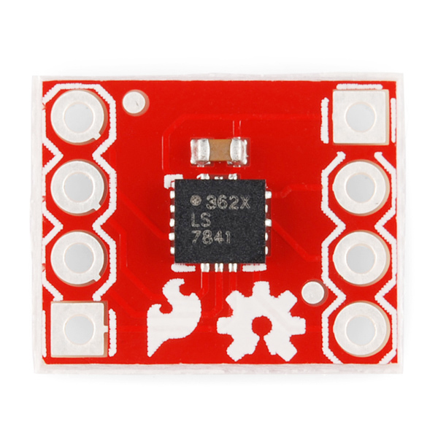
ADXL362 – Sparkfun breakout
V+
GND
INT1
INT2
SCK
MOSI
MISO
~CS

