Week 10: Traditional and Modern Spirit

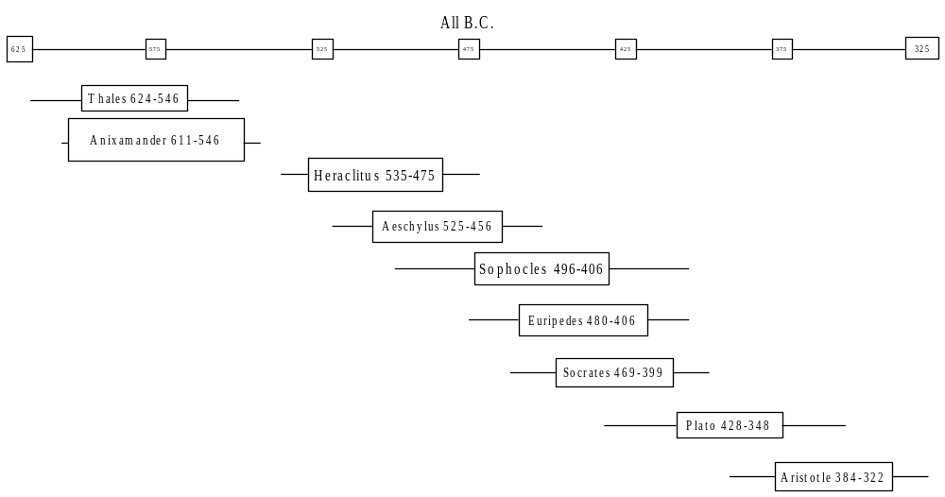“What observation knew as a given object in which the self had no part, is here a given custom [Sitte].” [PG 461]

…unalienated spirits transparent to themselves, stainless celestial figures that preserve in all their differences the undefiled innocence and harmony of their essential nature. The relationship of self-consciousness to them is equally simple and clear. They are, and nothing more; this is what constitutes the awareness of its relationship to them. Thus, Sophocles' Antigone acknowledges them as the unwritten and infallible law of the gods.
They are not of yesterday or today, but everlasting,
Though where they came from, none of us can tell.
They are. If I inquire after their origin and confine them to the point whence they arose, then I have transcended them; for now it is I who am the universal, and they are the conditioned and limited. If they are supposed to be validated by my insight, then I have already denied their unshakeable, intrinsic being, and regard them as something which, for me, is perhaps true, but also is perhaps not true. Ethical [sittlich] disposition consists just in sticking steadfastly to what is right, and abstaining from all attempts to move or shake it, or derive it. [PG 437]

“…immediate…ethical consciousness which knows its duty and does it, and is bound up with it as its own nature.”[PG 597]
However, although the Family is immediately determined as an ethical being, it is within itself an ethical entity only so far as it is not the natural relationship of its members…this natural relationship is just as much a spiritual one, and it is only as a spiritual entity that it is ethical…[T]he ethical principle must be placed in the relation of the individual member of the Family to the whole Family as the Substance…[PG 452]

[T]he two sexes overcome their [merely] natural being and appear in their ethical significance, as diverse beings who share between them the two distinctions belonging to the ethical substance. These two universal beings of the ethical world have, therefore, their specific individuality in naturally distinct self-consciousnesses, because the ethical Spirit is the immediate unity of the substance with self-consciousness—an immediacy which appears, therefore, both from the side of reality and of difference, as the existence of a natural difference.…It is now the specific antithesis of the two sexes whose natural existence acquires at the same time the significance of their ethical determination. [459]

“Nature, not the accident of circumstances or choice, assigns one sex to one law, the other to the other law.” [PG 465]
Thus, human law in its universal existence, that is, the community, in general is, in its setting itself into activity, the manliness of the community and, in its actual activity, is the government, moving itself and sustaining itself by absorbing into itself the particularization of the penates, that is, their self-sufficient individualization into different families over which women preside, and by preserving them as dissolved within its fluidity’s continuity. However, the family is in general at the same time its element and its universal activating ground is individual consciousness. Since the community gives itself enduring existence only by disrupting familial happiness and by dissolving self-consciousness into the universal, it creates an internal enemy for itself in what it suppresses and what is at the same time essential to it (femininity in general). Femininity — the community’s eternal irony — [erzeugt es sich an dem, was es unterdrückt und was ihm zugleich wesentlich ist, an der Weiblichkeit überhaupt seinen inneren Feind. Diese - die ewige Ironie des Gemeinwesens] changes by intrigue the government’s universal purpose into a private end, transforms its universal activity into this determinate individual’s work, and turns the state’s universal property topsy-turvy into the family’s possession and ornament. In this way, the feminine turns to ridicule the earnest wisdom of maturity, which, being dead to individuality — to pleasure and consumption as well as to actual activity — only thinks of and is concerned for the universal; she turns this mature wisdom into an object of ridicule for immature, high-spirited youths, and into an object of contempt for their enthusiasm, and she elevates in general youth’s force into what count as valid — elevating the son, born to the mother as her master, the brother as one in whom the sister finds a man as an equal with herself, and the youth through whom the daughter, freed from her non-self-sufficiency, achieves the enjoyment and the dignity of womanhood. — The community, however, can only sustain itself by suppressing this spirit of individuality; and because that spirit is an essential moment, the community equally creates it by its repressive stance towards it as a hostile principle. Nevertheless, since this principle, in separating itself from universal purposes, is only evil, is within itself nothing, it would be incapable of accomplishing anything if the community itself were not to recognize the force of youth (the manhood, which, while immature, is still subsumed under individuality) as the force of the whole. For the community is a people, it is itself individuality, and it is only essentially for itself in that other individualities are for it, only in that it excludes these from itself and knows itself to be independent of them. [PG 475]

Death… is a state which has been reached immediately, in the course of Nature, not the result of an action consciously done. The duty of the member of a Family is on that account to add this aspect, in order that the individual's ultimate being, too, shall not belong solely to Nature and remain something irrational, but shall be something done, and the right of consciousness be asserted in it. [PG 452]

The family “interrupts the work of Nature”, it
keeps away from the dead this dishonouring of him by unconscious appetites and abstract entities, and puts its own action in their place...The Family thereby makes him a member of a community which prevails over and holds under control the forces of particular material elements and the lower forms of life, which sought to unloose themselves against him and to destroy him. [PG 452]

Because, on the one hand, the ethical order essentially consists in this immediate firmness of decision, and for that reason there is for consciousness essentially only one law, while, on the other hand, the ethical powers are real and effective in the self of consciousness, these powers acquire the significance of excluding and opposing one another…. The ethical consciousness, because it is decisively for one of the two powers, is essentially character; it does not accept that both have the same essential nature. For this reason, the opposition between them appears as an unfortunate collision of duty merely with a reality which possesses no rights of its own…. Since it sees right only on one side and wrong on the other, that consciousness which belongs to the divine law sees in the other side only the violence of human caprice, while that which holds to human law sees in the other only the self-will and disobedience of the individual who insists on being his own authority. [PG 466]

The wrong which can be inflicted on an individual in the ethical realm is simply this, that something merely happens to him…the consciousness of [those who share] the blood of the individual repair this wrong in such a way that what has simply happened becomes rather a work deliberately done…[PG 462]

[S]elf-consciousness…learns through its own act the contradiction of those powers into which the substance divided itself and their mutual downfall, as well as the contradiction between its knowledge of the ethical character of its action, and what is in its own proper nature ethical, and thus finds its own downfall. In point of fact, however, the ethical substance has developed through this process into actual self-consciousness; in other words, this particular self has become the actuality of what it is in essence; but precisely in this development the ethical order has been destroyed. [PG 445]

Guilt is not an indifferent, ambiguous affair, as if the deed as actually seen in the light of day could, or perhaps could not, be the action of the self, as if with the doing of it there could be linked something external and accidental that did not belong to it, from which aspect, therefore, the action would be innocent. [PG 468]

Ethical self-consciousness now learns from its deed the developed nature of what it actually did...The resolve [Entschluß], however, is in itself the negative aspect which confronts the resolve with an 'other', something alien to the resolve which knows what it does. Actuality therefore holds concealed within it the other aspect which is alien to this knowledge, and does not reveal the whole truth about itself to consciousness: the son does not recognize his father in the man who has wronged him and whom he slays, nor his mother in the queen whom he makes his wife. In this way, a power which shuns the light of day ensnares the ethical consciousness, a power which breaks forth only after the deed is done, and seizes the doer in the act. For the accomplished deed is the removal of the antithesis between the knowing self and the actuality confronting it.... [PG 469]

It is…through culture that the individual acquires standing [Gelten] and actuality. His true original nature and substance is the alienation of himself as Spirit from his natural being. This externalization is…at once the means, or the transition, both of the [mere] thought-form of substance into actuality, and, conversely, of the specific individuality into essentiality. This individuality moulds itself by culture into what it intrinsically [an sich] is… its actuality consists solely in the setting-aside of its natural self. …it is the contradiction of giving to what is particular an actuality which is immediately a universal. [PG 489]

This substance is equally the universal work produced by the action of all and each as their unity and identity, for it is the being-for-self, self, action. [PG 439]

“Essence” is the norms. “Substance” is the community whose norms they are.

Pure Consciousness | Actual Consciousness | Recognition | Agency | Logic: Content/Force | Form
Faith | State Power | Recognitive Community | Tat: Agent- Responsibility | Universal / Necessary  (Norm) | In itself: Objectivity
Enlightenment | Wealth | Recognizing/Recognized Individual Self-Consciousnesses | Handlung: Agent-Authority | Particular / Contingent  (Performance) | For consciousness: Subjectivity

Actual Consciousness: Wealth and State Power
Wealth [Reichtum] is the thick institutional form in which the particular aspect of the certainty of individual self-consciousness is expressed by becoming actual or public, acquiring its truth in practical activity.
State power [Staatsmacht] is the thick institutional form in which another the universal aspect of the certainty of individual self-consciousness is expressed or becomes actual or public, acquiring its truth in practical activity.
Wealth is the individual as having authority over the application of concepts.
State Power is the individual as being responsible to the conceptual norms.
The division of these, their conflict, is the paradigmatic institutional form of alienation.

Pure Consciousness: Faith and Enlightenment
Pure consciousness is the way norms are conceived or conceptualized.
Enlightenment’s critique of Faith is a three-pronged attack. There is an ontological claim, an epistemological claim, and a practical, moral, claim.
Ontological mistake: It thinks that something exists, when it does not.
The epistemological objection of Enlightement to Faith is that even if there were such an object, we could not come to know about it in the way Faith claims to know about God.
Third, enlightenment accuses faith of bad intention or motivation or errors of action, of immoral activity. The priests are accused of trickery, the pretense of insight and knowledge, using that as a means to amass power.

Hegel: Enlightenment is fundamentally misunderstanding Faith by seeing it as in the first instance standing in a cognitive relation to some thing—as consisting at base in a claim to knowledge of the Absolute. It is not a kind of cognition, but a kind of recognition, and therefore a kind of self-constitution. Generically, it is the identification of the individual self with its universal rather than its particular aspect. That identification with the universal takes the form of sacrificing particular subjective attitudes and interests through service and worship.

Faith, for the believer, is not an alien thing which is just found in him, no one knowing how and whence it came. On the contrary, the faith of the believer consists just in him finding himself as this particular personal consciousness in the absolute being, and his obedience and service consist in producing, through his own activity, that being as his own absolute being. [PG 566]
But here enlightenment is foolish. Faith regards it as not understanding the real facts when it talks about priestly deception and deluding the people. It talks about this as if by some hocus pocus of conjuring priests, consciousness has been pawned off with something absolutely alien and other to it in place of its own essence. It is impossible to deceive a people in this manner. Brass instead of gold, counterfeit instead of genuine money may well be passed off, at least in isolated cases. Many may be persuaded to believe that a battle lost was a battle won, and other lies about things of sense and isolated happenings may be credible for a time. But in the knowledge of that essential being in which consciousness has immediate certainty of itself, the idea of this sort of delusion is quite out of the question.[ PG 550]

Whomsoever I trust, his certainty of himself is for me the certainty of myself; I recognize in him my own being-for-self, know that he acknowledges it and that it is for him purpose and essence. [PG 549]

The absolute Being of faith is essentially not the abstract essence that would exist beyond the consciousness of the believer; on the contrary, it is the Spirit of the [religious] community, the unity of the abstract essence and self-consciousness. It is the spirit of the community, the unity of the abstract essence in self-consciousness. [PG 549]

Summary:
Faith and Enlightenment are each one-sided appreciations of the true nature of norms in relation to attitudes.
Faith is on the right track on the practical recognitive dimension of self-consciousness, but has the wrong theoretical cognitive take on the side of consciousness. Faith is right in what it does: to give the norms determinate content by building a community. It builds a community of trust, which can develop and sustain determinately contentful norms. It is right to see that its relation to the norms should be one of acknowledgement and service. It is wrong to think that private conceptions and concerns must or can be totally sacrificed to make that possible. Faith is wrong to take over the traditional immediate conception of its relation to the norms: to ontologize, and in a sense naturalize them. It does not recognize itself in those norms. Neither its community, nor its individual activities are seen as essential or as authoritative with respect to those norms.
Enlightenment is right that the norms depend for both their force and their content on the attitudes and practices of the very individuals who become more than merely particular, natural beings by being acculturated, that is, by being constrained by those norms. It is wrong to think that all we contribute is the form. And it is wrong in the practical recognitive consequences of its insight into our authority over the norms. It is right in its criticism of Faith’s metaphysics, but wrong to think that undercuts its form of life. On the recognitive side of constituting communities and self-conscious individuals, the contrast between the Terror and the community of trust could not be more stark.
So what is needed is to combine the humanistic metaphysics of Enlightenment (with its cognitive emphasis on the contribution of the activity of individual self-consciousnesses) with the community of trust of Faith (with its practical emphasis on the contribution of the activity of individual self-consciousnesses through acknowledgement of, service to, and identification-through-sacrifice with the norms).

Enlightenment cannot understand the norms as both binding and contentful, and Faith cannot understand the role we play in instituting them: making them binding and contentful. The task is to reconcile the sittlich acknowledgment of the authority of the norms with the modern acknowledgment of the authority of subjective attitudes.
The explicit aspiration to do that, which is the bridge forward from modernity to a new epoch in the development of Spirit, Hegel calls “Moralität”. Kant is its prophet.

