Before building the project you must add do next steps:

1. Import to workspace “pulltoRefresh” project which you can find in “lib” folder of “gatoo” project (create new android project-> choose option “Create project from existing source”-> choose source in “lib - > pulltorefresh” )
2. In “gatoo” project properties add new library. In Eclipse IDE it’s look like this:

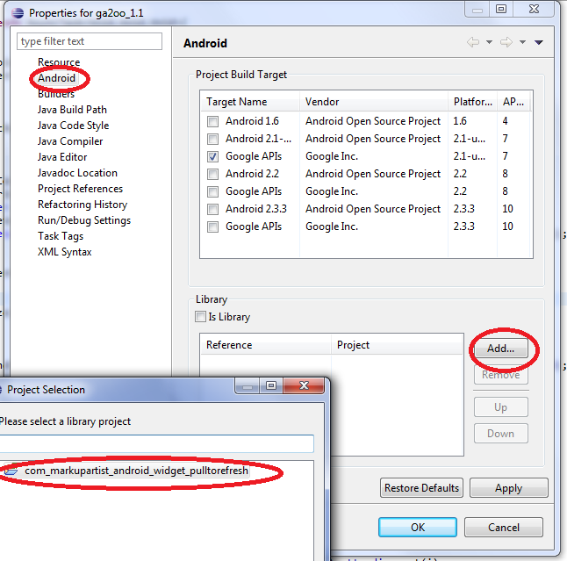

1. “Clean” “ga2oo” project.