Output:

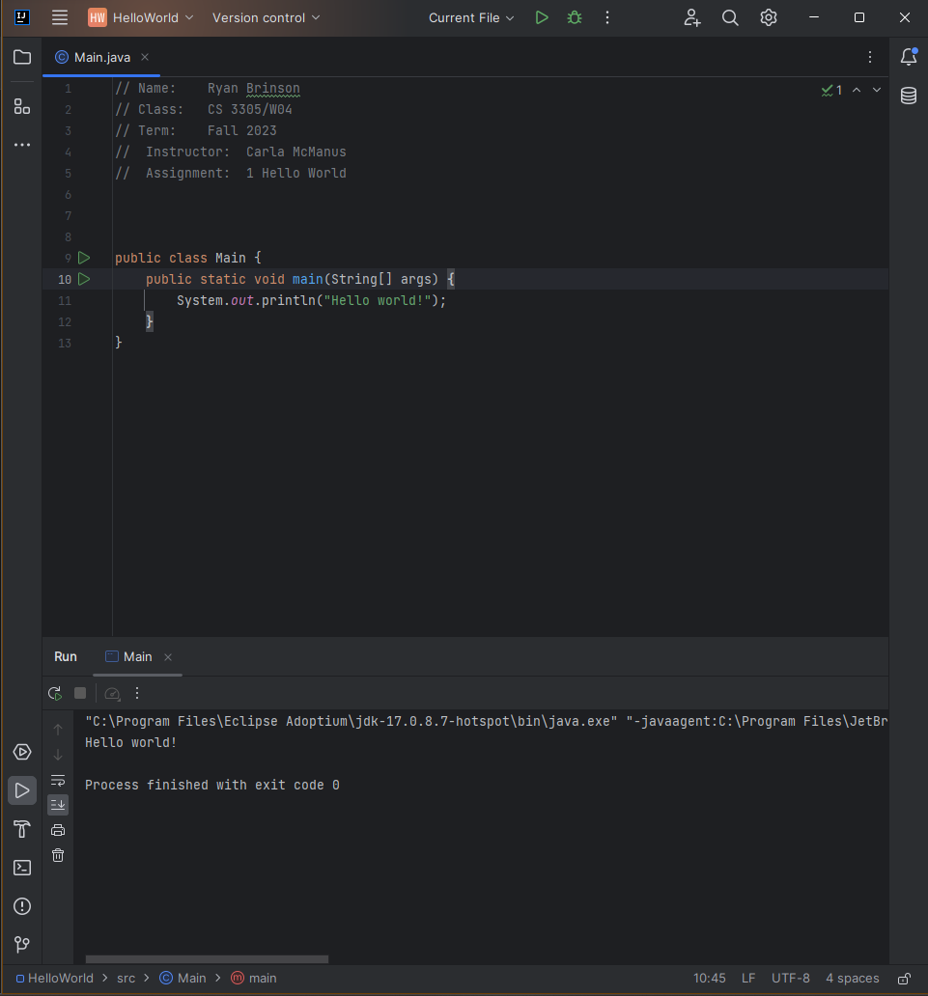

Code:

// Name: Ryan Brinson  
// Class: CS 3305/W04  
// Term: Fall 2023  
// Instructor: Carla McManus  
// Assignment: 1 Hello World  
  
  
  
public class Main {  
 public static void main(String[] args) {  
 System.*out*.println("Hello world!");  
 }  
}