|  |
| --- |
| UCCS |
| Monte Carlo Markov Chains Hellinger Convergence Metrics |
| [Type the document subtitle] |

|  |
| --- |
| Broberg, Ronald  [Pick the date] |

Table of Contents

[1 Monte Carlo Integration 3](#_Toc444175449)

[1.1 Example: Approximating the integral $xex$ 4](#_Toc444175450)

[1.2 Example: Approximating the expected value of the Beta distribution 5](#_Toc444175451)

[1.3 Monte Carlo Approximation for Optimization 7](#_Toc444175452)

[1.4 Example: Monte Carlo Optimization of $gx=e-(x-4)22$ 7](#_Toc444175453)

[1.5 Wrapping Up 8](#_Toc444175454)

[2 Markov Chains 8](#_Toc444175455)

[2.1 Example: Predicting the weather with a finite state-space Markov chain 10](#_Toc444175456)

[2.2 Continuous state-space Markov chains 12](#_Toc444175457)

[2.3 Example: Sampling from a continuous distribution using continuous state-space Markov chains 12](#_Toc444175458)

[2.4 Wrapping Up 13](#_Toc444175459)

[3 MCMC: The Metropolis Sampler 13](#_Toc444175460)

[3.1 Metropolis Sampling 14](#_Toc444175461)

[3.2 Example: Using the Metropolis algorithm to sample from an unknown distribution 15](#_Toc444175462)

[3.3 Reversibility of the transition operator 17](#_Toc444175463)

[4 MCMC: The Metropolis-Hastings Sampler 17](#_Toc444175464)

[4.1 Example: Sampling from a Bayesian posterior with improper prior 18](#_Toc444175465)

[4.2 Wrapping Up 22](#_Toc444175466)

[5 Hellinger distance 23](#_Toc444175467)

[5.1 Properties 23](#_Toc444175468)

[5.2 Examples 23](#_Toc444175469)

[1 Appendix: MCMC Monte Carlo Approximation of Integral Code 25](#_Toc444175470)

[2 Appendix: MCMC Monte Carlo Beta Expectation Code 26](#_Toc444175471)

[3 Appendix: MCMC Monte Carlo Optimization of Exponential Function Code 27](#_Toc444175472)

[4 Appendix: MCMC Markov Chain Finite State Transitions Code 28](#_Toc444175473)

[5 Appendix: MCMC Markov Chain Continous State Transitions Code 29](#_Toc444175474)

[6 Appendix: MCMC Metropolis Markov Sampler Code 30](#_Toc444175475)

[7 Appendix: MCMC Metropolis Hastings Priors and Posterior Code 32](#_Toc444175476)

# Monte Carlo Integration

<https://theclevermachine.wordpress.com/2012/09/22/monte-carlo-approximations/>

…

…

…

…

…

…

…

…

…

1. Identify $h\left(x\right)$
2. Identify $g\left(x\right)$ and from it determine $p\left(x\right)$ and $C$.
3. Draw $N$ independent samples from $p\left(x\right)$
4. Evaluate $I=CE[h(x)]≈\frac{C}{N}\sum_{i}^{N}{h(x_{i})}$

…:

## Example: Approximating the integral ${xe}^{x}$

…

$$I=\int_{0}^{1}{{xe}^{x}dx}$$

…

$$u=x, dv=e^{x}$$

$$du=dx, v=e^{x}$$

…

$$I=uv-\int_{ }^{ }{vdu}$$

$$I={xe}^{x}-\int_{ }^{ }{e^{x}dx}$$

$$I={xe}^{x}-e^{x}|_{0}^{1}$$

$$I=e^{x}(x-1)|_{0}^{1}$$

$$I=0-\left(-1\right)=1$$

…

**Step 1** we identify $h(x)=xe^{x}$

**Step 2** we identify $g(x)=1$

and from this can also determine the probability distribution function $p\left(x\right) ∈\left(a,b\right)=(0,1)$. According to the definition expression for $p\left(x\right)$ given above we determine $p\left(x\right)$ to be:

$$p(x)=\frac{g(x)}{\int_{a}^{b}{g(x)dx}}=\frac{1}{b-a}$$

**Step 3:** The expression on the right is the definition for the uniform distribution $U(0,1)$, which is easy to sample from using the MATLAB ***rand()*** (Notice too that the constant $C=b-a=1$).

**Step 4:** we calculate the Monte Carlo approximation as

$$I=C{E[x]}_{p\left(x\right)}h(x)≈\frac{1}{N}\sum_{i}^{N}{x_{i}e^{x_{i}}}$$

…

SEE Appendix MCMC Monte Carlo Estimate of Integral

…

## Example: Approximating the expected value of the Beta distribution

…

$$E[x]= \int_{p(x)}^{ }{p\left(x\right)xdx}$$

Where $x ∼p\left(x\right)=B(α_{1},α_{2})$ and $B$ is the Beta function.

**Step 1:** we identify $h(x)=xe^{x}$

**Step 2:** the function $g(x)$ is simply the probability density function $p(x)$ due the expression for $p(x)$ above:

$${p(x)}^{*}=\frac{p(x)}{\int_{ }^{ }{p(x)dx}}=p(x)$$

**Step 3** we can use MATLAB to easily draw $N$ independent samples $p\left(x\right)$ using the function ***betarnd()***. And finally,

**Step 4** we approximate the expectation with the expression

$${E[x]}_{B(α_{1}{,α}_{2})}≈\frac{1}{N}\sum_{i}^{N}{x_{i}}$$

…

SEE Appendix MCMC Monte Carlo Beta Expectation

…

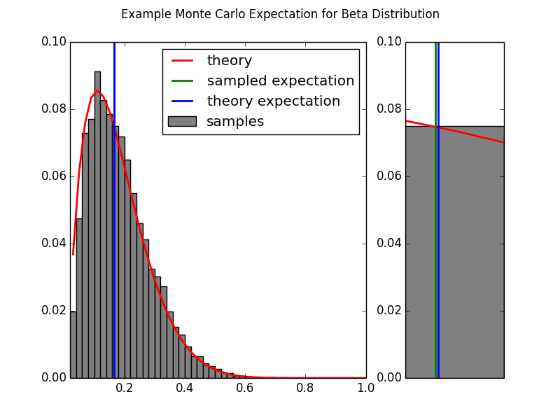

…

$${E[x]}_{B(2,12)}= \frac{α_{1}}{α_{1}+ α_{2}}=\frac{2}{12}≈0.167$$

…

## Monte Carlo Approximation for Optimization

…

$$\hat{x}= {argmax g(x)}_{x∈(a,b)}$$

…

$$p(x)=\frac{g(x)}{C}$$

…

$$\hat{x}= {argmax Cp(x)}_{x∈(a,b)}$$

….

## Example: Monte Carlo Optimization of $g\left(x\right)=e^{-\frac{{(x-4)}^{2}}{2}}$

…

$$x_{opt}= {argmax }_{x∈(a,b)}e^{-\frac{{(x-4)}^{2}}{2}}$$

…:

$$g\left(x\right)=C * \frac{1}{\sqrt{2π}}e^{-\frac{{\left(x-4\right)}^{2}}{2}}$$

$$g\left(x\right)=C * N(4,1)$$

…

SEE Appendix Monte Carlo Optimization of Exponential Function Code

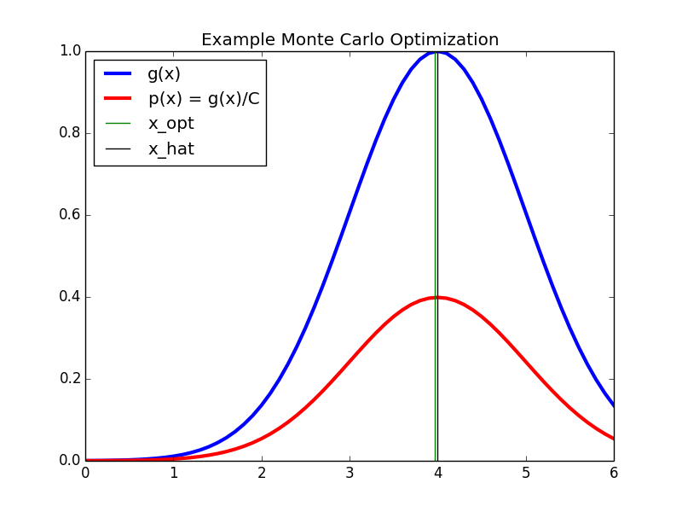

…

## Wrapping Up

…

# Markov Chains

…

$$x^{(0)}→x^{(1)}→x^{(2)}→⋯→x^{\left(t\right)}→…$$

…

1. A ***state space $x$*** , which is a set of values that the chain is allowed to take
2. A ***transition operator $p(x^{\left(t+1\right)}|x^{\left(t\right)})$*** that defines the probability of moving from state $x^{\left(t\right)}$ to $x^{\left(t+1\right)}$ .
3. An ***initial condition distribution $π^{\left(0\right)}$*** which defines the probability of being in any one of the possible states at the initial iteration $t=0$.

…

$$p\left(x^{\left(t+1\right)} | x^{\left(t\right)},x^{\left(t-1\right)},…,x^{\left(0\right)}\right)=p(x^{\left(t+1\right)}|x^{\left(t\right)})$$

…

…

$$p\left(x^{\left(t+1\right)} | x^{\left(t\right)})=p(x^{\left(t\right)}|x^{\left(t-1\right)}\right)$$

…

**Finite state-space (time homogenous) Markov chain**

…

$$p_{ij}=p\left(X^{\left(t+1\right)}=j | x^{\left(t\right)}=i\right)$$

…

## Example: Predicting the weather with a finite state-space Markov chain

…

If it is *sunny* today, then

* it is highly likely that it will be *sunny*next week
$p\left(X^{\left(week\right)}=sunny \right| X^{(today)}=sunny)=0.8$

* it is very unlikely that it will be *raining*next week
$p\left(X^{\left(week\right)}=rainy \right| X^{(today)}=sunny)=0.05$

* and somewhat likely that it will *foggy*next week

$p\left(X^{\left(week\right)}=foggy \right| X^{(today)}=sunny)=0.15$

If it is *foggy* today then

* it is somewhat likely that it will be *sunny*next week
$p\left(X^{\left(week\right)}=sunny \right| X^{(today)}=foggy)=0.4$

* but slightly less likely that it will be *foggy*next week
$p\left(X^{\left(week\right)}=foggy \right| X^{(today)}=foggy)=0.5$

* and fairly unlikely that it will be *raining*next week.

$p\left(X^{\left(week\right)}=rainy \right| X^{(today)}=foggy)=0.1$

If it is *rainy* today then

* it is unlikely that it will be *sunny*next week
$p\left(X^{\left(week\right)}=sunny \right| X^{(today)}=rainy)=0.1$

* it is somewhat likely that it will be *foggy*next week
$p\left(X^{\left(week\right)}=rainy \right| X^{(today)}=rainy)=0.3$

* and it is fairly likely that it will be *rainy*next week

$p\left(X^{\left(week\right)}=rainy \right| X^{(today)}=rainy)=0.6$

…

$$P= \left[\begin{matrix}0.8 & 0.15 & 0.05 \\ 0.4 & 0.5 & 0.1 \\ 0.1 & 0.3 & 0.6\end{matrix}\right]$$

…

SEE Appendix Markov Chain Finite State Transitions Code

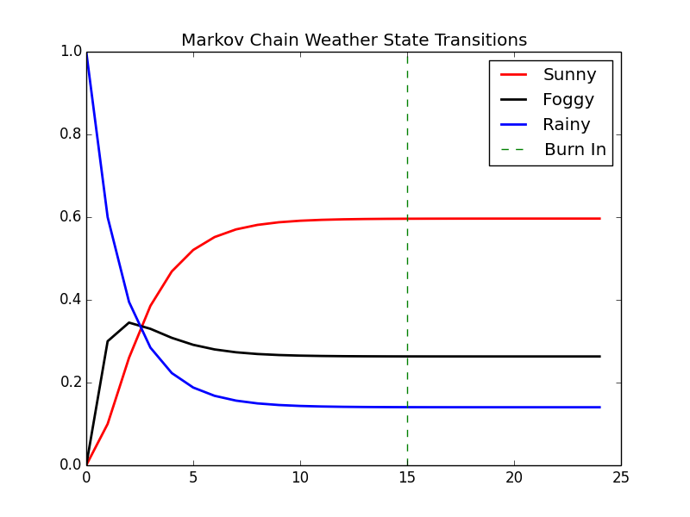

…

…

$$p\left(x^{\left(week2\right)}\right)=π^{(0)}P^{2}=[0.26,0.345,0.395]$$

np.dot(X[0,:],matpow(P,2)) = array([ 0.26 , 0.345, 0.395])

…

$$p\left(x^{\left(week24\right)}\right)=π^{(0)}P^{24}=[0.596,0.263,0.140]$$

np.dot(X[0,:],matpow(P,24)) = array([ 0.59648855, 0.26315895, 0.1403525 ])

…

## Continuous state-space Markov chains

…

## Example: Sampling from a continuous distribution using continuous state-space Markov chains

…

SEE MCMC Markov Chain Continuous State Transitions Code

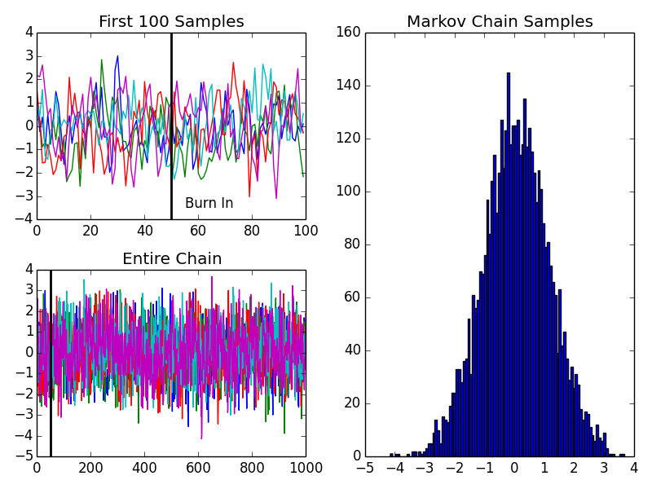

…

## Wrapping Up

…

# MCMC: The Metropolis Sampler

<https://theclevermachine.wordpress.com/2012/10/05/mcmc-the-metropolis-sampler/>

…

## Metropolis Sampling

… heuristics:

1. If $p\left(x^{*}\right)≥p(x^{t-1})$ , the proposed state is kept $x^{*}$ as a sample and is set as the next state in the chain (i.e. move the chain’s state to a location  where $p\left(x\right)$ has equal or greater density).
2. If $p\left(x^{*}\right)<p(x^{t-1})$–indicating that $p\left(x\right)$ has low density near $x^{*}$–then the proposed state may still be accepted, but only randomly, and with a probability $\frac{p\left(x^{*}\right)}{p(x^{t-1})}$.

…. Acceptance criteria ….

$$α=min⁡\left(1, \frac{p\left(x^{*}\right)}{p\left(x^{t-1}\right)}\right)$$

…

1. Set t = 0
2. generate an initial state $x^{(0)}$ from a prior distribution $π^{(0)}$ over initial states
3. repeat until $t=M$

set $t=t+1$

generate a proposal state $x^{*}$ from $q\left(x|x^{t-1}\right)$

calculate the acceptance probability $α=min⁡\left(1, \frac{p\left(x^{*}\right)}{p\left(x^{t-1}\right)}\right)$

draw a random number $u$ from a uniform distribution $U(0,1)$

if $u≤α$, accept the proposal and set $x^{(t)}=x^{*}$

else  set $x^{(t)}=x^{(t-1)}$

## Example: Using the Metropolis algorithm to sample from an unknown distribution

…

p(x) = (1 + x^2)^{-1}

…

\pi^{(0)} \sim \mathcal N(0,1)

q(x | x^{(t-1)}) \sim \mathcal N(x^{(t-1)},1),

…

SEE Appendix: MCMC Metropolis Sampler

TODO: Output accept/reject examples

In the figure above, we visualize the first 50 iterations of the Metropolis sampler…

…

p^*(x) = \frac{p(x)}{Z}

…

p(x) = Zp^*(x)

…

\frac{p(a)}{p(b)} = \frac{Zp^*(a)}{Zp^*(b)} = \frac{p^*(a)}{p^*(b)}

…

…

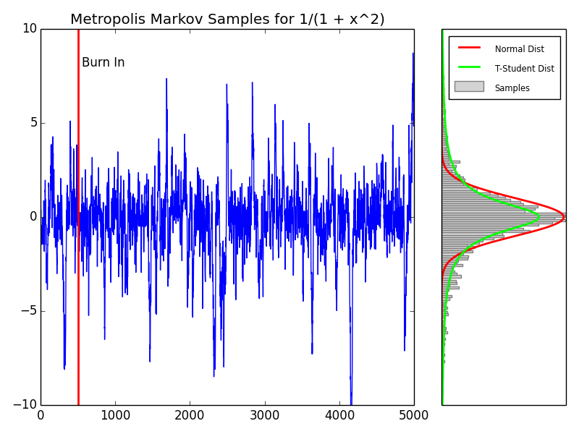

…

## Reversibility of the transition operator

…

# MCMC: The Metropolis-Hastings Sampler

<https://theclevermachine.wordpress.com/2012/10/20/mcmc-the-metropolis-hastings-sampler/>

*Note: Metropolis requires Pij = Pji (symmetric) but not the case for MH*

In an earlier [post](https://theclevermachine.wordpress.com/2012/10/05/mcmc-the-metropolis-sampler/) we discussed how the Metropolis sampling algorithm can draw samples from a complex and/or unnormalized target probability distributions using a Markov chain. The Metropolis algorithm first proposes a possible new state x^*in the Markov chain, based on a previous state x^{(t-1)}, according to the proposal distribution q(x^* | x^{(t-1)}). The algorithm accepts or rejects the proposed state based on the density of the the target distribution p(x)evaluated at x^*. (If any of this Markov-speak is gibberish to the reader, please refer to the previous posts on [Markov Chains](https://theclevermachine.wordpress.com/2012/09/24/a-brief-introduction-to-markov-chains/), MCMC, and the [Metropolis Algorithm](https://theclevermachine.wordpress.com/2012/10/05/mcmc-the-metropolis-sampler/) for some clarification).

One constraint of the Metropolis sampler is that the proposal distribution q(x^* | x^{(t-1)})must be symmetric. The constraint originates from using a Markov Chain to draw samples: a necessary condition for drawing from a Markov chain’s stationary distribution is that at any given point in time t, the probability of moving from x^{(t-1)} \rightarrow x^{(t)}must be equal to the probability of moving from x^{(t-1)} \rightarrow x^{(t)}, a condition known as ***reversibility*** or ***detailed balance***. However, a symmetric proposal distribution may be ill-fit for many problems, like when we want to sample from distributions that are bounded on semi infinite intervals (e.g. [0, \infty)).

In order to be able to use an asymmetric proposal distributions, the Metropolis-Hastings algorithm implements an additional correction factor c, defined from the proposal distribution as

c = \frac{q(x^{(t-1)} | x^*) }{q(x^* | x^{(t-1)})}

The correction factor adjusts the transition operator to ensure that the probability of moving from x^{(t-1)} \rightarrow x^{(t)}is equal to the probability of moving from x^{(t-1)} \rightarrow x^{(t)}, no matter the proposal distribution.

The Metropolis-Hastings algorithm is implemented with essentially the same procedure as the Metropolis sampler, except that the correction factor is used in the evaluation of acceptance probability \alpha.  Specifically, to draw Msamples using the Metropolis-Hastings sampler:

1. set t = 0
2. generate an initial state x^{(0)} \sim \pi^{(0)}
3. repeat until t = M

set t = t+1

generate a proposal state x^*from q(x | x^{(t-1)})

calculate the proposal correction factor c = \frac{q(x^{(t-1)} | x^*) }{q(x^*|x^{(t-1)})}

calculate the acceptance probability \alpha = \text{min} \left (1,\frac{p(x^*)}{p(x^{(t-1)})} \times c\right ) 

draw a random number ufrom \text{Unif}(0,1)

if u \leq \alphaaccept the proposal state x^*and set x^{(t)}=x^*

else set x^{(t)} = x^{(t-1)}

Many consider the Metropolis-Hastings algorithm to be a generalization of the Metropolis algorithm. This is because when the proposal distribution is symmetric, the correction factor is equal to one, giving the transition operator for the Metropolis sampler.

## Example: Sampling from a Bayesian posterior with improper prior

For a number of applications, including regression and density estimation, it is usually necessary to determine a set of parameters \thetato an assumed model p(y | \theta)such that the model can best account for some observed data y. The model function p(y | \theta)is often referred to as the likelihood function. In Bayesian methods there is often an explicit prior distribution p(\theta)that is placed on the model parameters and controls the values that the parameters can take.

The parameters are determined based on the posterior distribution p(\theta | y), which is a probability distribution over the possible parameters based on the observed data. The posterior can be determined using Bayes’ theorem:

p(\theta | y) = \frac{p(y | \theta) p(\theta)}{p(y)}

where, p(y)is a normalization constant that is often quite difficult to determine explicitly, as it involves computing sums over every possible value that the parameters and ycan take.

Let’s say that we assume the following model (likelihood function):

p(y | \theta) = \text{Gamma}(y;A,B), where

\text{Gamma}(y;A,B) = \frac{B^A}{\Gamma(A)} y^{A-1}e^{-By}, where

\Gamma( )is the [gamma function](http://en.wikipedia.org/wiki/Gamma_function). Thus, the model parameters are

\theta = [A,B]

The parameter Acontrols the shape of the distribution, and Bcontrols the scale. The likelihood surface for B = 1, and a number of values of Aranging from zero to five are shown below.

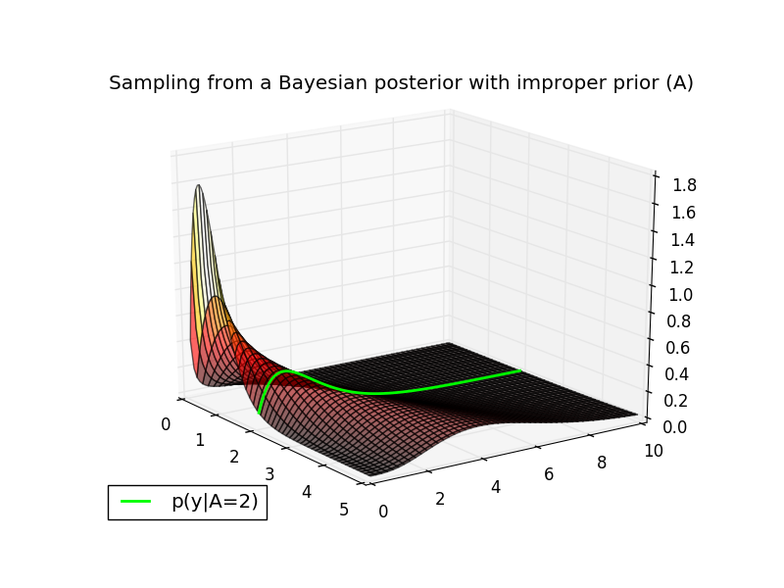

The conditional distribution p(y | A=2, B = 1)is plotted in green along the likelihood surface. You can verify this is a valid conditional in MATLAB with the following command:

|  |  |
| --- | --- |
| 1 | plot(0:.1:10,gampdf(0:.1:10,4,1)); % GAMMA(4,1) |

Now, let’s assume the following priors on the model parameters:

p(B = 1) = 1

and

p(A) = \text{sin}(\pi A)^2

The first prior states that Bonly takes a single value (i.e. 1), therefore we can treat it as a constant. The second (rather non-conventional) prior states that the probability of Avaries as a sinusoidal function. (Note that both of these prior distributions are called ***improper priors*** because they do not integrate to one). Because Bis constant, we only need to estimate the value of A.

It turns out that even though the normalization constant p(y)may be difficult to compute, we can sample from p(A | y)without knowing p(x)using the Metropolis-Hastings algorithm. In particular, we can ignore the normalization constant p(x)and sample from the unnormalized posterior:

p(A | y) \propto p(y |A) p(A)

The surface of the (unnormalized) posterior for yranging from zero to ten are shown below. The prior p(A)is displayed in blue on the right of the plot. Let’s say that we have a datapoint y = 1.5and would like to estimate the posterior distribution p(A|y=1.5)using the Metropolis-Hastings algorithm. This particular target distribution is plotted in magenta in the plot below.

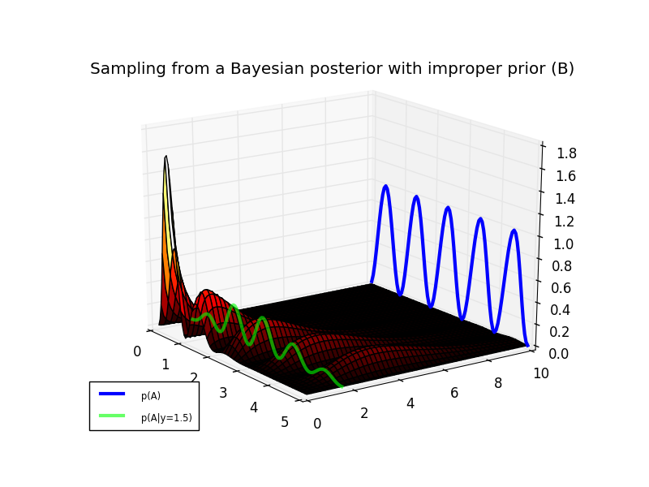

Using a symmetric proposal distribution like the Normal distribution is not efficient for sampling from p(A|y=1.5)due to the fact that the posterior only has support on the real positive numbers A \in [0 ,\infty). An asymmetric proposal distribution with the same support, would provide a better coverage of the posterior. One distribution that operates on the positive real numbers is the exponential distribution.

q(A) = \text{Exp}(\mu) = \mu e^{-\mu A},

This distribution is parameterized by a single variable \muthat controls the scale and location of the distribution probability mass. The target posterior and a proposal distribution (for \mu = 5) are shown in the plot below.

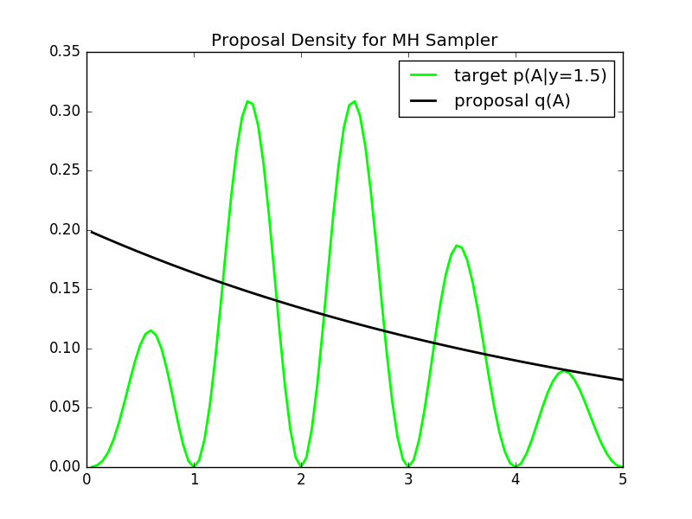

We see that the proposal has a fairly good coverage of the posterior distribution. We run the Metropolis-Hastings sampler in the block of MATLAB code at the bottom. The Markov chain path and the resulting samples are shown in plot below.

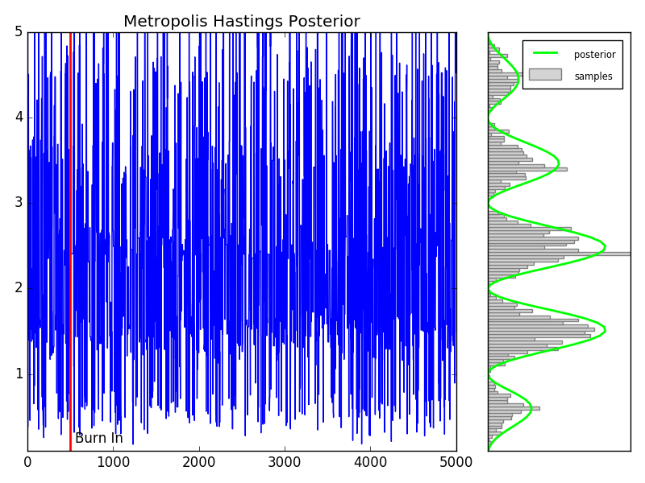

As an aside, note that the proposal distribution for this sampler does not depend on past samples, but only on the parameter \mu(see line 88 in the MATLAB code below). Each proposal states x^*is drawn independently of the previous state. Therefore this is an example of an **independence sampler**, a specific type of Metropolis-Hastings sampling algorithm. Independence samplers are notorious for being either very good or very poor sampling routines. The quality of the routine depends on the choice of the proposal distribution, and its coverage of the target distribution. Identifying such a proposal distribution is often difficult in practice.

The MATLAB  code for running the Metropolis-Hastings sampler is below. Use the copy icon in the upper right of the code block to copy it to your clipboard. Paste in a MATLAB terminal to output the figures above.

## Wrapping Up

Here we explored how the Metorpolis-Hastings sampling algorithm can be used to generalize the Metropolis algorithm in order to sample from complex (an unnormalized) probability distributions using asymmetric proposal distributions. One shortcoming of the Metropolis-Hastings algorithm is that not all of the proposed samples are accepted, wasting valuable computational resources. This becomes even more of an issue for sampling distributions in higher dimensions. This is where Gibbs sampling comes in. We’ll see in a later post that Gibbs sampling can be used to keep all proposal states in the Markov chain by taking advantage of conditional probabilities.

# Hellinger distance

## Properties

The Hellinger distance forms a [bounded](https://en.wikipedia.org/wiki/Bounded_function) [metric](https://en.wikipedia.org/wiki/Metric_%28mathematics%29) on the [space](https://en.wikipedia.org/wiki/Function_space) of probability distributions over a given [probability space](https://en.wikipedia.org/wiki/Probability_space).

The maximum distance 1 is achieved when *P* assigns probability zero to every set to which *Q* assigns a positive probability, and vice versa.

Sometimes the factor 1/2 in front of the integral is omitted, in which case the Hellinger distance ranges from zero to the square root of two.

The Hellinger distance is related to the [Bhattacharyya coefficient](https://en.wikipedia.org/wiki/Bhattacharyya_distance) BC(P,Q)as it can be defined as

H(P,Q) = \sqrt{1 - BC(P,Q)}.

Hellinger distances are used in the theory of [sequential](https://en.wikipedia.org/wiki/Sequential_analysis) and [asymptotic statistics](https://en.wikipedia.org/wiki/Asymptotic_statistics).[[4]](https://en.wikipedia.org/wiki/Hellinger_distance#cite_note-4)[[5]](https://en.wikipedia.org/wiki/Hellinger_distance#cite_note-5)

## Examples

The squared Hellinger distance between two [normal distributions](https://en.wikipedia.org/wiki/Normal_distribution) \scriptstyle P\,\sim\,\mathcal{N}(\mu_1,\sigma_1^2)and \scriptstyle Q\,\sim\,\mathcal{N}(\mu_2,\sigma_2^2)is:


  H^2(P, Q) = 1 - \sqrt{\frac{2\sigma_1\sigma_2}{\sigma_1^2+\sigma_2^2}} \,  e^{-\frac{1}{4}\frac{(\mu_1-\mu_2)^2}{\sigma_1^2+\sigma_2^2}}.
  

The squared Hellinger distance between two [exponential distributions](https://en.wikipedia.org/wiki/Exponential_distribution) \scriptstyle P\,\sim \,\rm{Exp}(\alpha)and \scriptstyle Q\,\sim\,\rm{Exp}(\beta)is:


  H^2(P, Q) = 1 - \frac{2 \sqrt{\alpha \beta}}{\alpha + \beta}.
  

The squared Hellinger distance between two [Weibull distributions](https://en.wikipedia.org/wiki/Weibull_distribution) \scriptstyle P\,\sim \,\rm{W}(k,\alpha)and \scriptstyle Q\,\sim\,\rm{W}(k,\beta)(where  k is a common shape parameter and  \alpha\, , \beta are the scale parameters respectively):


  H^2(P, Q) = 1 - \frac{2 (\alpha \beta)^{k/2}}{\alpha^k + \beta^k}.
  

The squared Hellinger distance between two [Poisson distributions](https://en.wikipedia.org/wiki/Poisson_distribution) with rate parameters \alphaand \beta, so that \scriptstyle P\,\sim \,\rm{Poisson}(\alpha)and \scriptstyle Q\,\sim\,\rm{Poisson}(\beta), is:


  H^2(P,Q) = 1-e^{-\frac{1}{2}(\sqrt{\alpha} - \sqrt{\beta})^2}.
  

The squared Hellinger distance between two [Beta distributions](https://en.wikipedia.org/wiki/Beta_distribution) \scriptstyle P\,\sim\,\text{Beta}(a_1,b_1)and \scriptstyle Q\,\sim\,\text{Beta}(a_2, b_2)is:


H^{2}(P,Q) =1-\frac{B\left(\frac{a_{1}+a_{2}}{2},\frac{b_{1}+b_{2}}{2}\right)}{\sqrt{B(a_{1},b_{1})B(a_{2},b_{2})}}
  

where Bis the [Beta function](https://en.wikipedia.org/wiki/Beta_function).

# Appendix: MCMC Monte Carlo Approximation of Integral Code

# MONTE CARLO APPROXIMATION OF INT(xexp(x))dx

# FOR TWO DIFFERENT SAMPLE SIZES

import numpy as np

np.random.seed(271828)

runs=1000

# THE FIRST APPROXIMATION USING N1 = 100 SAMPLES

N1 = 100;

x = np.random.uniform(size=N1);

I\_hat\_1 = sum(x\*np.exp(x))/N1

I\_hat\_1 # 0.95254390652501486

# A SECOND APPROXIMATION USING N2 = 5000 SAMPLES

N2 = 5000;

x = np.random.uniform(size=N2);

I\_hat\_2 = sum(x\*np.exp(x))/N2

I\_hat\_2 # 1.0209454002831784

# Estimate variance for N1=100

est=[]

for r in range(runs):

x = np.random.uniform(size=N1);

est.append(sum(x\*np.exp(x))/N1)

np.var(est) # 0.0063657238770784439

# Estimate variance for N1=5000

est=[]

for r in range(runs):

x = np.random.uniform(size=N2);

est.append(sum(x\*np.exp(x))/N2)

np.var(est) # 0.00012223069067703404

# variance decreases linearly with number of runs

0.0063657238770784439/0.00012223069067703404

# 52.079586900955817

# Appendix: MCMC Monte Carlo Beta Expectation Code

# MONTE CARLO EXPECTATION

import numpy as np

import scipy.stats as stats

import matplotlib.pyplot as plt

from matplotlib import gridspec

import pylab

np.random.seed(271828)

alpha1 = 2;

alpha2 = 10;

N = 10000;

#x = betarnd(alpha1,alpha2,1,N);

x = stats.beta.rvs(alpha1,alpha2, size=N)

# MONTE CARLO EXPECTATION

expectMC = np.mean(x);

# ANALYTIC EXPRESSION FOR BETA MEAN

expectAnalytic = 1.\*alpha1/(alpha1 + alpha2);

plt.figure(figsize=(8, 6))

plt.hist(x[:,0])

plt.show()

# DISPLAY

steps=0.02

bins = np.arange(0,1.+steps,steps)

h=np.histogram(x,bins)

counts=h[0]

probSampled = 1.\*counts/sum(counts);

probTheory = stats.beta.pdf(bins,alpha1,alpha2);

fig = plt.figure(figsize=(8, 6))

gs = gridspec.GridSpec(1, 2, width\_ratios=[3, 1])

ax0 = plt.subplot(gs[0])

ax0.bar(bins[1:],probSampled,width=steps,color='grey',label="samples")

ax0.plot(bins[1:]+0.5\*steps,probTheory[1:]/sum(probTheory[1:]),'r',linewidth=2,label="theory")

ax0.axvline(x=expectMC,color='g',linewidth=2,label="sampled expectation")

ax0.axvline(x=expectAnalytic,color='b',linewidth=2,label="theory expectation")

ax0.set\_xlim([0.02,1.00])

leg=ax0.legend(loc='upper right')

ltext = leg.get\_texts()

llines = leg.get\_lines()

frame = leg.get\_frame()plt.setp(ltext, fontsize='x-small')

fig.suptitle("Example Monte Carlo Expectation for Beta Distribution")

ax1 = plt.subplot(gs[1])

ax1.bar(bins[1:],probSampled,width=steps,color='grey')

ax1.plot(bins[1:]+0.5\*steps,probTheory[1:]/sum(probTheory[1:]),'r',linewidth=2)

ax1.axvline(x=expectMC,color='g',linewidth=2)

ax1.axvline(x=expectAnalytic,color='b',linewidth=2)

ax1.set\_xlim([0.16,0.18])

ax1.xaxis.set\_major\_locator(pylab.NullLocator())

#ax1.yaxis.set\_major\_locator(pylab.NullLocator())

# plt.show()

plt.savefig('mcmc-monte-carlo-beta-expectation.png')

# Appendix: MCMC Monte Carlo Optimization of Exponential Function Code

# MONTE CARLO OPTIMIZATION OF exp(x-4)^2

import numpy as np

import scipy.stats as stats

import matplotlib.pyplot as plt

from matplotlib import gridspec

import pylab

np.random.seed(271828)

def g(x):

return np.exp(-0.5\*(x-4)\*\*2)

# INITIALZIE

N = 100000

step=0.1

x = np.arange(0,6+step,step)

C = np.sqrt(2\*np.pi)

y = stats.norm.pdf(4,1,x)

# CALCULATE MONTE CARLO APPROXIMATION

#x = normrnd(4,1,1,N);

n = np.random.normal(4,1,size=N)

h=np.histogram(n,100)

counts=h[0]

bins=h[1]

optIdx = np.argmax(counts)

x\_hat = bins[optIdx];

# OPTIMA AND ESTIMATED OPTIMA

# ph = plot(x,g(x)/C,'r','Linewidth',3); hold on

# gh = plot(x,g(x),'b','Linewidth',2); hold on;

# oh = plot([4 4],[0,1],'k');

# hh = plot([xHat,xHat],[0,1],'g');

plt.plot(x,g(x),color='blue',linewidth=3,label="g(x)")

plt.plot(x,g(x)/C,color='red',linewidth=3,label="p(x) = g(x)/C")

plt.axvline(x\_hat, color='green',linewidth=1,label="x\_opt")

plt.axvline(4, color='black',linewidth=1,label="x\_hat")

leg=plt.legend(loc='upper left')

ltext = leg.get\_texts()

llines = leg.get\_lines()

frame = leg.get\_frame()

plt.title("Example Monte Carlo Optimization")

#plt.show()

plt.savefig('mcmc-monte-carlo-optimization-exp.png')

# Appendix: MCMC Markov Chain Finite State Transitions Code

# FINITE STATE-SPACE MARKOV CHAIN EXAMPLE

import numpy as np

import scipy.stats as stats

import matplotlib.pyplot as plt

from matplotlib import gridspec

import pylab

# TRANSITION OPERATOR

# S = Sunny

# F = Foggy

# R = Rainy

# S->S F->S R->S

# S->F F->F R->F

# S->R F->R R->R

P = np.array([[ 0.8 , 0.15, 0.05],

[ 0.4 , 0.5 , 0.1 ],

[ 0.1 , 0.3 , 0.6 ]])

nWeeks = 25

# time series of state vectors

X = np.zeros((nWeeks,3))

#INITIAL STATE IS RAINY

X[0,:] = [0,0,1];

# RUN MARKOV CHAIN

for iB in range(nWeeks-1):

X[iB+1,:] = np.dot(X[iB,:],P)

# DISPLAY

plt.plot(X[:,0],color='r',linewidth=2,label='Sunny')

plt.plot(X[:,1],color='k',linewidth=2,label='Foggy')

plt.plot(X[:,2],color='b',linewidth=2,label='Rainy')

plt.axvline(15, color='g',ls='dashed',label='Burn In')

leg=plt.legend(loc='upper right')

ltext = leg.get\_texts()

llines = leg.get\_lines()

frame = leg.get\_frame()

plt.title("Markov Chain Weather State Transitions")

#plt.show()

plt.savefig('mcmc-markov-chain-finite-state.png')

# Appendix: MCMC Markov Chain Continous State Transitions Code

# EXAMPLE OF CONTINUOUS STATE-SPACE MARKOV CHAIN

import numpy as np

import scipy.stats as stats

import matplotlib.pyplot as plt

from matplotlib import gridspec

import pylab

# INITIALIZE

np.random.seed(271828)

nBurnin = 50; # BURNIN

nChains = 5; # MARKOV CHAINS

# DEFINE TRANSITION OPERATOR

def P(x,n):

return np.random.normal(0.5\*x,1,size=n)

nTransitions = 1000;

x = np.zeros((nTransitions,nChains));

x[0,:] = np.random.normal(1,1,size=nChains);

# RUN THE CHAINS

for iT in range(nTransitions-1):

x[iT+1,:] = P(x[iT],nChains);

plt.close('all')

fig = plt.figure()

ax1 = plt.subplot(221) # Burn In

ax2 = plt.subplot(223) # Full Chains for 5 runs

ax3 = plt.subplot(122) # Histogram of Full without Burnin

ax1.plot(x[0:100,:])

ax1.axvline(50,color='k',linewidth=2,label="Burn In")

ax1.text(50+5,np.floor(np.min(x[:100,:])) + 0.5, r'Burn In')

ax1.set\_title("First 100 Samples")

ax2.plot(x[:,:])

ax2.axvline(50,color='k',linewidth=2,label="Burn In")

ax2.set\_title("Entire Chain")

h=ax3.hist(np.ndarray.flatten(x[100:,:]),bins=100)

ax3.set\_title("Markov Chain Samples")

plt.tight\_layout()

#plt.show()

plt.savefig('mcmc-markov-chain-continuous-state.png')

# Appendix: MCMC Metropolis Markov Sampler Code

# METROPOLIS SAMPLING EXAMPLE

import numpy as np

import scipy.stats as stats

import matplotlib.pyplot as plt

from matplotlib import gridspec

import pylab

np.random.seed(271828)

# DEFINE THE TARGET DISTRIBUTION

def p(x):

return 1./(1.+x\*\*2)

# INITIALIZE CONSTANTS

nSamples = 5000;

burnIn = 500;

nDisplay = 30;

sigma = 1;

minn = -20;

maxx = 20;

step=0.1

xx = np.arange(3.\*minn,3.\*maxx+step,step);

target = p(xx);

pauseDur = .8;

# INITIALZE SAMPLER

x = np.zeros((1,nSamples));

x[0,0]= np.random.normal()

# RUN SAMPLER

for t in range(nSamples-1):

# SAMPLE FROM PROPOSAL

xStar = np.random.normal(x[0,t],sigma);

proposal = stats.norm.pdf(xx,x[0,t],sigma);

# CALCULATE THE ACCEPTANCE PROBABILITY

alpha = min([1., p(xStar)/p(x[0,t])]);

# ACCEPT OR REJECT?

u = np.random.uniform()

if u < alpha:

x[0,t+1] = xStar;

str = 'Accepted';

else:

x[0,t+1] = x[0,t];

str = 'Rejected';

#end

# DISPLAY SAMPLING DYNAMICS

# to do

# DISPLAY RESULTS

# generate some data

a = np.arange(1,nSamples+1,1)

# plot it

fig = plt.figure(figsize=(8, 6))

gs = gridspec.GridSpec(1, 2, width\_ratios=[3, 1])

# DISPLAY MARKOV CHAIN

ax0 = plt.subplot(gs[0])

ax0.set\_ylim([-10,10])

ax0.plot(a, x[0,:])

ax0.axvline(x=burnIn,color='r',linewidth=2)

ax0.text(burnIn+50, 8, r'Burn In')

plt.title('Metropolis Markov Samples for 1/(1 + x^2)')

# DISPLAY SAMPLES

ax1 = plt.subplot(gs[1])

ax1.set\_ylim([-10,10])

ax1.xaxis.set\_major\_locator(pylab.NullLocator())

ax1.yaxis.set\_major\_locator(pylab.NullLocator())

h=ax1.hist(x[0,burnIn:],bins=200,orientation="horizontal",color='lightgrey',edgecolor = 'grey',label="Samples")

b=np.arange(-10,10,0.1)

n=stats.norm.pdf(b)

t=stats.t.pdf(b,1)

plt.plot(n\*nSamples/sum(n),b,color='r',linewidth=2,label="Normal Dist")

plt.plot(t\*nSamples/sum(n),b,color='lime',linewidth=2,label="T-Student Dist")

#plt.ylabel('samples')

leg=ax1.legend(loc='upper left')

ltext = leg.get\_texts()

llines = leg.get\_lines()

frame = leg.get\_frame()

plt.setp(ltext, fontsize='x-small')

plt.tight\_layout()

#plt.show()

plt.savefig('mcmc-metropolis-sampler.png')

# Appendix: MCMC Metropolis Hastings Priors and Posterior Code

# METROPOLIS-HASTINGS BAYESIAN POSTERIOR

import numpy as np

#import scipy.stats as stats

import matplotlib.pyplot as plt

from matplotlib import gridspec

import pylab

from math import gamma

# INITIALIZE

np.random.seed(271828)

# PRIOR OVER SCALE PARAMETERS

B = 1.;

# DEFINE LIKELIHOOD

# likelihood = inline('(B.^A/gamma(A)).\*y.^(A-1).\*exp(-(B.\*y))','y','A','B');

def likelihood(y,A,B):

return (B\*\*A/gamma(A))\*y\*\*(A-1.)\*np.exp(-(B\*y))

# CALCULATE AND VISUALIZE THE LIKELIHOOD SURFACE

# yy = linspace(0,10,100);

# AA = linspace(0.1,5,100);

# avoid infinite edges

yy=np.arange(0.1,10.1,0.1)

AA=np.arange(0.05,5.05,.05)

likeSurf = np.zeros((yy.size,AA.size));

for iA in range(AA.size):

likeSurf[:,iA]=likelihood(yy[:],AA[iA],B)

from mpl\_toolkits.mplot3d import axes3d

from matplotlib import cm

#PLOT

fig = plt.figure()

ax = fig.add\_subplot(111, projection='3d')

axs=ax.get\_axes()

axs.azim=-35.

axs.elev=20.

#axs.dist=

Ys, As = np.meshgrid(yy, AA)

ax.plot\_surface(As.T,Ys.T,likeSurf, rstride=2, cstride=2, alpha=0.6,cmap=cm.hot)

ax.set

# plot A=2

ax.plot(list(As[39]),list(yy), list(likeSurf[:,39]), color='lime', linewidth=2,label='p(y|A=2)')

leg=plt.legend(loc='lower left')

ltext = leg.get\_texts()

llines = leg.get\_lines()

frame = leg.get\_frame()

plt.title("Sampling from a Bayesian posterior with improper prior (A)")

#plt.show()

plt.savefig('mcmc-metropolis-hastings-improper-prior-A.png')

# DEFINE PRIOR OVER SHAPE PARAMETERS

#prior = inline('sin(pi\*A).^2','A');

def prior(A):

return np.sin(np.pi\*A)\*\*2

# DEFINE THE POSTERIOR

# p = inline('(B.^A/gamma(A)).\*y.^(A-1).\*exp(-(B.\*y)).\*sin(pi\*A).^2','y','A','B');

def p(y,A,B):

return (B\*\*A/gamma(A))\*y\*\*(A-1.)\*np.exp(-(B\*y))\*np.sin(np.pi\*A)\*\*2

# CALCULATE AND DISPLAY THE POSTERIOR SURFACE

postSurf = np.zeros(likeSurf.shape);

for iA in range(AA.size):

postSurf[:,iA]=p(yy[:],AA[iA],B)

fig = plt.figure()

ax = fig.add\_subplot(111, projection='3d')

axs=ax.get\_axes()

axs.azim=-35.

axs.elev=20.

Ys, As = np.meshgrid(yy, AA)

ax.plot\_surface(As.T,Ys.T,postSurf, rstride=2, cstride=2, alpha=1.0,cmap=cm.hot)

ax.set

# prior

ax.plot(AA,np.ones((1,AA.size)).T\*10,prior(AA),color="blue",linewidth=3,label="p(A)")

# posterior (not shadowed properly)

ax.plot(As[:,14],np.ones((1,AA.size)).T\*1.6,postSurf[14,:],color="lime",alpha=0.6,linewidth=3,label="p(A|y=1.5)")

leg=plt.legend(loc='lower left')

ltext = leg.get\_texts()

llines = leg.get\_lines()

frame = leg.get\_frame()

plt.setp(ltext, fontsize='x-small')

plt.title("Sampling from a Bayesian posterior with improper prior (B)")

#plt.show()

plt.savefig('mcmc-metropolis-hastings-improper-prior-B.png')

# INITIALIZE THE METROPOLIS-HASTINGS SAMPLER

# DEFINE PROPOSAL DENSITY

# q = inline('exppdf(x,mu)','x','mu');

def exppdf(x,a=1.0):

return 1./a \* np.exp(-x/a)

def q(x,mu):

return exppdf(x,mu)

# MEAN FOR PROPOSAL DENSITY

mu = 5.;

fig = plt.figure()

plt.plot(AA,postSurf[14,:],color='lime',linewidth=2,label='target p(A|y=1.5)')

plt.plot(AA,q(AA,mu),color='black',linewidth=2,label='proposal q(A)')

leg=plt.legend(loc='upper right')

ltext = leg.get\_texts()

llines = leg.get\_lines()

frame = leg.get\_frame()

plt.title("Proposal Density for MH Sampler")

#plt.show()

plt.savefig('mcmc-metropolis-hastings-proposal-density.png')

# DISPLAY TARGET AND PROPOSAL

# SOME CONSTANTS

nSamples = 5000;

burnIn = 500;

minn = 0.1; maxx = 5.;

# INTIIALZE SAMPLER

x = np.zeros((1 ,nSamples));

x[0,0] = mu;

t = 0;

y=1.5

# RUN METROPOLIS-HASTINGS SAMPLER

for t in range(nSamples-1):

# SAMPLE FROM PROPOSAL

xStar = np.random.exponential(mu);

# CORRECTION FACTOR

c = q(x[0,t],mu)/q(xStar,mu);

# CALCULATE THE (CORRECTED) ACCEPTANCE RATIO

alpha = np.min([1., p(y,xStar,B)/p(y,x[0,t],B)\*c]);

# ACCEPT OR REJECT?

u = np.random.rand();

if u < alpha:

x[0,t+1] = xStar;

else:

x[0,t+1] = x[0,t];

# xStar = np.random.exponential(mu); c = q(x[0,t],mu)/q(xStar,mu); p(y,xStar,B)/p(y,x[0,t],B)\*c;

# DISPLAY RESULTS

# x-axis steps (t)

step=1

a = np.arange(1,nSamples+step,step)

# plot it

fig = plt.figure(figsize=(8, 6))

gs = gridspec.GridSpec(1, 2, width\_ratios=[3, 1])

# DISPLAY MARKOV CHAIN

ax0 = plt.subplot(gs[0])

ax0.set\_ylim([minn,maxx])

ax0.plot(a, x[0,:])

ax0.axvline(x=burnIn,color='r',linewidth=2)

ax0.text(burnIn+50, 0.2, r'Burn In')

plt.title('Metropolis Hastings Posterior')

# DISPLAY SAMPLES

ax1 = plt.subplot(gs[1])

ax1.set\_ylim([minn,maxx])

ax1.xaxis.set\_major\_locator(pylab.NullLocator())

ax1.yaxis.set\_major\_locator(pylab.NullLocator())

h=ax1.hist(x[0,burnIn:],bins=200,orientation="horizontal",color='lightgrey',edgecolor = 'grey',label="samples")

#b=np.arange(-10,10,0.1)

#n=stats.norm.pdf(b)

#t=stats.t.pdf(b,1)

#plt.plot(n\*nSamples/sum(n),b,color='r',linewidth=2,label="Normal Dist")

#plt.plot(t\*nSamples/sum(n),b,color='lime',linewidth=2,label="T-Student Dist")

plt.plot(postSurf[14,:]\*(nSamples-burnIn)/sum(postSurf[14,:]),AA, color='lime', linewidth=2,label="posterior");

#plt.ylabel('samples')

leg=ax1.legend(loc='upper right')

ltext = leg.get\_texts()

llines = leg.get\_lines()

frame = leg.get\_frame()

plt.setp(ltext, fontsize='x-small')

plt.tight\_layout()

#plt.show()

plt.savefig('mcmc-metropolis-hastings-posterior.png')