Write a C Program to Simulate Multiple Programming with fixed Number of Tasks (MFT)

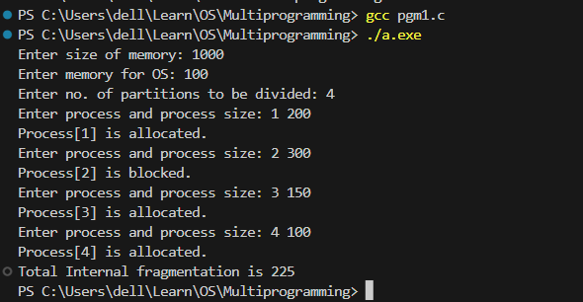

Write a C Program to simlulate Multiprogramming with Varible Number of Tasks (MVT)

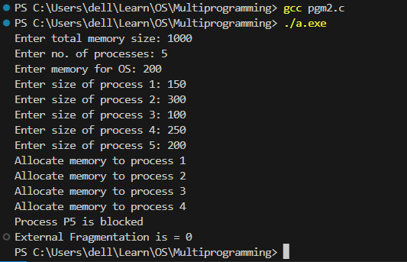

Code at <https://github.com/rbrox/Operating-Systems/tree/main/Multiprogramming>