1. Go to <http://windows.github.com/> and download github
2. When it’s finished downloading, click the githubsetup.exe to install (it may take a few minutes)
3. It will automatically install GitHub and GitShell. You can pretty much ignore GitShell.

GitHub’s Icon:

1. 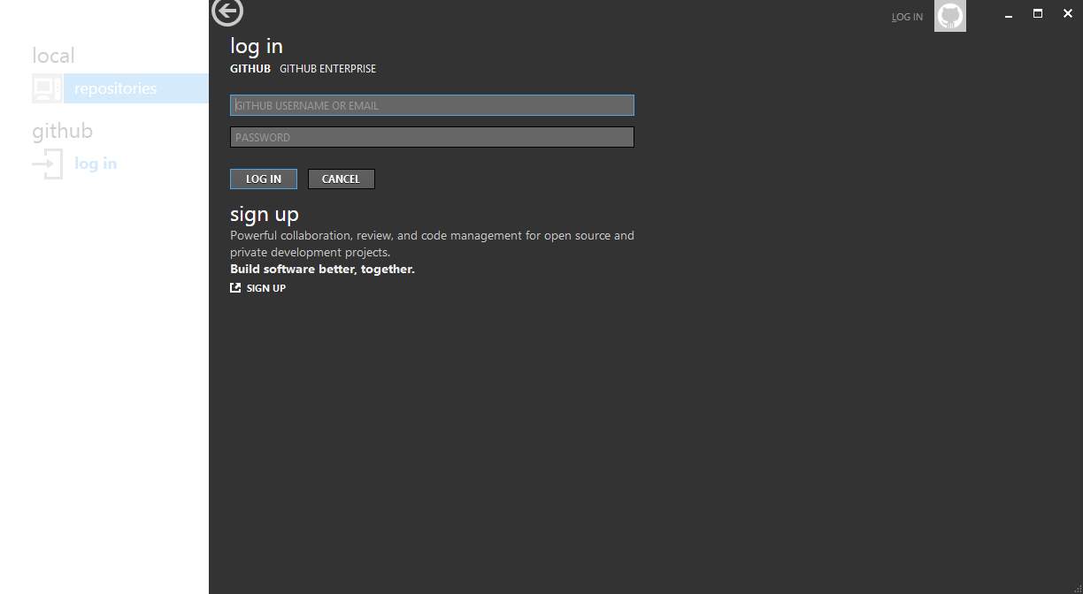Click on GitHub to open this application:
2. Type in your github username and password that you created online:
   1. It should pull up a screen like this (although you will have your own username listed):

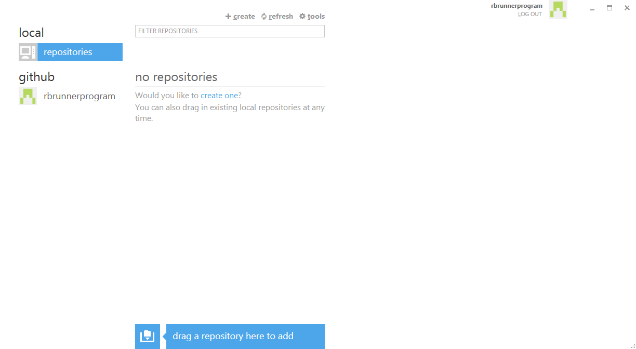

Click on your username

1. 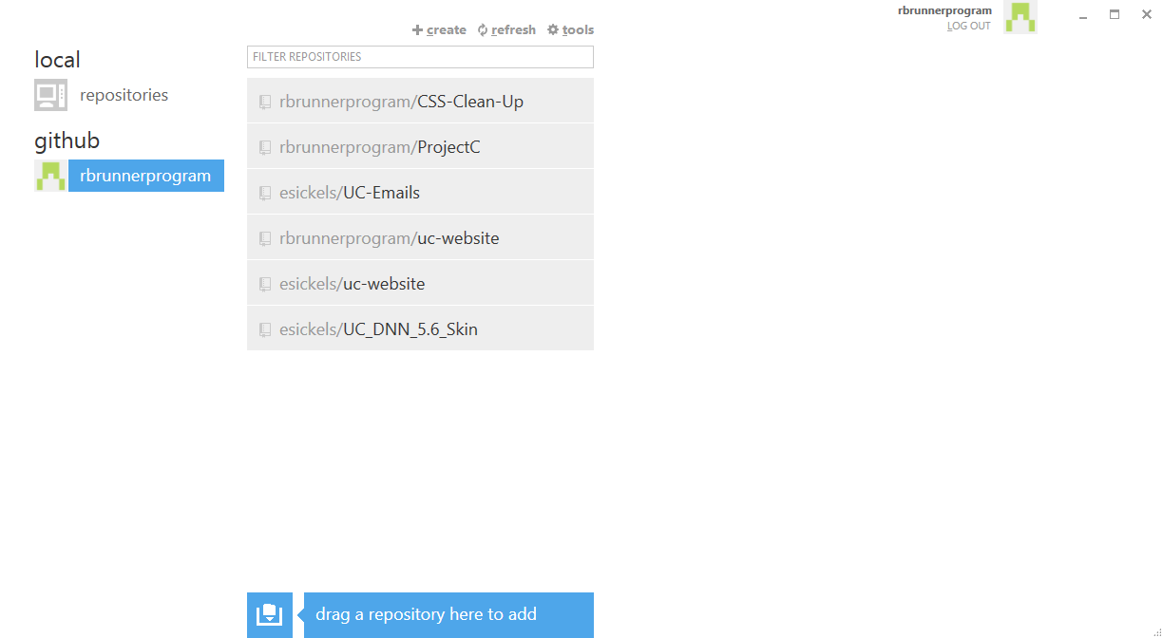Something similar to this should show (you will probably have fewer repositories):
2. Hover over the ProjectC repository and click clone. If the repository isn’t there, email me and I’ll look into the problem.
3. When it is done cloning, click here:

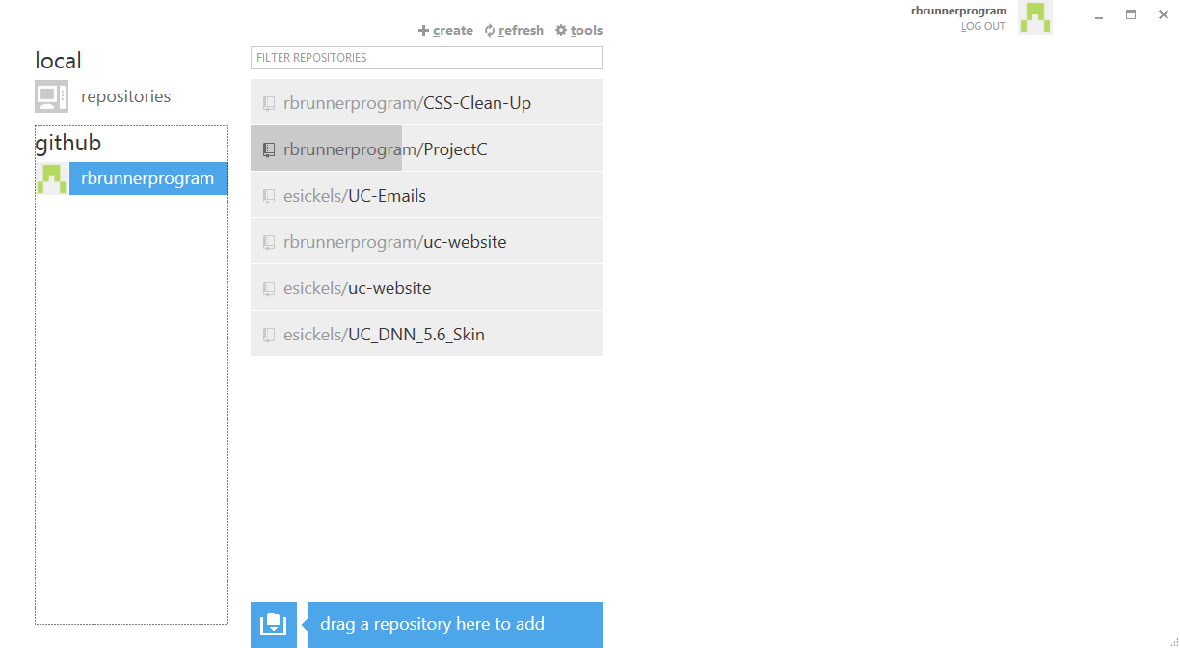

1. 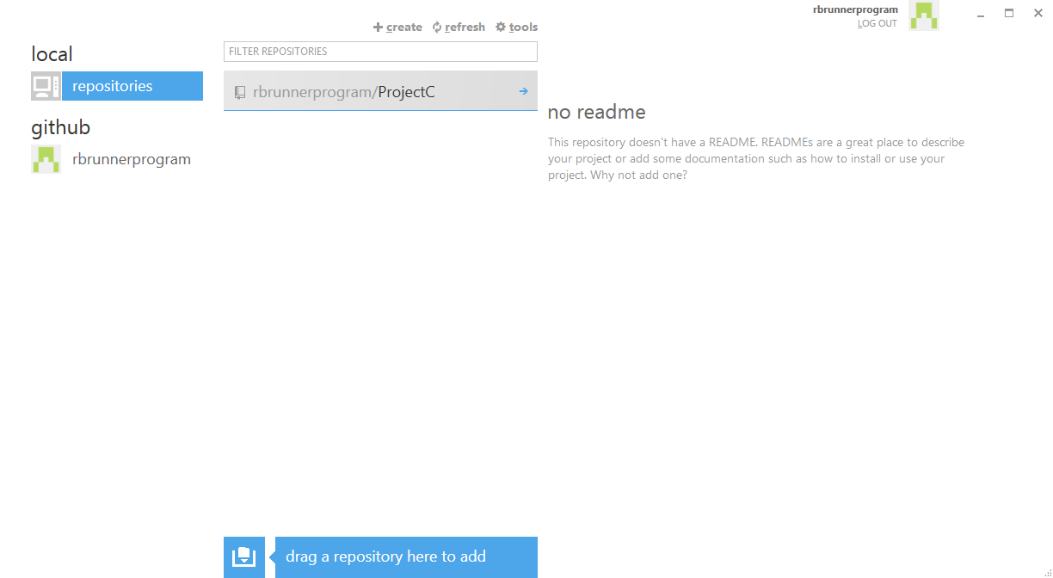Hover over project (in your local repository) and click the right arrow that says “open this repo”
2. It should look something like this:

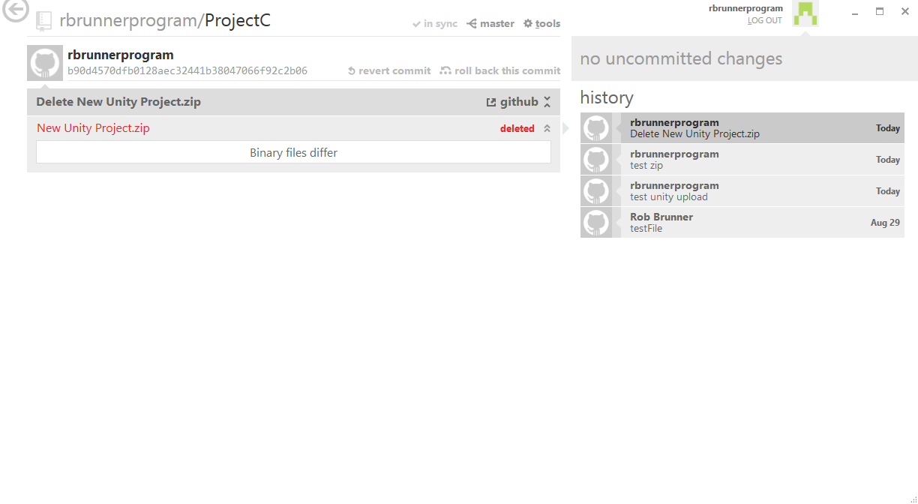

Make sure this says “in sync”

This is where commits are shown. Commits are basically just saves except with an explanation. I’ll show this in a second. If the sync button does not say “in sync”, click it to sync your local repository.

1. Click the tools button at the top.

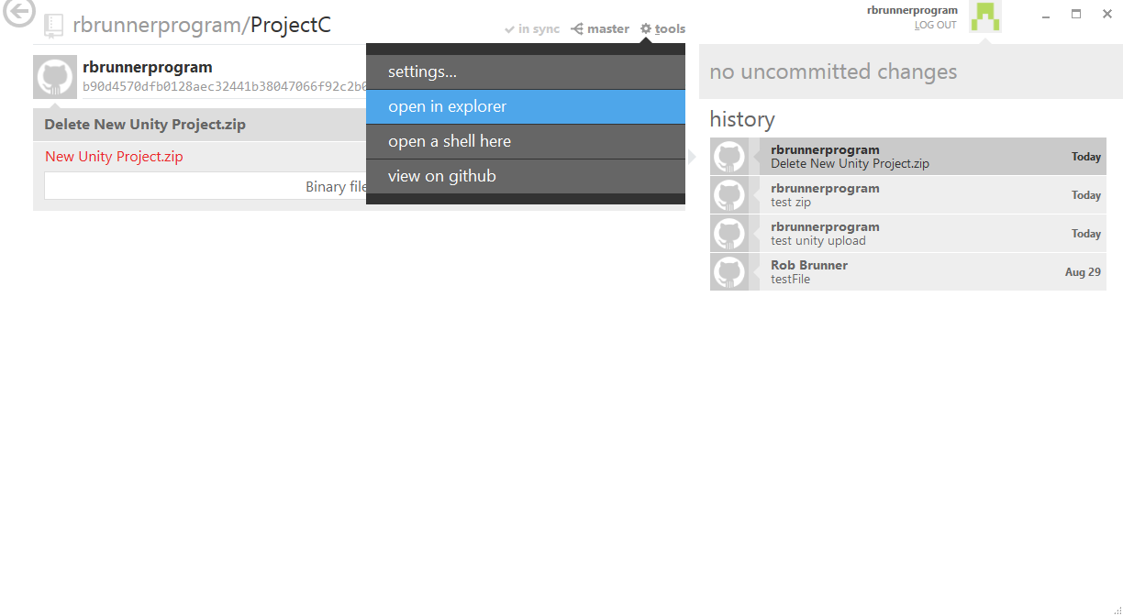

1. Click “open in explorer.” It will open up the file location of your repository on your local machine:

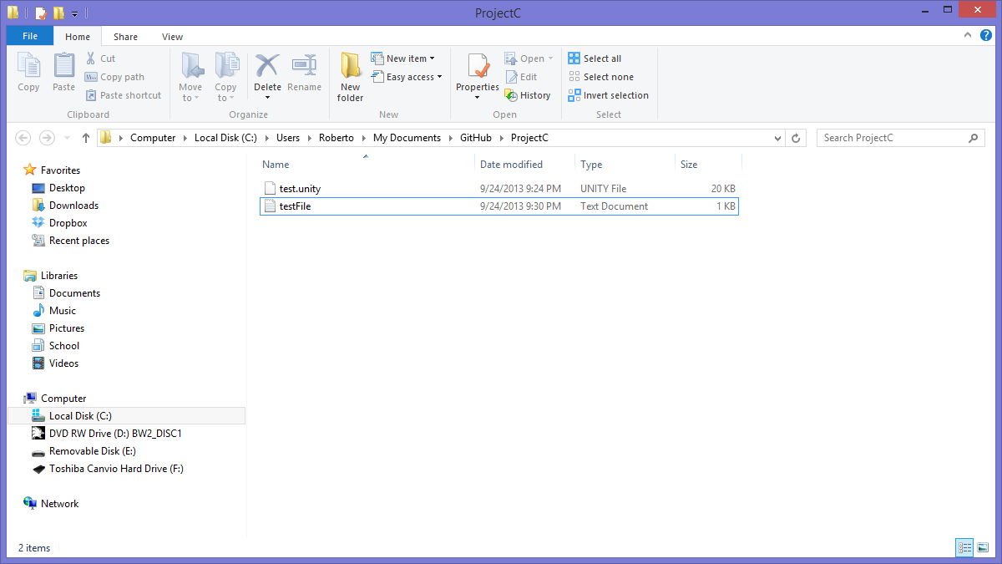

This is where all the files in our repository can be accessed. You can also access them from the web application at github.com.

1. If we open the testFile.txt:

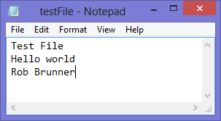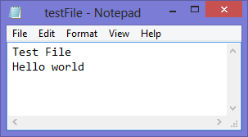

And change it to:

And then save.

1. 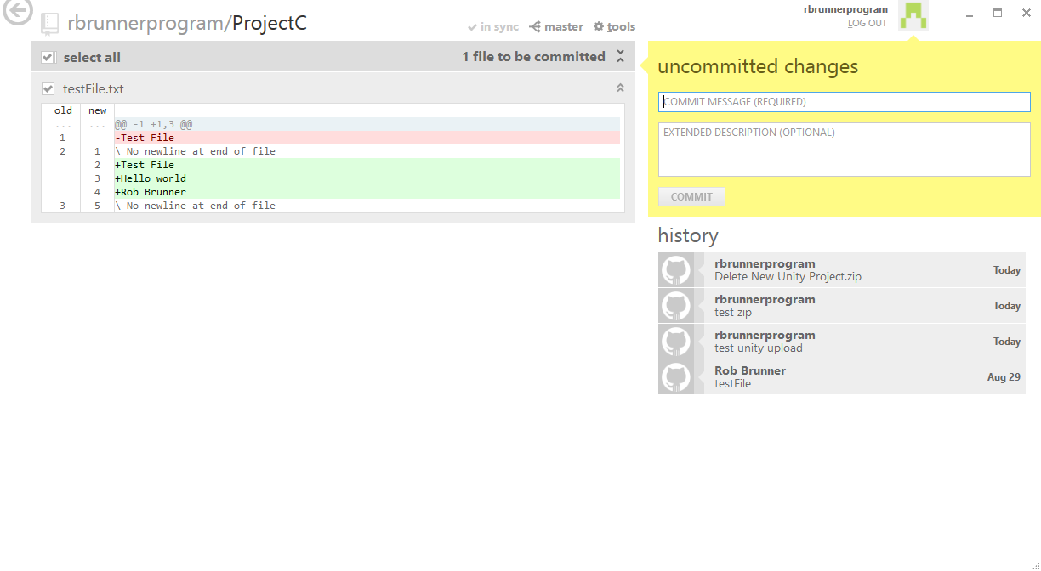Go back to the github desktop application, and it should change to this (press the back arrow in the upper lefthand corner of the application and then the small blue arrow again if your screen doesn’t change):

You may also have a blue box here that says something along the lines of “you have uncommitted changes.” Just click the button it gives in the box to get this yellow box.

1. After filling out a description of the changes, click the commit button.

**AND THEN BE SURE TO CLICK THE SYNC BUTTON!!!!!!!!!!!!!**

1. To create a new file, simply save it to your local repository area:



And follow step 15.