About

This document describes the deletion mechanism.

How it works

Deleting is a bit fun because we also have to delete the file from other instances as well if it is cached. The process as below
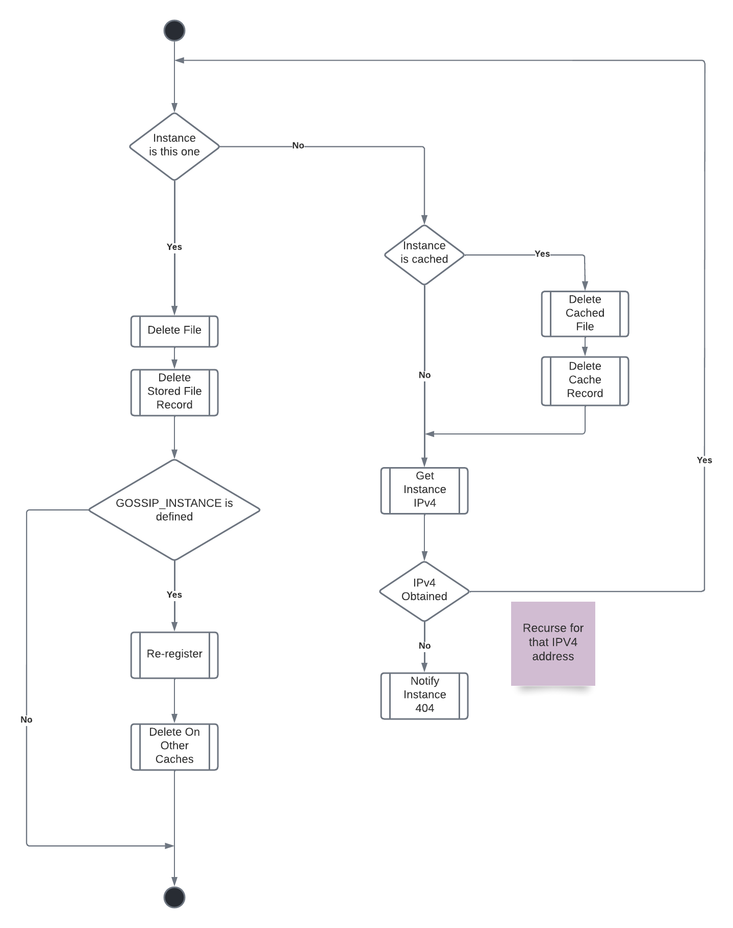

API Calls

(POST) /api/version/delete → delete file
headers(SHARD_KEY)
Parameters:
query_string: file cache query string
Responses:
200 → Success (Query String Attached)
*

(POST) /api/version/delete_cache → deleted a file from the cache
headers(SHARD_KEY)
Parameters:
query_string: file cache query string
Responses:
200 → Success
*

