About

This document describes the memory management and cache invalidation.

How it works

2OGB memory is reserved for cache. If this was not the case an instance would not be able to fetch files from other instances. The rest is reserved for storage, however it is important to note that the cache can grow over 20GB if there is free memory. Memory management is called every time a file is to be cached with the following logic.
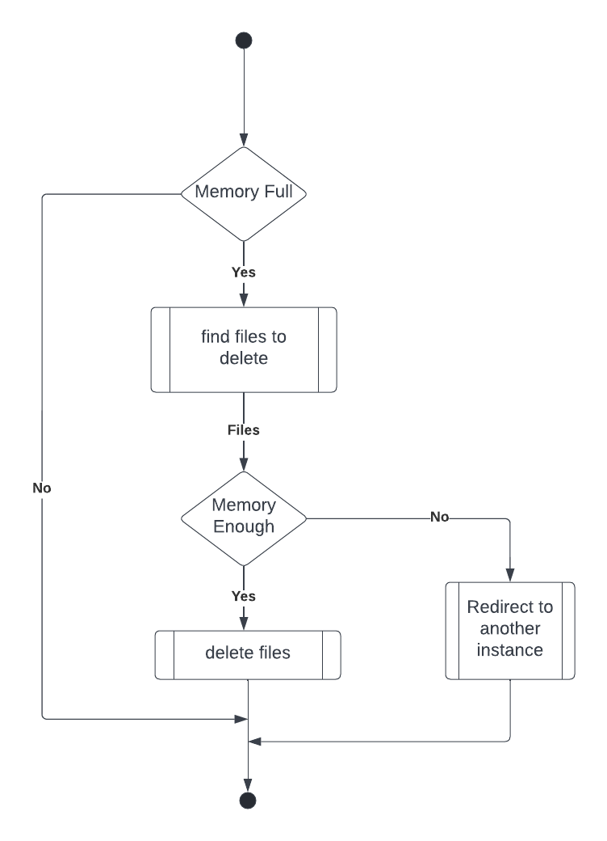

File Suitability

Determining the files to delete is definitely a complex and hard task. The following are things to consider when finding cached files to delete.
- Priority
- Cached date
- Reads
- Size

So after some really long consideration, invalidation is based on the file with the lowest reads and priority.

