About

This document describes shard caching, a mechanism to increase the availability of a file.

How it works

In this mechanism a file is cached on other instances to increase its availability, as the file does not have to be fetched instances storing that file when a request is made. Caching is done every time an instance receives a request for a file that is on another instance, that file is downloaded from the other instance and cached locally. The file will only be fetched again if the cached file was deleted or it has been outdated. All files cached like this have a priority of 0.
See 10_outdated_file_cache_invalidation.odt on how a file determined to be outdated.
The other way to cache a file is by making a cache request to the gossip instance. This is meant to provide more control on caching by giving the option to define the priority of the file being cache. Meaning that file if only removed from the cache when other files have higher priority and the cache is full. The gossip instances after receiving the cache request will notify all registered instances to cached the file from an instance.

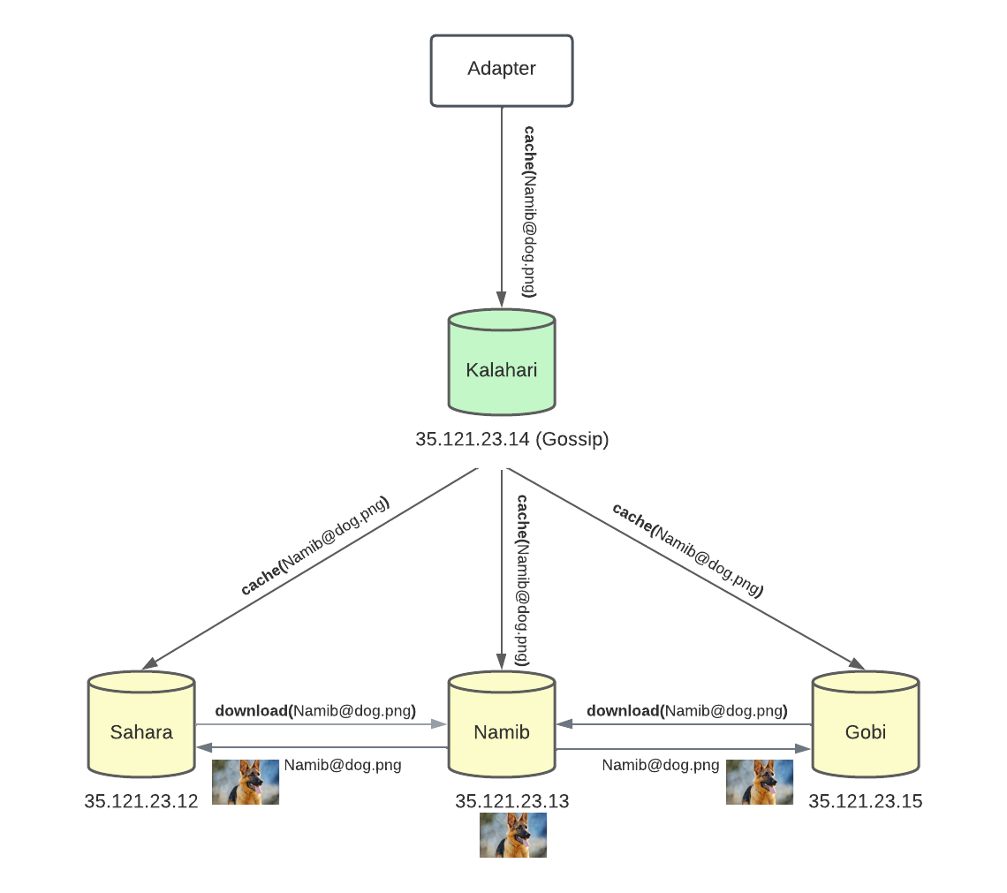

API Calls

(POST) /api/version/shard_cache → (Gossip) cache a file on all registered instances
headers(SHARD_KEY)
Parameters:
priority: real number 1 to 2^32-1
query_string: file cache query string
Responses:
200 → Success
*

(POST) /api/version/cache → cache a file on that instance
headers(SHARD_KEY)
Parameters:
priority: real number 1 to 2^32-1
query_string: file cache query string
Responses:
200 → Success
*

Cache Limits

The cache limit is storage that is reserved for cache by an instance. If we did not reserve this an instance would fill its memory, and we would not be able to retrieve files from other instances. By default the cache limit is set to 40GB, but this can be updated by defining a CACHE_LIMIT parameter.

