Diodes

A standard LED generally needs a voltage of around 2V and a current of 20mA

|  |  |  |  |
| --- | --- | --- | --- |
| Diode | Description | Junction voltage | Diagram |
| PN junction diode | Junction made due to barrier, therefore needs a strong voltage to push the electrons across to the holes, so that current flows. | 0.7V |  |
| Schottky diode | Junction made from a metal semiconductor therefore small threshold voltage required to create large current across the junction. | 0.3-0.4V  Used for low voltage application |  |
| Zener diode | In reverse bias when the reverse voltage supplied to zener reaches its breakdown voltage, the voltage across diode remains constant even if the current through it continues to increase or vary. | Used as voltage regulator. A load has to be connected across zener to get steady voltage |  |
| Shockley diode | Also called as four layer diode, described as PNPN diode. Used for switching applications. When the voltage applied is less than the trigger voltage diode resistane is max and act as off switch, when voltage is above trigger voltage the switch on resistance is very low. Mostly used in ckts to turn on SCRs. | The diode requires less current to turn on  (this diode is not used greatly) |  |
| Photo  diode | Used as high voltage rectifier, photo detector, radio frequency switch |  |  |

**Motor:**

* Electrical machine that converts electrical energy to mechanical energy

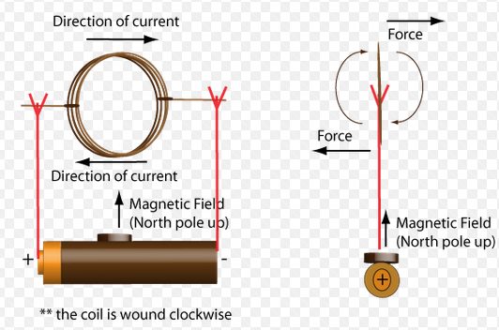

**Switch:**

* Device that allows or breaks the flow of electricity, providing off/on action

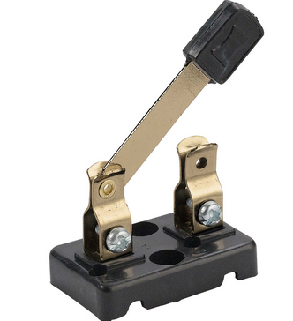

**Battery:**

* Device that provides power to other devices.
* Has positive and negative terminals

