

Qvu Data Service
Help

Ver: 0.1.3
Last Updated: 10/11/2023
Table of Contents
Overview 4
Administration 4
System Settings 5
Authentication 5
Scheduler 7
SSL 8
Misc 8
Scheduling 9
Repository Backup 12
Add/Edit a Datasource 13
Datasource Entry Fields 14
Datasource Table Settings 15
Table Column Settings 16
Table Foreign Key Settings 17
Custom Foreign Keys 19
Testing the Database Connection 22
Add/Edit a Role 23
Add/Edit a User 24
Add/Edit a Document Group 26
Query Design 27
Column Select Pane 27
Table Tree Icon Descriptions 29
Root Table 29
Root View 29
Imported Foreign Key Table (parent) 29
Exported Foreign Key Table (child) 30
Root Table with Column Selections 30
Root View with Column Selections 30
Imported Table with Column Selections 30
Exported Table with Column Selections 30
Imported Table with Inner Join (joins default to outer) 30
Imported Table with Inner Join and Column Selections 30
Exported Table with Inner Join (join defaults to outer) 30
Exported Table with Inner Join and Column Selections 30
Column 30
Primary Key Column 31
Setting Join Type 31
Related Table Display 31
Query Design Data Tab 32
Data Column Configuration Description 33
Data Column Configuration Panel Icons 33
Column Details Icon 33
Duplicate Column Icon 34
Copy Table Alias and Name to Clipboard 34
Move Column Position 34
Data Column Entry Fields 35
Query Design Filter Tab 35
Query Design SQL Tab 38
SQL Tab SQL Pane 38
Filter Values Prompts 39
Saving a Query Document 40
Loading a Saved Query Document 41
REST API 42
Custom Security 44
Qvu Repository 45
Qvu Repository config Folder 45
Qvu Repository documents Folder 45
Qvu Repository help Folder 46
Qvu Repository logs Folder 46
Language Support 46

Overview
Qvu Data Service is an ad-hoc query and api data service design tool that allows users to create and save query designs in a user-friendly, web-based UI. Qvu Data Service provides REST API endpoints for users and applications to execute saved query documents and return results in tabular or json formatted result sets. Qvu Data Service provides role-based datasource, table column and document group access control and supports both Basic and OIDC authentication.

Administration
The Qvu Admin tab allows users with the administration role to add and configure datasources, users, roles, document groups and scheduled query execution as well as the desired authentication scheme and SSL. After initializing the Qvu repository (see qvu-gettingstarted.pdf), start Qvu and login as the admin user – you should see the screen below:

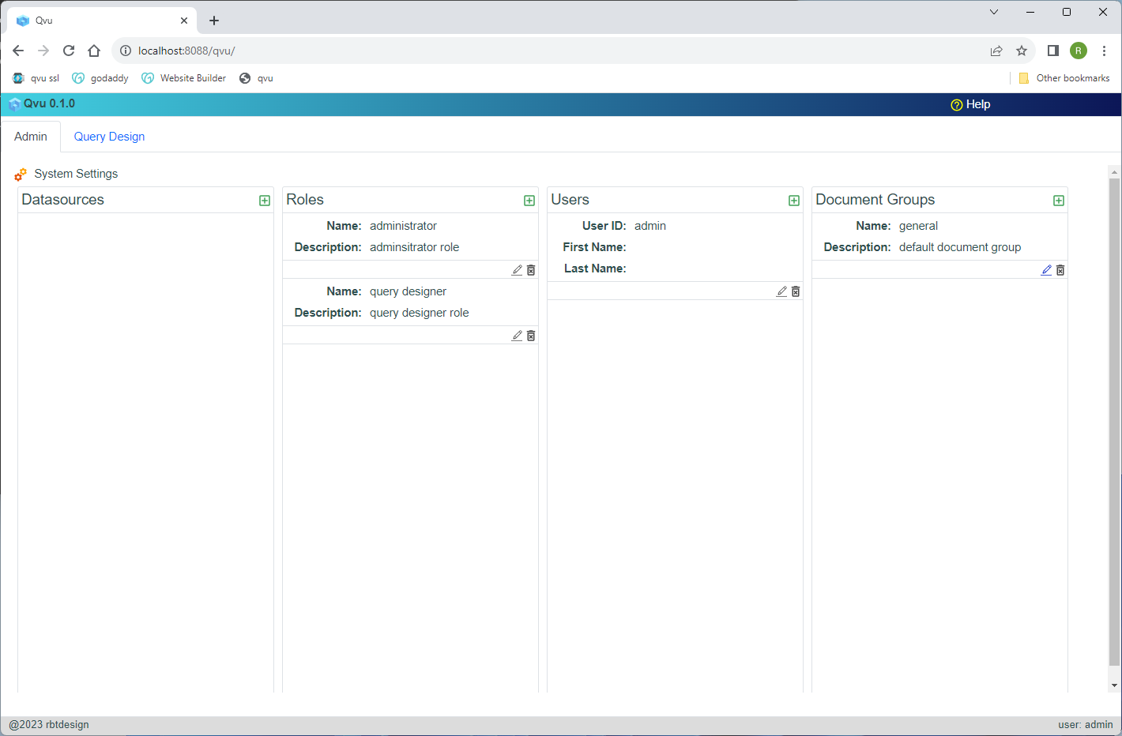
The initial admin tab will have no datasources, 2 default roles – administrator and query designer and one user – admin.

System Settings
System Settings is used to configure various system-related settings in the Qvu Data Service. authentication.

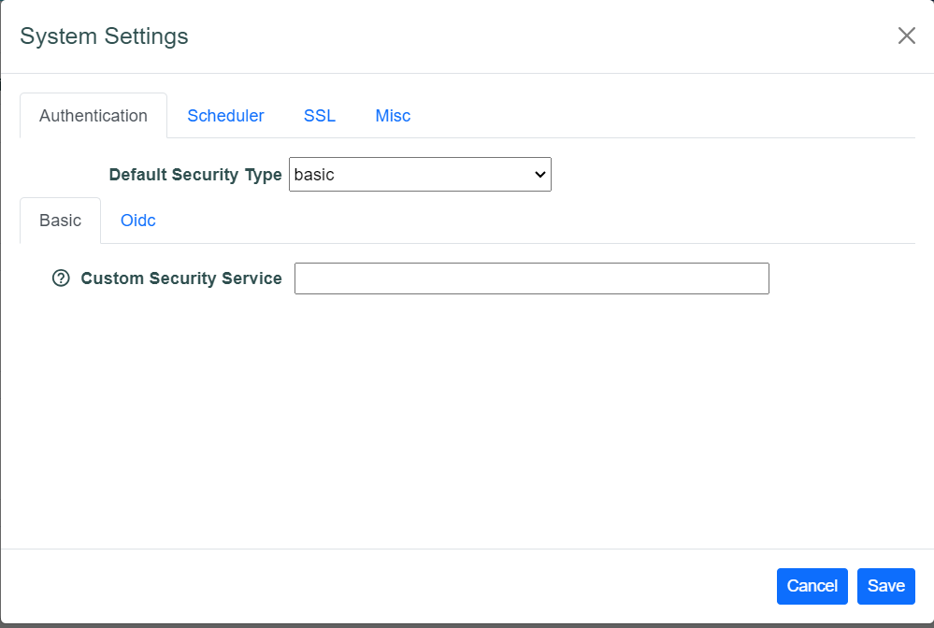

Authentication
The Authentication tab allows the user to setup Qvu Authentication here are the 3 choices:
- Basic Authentication
- Basic Authentication with Custom Security
- OIDC

Click the System Settings icon in the Admin tab to display the System Settings dialog:

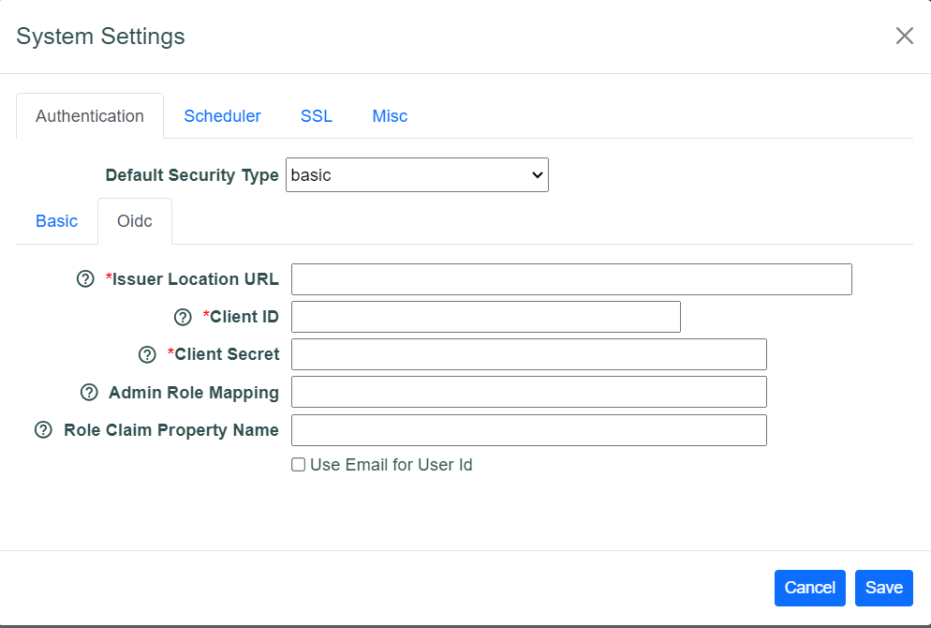

Select the desired Default Security Type and complete the associated entry fields. If basic is selected then no other action is required. Security objects will be stored locally in the configured Qvu repository. If you wish to use a custom security implementation then a Java class must be entered in the Custom Security Service field. See the Custom Security section in this document for more information on this topic.

If oidc is chosen as the Default Security Type, complete the required entries on the Oidc tab
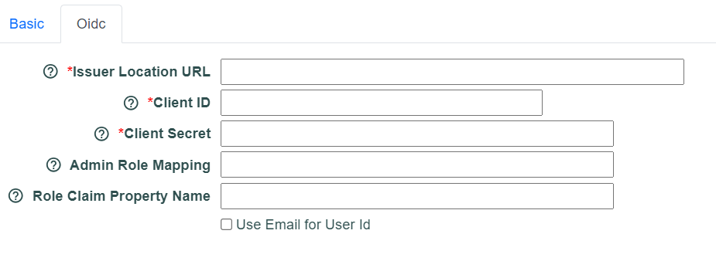
Issuer Location URL, Client ID and Client Secret are standard OIDC entries associated with your identity provider.

The Admin Role Mapping is used to map incoming OIDC role claims to the Qvu administrator role. This is used in conjunction with the Role Claim Property Name entry. In Role Claim Property Name enter the user claims name for the user roles. This is expected to an array of role names. In the Admin Role Mapping enter a comma-delimited list of incoming roles that should be mapped to the Qvu administrator role.

Scheduler
Qvu Data Service supports scheduled query runs which will email the results via SMTP as an attachment of type csv, excel, JSON flat or JSON Object Graph. The System Settings Scheduler tab provides the email configuration setup.
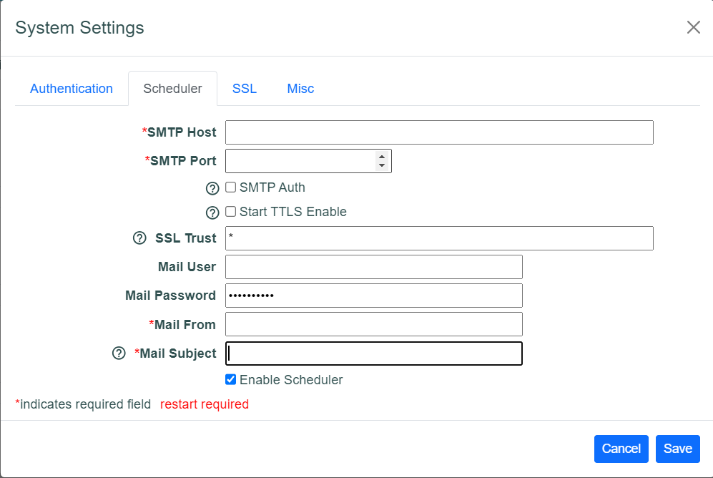
The entry fields:
- SMTP Host
- SMTP Port
- SMTP Auth
- Start TTLS Enable
- SSL Trust

Correspond to standard Java Mail Api properties shown below:
- mail.smtp.host
- mail.smtp.port
- mail.smtp.auth
- mail.smtp.starttls.enable
- mail.smtp.ssl.trust

Mail User and Mail Password are the mail host authentication credentials. Mail Subject is the default subject for generated emails. Replacement variable $g, $d and $ts can be added to the subject line to inject runtime values:
- $g – document group
- $d – document name
- $ts – document run timestamp

The Enable Scheduler checkbox turns the scheduler on and off

SSL
The SSL tab is where SSL is configured for the Qvu Data Service:

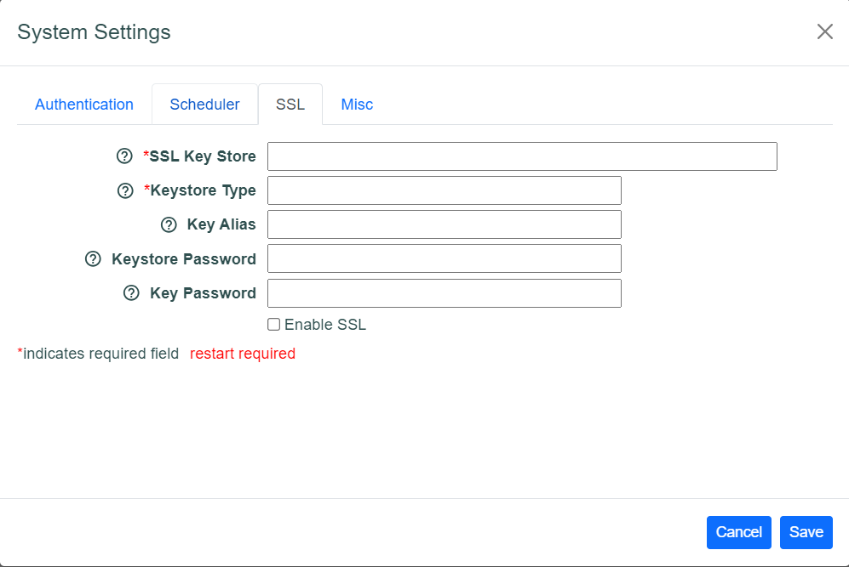
Enter the appropriate SSL entries to configure the SSL. The SSL Key Store entry is expected to be a valid path to a cert file. The Enable SSL checkbox will turn on and off the SSL requirement for Qvu Data Service. If you enable SSL it would be best to update the server port on the Misc tab described below:

Misc
The System Settings Misc tab is shown below:

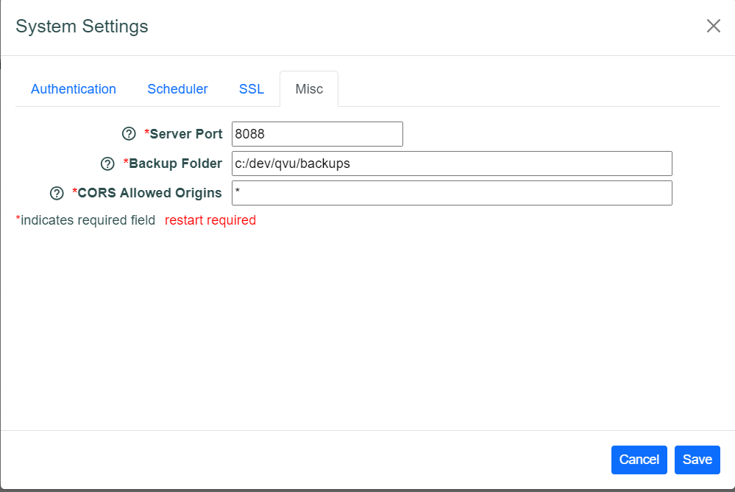

The Server Port entry sets the Port that the web server runs on. Backup Folder sets the location where Qvu backup files are stored and the CORS Allowed Origins allows the user to control the CORS access setting.

Scheduling
Click the Scheduling icon to display the current scheduled documents:
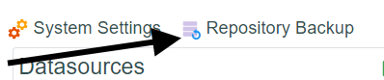
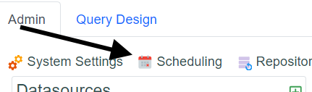

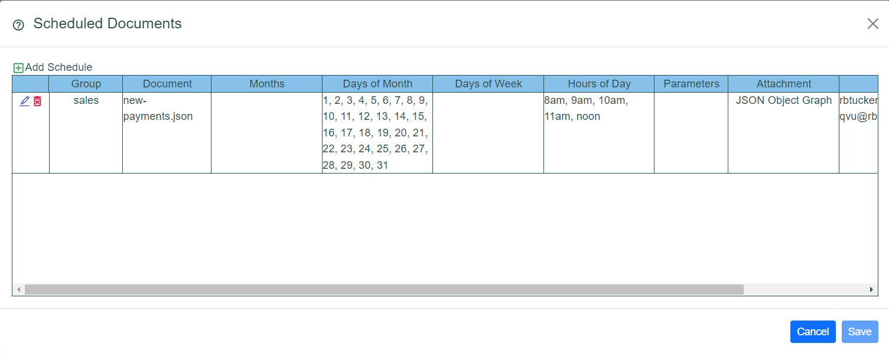

To add a new schedule click the Add Schedule icon:



This will display the Schedule Entry dialog:

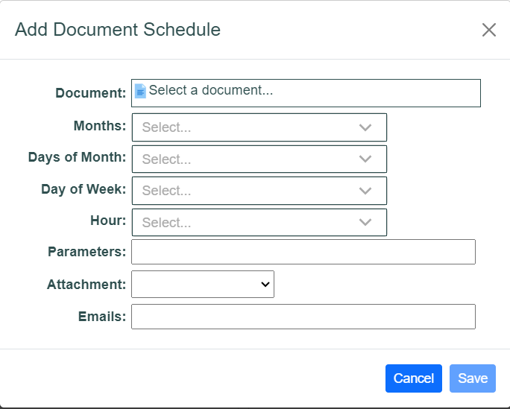

Select a document by clicking the document select icon to display the document select dialog:

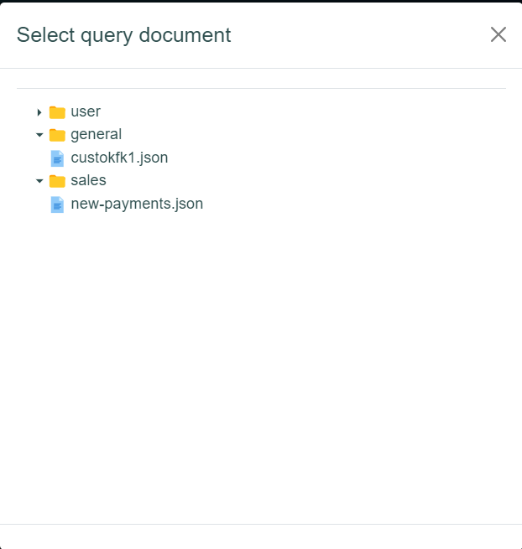

The Months, Days of Month, Days of Week and Hours entry controls are multi-select drop downs:
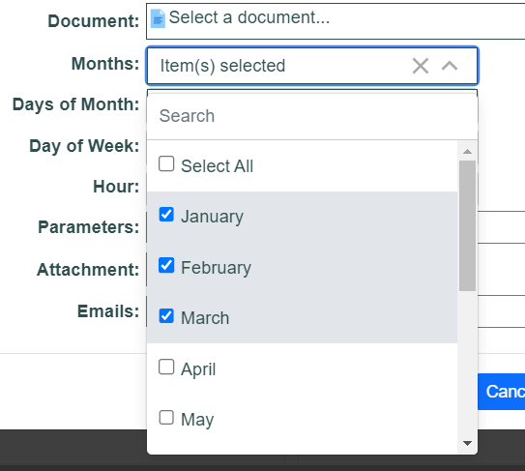

Days of Month and Days of Week are mutually exclusive. The minimum run frequency is every hour. In the multi-select controls, no selection is understood to mean all. For example, if no months are selected then it is assumed that the schedule will run for every month.

If runtime parameters are required for the selected document enter these as a comma-delimited list of values in the Parameters field. Dates should be entered in the yyyy-mm-dd format. You can use current date replacement tokens for date parameters - $dt is the current date, $dt-1 would be used for yesterday and $dt+1 would be tomorrow.

Select the desired results attachment type from the Attachment drop down:

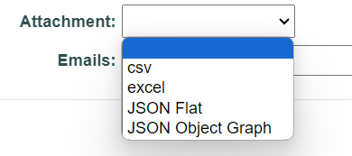

Enter a comma-delimited list of emails for the results delivery target emails:

To edit or delete a schedule click the desired edit/delete icon:

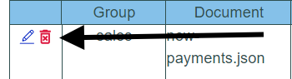

Repository Backup
Click the Repository Backup icon to backup the repository:



A backup file target folder is specified in the <respository-folder>/config/application.properties file. This defaults to <respository-folder>/backups but can be changed (must restart the
server).

backup.folder=c:/dev/qvu/backups

The backup file format is qvu-backup-yyyyMMddhhmmss.zip.

Add/Edit a Datasource
To add a datasource, click the add icon on the Datasources control:

The Create new datasource dialog should display:
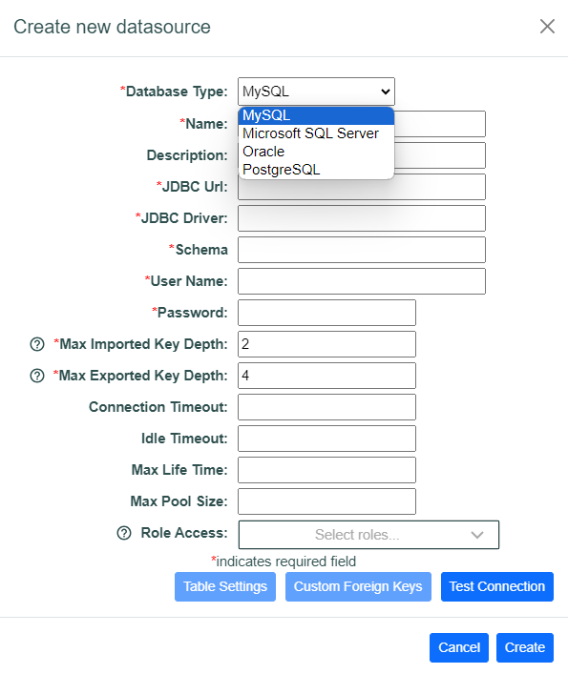

Select the desired database type and fill in the required entries. The table below describes each entry field:

Datasource Entry Fields
Database Type | MySQL, Microsoft SQL Server, Oracle or PostgreSQL
Name | This is the datasource name which will show up in the Datasource selection drop down and be associated with the query document. The name must be unique
Description | A description of this datasource
JDBC Url | The database-specific JDBC URL to connect to the database. When specifying a Url for MySQL be sure to include nullDatabaseMeansCurrent=true, for Microsoft SQL Server you may need to include encrypt=true;trustServerCertificate=true
JDBC Driver | The JDBC Driver java class name
Schema | The database schema for this datasource
User Name | Database user name to use to connect to the database
Password | User password ti use to connect to the database
Max Imported Key Depth | The max depth to recurse through the imported (parent table) foreign key definitions when building table relationships.
Max Exported Key Depth | The depth max depth to recurse through the exported (child table) foreign key definitions when build table relationships
Connection Timeout | the maximum number of milliseconds to wait for a database connection checkout. Defaults to 30000 (30 seconds)
Max Pool Size | Maximum size that the connection pool is allowed to reach, including both idle and in-use connections. Basically this value will determine the maximum number of actual connections to the database backend. Defaults to 10.
Role Access | Roles required to access this datasource – no selections indicates datasource is available to all users

To edit/delete a datasource click the Edit/Delete icon

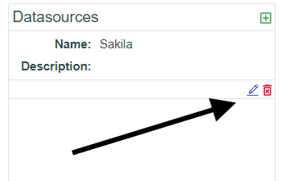

Datasource Table Settings
A user can customize how datasource tables and columns are displayed in the UI and control user access to tables and columns by role assignment. To modify these setting click the Table Settings button to display the Table Settings dialog::

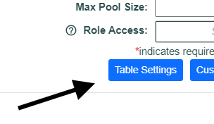

The Table Settings dialog will display a list of tables associated with the datasource. For each table the following fields can be set to handle the way the table is presented to the user in the UI:
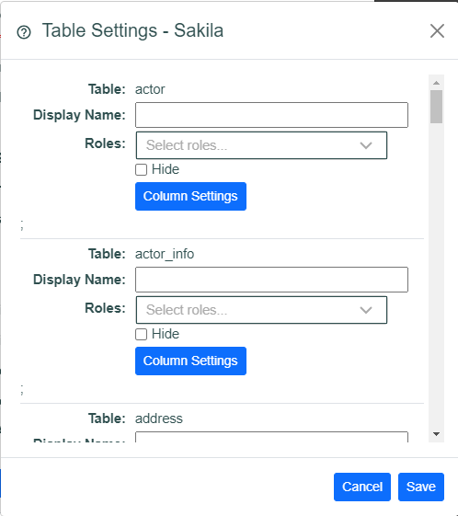

Display Name | A user friendly name can be entered that will be used in the UI whenever the table is presented to the end user
Roles | Roles can be associated with the table and only users that are members of the selected roles will be able to see the table in the UI. No selection means the table is available to all users.
Hide | When checked the table will not be displayed in the UI for any user.

Table Column Settings
Click the Column Settings button on any table in the Table Settings dialog to configure how the associated columns are displayed in the UI for the table. When clicked the Column Settings dialog will display:

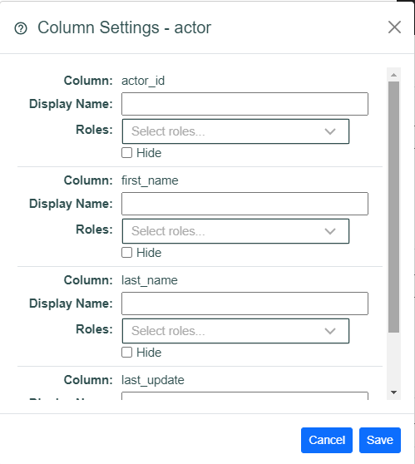

The Column Settings dialog will display a list of columns associated with the table. For each column the following fields can be set to handle the way the column is presented to the user in the UI:

Display Name | A user friendly name can be entered that will be used in the UI whenever the column is presented to the end user
Roles | Roles can be associated with the column and only users that are members of the selected roles will be able to see the column in the UI. No selection means the column is available to all users.
Hide | When checked the column will not be displayed in the UI for any user.

Table Foreign Key Settings
The table foreign key settings allow an administrator to customize how foreign key tables are displayed in the data select tree. The foreign key settings also provides a means to set the field name for the child data field of foreign key data when retrieving data as an object graph. To add foreign key settings click the Foreign Key Settings button for the desired table in the Table Settings dialog to display the Foreign key settings dialog:

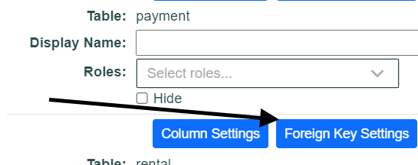

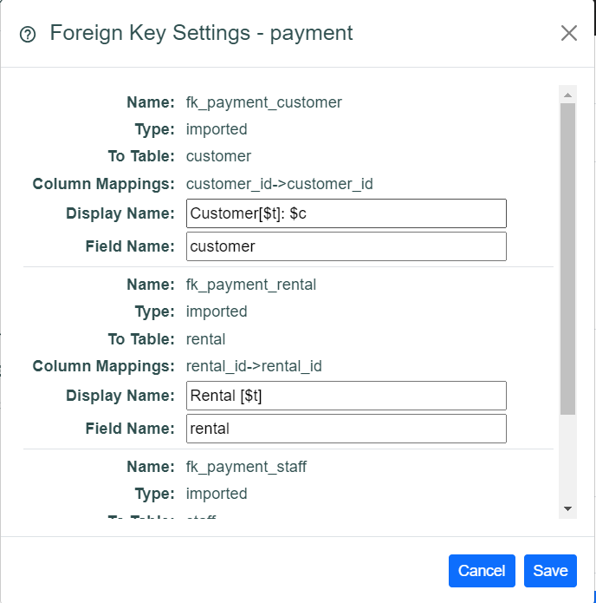

Enter the desired Display Name and/or Field Name for the selected table foreign key relationship. By default the foreign key is displayed as:

<foreign-table-name>: fromColumn1→toColumn1, fromColumn2→toColumn2…

You can enter a $t in the Display Name to include the foreign table in the Display Name. You can add $c to include the foreign key column mappings in the Display Name.

Custom Foreign Keys
Configured database foreign keys are used by Qvu to define the table relationships for query design. In cases where a desired foreign key does not exist in the database Qvu supports defining pseudo foreign key definitions. To create a pseudo foreign key click the Custom Foreign Key button to display the Custom Foreign Key dialog

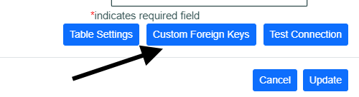

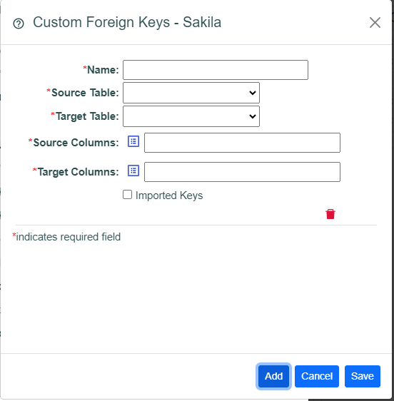

Enter a unique name for the foreign key, select the source and target tables from the associated drop downs:

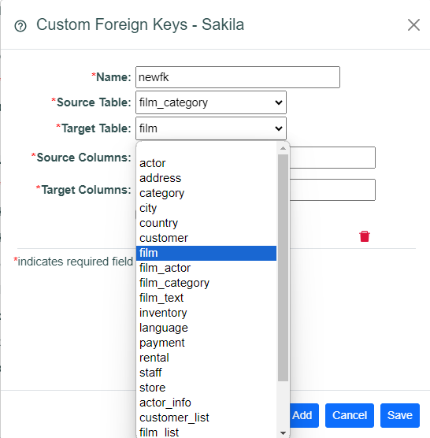

Now choose source and target foreign key columns. When choosing the foreign key columns you will be presented with a multi-select control. Selection order is import. The columns will added as a comma-delimited list in the order selected, make sure you choose the associated columns in the correct order to map the table relationship correctly.

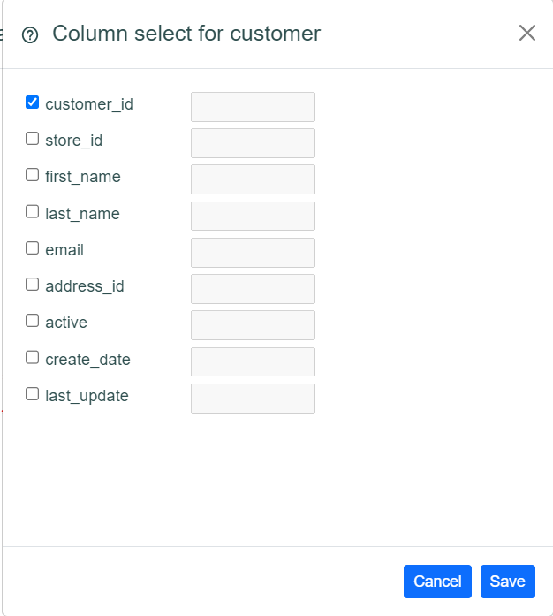

For exported foreign tables a user can enter a raw comparison value in the text entry field if desired as shown below:

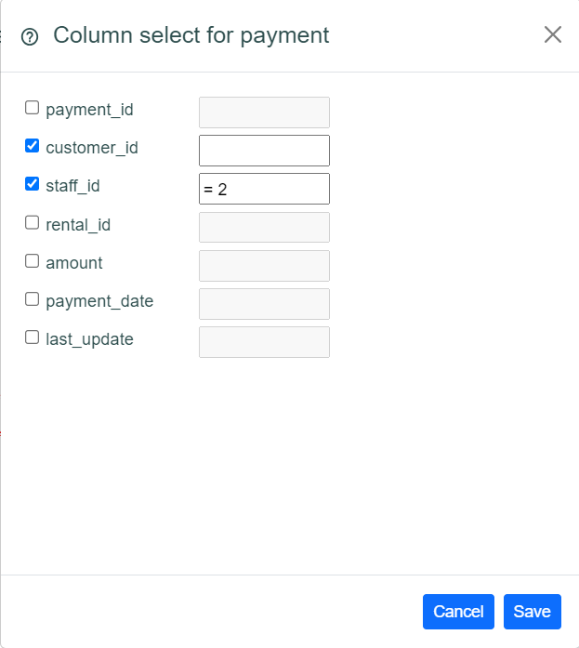

This will produce a join clause similar to this:

FROM `customer` `t0`
left outer join `payment` `t1` ON
(`t1`.`customer_id` = `t0`.`customer_id` and `t1`.`staff_id` = 2)
WHERE

Check the Imported Key checkbox if this relationship is to a parent table – leave blank if it is to a child table.

Testing the Database Connection
Once the datasource entries are complete you can test the database connection by clicking the Test Connection button. If the connection succeeds you will receive a success message:


Add/Edit a Role
To add a new role click the Add icon to display the Create new Role dialog::
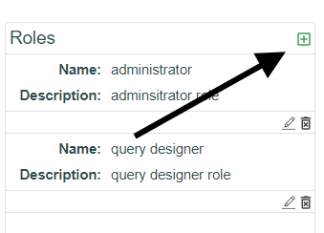

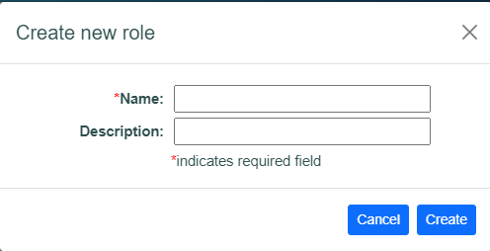

T

To edit/delete a role click the Edit/Delete icon:

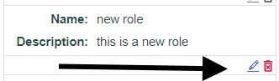

There are 2 canned system roles that cannot be edited or deleted – administrator and query designer. On these roles the edit/delete icons are disabled.

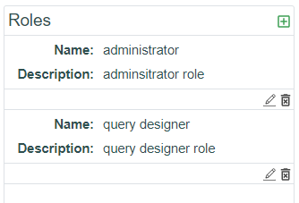

Add/Edit a User
Qvu Users are handled a bit differently than other security-related entities. If Qvu is configured to use the local Qvu repository for authentication then a user can be added, edited and deleted.

If authentication is configured to use OIDC, when an authenticated user does not exist in the local Qvu repository that user will be added for user information purposes – authentication will is handled by the OIDC identity provider. A role mapping can be setup to map incoming role claims to the administration role if desired – see the System Settings section for more information on this topic.

If the custom authentication plugin is enabled then the custom authentication service is responsible for providing user information and expected roles (administrator and query designer). The user will be read only in the Qvu application.

There is a canned system user – Admin – which cannot be edited or deleted.

To add a new user when Qvu is configured to use local repository authentication click the Add icon to display the Create new User dialog:

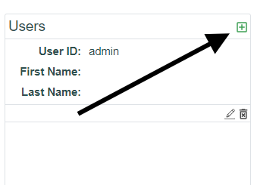

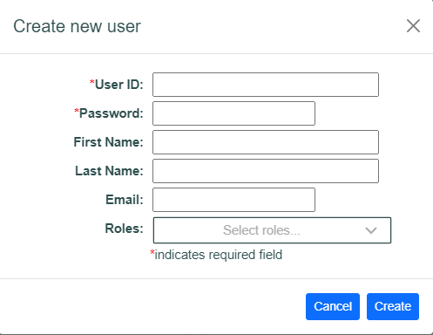

Complete the required and entries and save the user. To assign roles to the user, click the Roles drop down and select the desired roles:

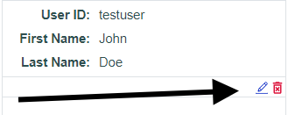

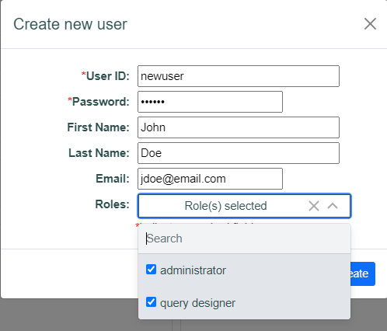

User passwords are stored locally as a md5 hash of the entered passwords. See the Qvu Repository section for more information.

To edit/delete a user when enabled click the Edit/Delete icon:

Add/Edit a Document Group
When query documents are saved they must be assigned a document group. A canned, default document group user is always available and cannot be edited or deleted. Documents in the user document group can only be seen by the current user. Additional document groups can be created as desired.
To add and new Document Group click the Add icon to display the Create new Group dialog:

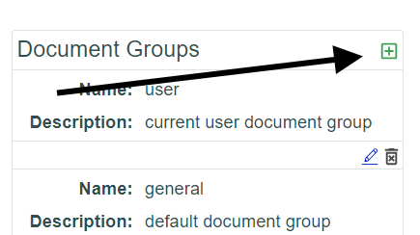

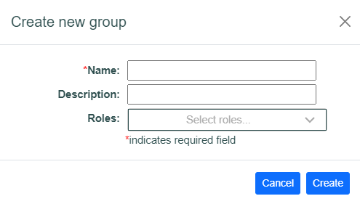

Enter the required fields – the name must be unique. Roles can be assigned to a document group. Only users that are members of the selected roles will be able to see the documents in the group. If no role is selected, all users can access the documents in the group.

To edit/delete a document group click the Edit/Delete icon:

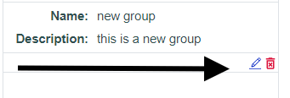

If a document group is deleted the document group folder is backed up to the configured backup folder then the group folder and any documents are deleted. A query document can be assigned a new document group. See Saving a Query Document for more information on this topic.

Query Design
The Qvu UI is built on React and provides a rich, user-friendly interface for query design. Query design is based on a root table selection from a selected datasource. Defined table relationships associated with the selected root table are displayed in a tree view that allows users to select data columns as desired.

Column Select Pane
From the Qvu Query Design tab select the desired datasource to display the table hierarchy tree:
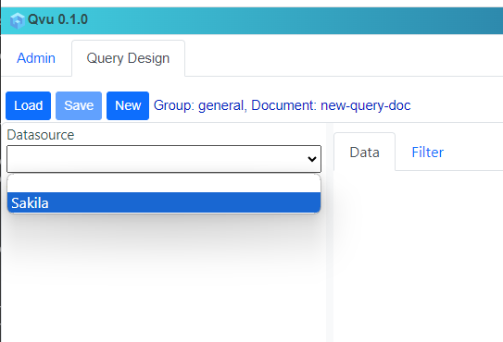

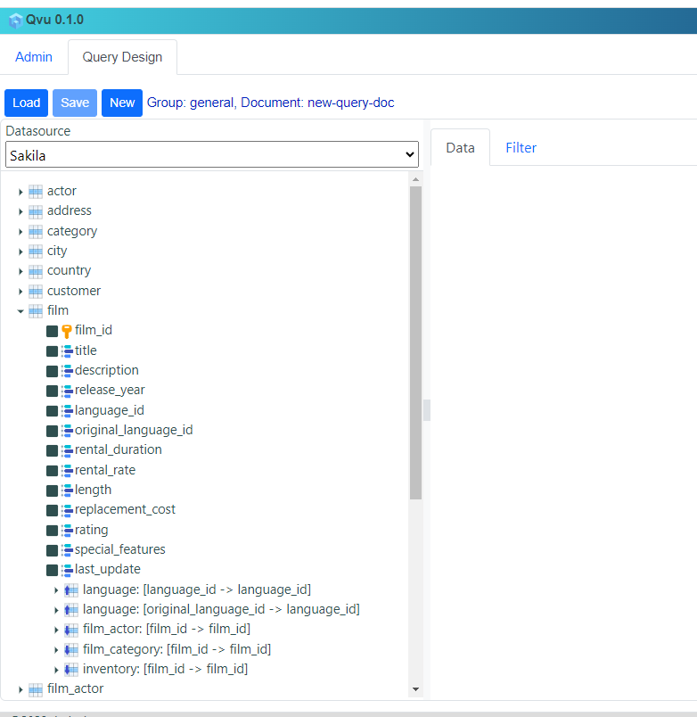

Tables and columns displayed in the tree are based on the role settings discussed in the Administration section above. The user can now select the desired columns. Column selection order determines the initial order of the result set columns. This can be changed in the Data tab on the right split pane. As columns are selected the Data tab will populate with column configuration panes.

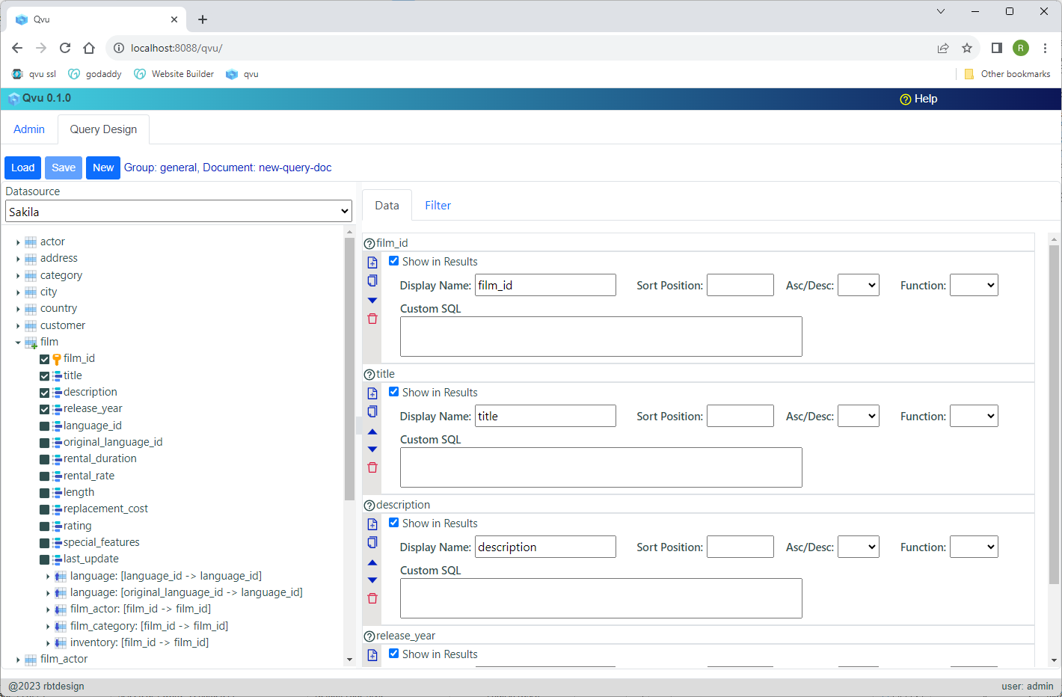

Table Tree Icon Descriptions
Below is described the various icons you see in the table tree:

Root Table


Root View


Imported Foreign Key Table (parent)


Exported Foreign Key Table (child)


Root Table with Column Selections


Root View with Column Selections


Imported Table with Column Selections


Exported Table with Column Selections


Imported Table with Inner Join (joins default to outer)


Imported Table with Inner Join and Column Selections


Exported Table with Inner Join (join defaults to outer)


Exported Table with Inner Join and Column Selections


Column

Primary Key Column

Setting Join Type
Right click on a related table to display the Join Type dialog and select the desired join type:

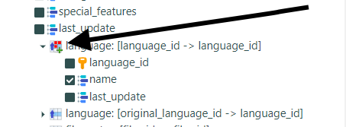

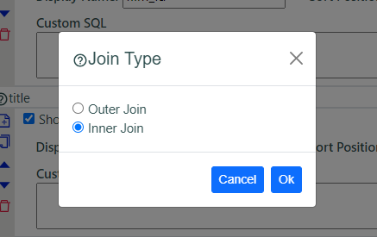

Related Table Display
Related tables are displayed in the following format in the table tree:

to_table_name[to_column1→from_column1, to_column2→from_column2…]

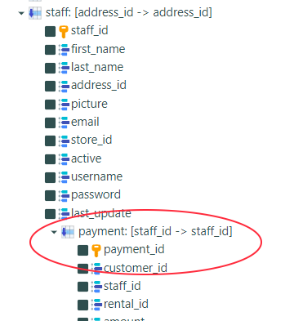

Query Design Data Tab
For each column selected in the data select tree pane an associated column configuration panel will display in the Data tab.

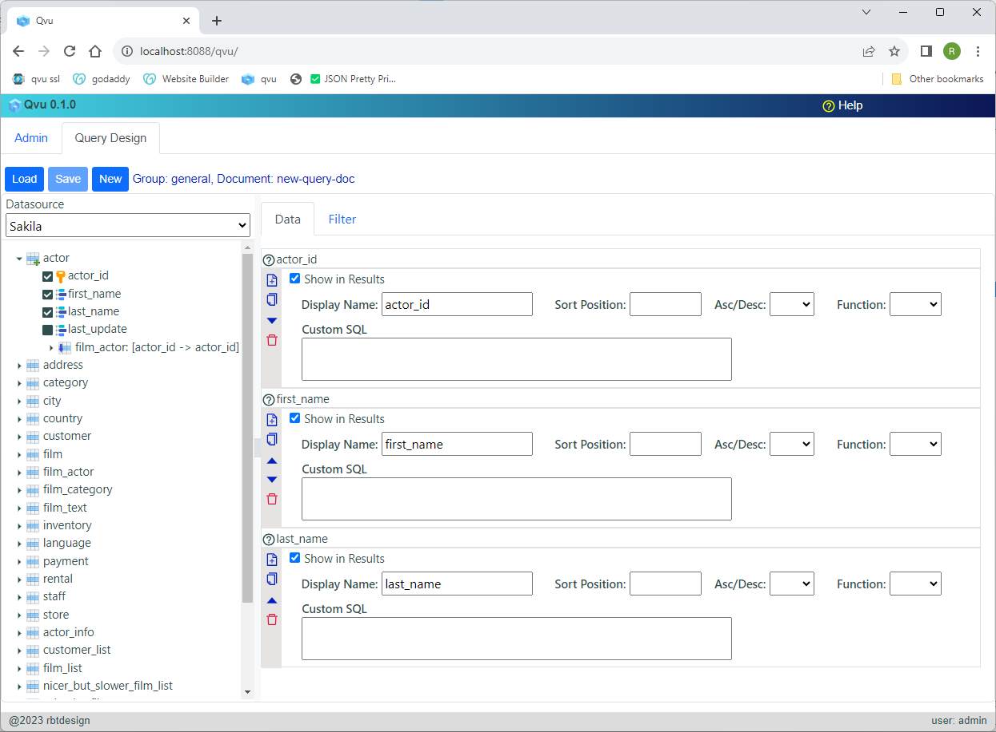

Data Column Configuration Description
The user can apply various options to each selected data column. In addition, the column configuration panel support deleting, moving and duplication the associated column.

Data Column Configuration Panel Icons
Below you will find a description of the icon functionality on panel:
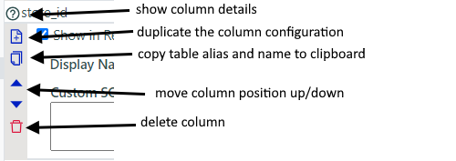

Column Details Icon
Clicking the column details icon display more information about the column:
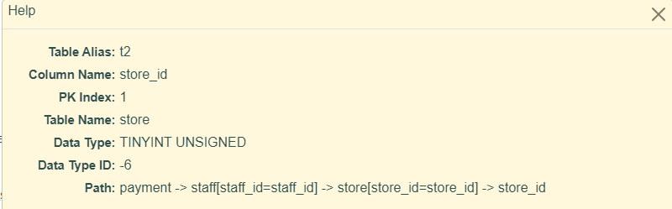

Duplicate Column Icon
Clicking the duplicate column icon will create a duplicate column definition which the user can then configure in a different manner than the original. This allows for the same column to be selected in different ways in final select statement.
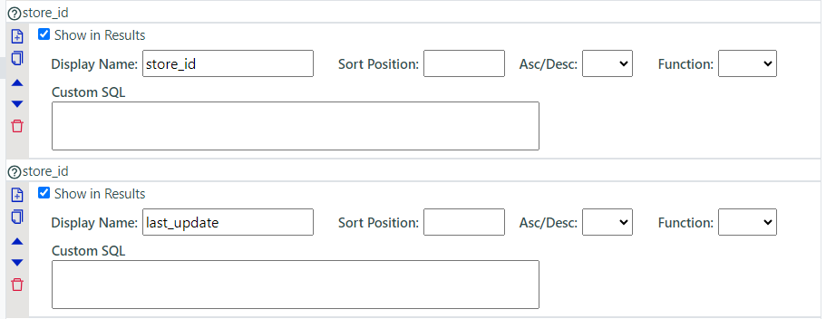

Copy Table Alias and Name to Clipboard
This is a useful tool when making a custom SQL entry. A custom SQL entry must contain database-specific valid SQL with the associated raw base table aliases and column names. Name. Clicking this icon will copy this name to the clipboard – for example: t2.store_id

Move Column Position
The generated SQL select column order will be in the order of the columns listed in the Data tab. To change this order the user can click the associated arrow icons to move a column up and down. The column can also be dragged by clicking on the name bar and dragging the column configuration to the desired position.

Data Column Entry Fields
The entry fields are described in the table below:
Display in Results | This is checked by default. If unchecked, column is still available for filtering but will not appear in the result set data
Display Name | This will be the column name return from the SQL query – will become the “as” clause in the select.
Sort Position | Enter an integer sort position greater than 0 here if you want to sort by this column
Asc/Desc | Select sort direction – defaults to Asc
Function | Aggregate functions can be applied to the column based on type. Select the function as desired. Qvu will handle building the appropriate Group By and Having clauses
Custom SQL | The user can enter database-specific SQL here to perform any query operation desired. The entered SQL must be valid for the database type. This is where the Copy Table Alias and Name clipboard functionality discussed above comes into play. The user can sum multiple columns, apply database-specific functions etc. When this field is populated the actual column associated with the panel is ignored and the select SQL is replaced by the custom SQL entered.

Query Design Filter Tab
The filter tab allows the user to build the SQL where clause. In order to execute a query it must have a filter configuration – no open-ended queries are allowed.
To add a filter column select the desired column from the drop down and click the Add icon:

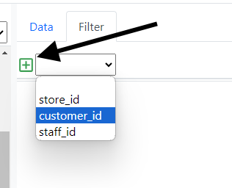

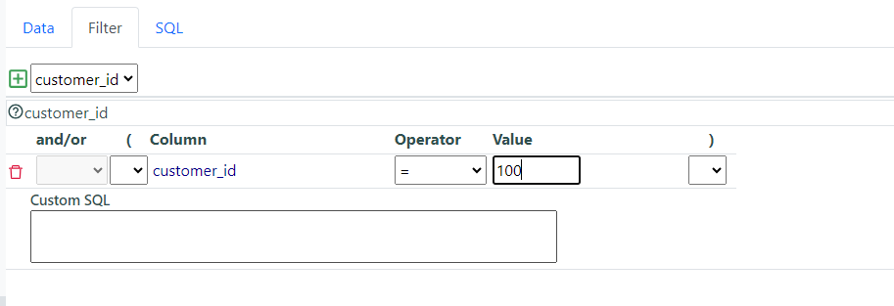
The user can select parenthesis and the and/or operators as required. If the user hovers over the filter select drop down additional column details will display:

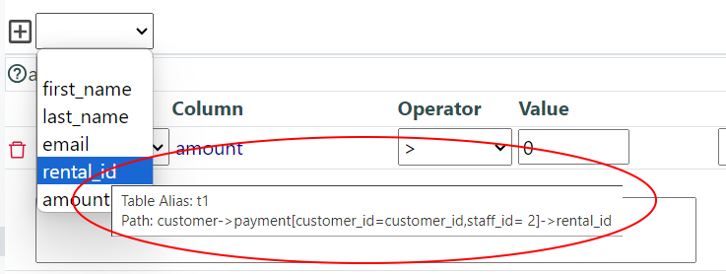

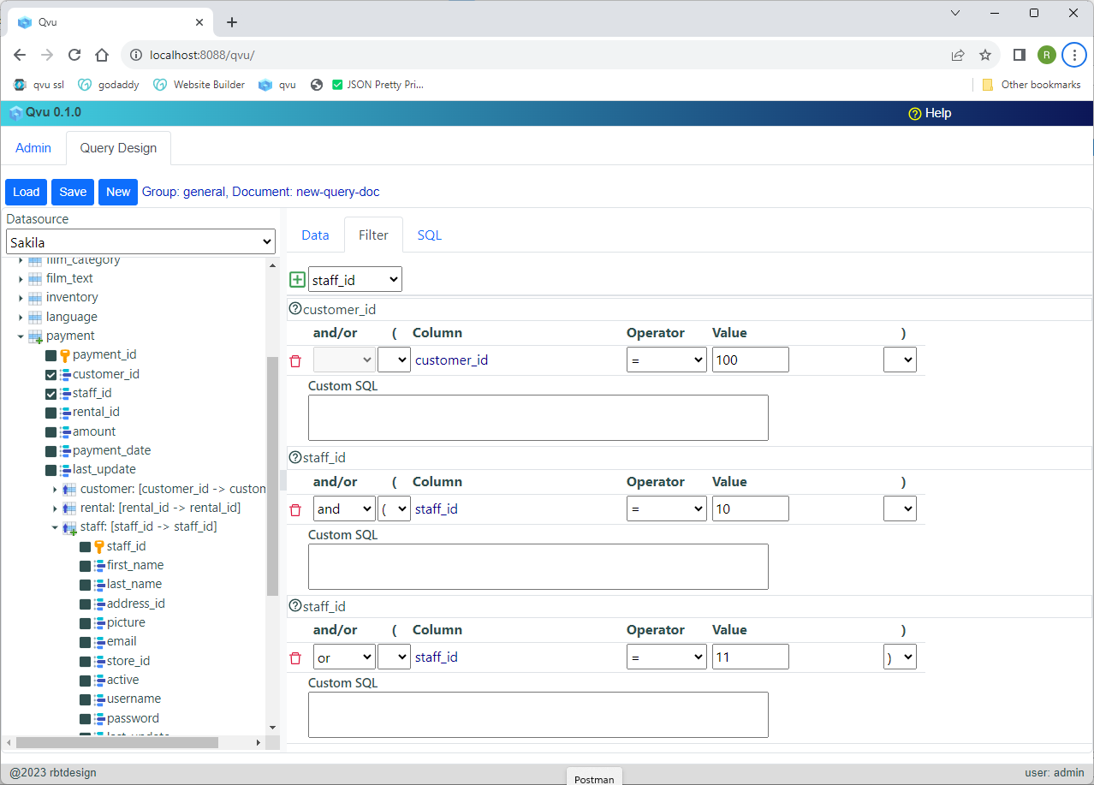
The available comparison operators are shown below:
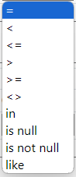

When entering comparison operator enter the value only – no quotes are required. When using the “in” operator, enter a comma-delimited list of values. When using the “like” operator enter the appropriate wildcard characters (% and _).
Similar to the data select entry, custom SQL can be entered in the Custom SQL field – see the discussion of the custom SQL entry in the Data Column Entry Fields table for more information.

Query Design SQL Tab
Once filter entries have been created the SQL Tab becomes visible

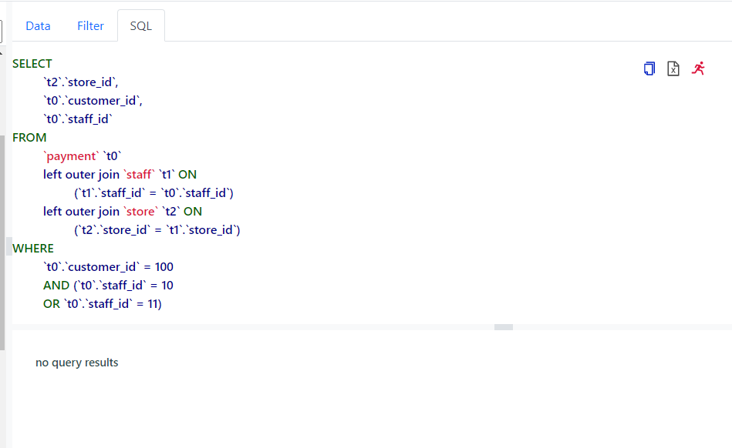
The SQL tab is a split pane with 2 sections – the upper section displays the generated SQL and action icons and the lower pane displays the query results after the query is run.

SQL Tab SQL Pane
The SQL Pane displays the database-specific generated SQL statement as well as action icons. The icons functions are described below:
Clicking this icon will copy the SQL statement to the clipboard
Clicking this icon will export query results to excel – icon is disabled if no
results available.

Clicking this icon will run the query.

When the run icon is clicked, the query will execute and results will populate the results table in the bottom SQL Tab pane:
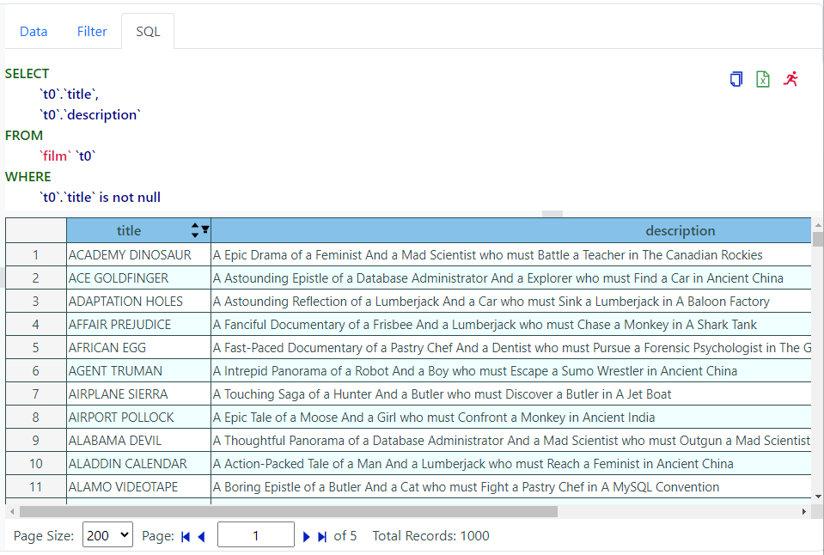

Filter Values Prompts
When a defined filter value is left blank in the Filter Tab the user will be prompted for entry when running the query – for example if the user creates this filter:

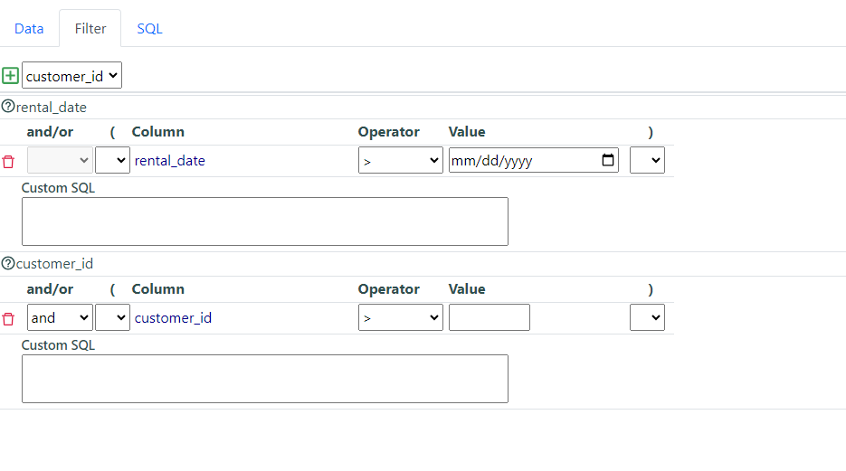
Then when the run icon is clicked the Run query value entry dialog will display to prompt for user input:

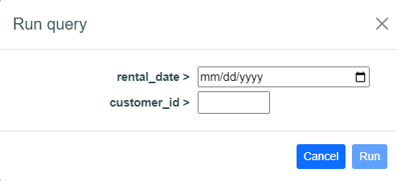

Saving a Query Document
Once a user has created a query the query can be saved as a re-usable Query Document. To save a query click the Save button

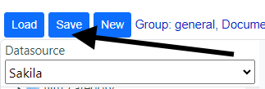

to display the Save Document dialog:

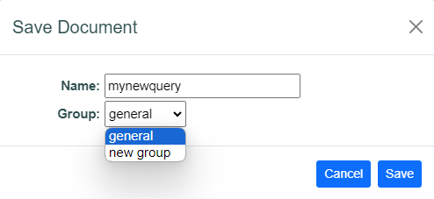

Enter a unique name for the new Query Document and select an appropriate Document Group then click Save. If document saves successfully you should see a success message:



Loading a Saved Query Document
To load a saved query document click the Load button to display the Select query document dialog, open the appropriate document group and select the desired document.

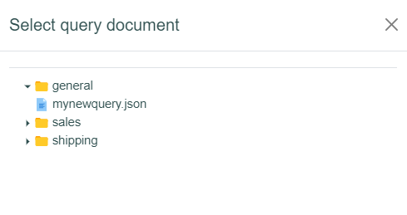

The Query Design tab should populate with the selected query document setting.
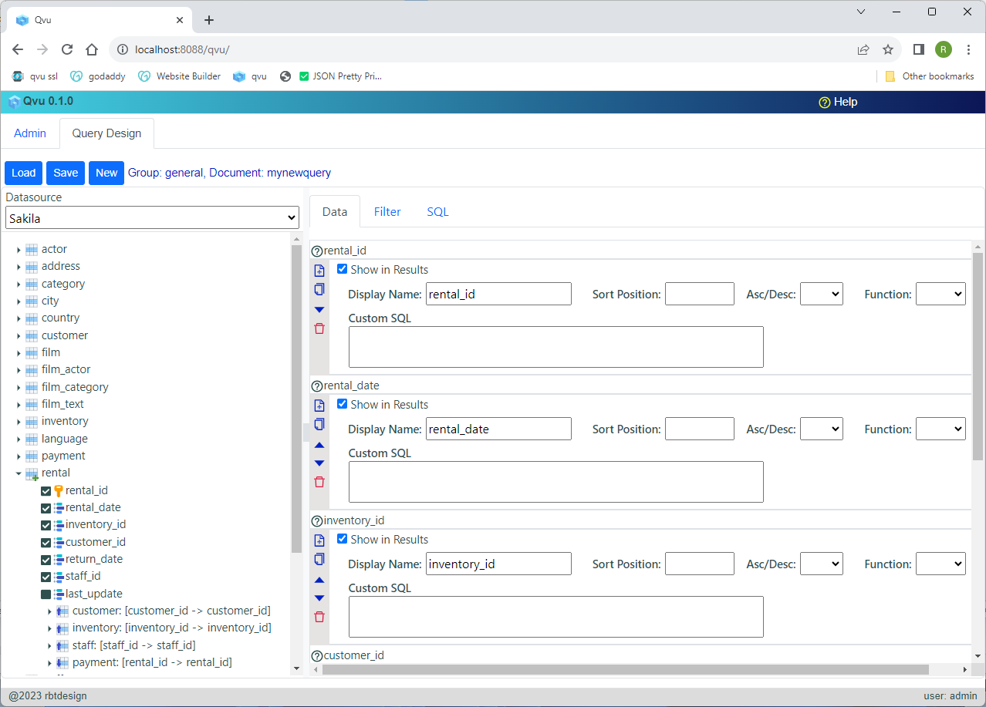

REST API
The Qvu Data Service provides REST API endpoint to execute created query documents. The requesting application must successfully authenticate when using the API. For Basic Auth this consists of sending an appropriate username and password in the header. For OIDC this is dependent open the identity provider.

The API calls to retrieve data are shown below:

- <qvu-hostname>/qvu/api/v1/query/run/json
- <qvu-hostname>/qvu/api/v1/query/run/json/objectgraph
- <qvu-hostname>/qvu/api/v1/query/run/tabular

The /run/json endpoint return results as an array of flat JSON records. The /run/json/objectgraph endpoint returns a json object graph with parent child relationships.
and the /run/tabular returns a JSON object with tabular results in the following format:
{
"rowCount": 100,
"header”: ["header1”, "header2”…],
"columnTypes”: [jdbcType1, jdbcTy2…],
"initialColumnWidths”: [column1Width, column2Width…],
"data”: [[row1col1, row1col2…], [row2col1, row2col2…]]
}

The fist data column in the tabular results will hold the row number.

All endpoints expect a POST request with a JSON body in the following format:
{
"documentName": "query-document-name",
"groupName": "query-document-group",
"user": "current-user-name",
"parameters": [someIntValue, “someStringValue”...]
}

Runtime parameters are inserted by position based on the where clause of the query document. Any filter value left blank the query design will require that runtime parameters be passed. Dates should be passed as a string in the format yyyy-mm-dd. In addition, current-date replacement variables can be passed in the following ways:

$dt
this value will be replaced with the current run date.
$dt +/- some number
this allows for date math: current run date + or minus some number of days.

Custom Security
To implement a custom security scheme in Qvu Data Service follow the following steps:
- Clone the qvu-client-utils git project found at:
https://rbtucker@github.com/rbtucker/qvu-client-utils.git
- Build the project with “mvn clean package”
- Install the qvu-client-utils-1.0.0.jar in your local git repository using the following command:
mvn install:install-file -Dfile=qvu-client-utils-1.0.0.jar -DgroupId=org.rbtdesign -DartifactId=qvu-client-utils -Dversion=1.0.0 -Dpackaging=jar
- Build a custom service class that implements the org.rbtdesign.qvu.client.utils.SecurityService interface from the library built in step 3. Make sure that the maven dependency for the qvu-client-utils is set to scope “provided”
- An example project can be found at https://rbtucker@github.com/rbtucker/qvu-custom-security-example.git
- Copy the SecurityService implementation jar to the <qvu-reposititory-folder>/extlibs
- Now start the qvu data service with the system parameter:
-Dloader.path=<qvu-respository-folder>/extlibs

You can now enter your custom java class in the System Settings Custom Security Service field as shown below:

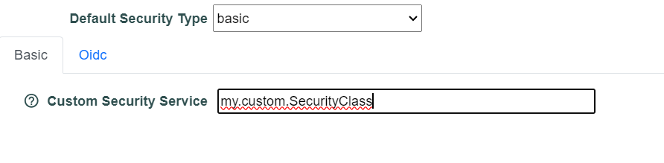
Restart the Qvu Data Service and the custom class should be used for user authentication.

Qvu Repository
The Qvu repository is where all the Qvu artifact and configuration is stored – the layout is shown below:
<repository-root>
|
|_____ config
|_____ documents
|_____ extlibs
|_____ help
|_____ logs

Below is a description of each folder:

Qvu Repository config Folder
The config folder holds the following configuration files used by the Qvu Data Service:
- application.properties – contains basic server configuration information such as root context, SSL properties and server port
- qvu-datasources.json – contains the configured Qvu datasources
- qvu-document-groups.json – contains the configured document groups
- qvu-document-schedules.json – contains configured document execution schedules
- qvu-language.json - contains the Qvu language text setup
- qvu-security.json – contains the authentication setup and the configured users and roles
- scheduler.properties – hold the scheduler email setup from the System Settings Scheduler tab

Qvu Repository documents Folder
The documents folder contains query documents stored by group name in the following layout:
documents
|____ group1
| |_____query
| doc1.json
| doc2.json
|____group2
|_____query
doc1.json
doc2.json
|
|_____user
|
|_____ username
|
|_____query
doc1.json
doc2.json

Qvu Repository help Folder
Contains Qvu help and getting started documents. Document names are in the format qvu-gettingstarted-<language-property>.pdf and qvu-help-<language-property>.pdf. The default files are qvu-gettingstarted-EN-us.pdf and qvu-help-EN-us.pdf. Other language help files can be added as desired. If no file for a particular language exists then the EN-us version will be used.

Qvu Repository logs Folder
Holds the Qvu server logs and archived logs

Language Support
The Qvu Data Service is designed to support multiple languages. The base language file is found in the Qvu repository at config/qvu-language.json. A snippet of the file is shown below:
{
"en-US": {
"?": "?",
"Add datasource": "Add datasource",
"Add group": "Add group",
"Add role": "Add role",
"Add role": "Add role",
"Add user": "Add user",
"Add user": "Add user",
"Admin": "Admin",
.
.
.

To add another language add the associated language property and replace the JSON value fields with the appropriate text. You can also modify the existing text to customize the UI display as desired.

The default help files are located in the Qvu repository under the help folder:
qvu-gettingstarted-en-US.pdf
qvu-help-en-US.pdf

Custom help files can be created with the appropriate language property included in the name and those will display based on the language property provided by the browser.

