
Qvu
Getting Started
- Ensure java 8 or higher is installed on the server that will run Qvu.
- Download the Qvu qpplication from http://myqvu.com
- Create the server-side folder that will be house the Qvu repository.
- Start the Qvu application by running the following command:
java -jar qvu.jar
- Once the application starts, pull up the initialization page by going to
http://localhost:8088/qvu
and logging in with:
username: admin
password: admin
- the initialization screen shown below should display:
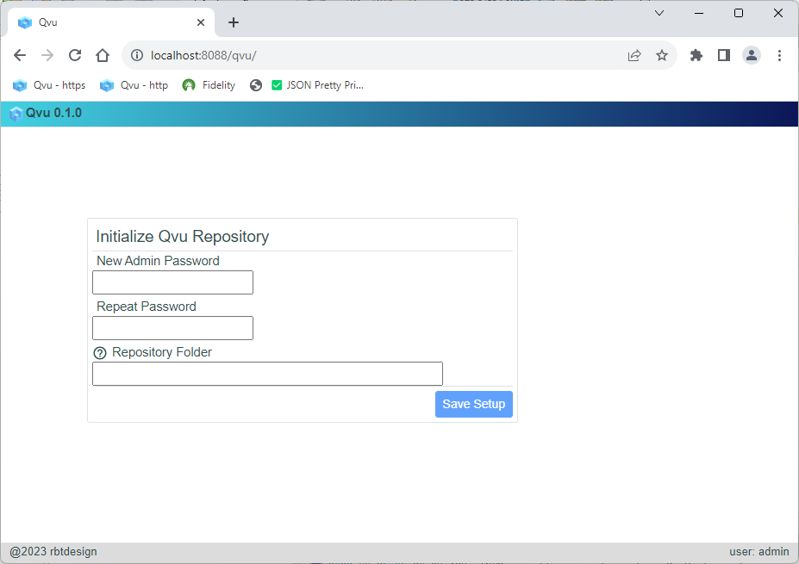
- Enter a new admin password and the repository folder created in step 3.
- Click “Save Setup” – if Qvu was successfully initialized you should see a message similar to the following:
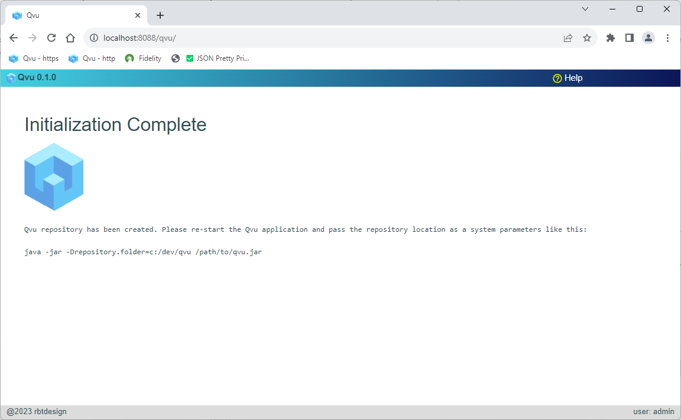

- Once initialization is complete, stop the application and restart passing the repository folder location as a system parameter as follows:
java -jar -Drepository.folder=/my/repository/location qvu.jar
- Pull up the application at http://localhost:8088/qvu, login with username=admin and
password=<new password> and you should see the administration page displayed:

By default basic authentication is used and users and roles are stored as json in the file <repository.folder>/config/qvu-security.json. Qvu supports SAML, OIDC and Basic authentication. You can change this setup by clicking the “System Settings” icon in the admin tab.
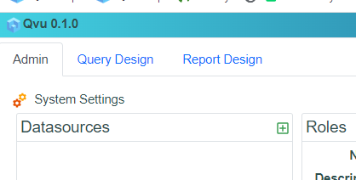

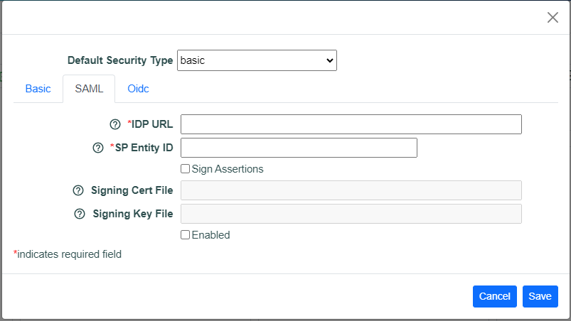

Once changed you will have to restart the application. You can also implement your own customized security. See the help documentation for more information on this process.
If you wish to enable SSL, modify the <repository.folder>/config/application.properties file. Uncomment and fill in values for the following properties:
#server.ssl.key-store=
#server.ssl.key-store-type=
#server.ssl.key-alias=
#server.ssl.key-store-password=
#server.ssl.key-password=
Again, you will have to restart the application. You will probably also want to change the port property at the same time:
server.port=<desired https port>

