# Metadata Guide

Dägg and Janné, "Money, Happiness and the Midlife Crisis"

This study uses data from two original data files, which are preserved in this documentation with the names *OriginalPEW.sav* (originally named as *Pew GAP final 44 country dataset 1.1sav.sav* from the source) and *OriginalWDI.xlsx* (a name given to the download data from the WDI).

# Supporting information for original-pew.sav

Bibliographic citation:

Pew Research Center Global Attitudes Project (2002a). SUMMER 2002 SURVEY DATA: 44- Nation Survey Conducted July 2-October 31, 2002 [Dataset]. Accessed at <http://www.pewglobal.org/category/datasets/2002/>, June 1, 2014.

Accessing the data:

A zipped folder containing the data file used for this paper as well as supporting information can be downloaded from the URL given above. The data file contained in the zipped folder is named "Pew GAP final 44 country dataset 1.1sav.sav" [*sic*]. In the documentation preserved with this paper, the name of this file has been changed to *OriginalPEW.sav*.

No DOI has been assigned to this data set. Additional information:

Definitions and coding of all the variables in original-pew.sav can be found in a document named "Pew GAP Survey details 1.1", a copy of which can be found in the **Metadata/** folder located within the **OriginalData/** folder of this documentation. This document was included in the zipped folder containing the original data file that was downloaded from <http://www.pewglobal.org/category/datasets/2002/>on June 1, 2014.

# Supporting information for original-wdi.xlsx

Bibliographic citation:

World Bank (2014). World Development Indicators On-line. Accessed at <http://data.worldbank.org/data-catalog/world-development-indicators>, June 1, 2014.

Accessing the data:

This data file was extracted from the World Development Indicators database using a menu-driven interface accessible at the above URL. From that interface, we selected data for two series, 7 countries and one year:

Series: GDP per capita (in current [2002] US dollars)

Government consumption expenditure (percentage of GDP) Countries: China, India, Indonesia, Jordan, Pakistan, Russian Federation, US

Year: 2002

These data were downloaded in an Excel workbook that is preserved in this documentation with the name *OriginalWDI.xlsx*

No DOI has been assigned to this data set. Additional information:

The following definitions of the two variables we extracted from the WDI were downloaded interactively while the data were being extracted from [http://data.worldbank.org/data-](http://data.worldbank.org/data-catalog/world-development-indicators)  [catalog/world-development-indicators](http://data.worldbank.org/data-catalog/world-development-indicators). These definitions are reproduced here in the form of images that we copied from the WDI website.

GDP per capita

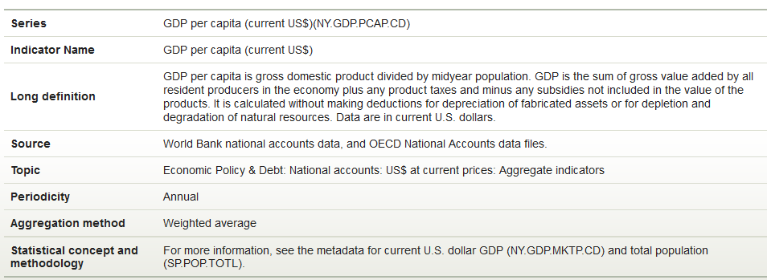

General Government Consumption Expenditure

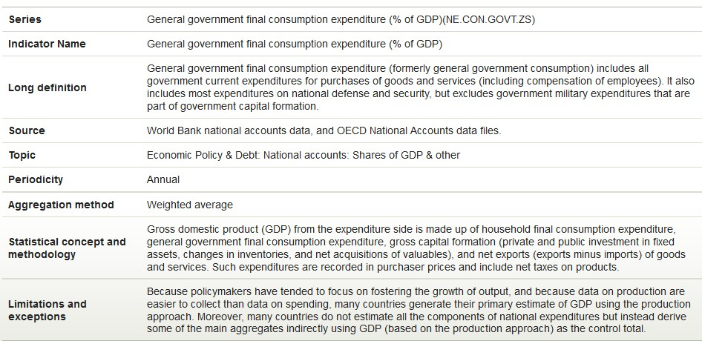

Richard Ball 2016-09-08

2