University of California, San Diego Extension

Guangzhou University

Summer 2019 GIS Program

**LAB 7a – Map Hurricane Storm Surge**

**Summary**: Use global elevation data to predict how storm surges will flood coastlines in New York City. You will utilize the Living Atlas to download data and perform analysis using a Digital Elevation Model (DEM). This type of analysis can be repeated anywhere in the world and as noted can be used to study future sea level rise scenarios. Additionally, you will export the results in GeoJSON format, which is a very popular open-source format for sharing GIS data. Steps for Lab include:

* Export an elevation raster from the Living Atlas Terrain layer.
* Use the Con tool to find those areas that are below a certain elevation.
* Map a storm surge
* Map flooding from Hurricane Sandy
* Map a 9-meter storm surge

**Deliverables**: Flood map and GeoJSON File (see below)

**Estimated Time**: 45 minutes

**Instructions:** Follow the directions in the case study [Map Hurricane Storm Surges](https://learn.arcgis.com/en/projects/map-hurricane-storm-surges/)

1. **Read about the case study and relevant datasets:**

* Storm surge information: [NHC website](https://www.nhc.noaa.gov/surge/)
* ArcGIS Pro Documentation: [Con Tool](https://pro.arcgis.com/en/pro-app/tool-reference/spatial-analyst/con-.htm)
* ArcGIS Pro Documentation: [JSON toolbox](https://pro.arcgis.com/en/pro-app/tool-reference/conversion/an-overview-of-the-json-toolset.htm)

1. **Find elevation data** (Help video: [Find elevation data](https://youtu.be/cBvz8V-snyA))

To map any kind of flooding, you'll need to know the elevation of the land in your study area. [Living Atlas](https://livingatlas.arcgis.com/) provides global elevation data that you can extract from to conduct your analysis.

1. **Export a raster** (Help video: [Export a raster](https://youtu.be/mzzXHJKZelY))

Next, you'll export a file-based raster from the Terrain imagery layer that only covers your area of interest, so you can perform analysis with it. Make sure to zoom into the city of New York and use the following settings in Export Raster:

* Clipping Geometry: Current Display Extent
* Cell Size: 10 (for X and Y)

The number of rows and columns need to be smaller than 5000 x 5000 – zoom in closer to decrease this number.

1. **Map a storm surge** (Help video: [Map a 3m storm surge](https://youtu.be/eexM1rsKB3M))

Now that you have elevation data, you can use it to find low-lying coastal lands and predict which areas might flood when hit with a hurricane.

1. **Map flooding from Hurricane Sandy** (Help video: [Map Hurricane Sandy inundation](https://youtu.be/6-D2ZH_GT14))

Compare the 3-meter storm surge map to a map of actual flooding from Hurricane Sandy. Note: the URL does not work (step 2) – this is one of the disadvantages to web mapping technology. I found the data outside of ESRI/ArcGIS after an internet search [here](https://data.cityofnewyork.us/Environment/Sandy-Inundation-Zone/uyj8-7rv5) – you will need to **export** the data from the website as either a KMZ or Shapefile and then import into ArcGIS Pro.

1. **Map a 9-meter storm surge** (Help video: [Map 9m storm surge](https://youtu.be/R9TttUgVWL0))

Map what such a large surge would look like in the present-day city. You will use the Con function again. This time use the following options:

Input conditional raster: Terrain.tif

Clause: Where Value is less than or equal to 9

Input true raster or constant value: 1

Input false raster or constant value: <Leave Empty>

Output raster: StormSurge_9m

Convert the resulting raster to polygon (Raster To Polygon tool).

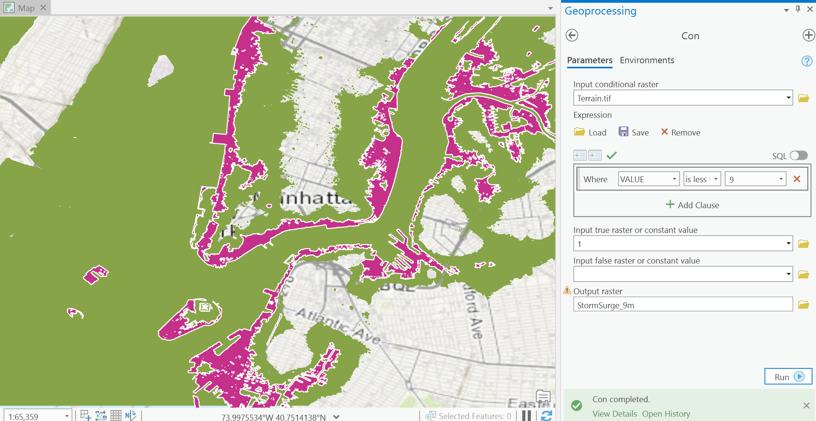

**Deliverables:**

1. **Deliverable 1: Map of flooding from Hurricane Sandy (step 5 above). Include a legend that clearly shows the 3-meter surge versus surge from hurricane Sandy.**
2. **Deliverable 2: Export a GeoJSON file of 9-meter storm surge feature polygon layer. Use the Features To JSON tool. Make sure to check the following options:**

* **Output to GeoJSON**
* **Project to WGS_1984 (the source data are not in lat/lon coordinates)**

**You can check the results of the output GeoJSON file** [here](http://geojson.io/)**.**