Assignment 9.2

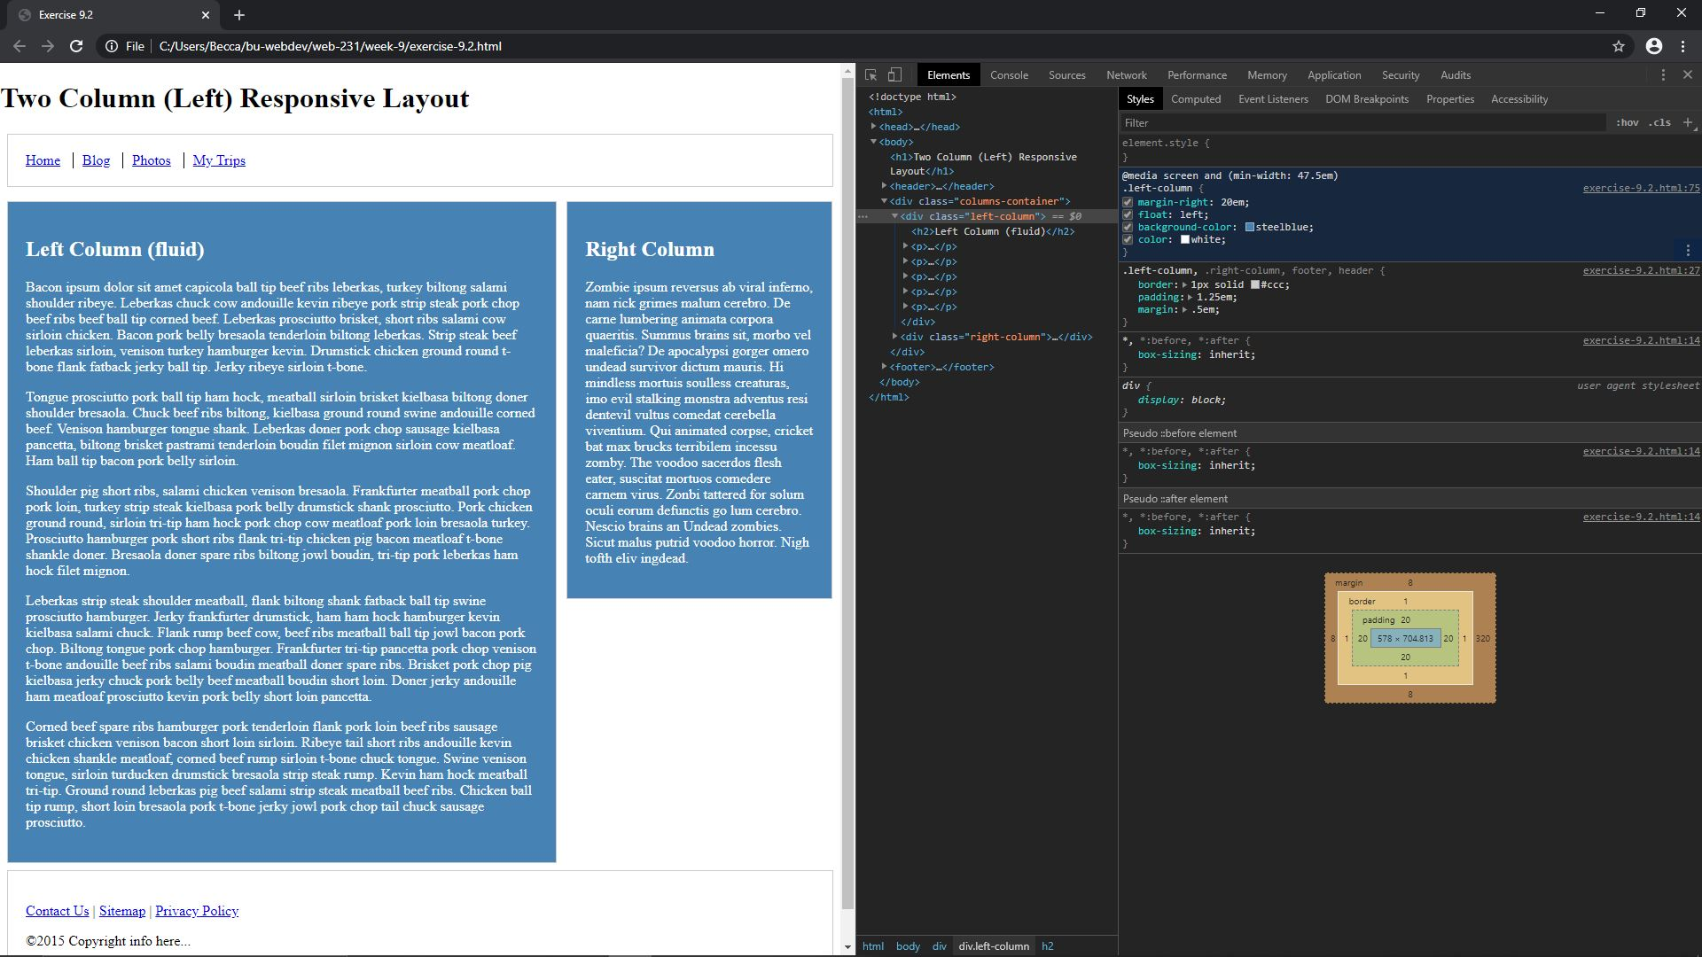

See below for bigger picture

