Assignment 9.3

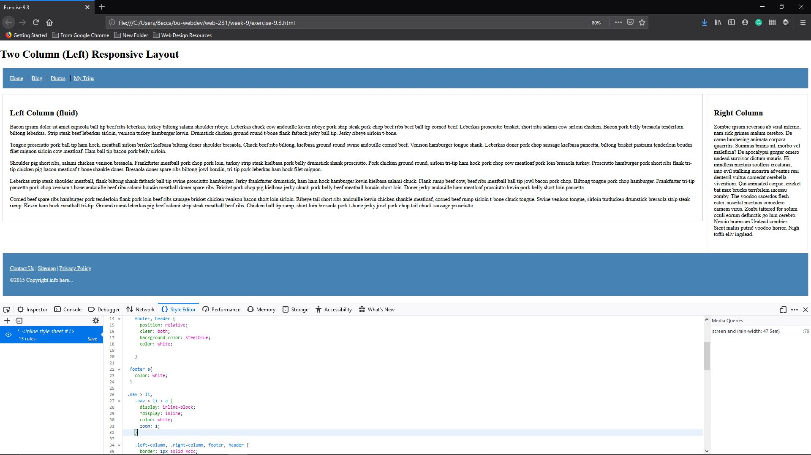

See below for bigger picture

