**Unlet Assignment 1.3**

*Becca Buechle*

*July 7, 2020*

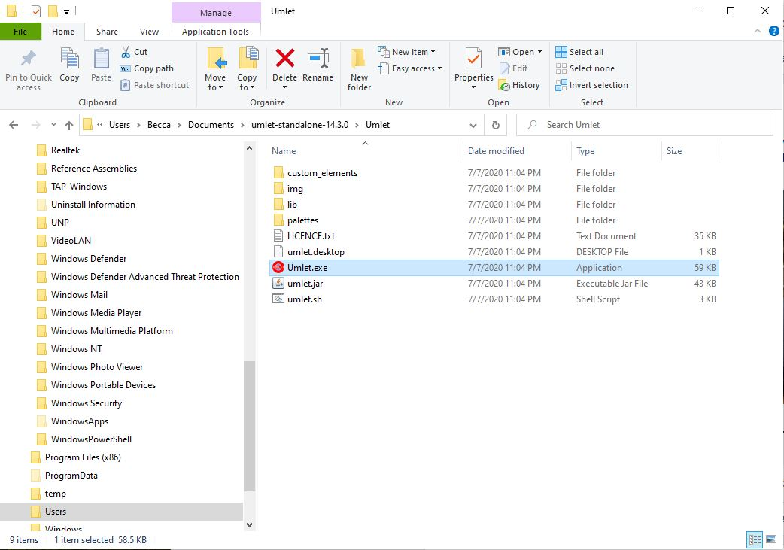

(See below for next)

