**Assignment 1.4 Data Models**

*Becca Buechle*

*July 8, 2020*

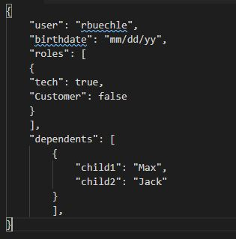

*(See Below)*

