**Assignment 2.2 NodeShopper ORD**

*Becca Buechle*

*July 14, 2020*

*ORD Chart*

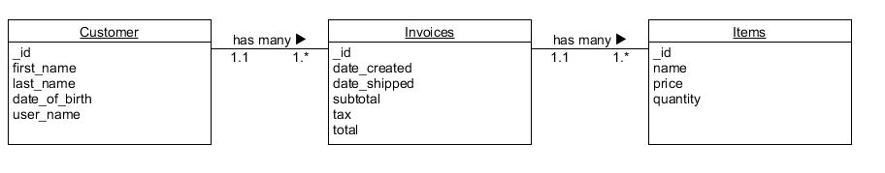

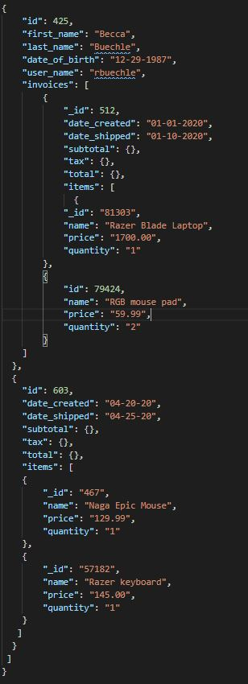

*NoSQL Data Structure*