Assignment 3.2 Node Security

*Becca Buechle*

*July 21, 2020*

**Business Rules**

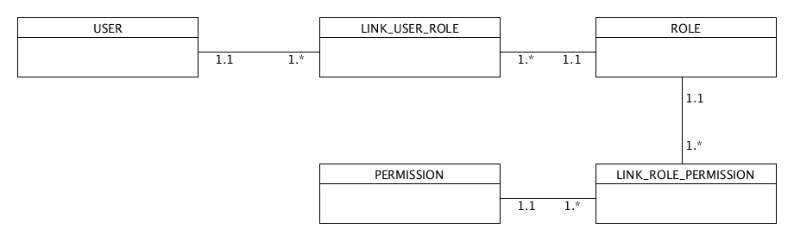

A user can have many roles

A role can be linked to many users

A permission can be linked to many roles

A role can have many permissions

A user can have many permissions

