Assignment 3.3 Node Book Co.

*Becca Buechle*

*July 21, 2020*

*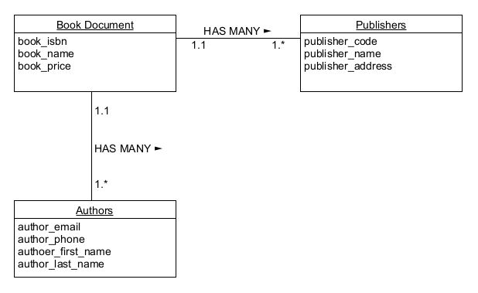*

*(See below)*

*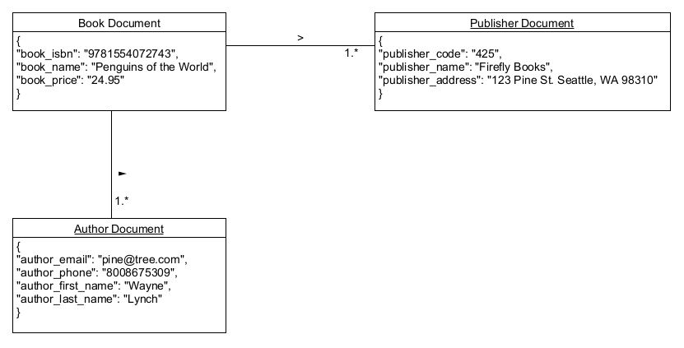*

*(See below)*

*