Assignment 4.2

*Becca Buechle*

*July 27, 2020*

Install

*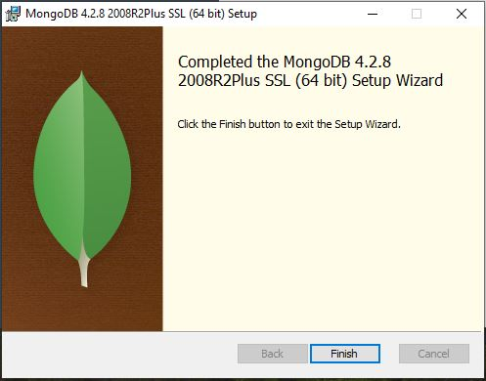*

*Website MongoDB*

*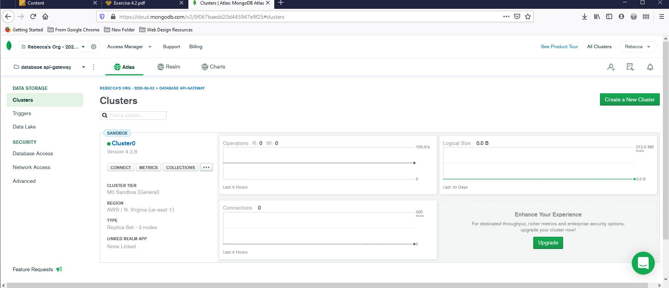*

*App*

*