Assignment 4.3

*Becca Buechle*

*July 27, 2020*

helloWorld

*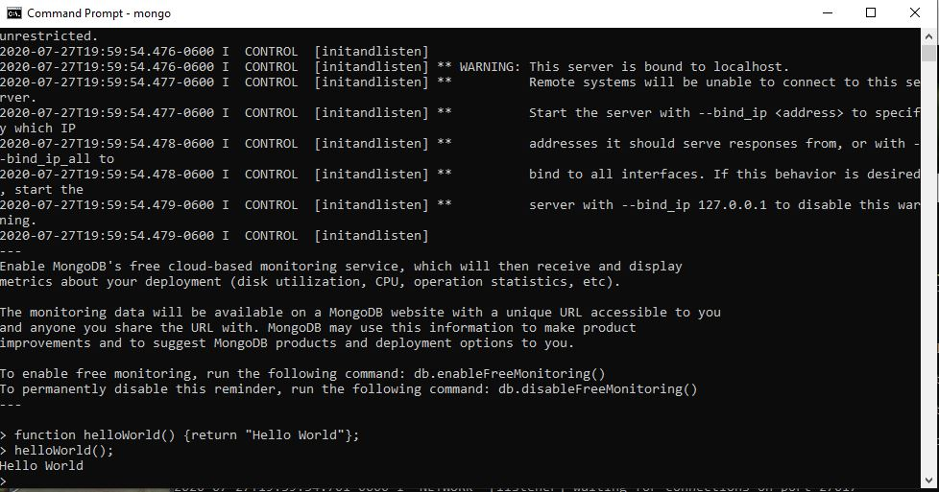*

myWorld

*