Assignment 4.4

*Becca Buechle*

*July 27, 2020*

*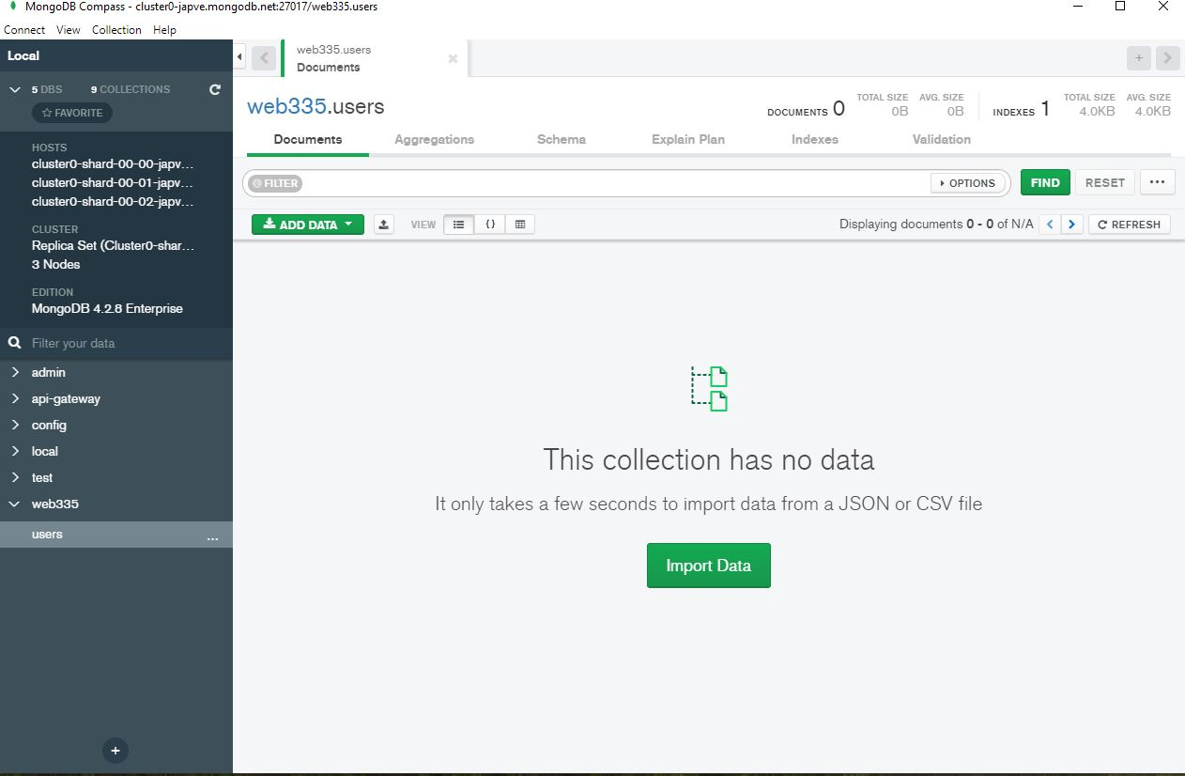*

*(See Below)*

*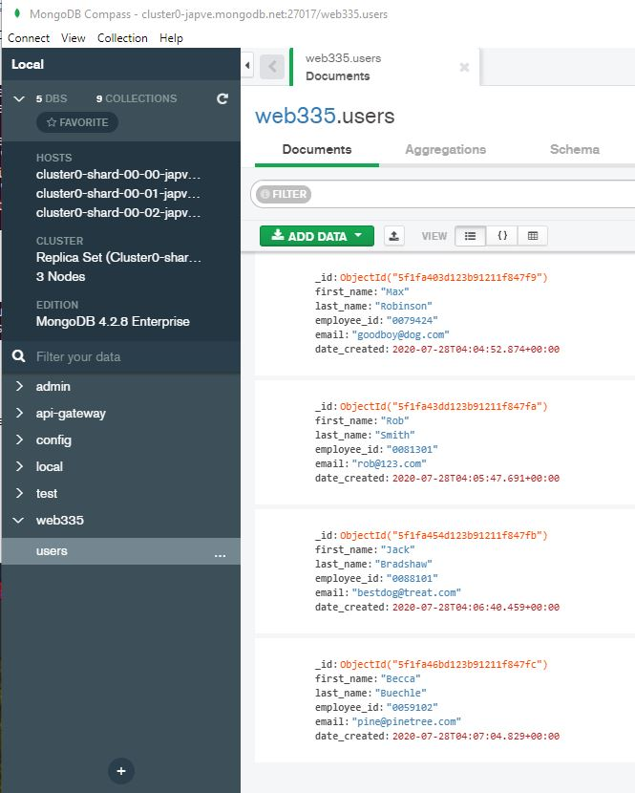*

*(See Below)*

*