Assignment 5.3

*Becca Buechle*

*August 3, 2020*

**First findOne()**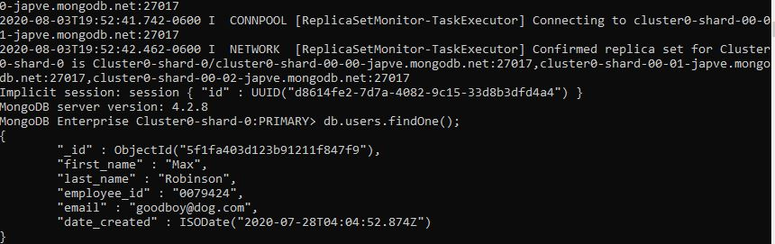

**update() **

**Second findOne()** 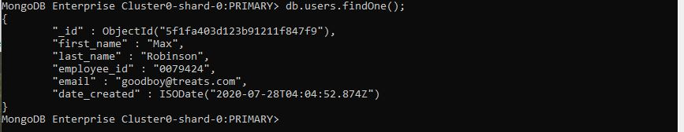

**(See Below)**

**Updated on MongoDB**

