Assignment 5.4

*Becca Buechle*

*August 3, 2020*

**remove()** 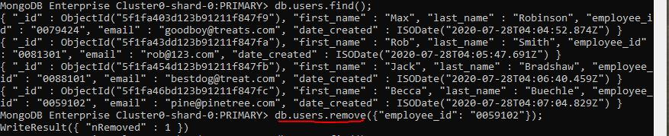

**find()** 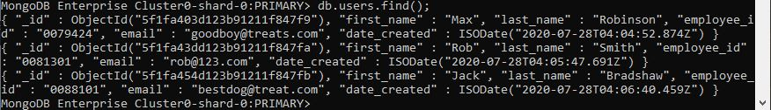

**MongoDB (see below)**

