Assignemnt 8.2

*Becca Buechle*

*August 25, 2020*

*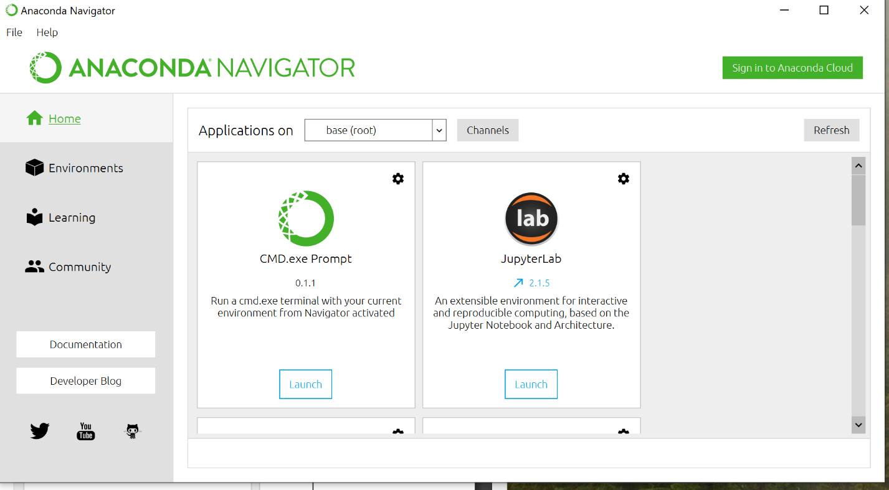*

*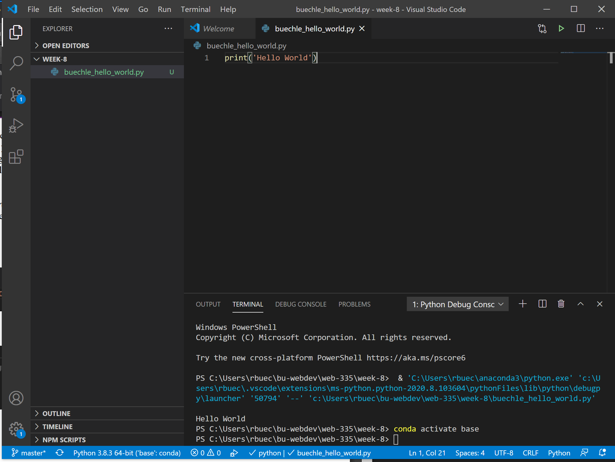*

*Ran without debug but it still debugged.*