**Assignment 8.4**

*Group Name: Rainy Day Coder*

*August 26, 2020*

**Wireframe (based on user stories)**

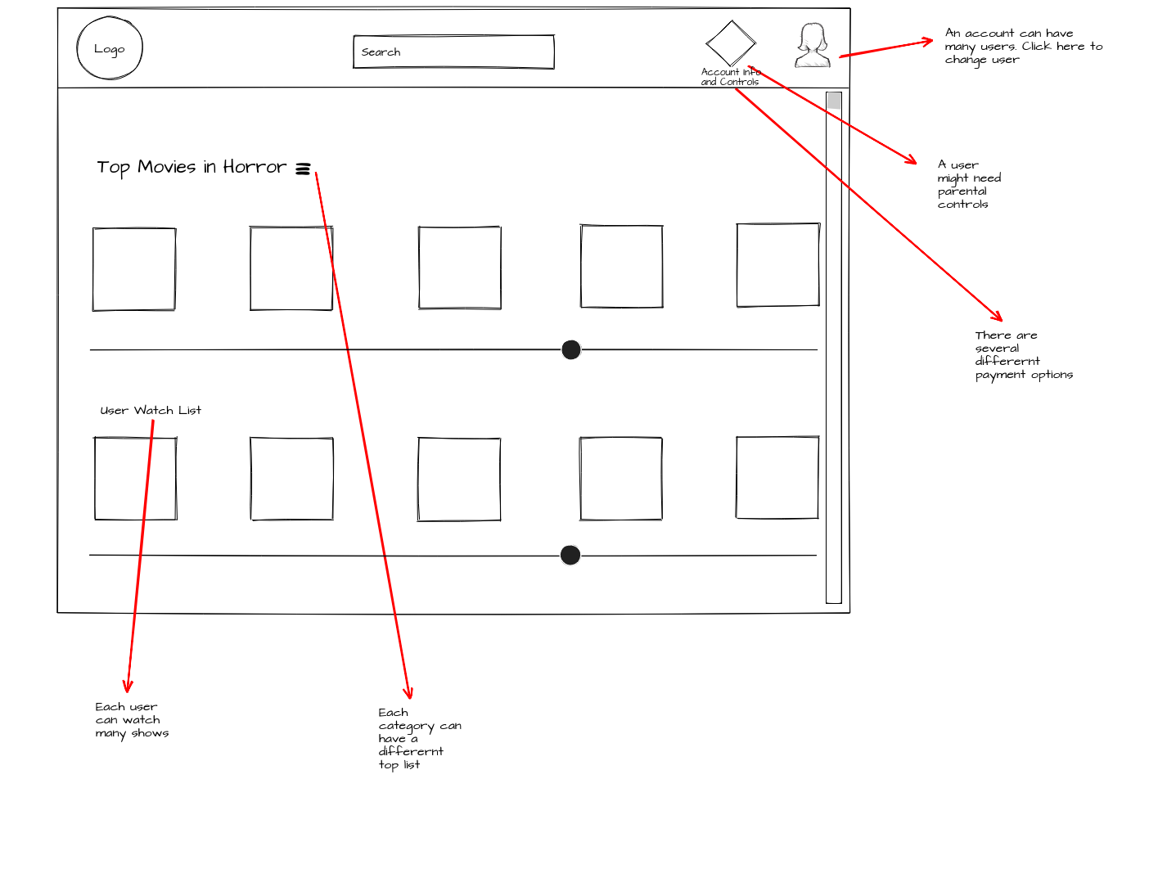

**Business Rules (based on identified user stories and wireframes)**

1. As a product user, I need an application that will allow me to setup parental controls so that I can make sure my child isn’t watching something they shouldn’t.

* A user can implement many parental controls
* Each child account can be limited by many different controls

1. As a product user, I need an to be able to save titles to a watch list so that I can go back to them later.

* A show/movie has a title
* A show / move has a description

1. As a product user, I need profiles so that our family can have separate saved list of what they are watching.

* An account can have many users
* Each user can watch many different shows or movies

1. As a product user, I need different payment options so that I can setup my own account with the payment method I have.

* There are many different users
* There are many different payment methods

1. As a product user, I need to be able to have more than one user watching at a time so that my kids can watch something as so can I at the same time.

* There are many families with more than one person
* Some users need to be able to watch on several devices at one

**ORD (based on business rules)**

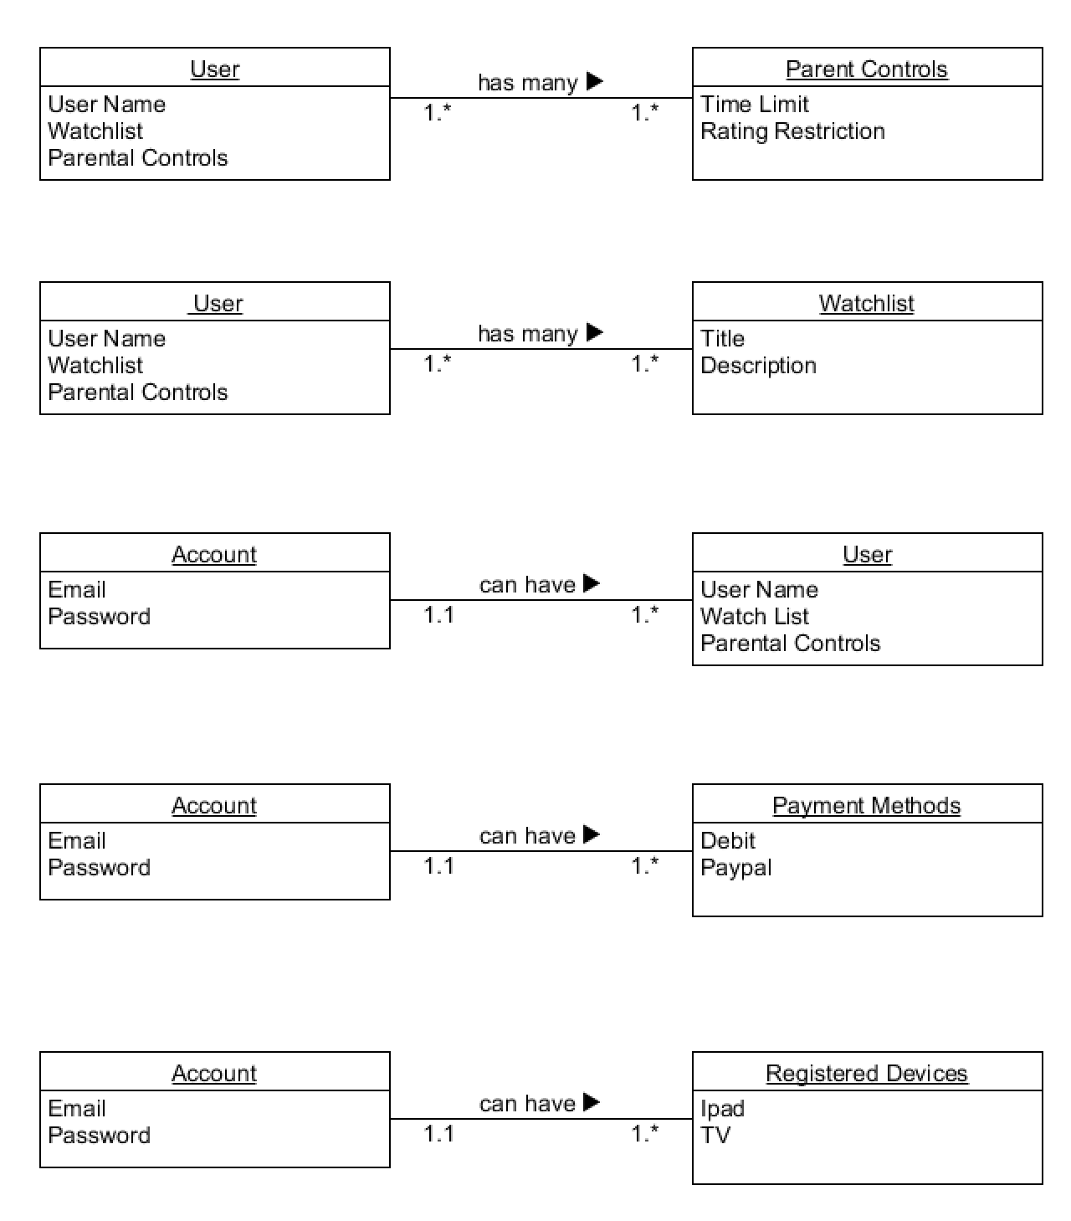

**Document Model**

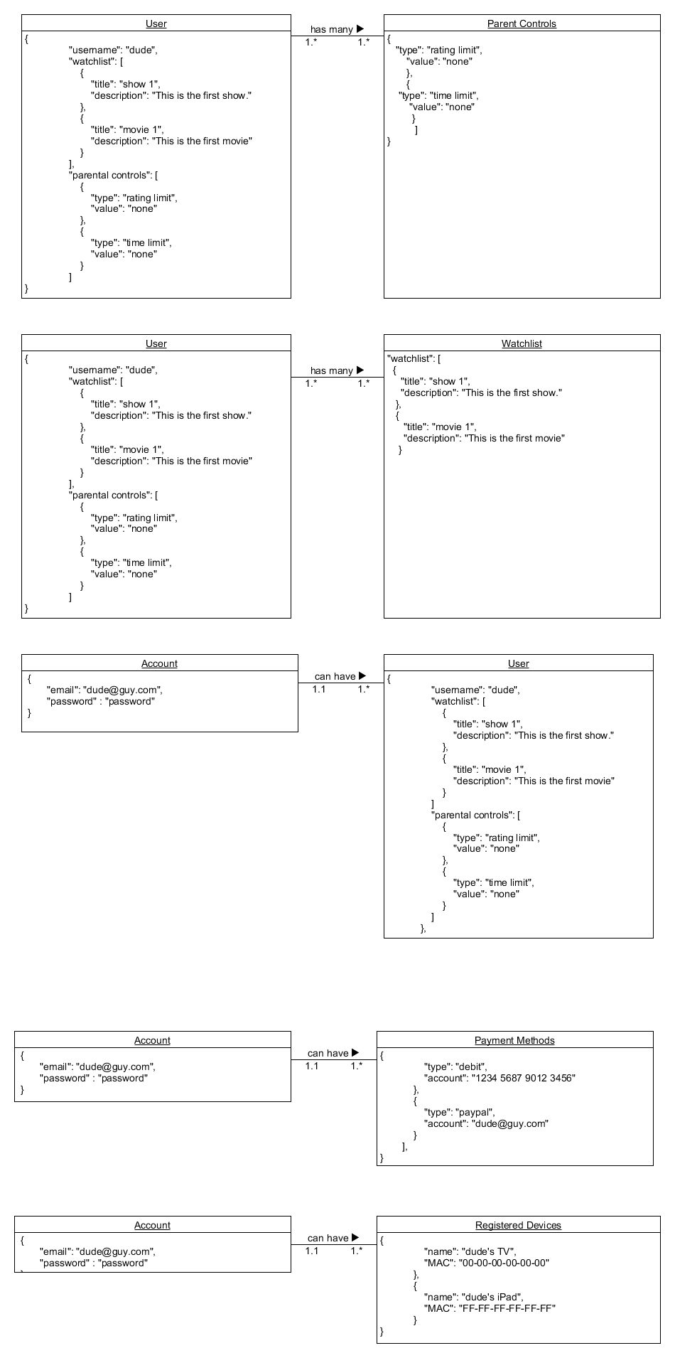

**JSON structure (Document model to JSON)**

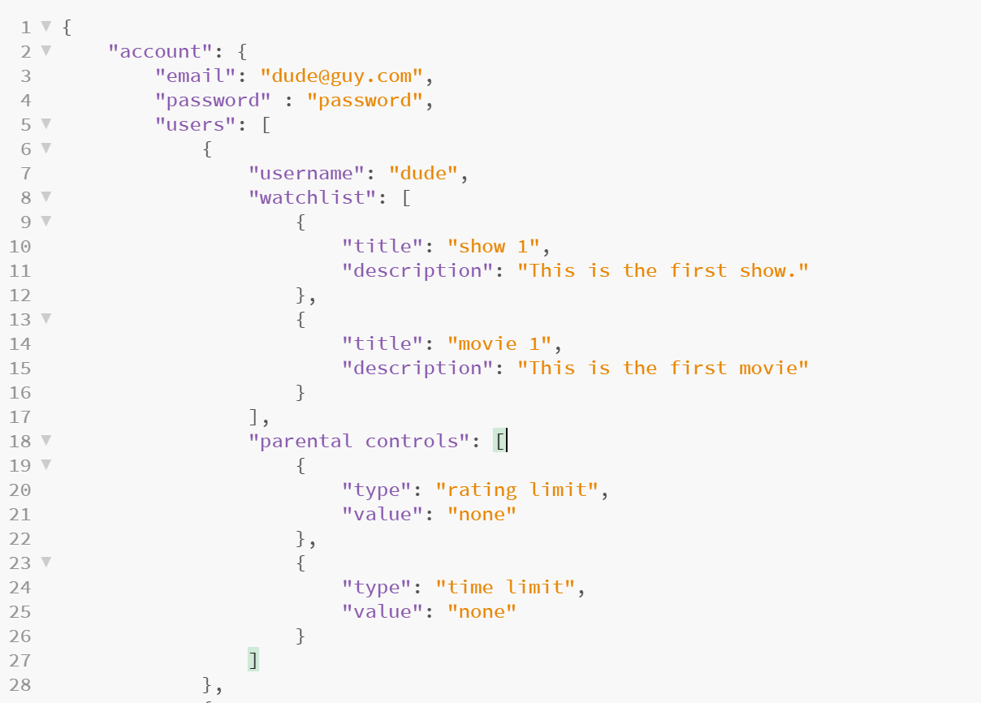

**(continued below)**

