For this week’s discussion board assignment, research application and resource state and answer the following questions:

 For questions one and two, keep the explanations concise and readable to a non-technical person.

1. **What is application state?**  The application state is where the application resides meaning where its being ran from and where the memory is stored for the application. (Microsoft.)
2. **What is resource state?** The resource state is the current state of a resource that is located on the server at any point of time. It what we get as a response from the server. (Fielding, R. )
3. **Create two simple diagrams depicting the flow of application and resource state.**

(see below)

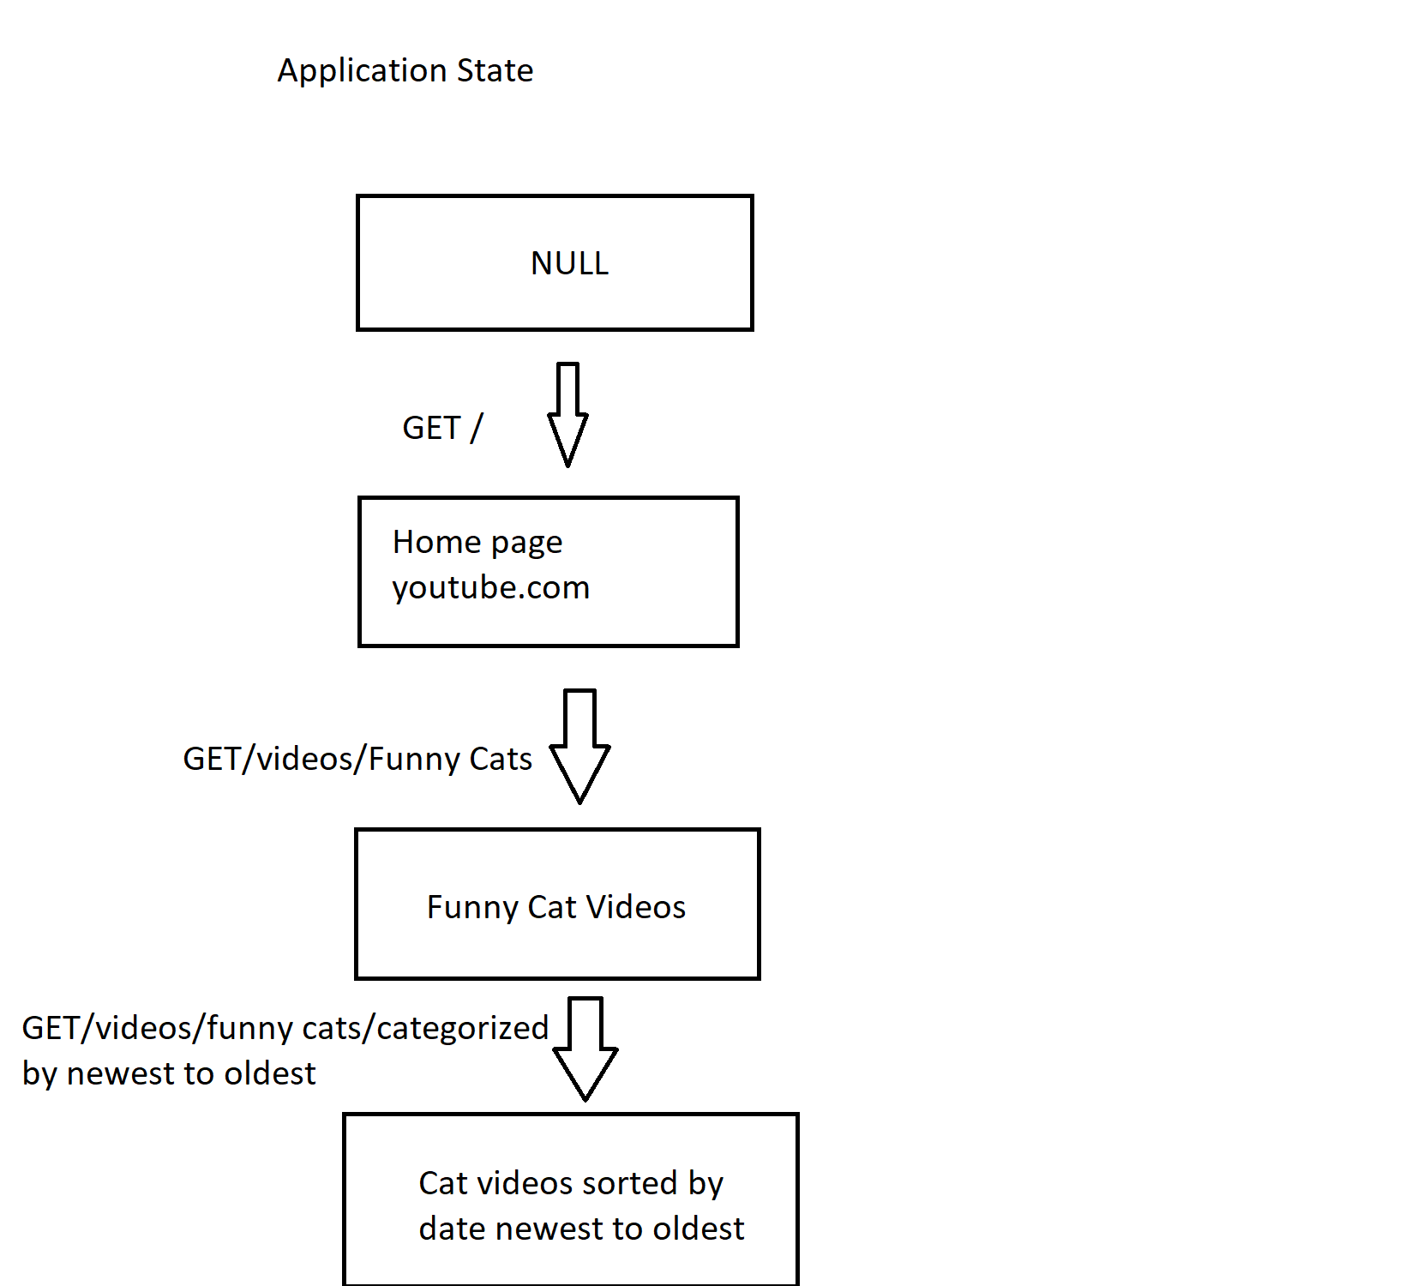

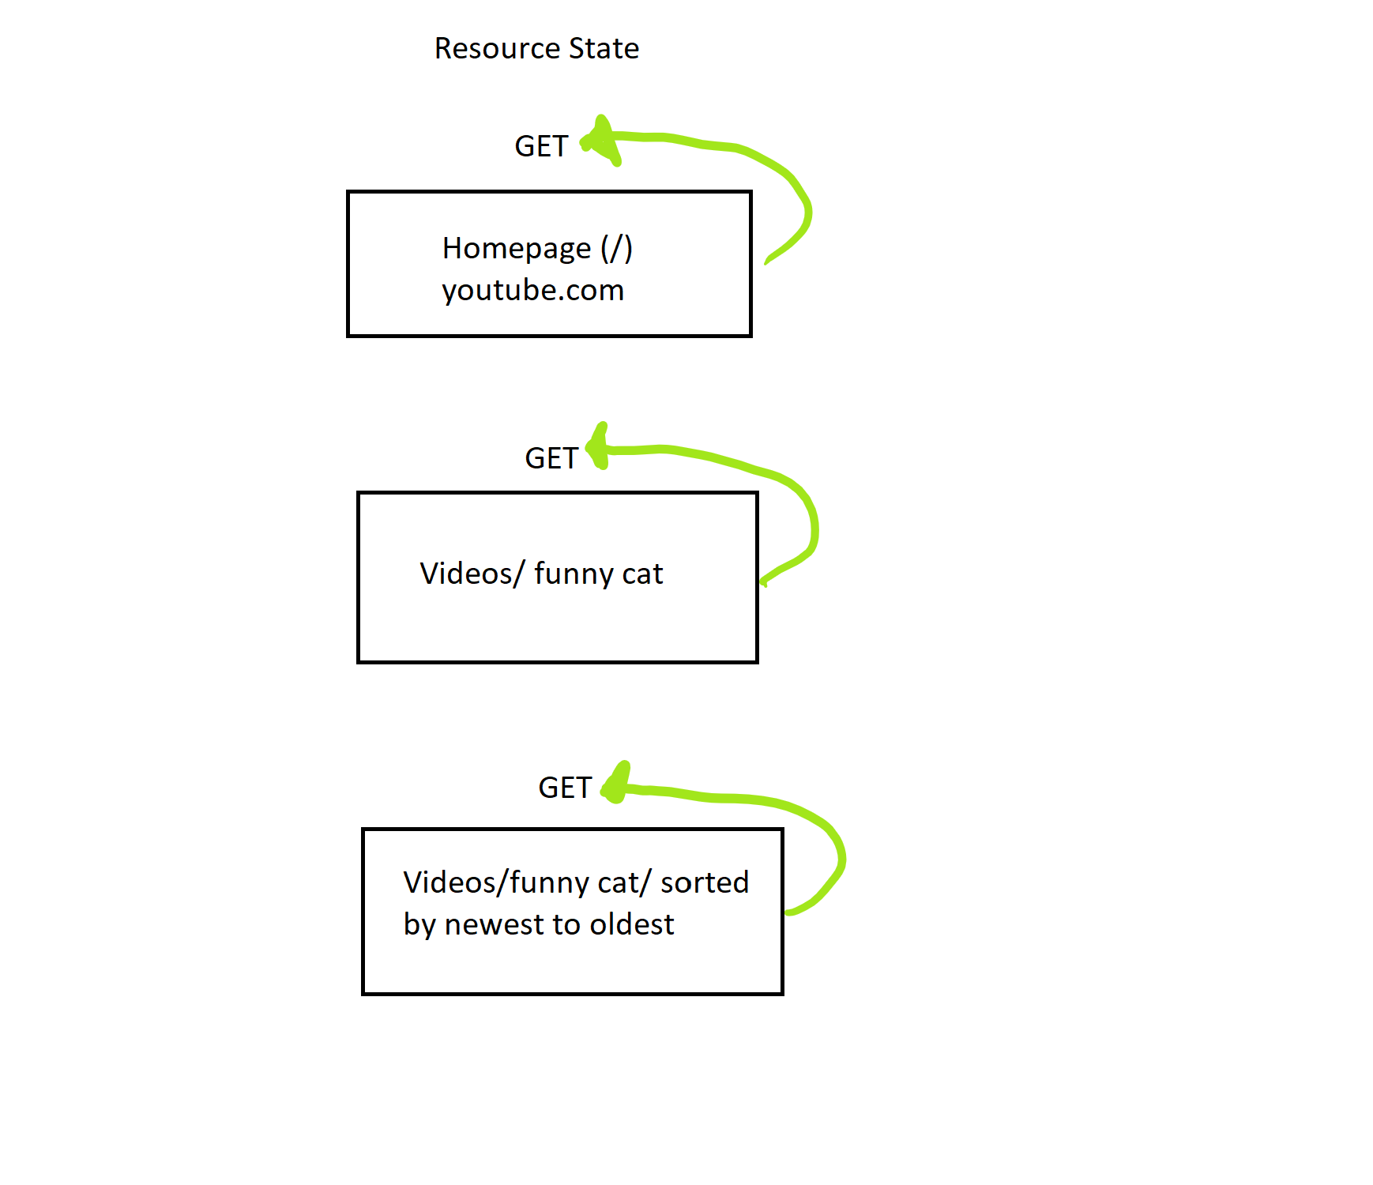

**Bibliography**

Microsoft. (2014, December 4). ASP.NET Application State Overview. Retrieved July 06, 2020, from <https://docs.microsoft.com/en-us/previous-versions/ms178594(v=vs.140)?redirectedfrom=MSDN>

Fielding, R. (n.d.). REST. Retrieved July 06, 2020, from https://restfulapi.net/statelessness/