Assignment 5.2

*Becca Buechle*

*August 3, 2020*

**HTTPGet Request** 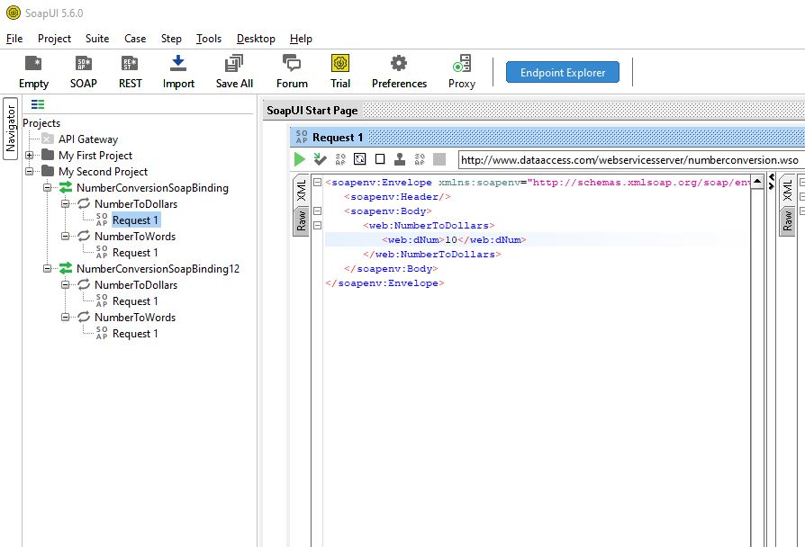

**(see below)**

**HTTPGet Response** 