To: Professor Itskovich

From: Rebecca Buechle

Date: 21 August 2020

Subject: From Legacy to SOA

I have been doing some research on SOA (service oriented architecture) and it seems like it would be a wonderful tool that can add a lot to our company. It would take quite a lot of work to integrate it into our systems but after it was fully integrated I believe that it would help us greatly. Some of the things that it could help with is; the online Doggo’s ordering app, order management, the Doggo’s warehouse app, as well as inventory and customer management. Below I will go into a bit more detail on how SOA will benefit us.

First off moving over to a service oriented architecture (SOA) would help us with in many ways with our Doggo’s apps and management tools. SOA will do this by allowing us to re-using services. Meaning that each created service will be able to be reused in some way throughout the business. (IBM.) SOA services are a lot easier to maintain because there are no complications from interactions with other connected interacting services. (Griffin, L.) Another huge plus to SOA is the scalability. Because SOA is not tied to one server and can run of several different ones it allows for increased workloads. (Doveltech.) The last thing I want to mention is SOA tends to be more reliable because its easier to debug small programs rather than huge sections of code.

To migrate to SOA we will need to do several things. The first one will be to configure our service oriented architecture infrastructure. Next we will want to configure the SOA oracle suit and BPM profiles. Followed by configuring the audit, payload validation, and the default query. From there we’ll move on to setting up the registry properties and the callback server and URLs and any advanced infrastructure properties as well. We’ll then stop / start the managed server and change over to the SOA infrastructure URL property port in the system MBean browser and configure all the log files that are needed. The driver name will also need to change to support the XA custom driver with timeout values. Once that is all done we will then setup our database processing thread and make sure that the local optimization is good.

To sum it up I believe that switching over to a service based architecture (SOA) would greatly benefit us here at Doggo’s for many reasons. While it might create some downtime in the start I believe that once we have everything up and running it will greatly reduce that. SOA will allow our customers to have the same experience across all platforms. It will also have fewer bugs because it will be far easier to test which will give our customers a far better experience. Lastly, once we are switched over it should be far easier to maintain and have a lot less downtime. Thanks for taking the time to read this I look forward to hearing your thoughts!

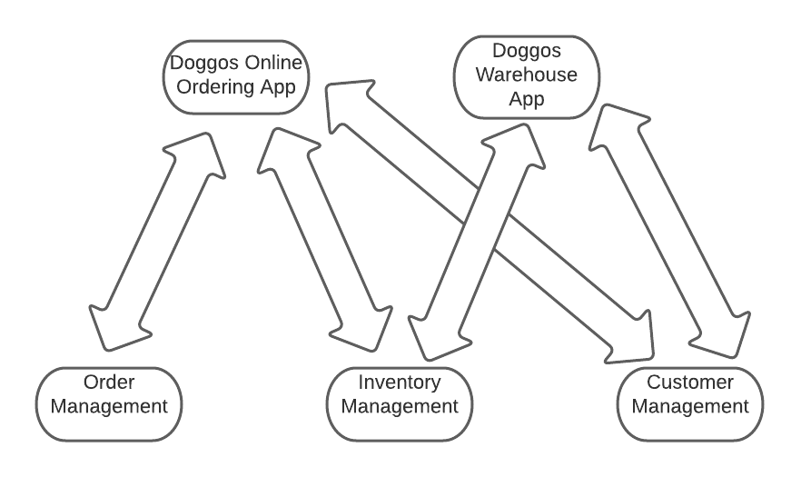

Source: (Rajadhyaksha, V.)

References

Doveltech. (2018, July 26). Scaling SOA. Retrieved August 21, 2020, from https://doveltech.com/innovation/scaling-soa/

Griffin, L. (2020). Advantages & Disadvantages of Service-Oriented Architecture. Retrieved August 22, 2020, from <https://study.com/academy/lesson/advantages-disadvantages-of-service-oriented-architecture.html>

IBM. (2020). Soa. Retrieved August 21, 2020, from <https://www.ibm.com/cloud/learn/soa>

Rajadhyaksha, V. (2013, October 02). SOA Service Oriented Architecture. Retrieved August 21, 2020, from <https://www.slideshare.net/vinayrajadhyaksha/soa-service-oriented-architecture-26774575>

Oracle. (2016, November 17). Fusion Middleware Administering Oracle SOA Suite and Oracle Business Process Management Suite. Retrieved August 21, 2020, from <https://docs.oracle.com/middleware/1221/soasuite/administer/GUID-F4D5D16C-EA1A-4DB8-AEA5-1E1F6B28C1D2.htm>