**Week 7**

**For this week’s discussion board assignment, complete the following:**

* **Select two domain-specific formats and explain their purpose, protocol semantics, application semantics, medium, and where they are defined.**

**Maze+XML**

**Purpose -** The purpose of Maze+XML is a XML data format that allows for sharing of maze state info between client and servers and it can also be used to implement simple mazes, adventure games and other related data. (Richardson, L., & Amundsen, M.)

**Protocol Semantics –** Navigation using GET links

**Applications Semantics –** Maze game

**Medium –** XML

**Defined –** Personal standard (<http://amundsen.com/media-types/maze/>)

**OpenSearch**

**Purpose –** The purpose of OpenSearch is to create a standard for representing search forms. It can be used alone or incorporated into an API using the search link relation. (Richardson, L., & Amundsen, M.)

**Protocol Semantics –** Searching using GET

**Application Semantics –** Search Queries

**Medium –** XML

**Defined –** Consortium Standard (<http://www.opensearch.org/Specifications/OpenSearch/1.1>)

* **Create two original diagrams showing the work-flow of the selected formats.**

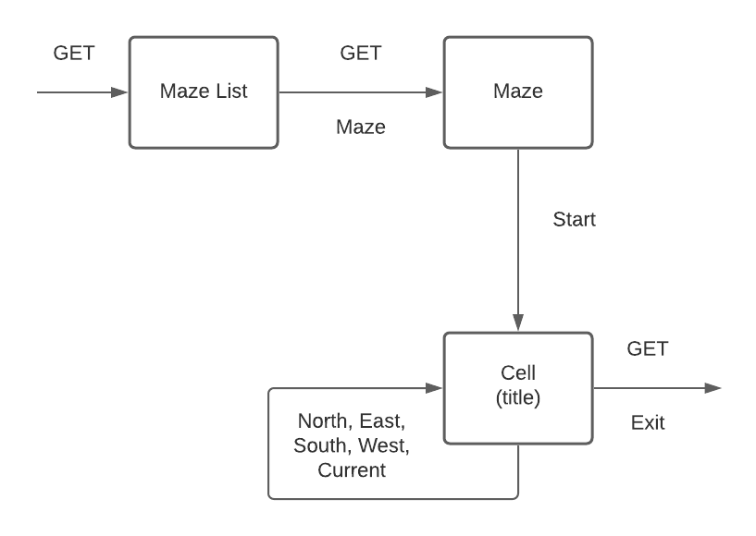

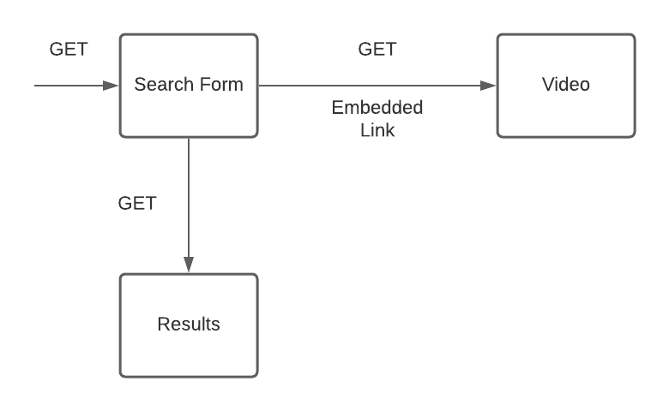

**Bibliography**

Richardson, L., & Amundsen, M. (2015). *RESTful Web APIs*. Beijing: O'Reilly.