Assignment 9.3 API Gateway Part VI (Heroku Deployment)

*Becca Buechle*

*August 31, 2020*

*Registration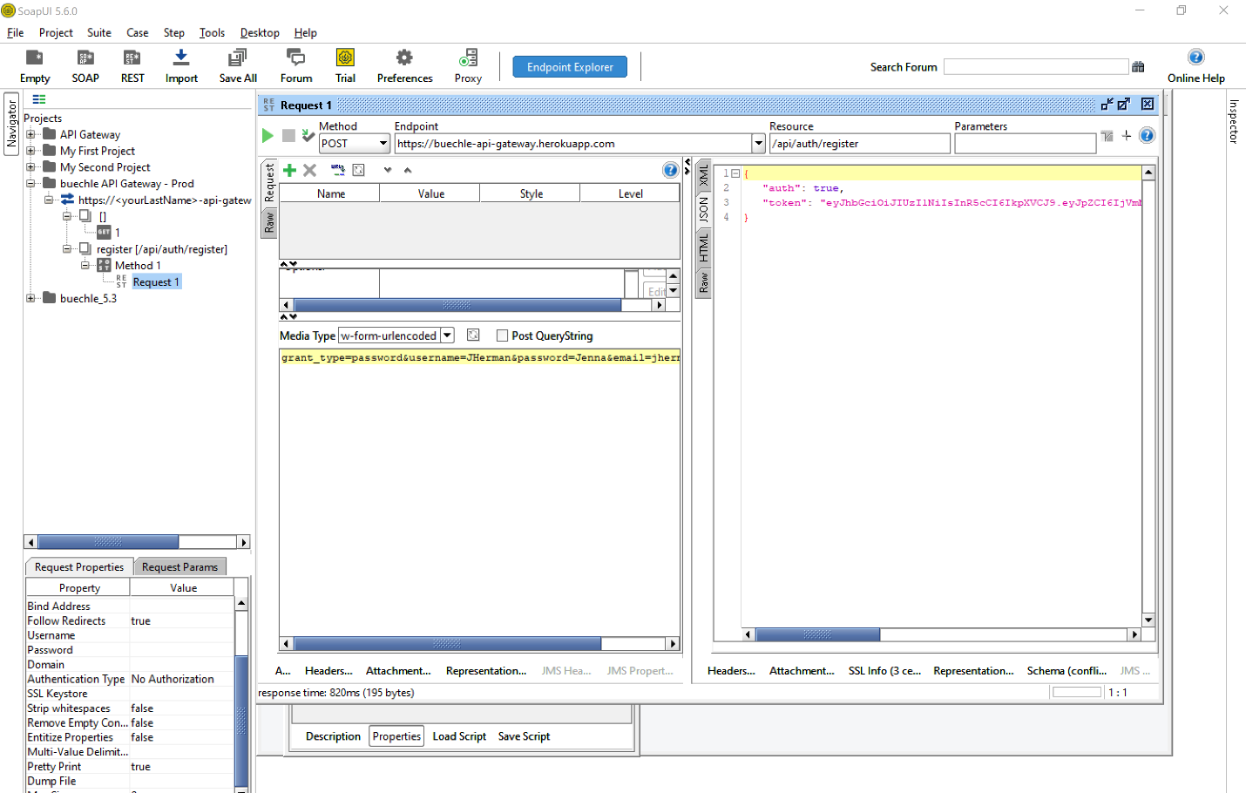*

*Token*

*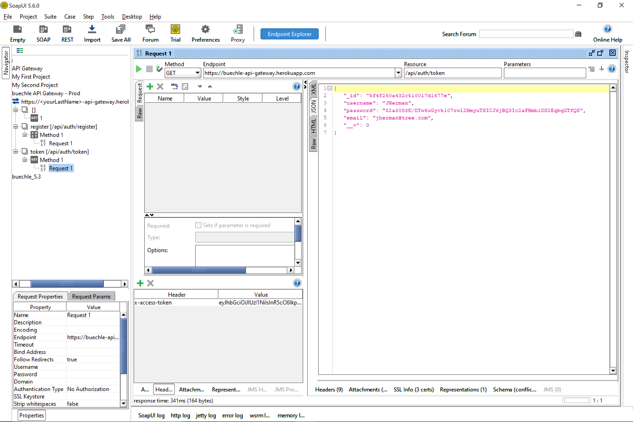*

*(see below)*

*Login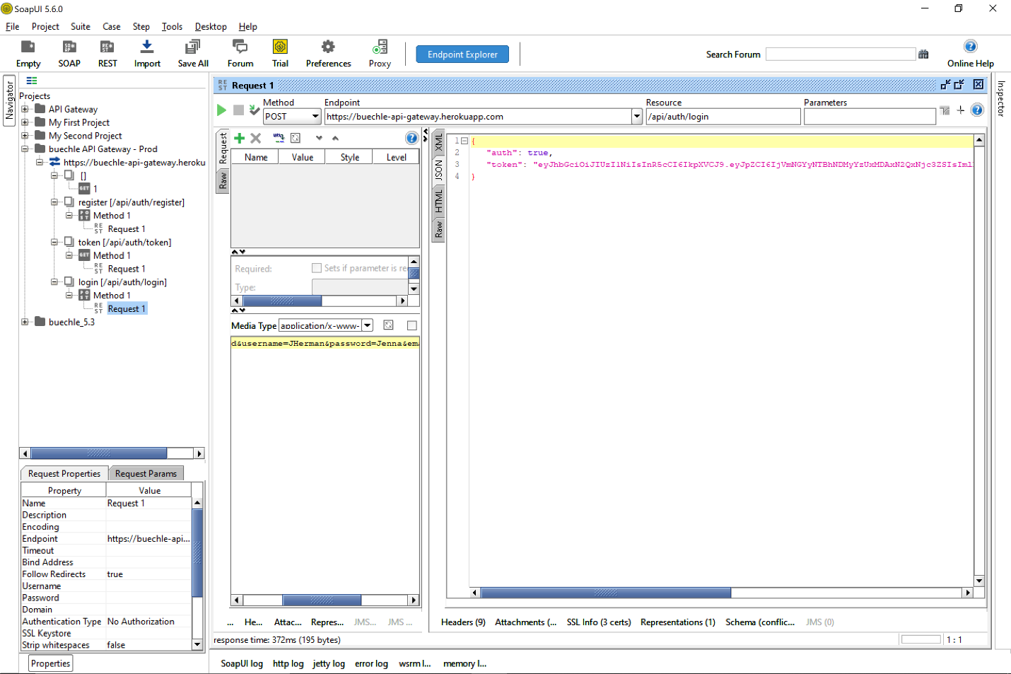*

*(see below)*

*Logout