**Assignment 9.3 Bob’s Computer Repair Shop**

*Becca Buechle*

*November 09, 2020*

Home page

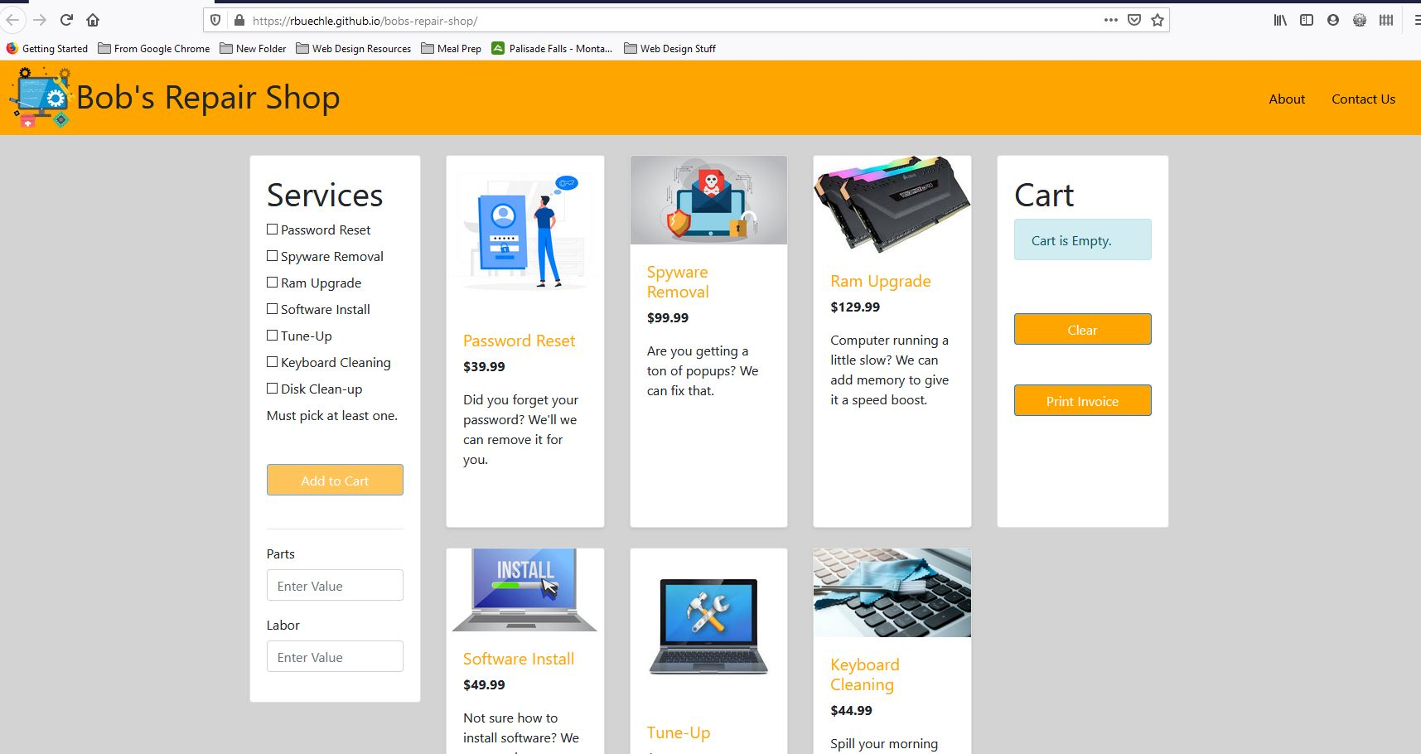

Click and add services and labor cost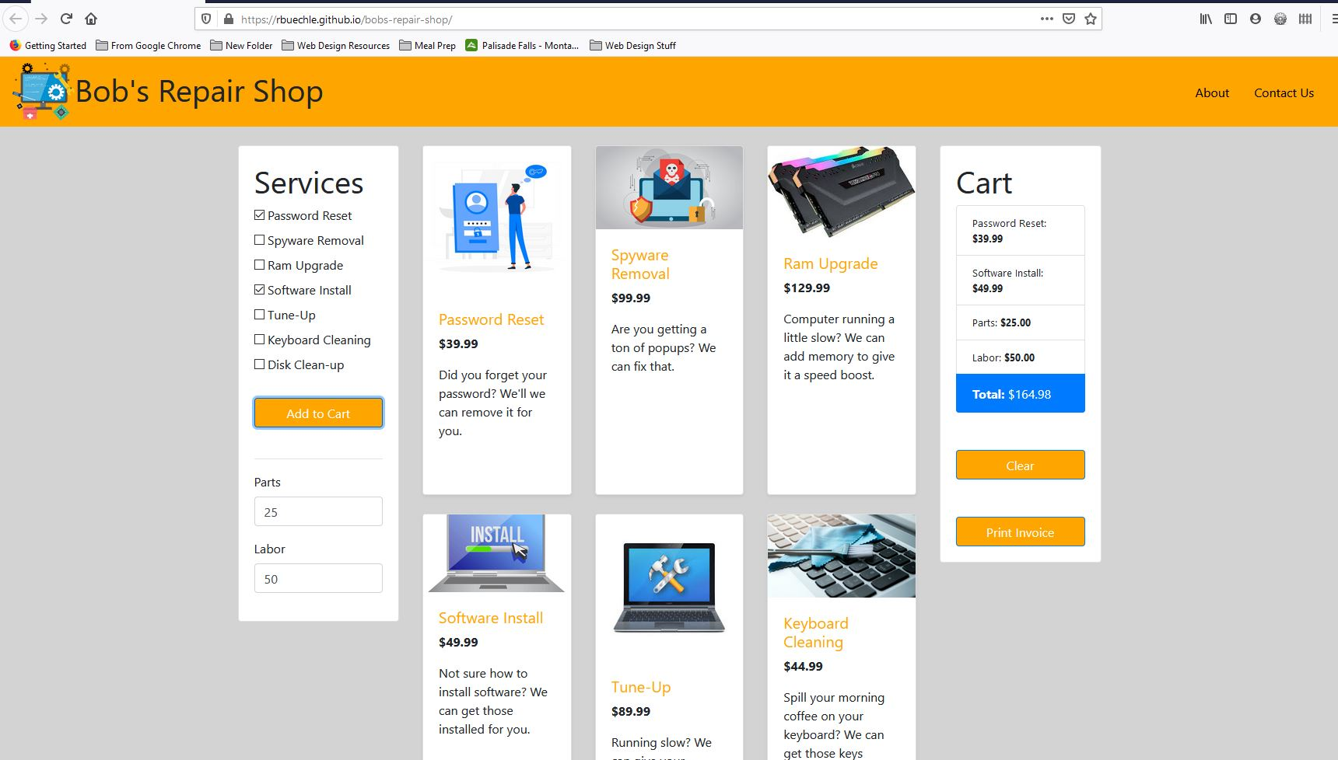

When clicking the Print Invoice Button