RBW Designs (fictional company) was founded in 2015. The company’s mission is to provide minimalistic, high-quality backpacks for all consumer needs ranging from children’s backpacks to high-end luxury backpacks for company executives. The Company believes that its minimalistic designs are the reason for its success as the world’s inhabitants are living in a world that is over-designed, and simplicity is the new trend. RBW Designs was founded by Rachel Burstiner and Brooke Wheeling while they were pursuing their undergraduate degrees at Babson College in Wellesley, Massachusetts. The concept behind RBW Designs began when Wheeling was four-years old and desperately wanted a backpack. Since her parents were adamant that she did not need a backpack at that time, Wheeling began to brainstorm her future backpack business to spite her parents and her denied request. Wheeling met Burstiner in 2014 and the partnership developed. RBW Designs opened its first store in 2015 in Wellesley and has since become a national hit, expanding into at least 5 locations in every state throughout the United States. RBW Designs backpacks are everywhere and consumer cannot seem to get enough of the high-quality and well-thought out designs. The RBW’s products are manufactured by the Company in the United States and the raw materials are also sourced within the United States. Given its minimalistic designs, all backpacks are created using one main material with a drawstring enclosure. Due to this, manufacturing costs are extremely low, yielding a high operating margin. Currently, the Company is on its way to reach over $100 million in sales for fiscal year 2016.

Database Design

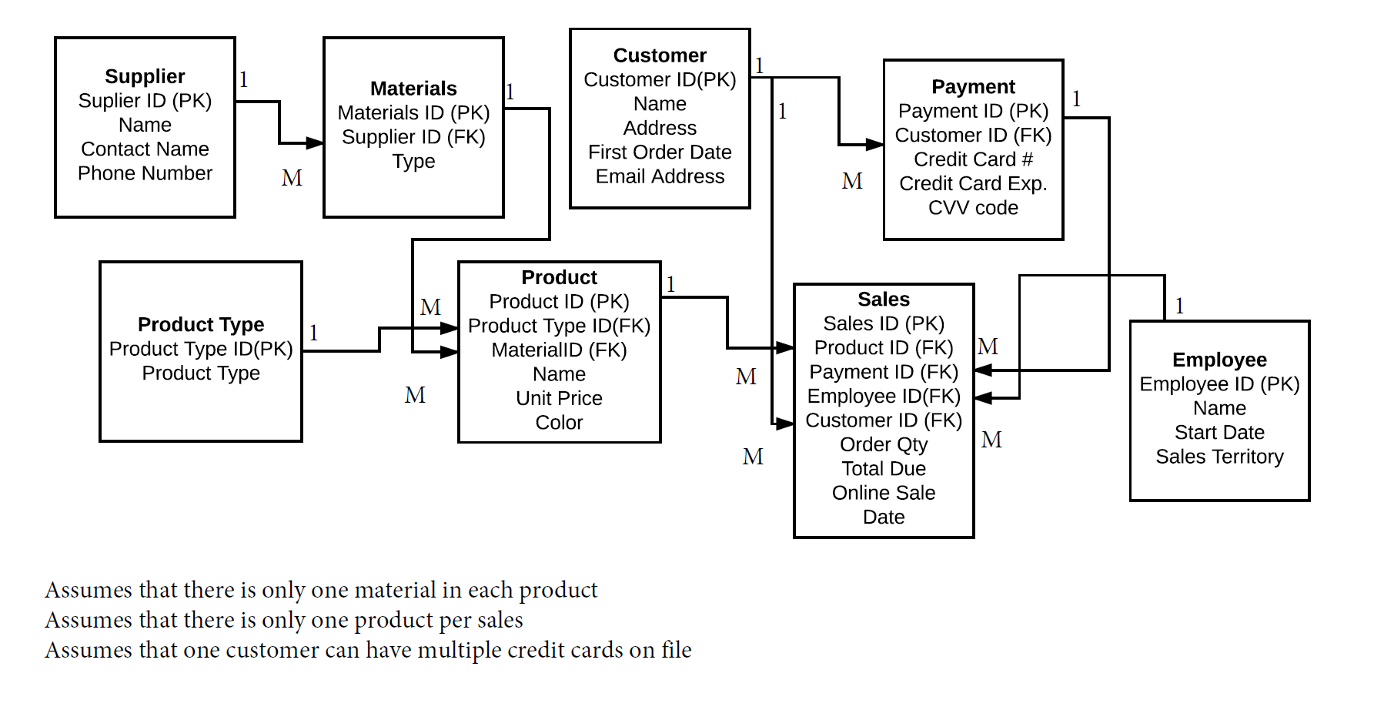

The team for this project includes Rachel Burstiner and Brooke Wheeling.