**CS551 Advanced Software Engineering**

**First Increment Report (PG-7)**

**Title: Myspare Time Application**

By: Beeravalli, Ramakrishna Reddy (Class ID: 7) (TL)

Mayathari, Vijay Kumar (Class ID: 23)

Dubbaka, Medha (Class ID: 13)

Sura, Sindhuja (Class ID: 36)

**I. Introduction**

Everyone likes to keep themselves busy most of the time. But, there would be instances where a person is left idle. This joblessness makes a person much bored. What if there is an application, where a person can search for work- either to pass time or make money instantly during the spare time. Our project intends to be a resource for them, where a user can make an online search of activities which he/she would be interested in, to make a wise utilization of free time. Often people are interested in doing many activities but they don’t have proper idea regarding when and where to attend them. Our application provides a platform for them by listing them all the available activities. There is choice to choose from a wide-range of activities locally or per-preference. Our project also integrates other features, making it more resourceful.

**II. Goal of the Project**

The main goal of our project is to create an application where-in a user can search for activities which can be done during the spare-time either to utilize free-time or make money based on their preferences.

**III. Existing Services/ APIs**

**GetJobList**

[http://api.sandbox.freelancer.com/Job/getJobList.{xml|json}](http://api.sandbox.freelancer.com/Job/getJobList.%7bxml%7Cjson%7d)

**User feedback API**

[http://api.sandbox.freelancer.com/User/getUserFeedback.{xml|json}](http://api.sandbox.freelancer.com/User/getUserFeedback.%7bxml%7Cjson%7d)

**Post A Project**

[http://api.sandbox.freelancer.com/Employer/postNewProject.{xml|json}](http://api.sandbox.freelancer.com/Employer/postNewProject.%7bxml%7Cjson%7d)

**Money transfer API**

[http://api.sandbox.freelancer.com/Payment/transferMoney.{xml|json}](http://api.sandbox.freelancer.com/Payment/transferMoney.%7bxml%7Cjson%7d)

**Post Feedback API**

[http://api.sandbox.freelancer.com/Common/postFeedback.{xml|json}](http://api.sandbox.freelancer.com/Common/postFeedback.%7bxml%7Cjson%7d)

**Delete a Draft project API**

[http://api.sandbox.freelancer.com/Employer/deleteDraftProject.{xml|json}](http://api.sandbox.freelancer.com/Employer/deleteDraftProject.%7bxml%7Cjson%7d)

**Get Jobs by Category List**

[http://api.sandbox.freelancer.com/Job/getCategoryJobList.{xml|json}](http://api.sandbox.freelancer.com/Job/getCategoryJobList.%7bxml%7Cjson%7d)

**IV. Design**

System Design sits at the technical kernel of the software engineering process. Design is the place where quality is fostered in software development. System Design includes the business requirement and functional requirement. Business requirement give details regarding the access that is being provided to each other.

**Class Diagram:**

Class Diagram identifies the class structure of a system, including the properties and methods of each class. Also depicts the various relationships that can exist between classes such as inheritance,specialization,generalization etc.

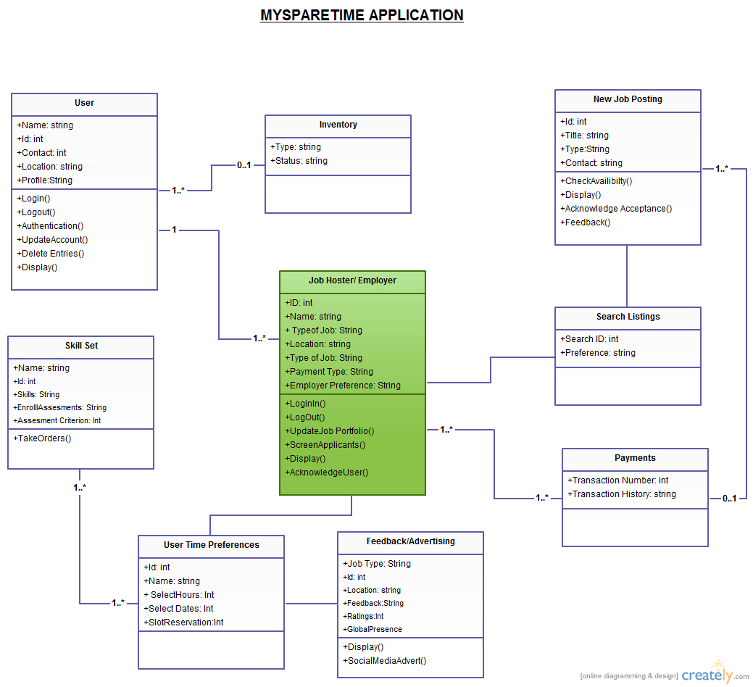

**Sequence Diagram:**

A Sequence Diagram is a kind of interaction diagram that shows how processes operate with one another in a particular order. It is a construct of message sequence chart.

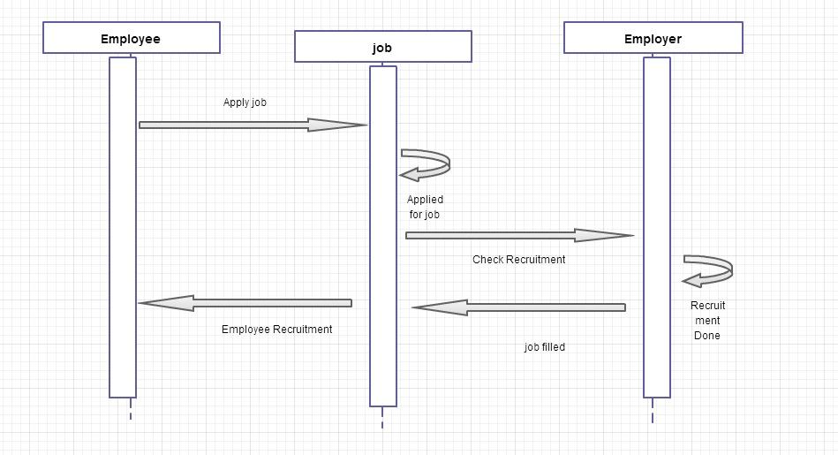

**V. Implementation**

Implementation is the process of having systems personnel check out and put new equipment into use, train users, install the new application depending on the size of the organization that will be involved in using the application and the risk associated with its use, system developers may choose to test the operation in only one area of the firm, say in one department or with only one or two persons .Sometimes they will run the old and new systems together to compare the results. In still other situation, developers stop using the old system one day and begin using the new one the next. As we will see, each implementation strategy has its merits, depending on the business situation in which it is considered. Regardless of the implementation strategy used, developers strive to ensure that the system initial use in trouble-free.

**Implementation of Services:**

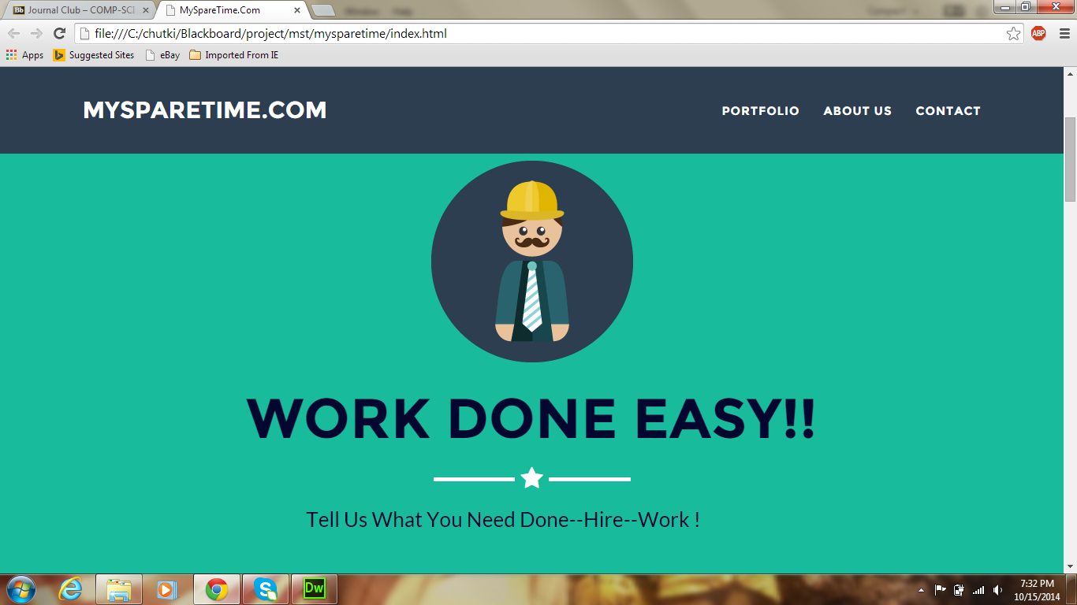

**Fig 1: Home Page**

This page allows a user to have a first of our website.

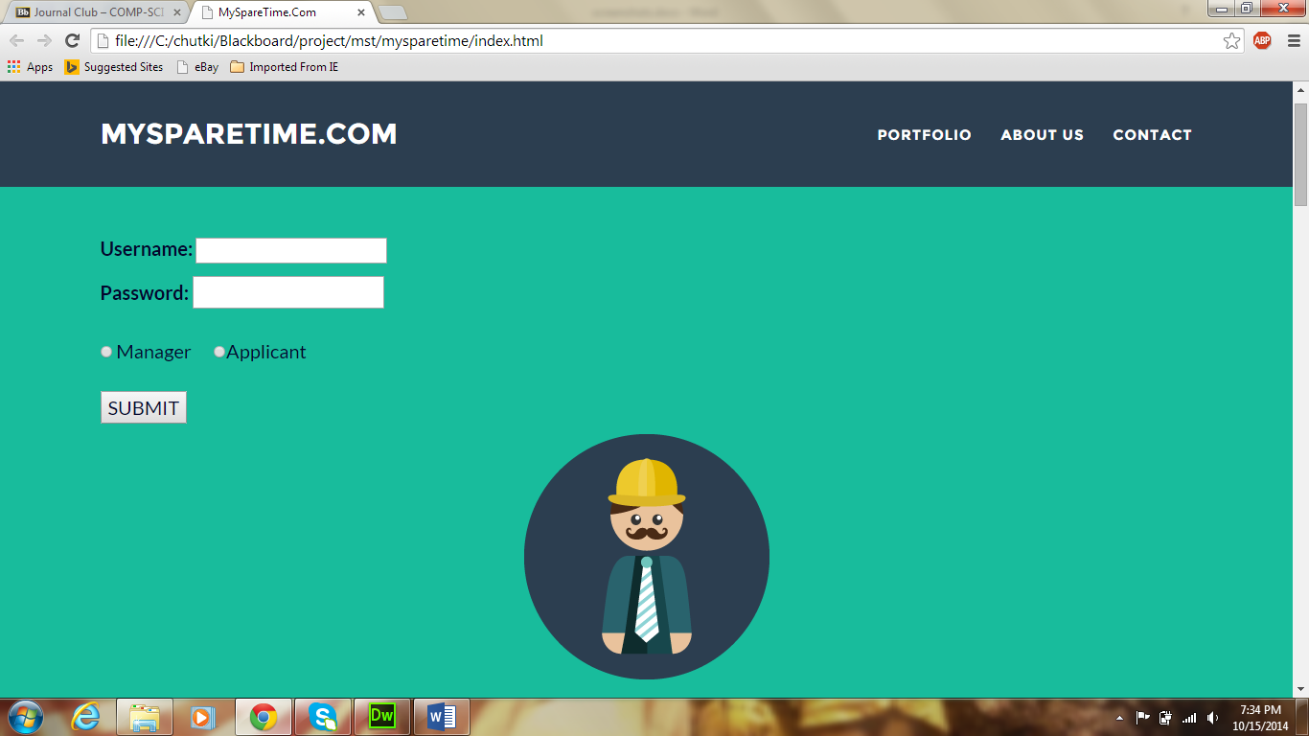

**Fig 2: Login Page**

Login page allows a user to log into his account by giving his username and password. He then should select the type of user i.e., Manager or an Applicant and submit his details.

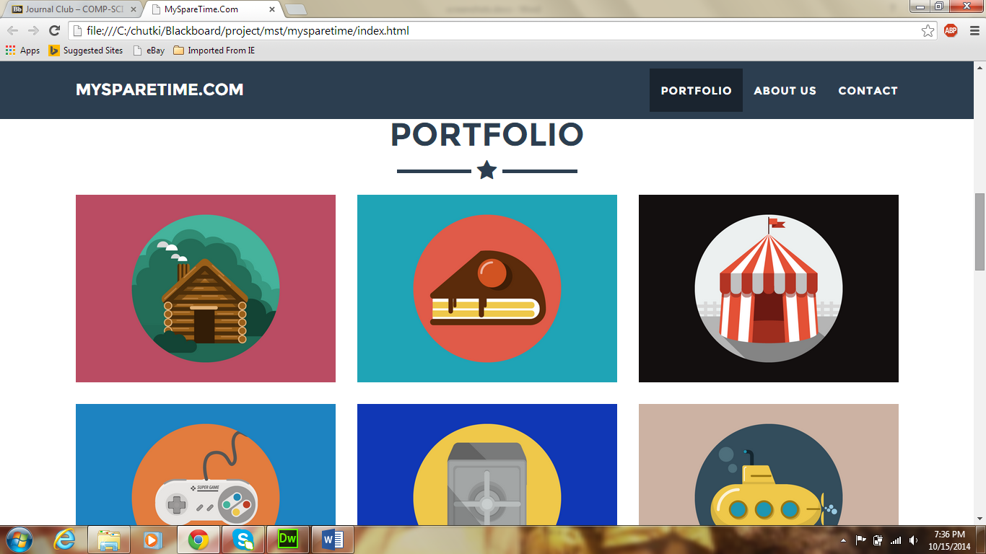

**Fig 3: Portfolio Screen**

Here the user can have a view of all the categories of work available for him, Which he can select according to his choice.

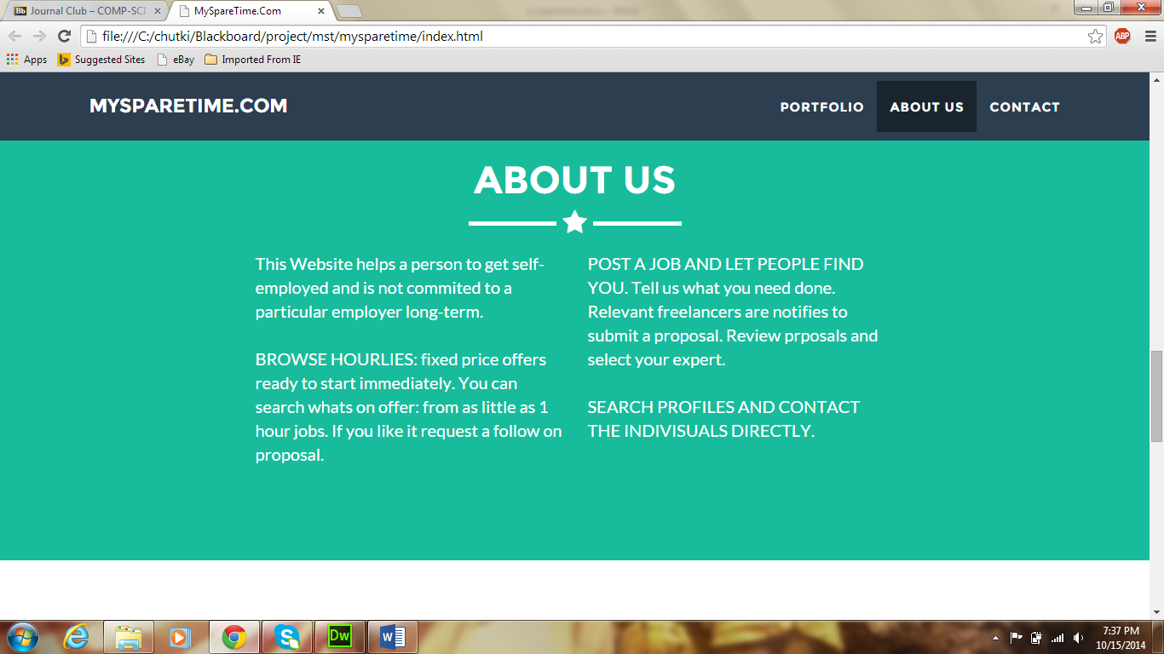

**Fig 4: About Us**

This page gives a brief description of the website for a new user.

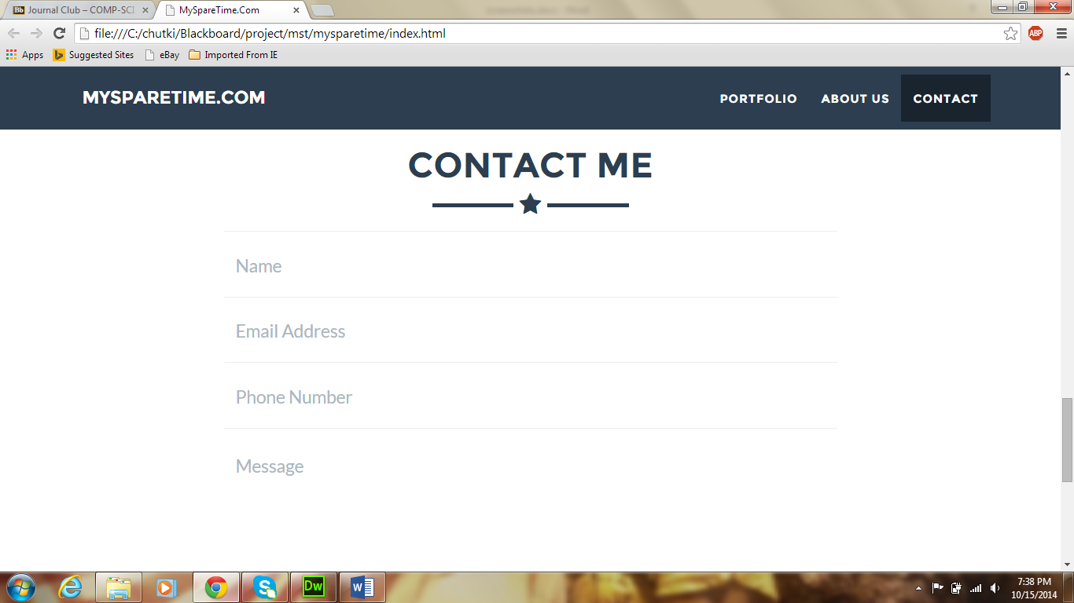

**Fig 5: Contact Screen**

Using this page, a user can give his details which can be used to contact him later by the other users.

**User Interface (Mobile Apps)**

Still working on the Android Version.

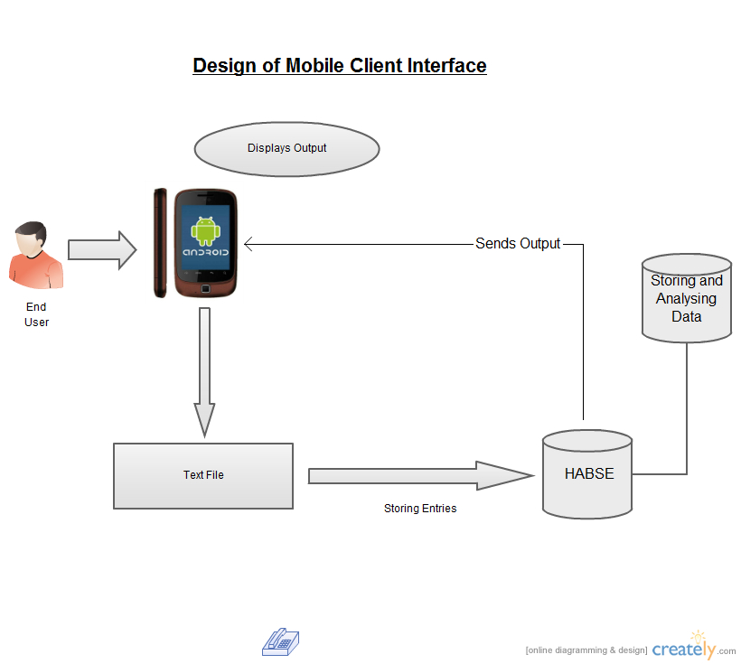

**Implementation of Test cases:**

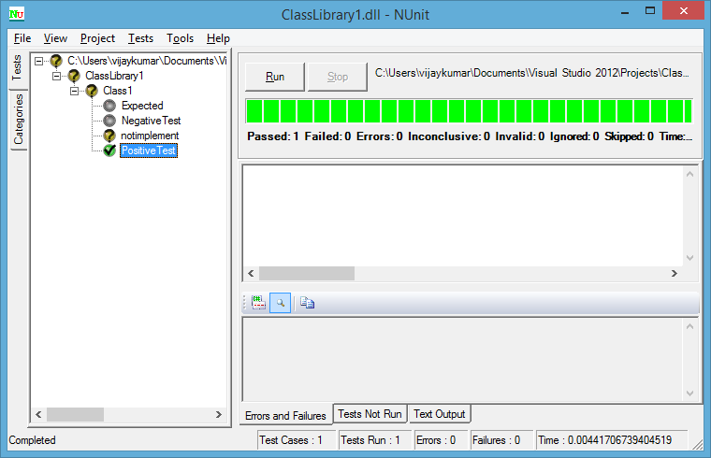

**VI. Testing**

Software Testing is a critical element of software quality assurance and represents the ultimate review of specification, designing and coding.

**Unit Testing:**

Unit testing ,focuses verification effort on the smallest unit of software i.e. the module. Using the detailed design and the process specification testing is done to uncover errors within the boundary of the module.

**NUnit Testing:**

NUnit is a Testing framework used with .Net. Unique functionalities coded with C# can be tested with N unit. This tool is used for Unit testing of the product developed.

Following are the functions developed for testing the My Spare -time application.

* **PositiveHomePageTest()**

This function tests for the Successful loading of the My Spare-Time Home page.

* **NegativeHomePageTest()**

This function tests for if any failure occurred while loading My Spare-Time Home page.

* **PositiveLoginPageTest()**

This function tests for the Successful loading of the My Spare-Time Login page.

* **NegativeLoginPageTest()**

This function tests for if any failure occurred while loading My Spare-Time Login page.

* **PositiveLoginSuccessTest()**

This function tests for the Successful authentication of username, Password of the My Spare-Time Login page.

* **NegativeLoginTest()**

This function tests for the failures while authentication of username, Password of the My Spare-Time Login page.

* **PositivePortfolioPageTest()**

This function tests for the display of Portfolio page of the My Spare-Time application.

* **NegativePortfolioTest()**

This function checks for failures while loading the Portfolio page of My Spare-Time application.

* **PositiveAboutusTest()**

This function tests for the display of About Us page of the My Spare-Time application.

* **NegativeAboutusTest()**

This function checks for failures while loading the About Us page of My Spare-Time application.

* **PositiveContactTest()**

This function tests for the display of Contact page of the My Spare-Time application.

* **NegativeConatctTest()**

This function checks for failures while loading the Contact page of My Spare-Time application.

**VII. Deployment**

**SrumDo Link :**

**https://www.scrumdo.com/projects/project/mysparetime1/iteration/113004/board**

**Github Link:**