|  |
| --- |
| **CS 590 BD – Big Data Analytics and Applications** |
| **Lab 1 - Assignment** |
| ***Submitted By: Beeravalli Ramakrishna Reddy (16179758)*** |

|  |
| --- |
| Ramakrishna Reddy Beeravalli  6-17-2014 |

***Task 2: Cloudera***

{Open source Hadoop Framework }

Cloudera enables us to run the programs on framework from any remote server.

Task2.1 Accessing UMKC cloudera server

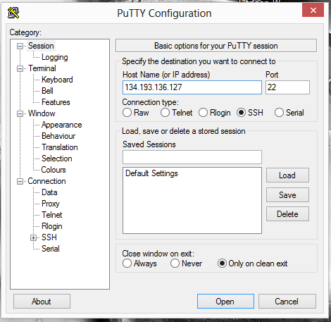

Accessing UMKC Cloudera server

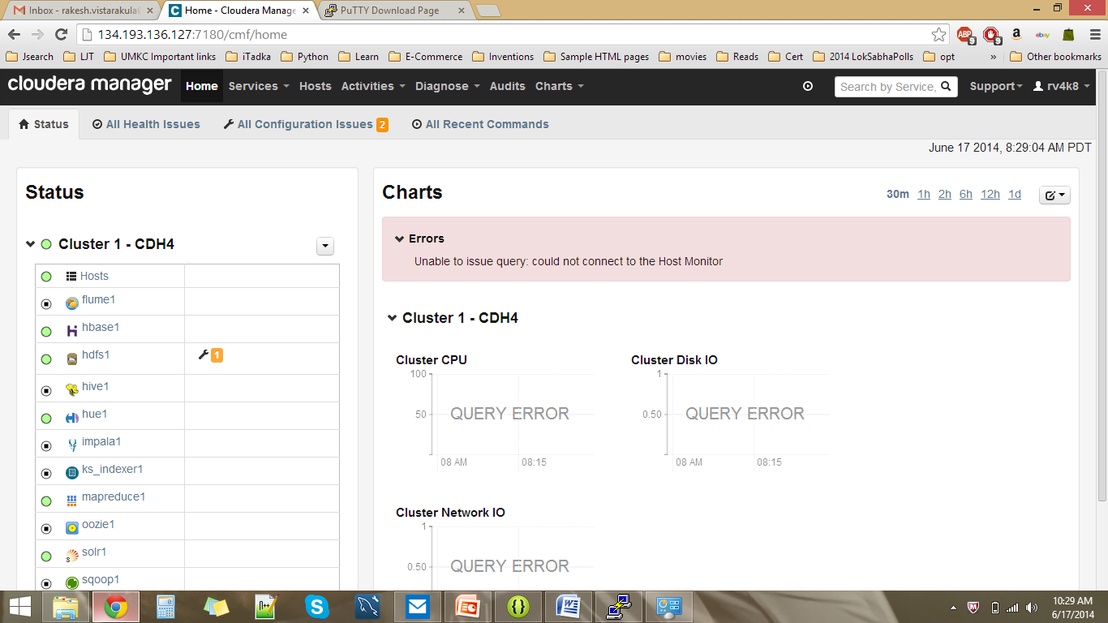

Task 2.2 Installing own cloudera Server

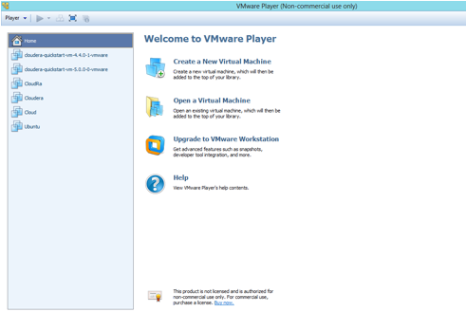

Task2.2 Installation of our own Cloudera Server

Initially we need to install the VMware player, the next step is to install quickstartVM.

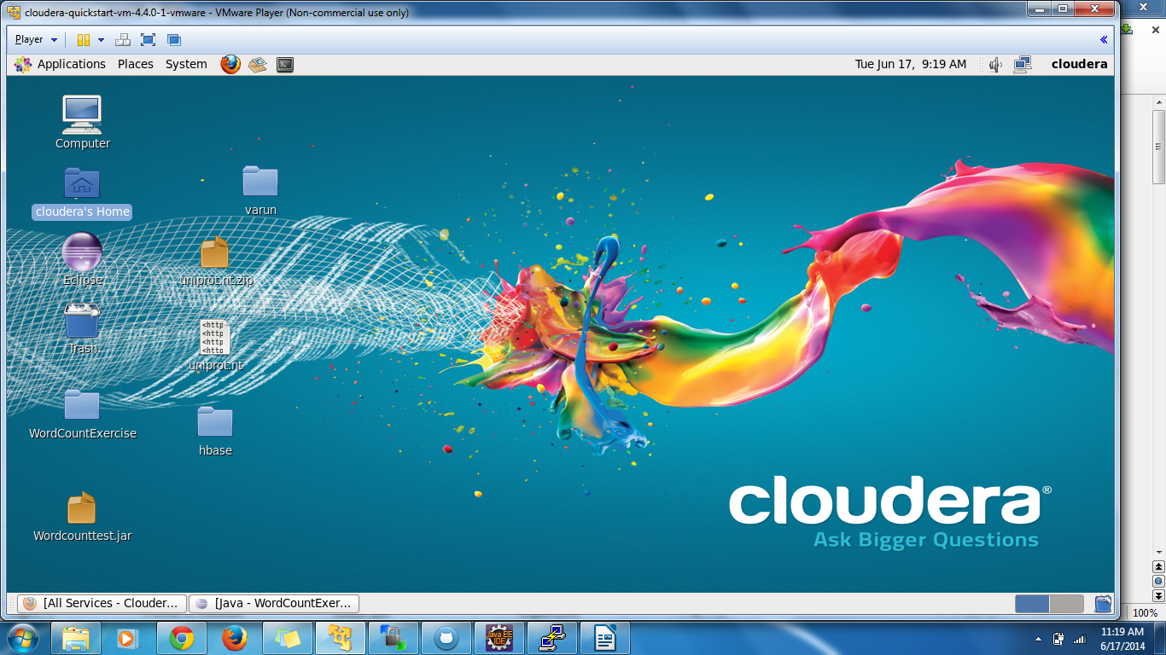

Transferring files

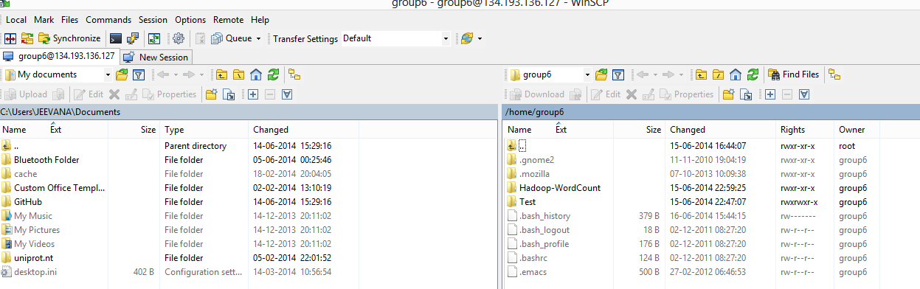

Task 2.3 Running program “Word Count” on cloudera. This is how the screenshot looks like

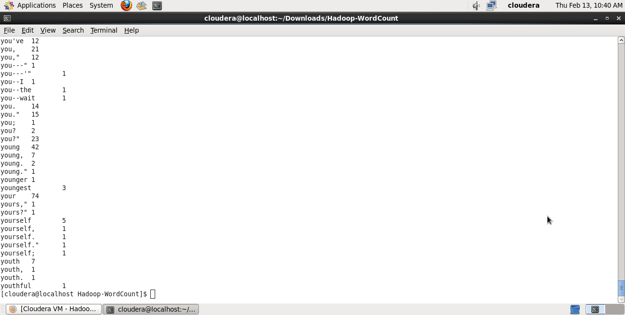

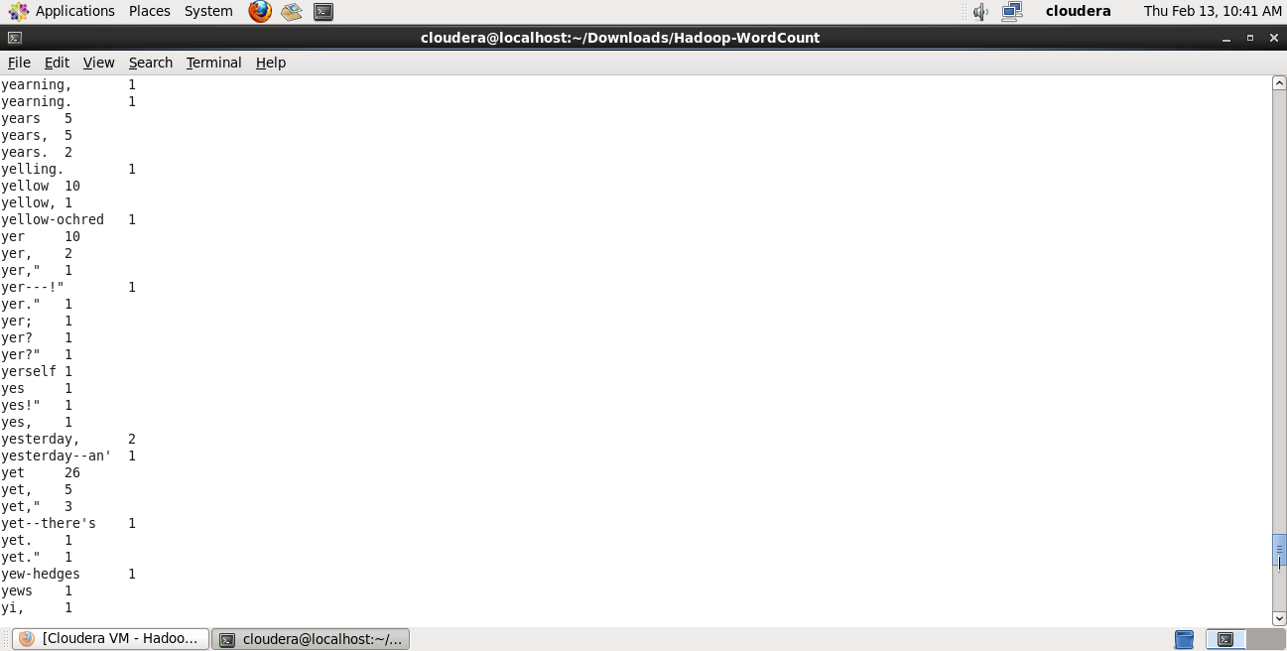

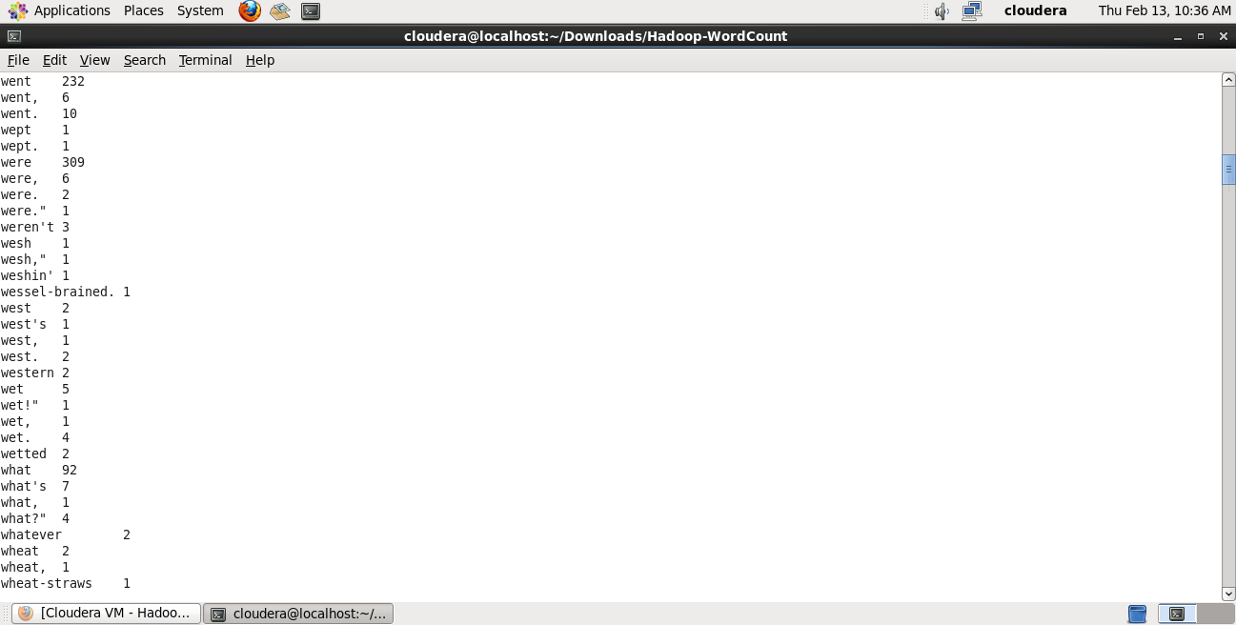

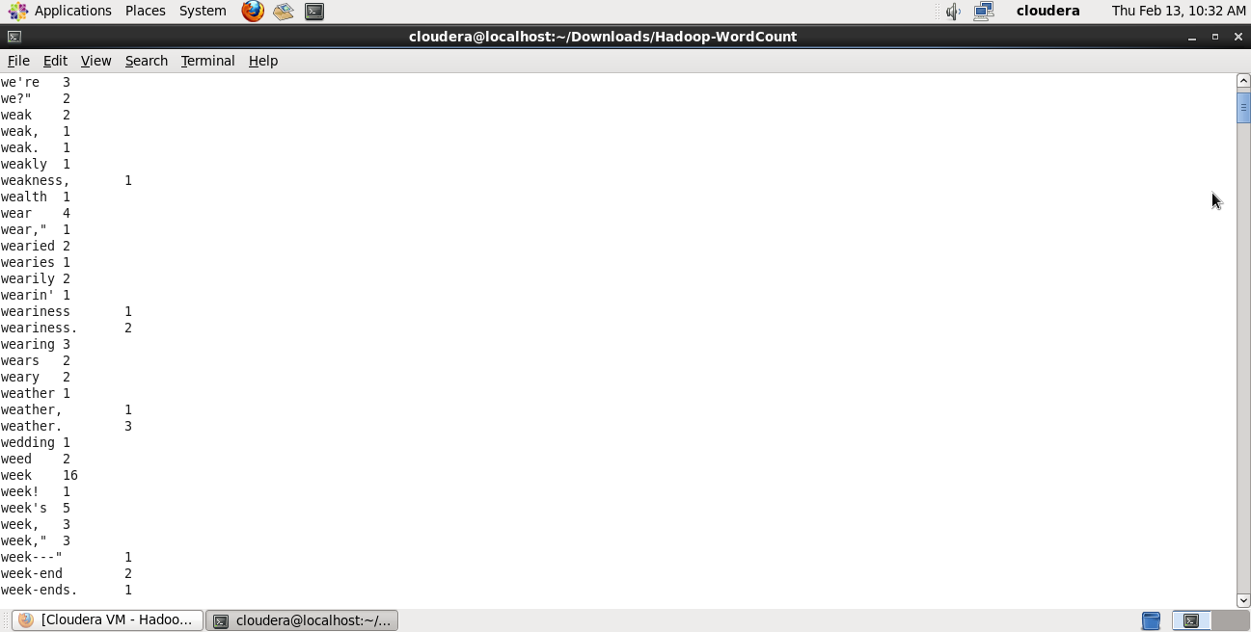

***Task 3: Accessing Github & ScrumDo***

***Task 3.1 Github***

Creating Account

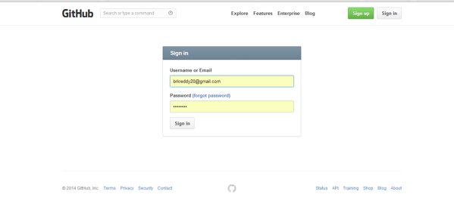

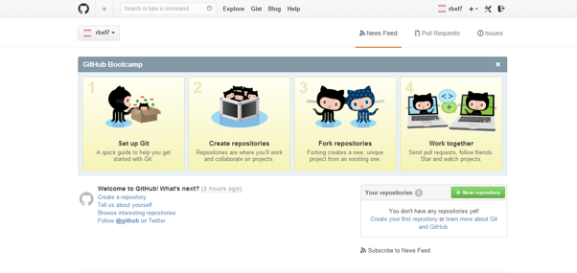

Create Repository

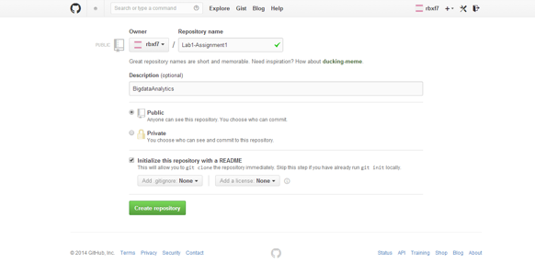

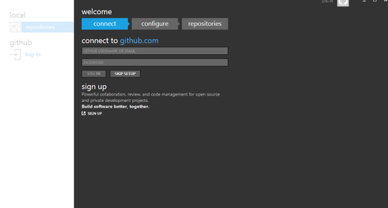

Creating and Cloning, Sync New Repository

x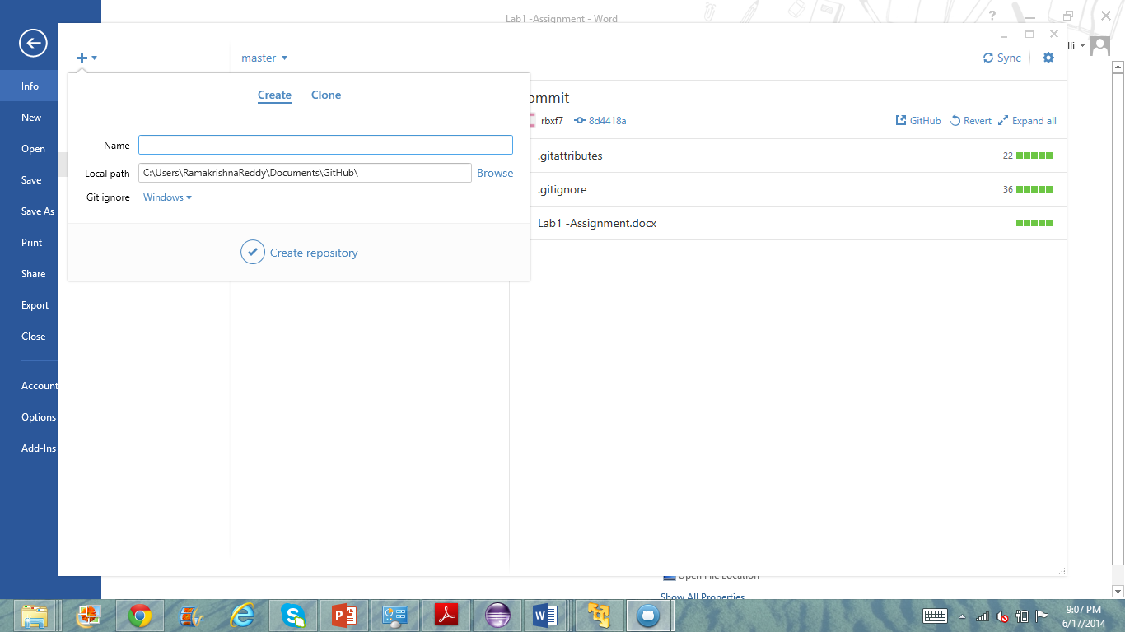

Created and now sync

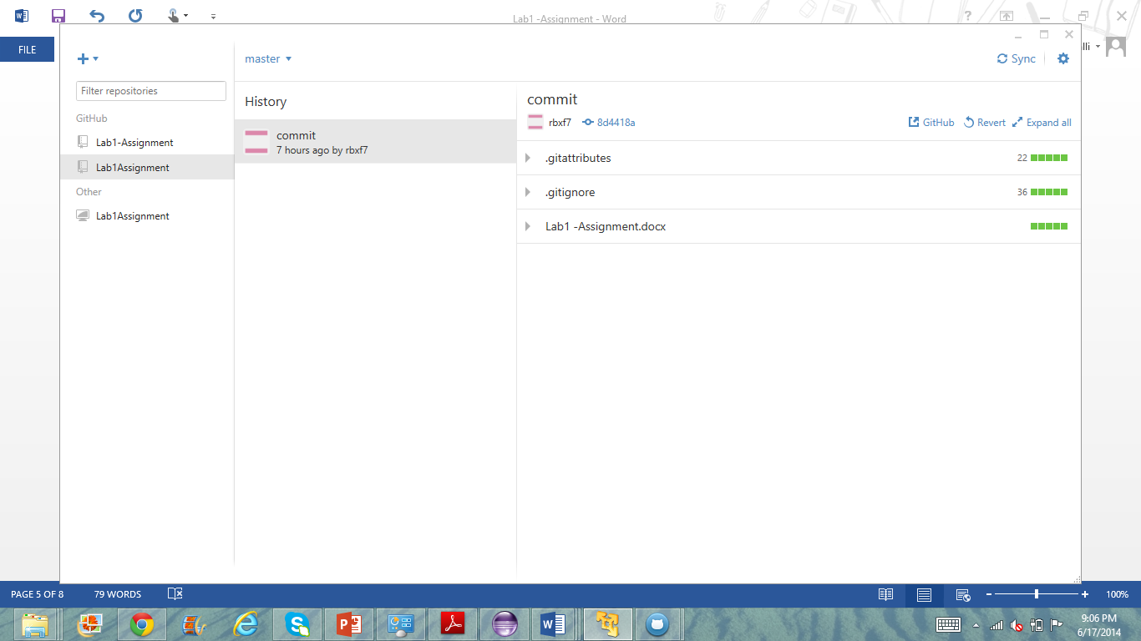

***Task 3.2 To create an account and projects with scrumdo***

ScrumDo is an agile management tool

Step 1

Creating Account

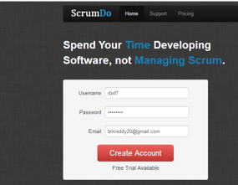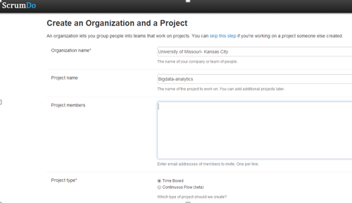

Creating Iteration

