TASK 1

Implement an application to generate a file showing any four of the given activities

The first step in order to implement an application to generate a file with activities i.e., Humidity, Temperature, GPS and Date, Time would be to import the project which is available on Blackboard.

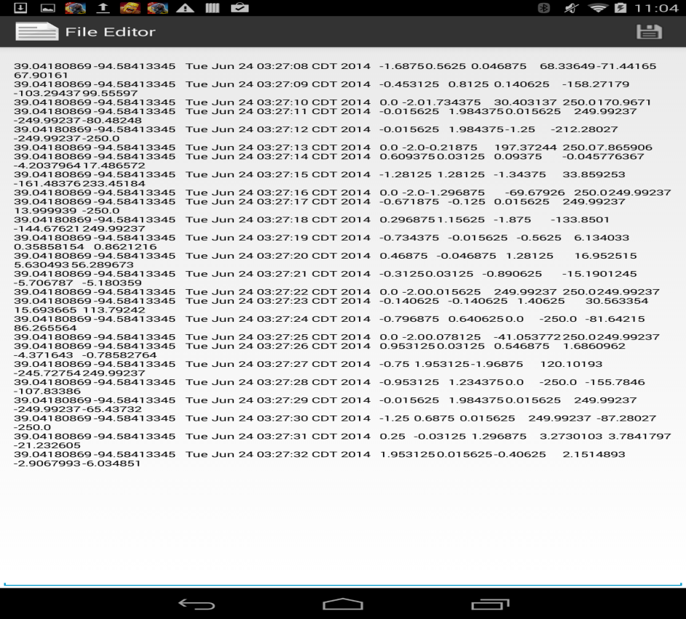

The next step would be to run the code:

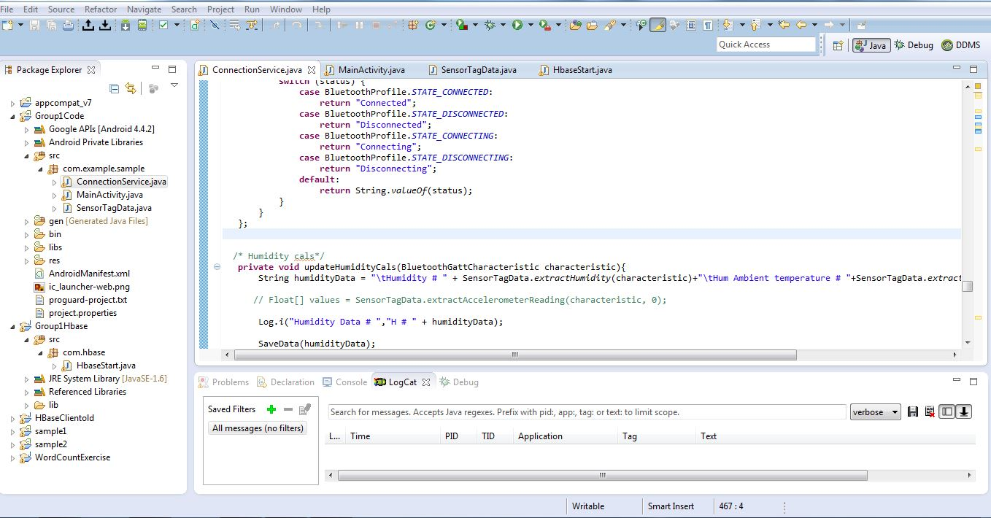

Upon analyzing the code, the code would be run, for the following four functions namely:

Runhbasecreate()

Runhbaseinsert()

Runhbaseretreiveall()

Runhbasedelete()

For the values of Humidity, Temperature the code would be run.

TASK-2: Uploading the data into HBase using WEB SERVICE

In order to upload the data into Hbase, I have used the servers which are from the UMKC VPN access.

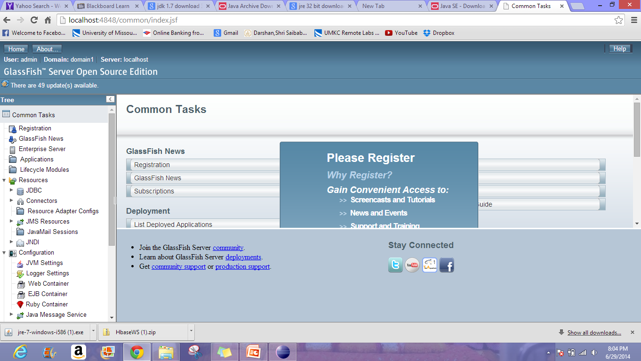

This is the glass fish server, which I have downloaded from the eclipse JEE version.

The WAR file, upon being exported and deployed on glassfish server, would look as below:

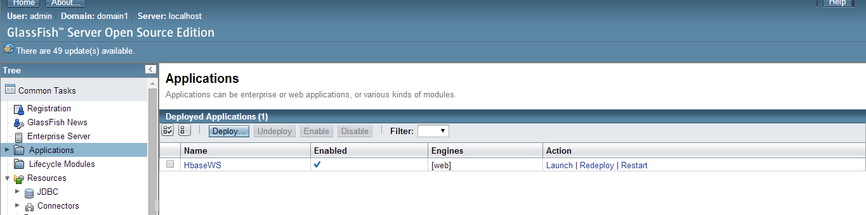

Retrieving the data from Hbase tables would look as below:

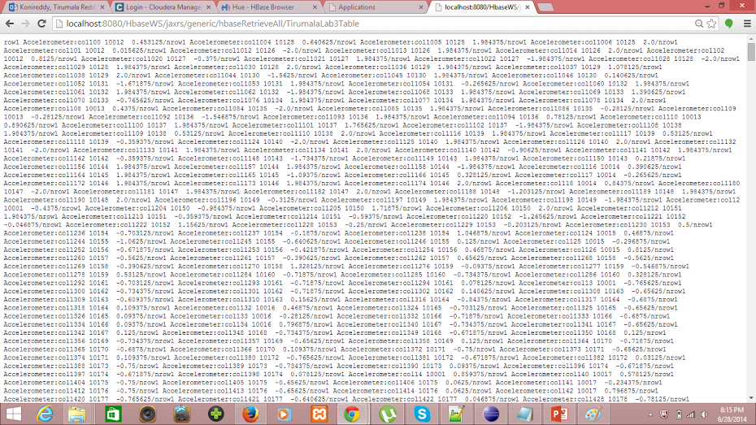

Also the commands for creation and insertion are being experimented and the results were being output in the corresponding format.