**BIG DATA ANALYTICS & APPLICATIONS**

**Lab II**

**By**

***Beeravalli, Ramakrishna Reddy (16179758)***

Report:

The lab II involved working with Sensor Tag. The Main Task involved application on Sensor tag. It was further divided into many subtasks. The first main Subtask was to Implement an application to generate a file which outputs for four different activities.

Procedure:

In-order to perform the subtask-1, we need to initially import the code which is already provided , and run the application by making appropriate changes in the code. I have made changes in the table names, and for different classes. The given code, upon modification can actually run for four different activities like Accelerometer, Geolocation, Data and Humidity.

The code given for each of different activities is the following.

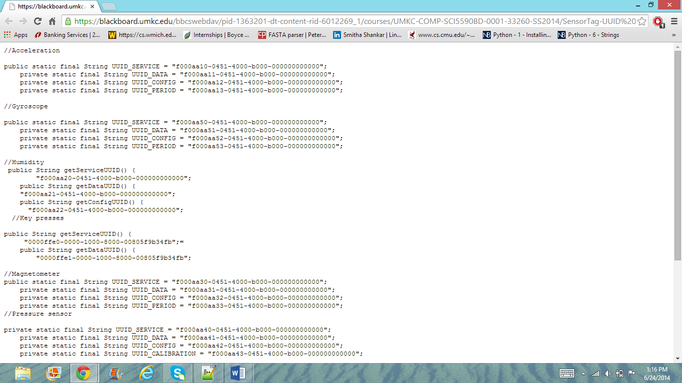

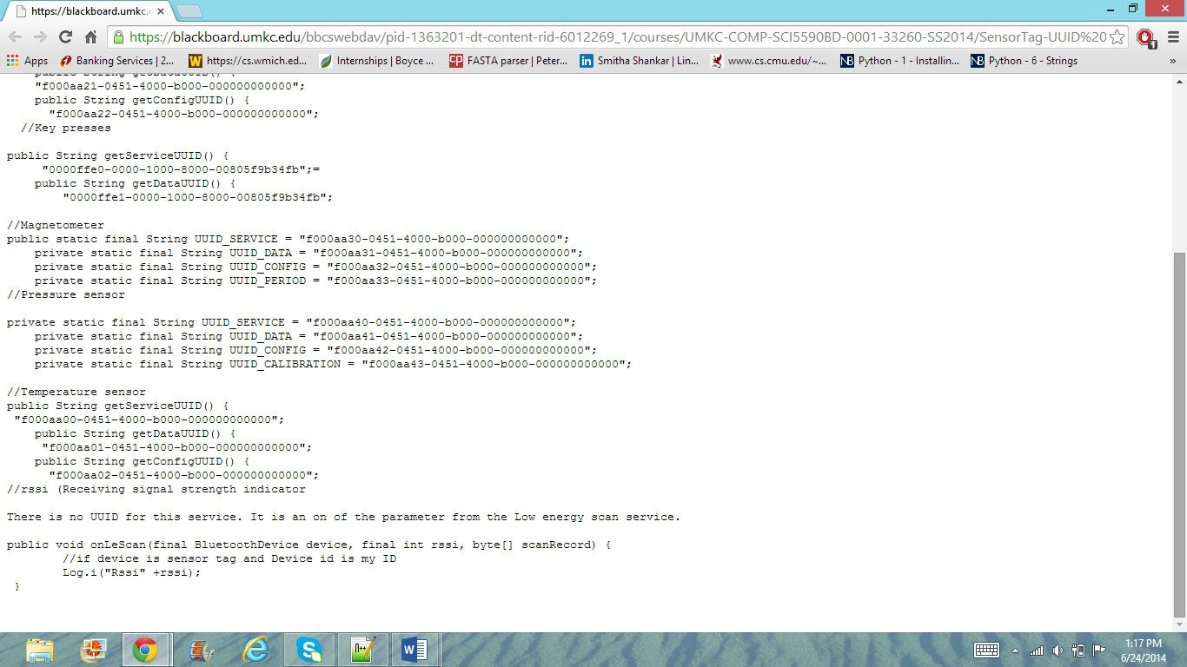

Since, we have run the application on only four different activities like accelerator, Humidity, Geo locations and Data. We would be considering only these four different datasets alone and the associated pieces of code.The next step would be to run the application on an android device. I considered running the application on a Google Nexus tablet. Upon running the application, the The file generated in the phone is sensor_group6.txt as follows in Astro file manager. The screenshot of the output looked as follows:

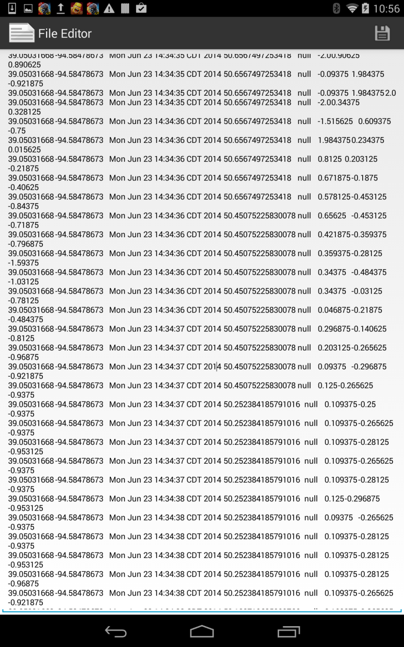

The next step involved generation of output file. The output file was generated using the Notepad++.

**Uploading into Hbase:**

In order to create a table with tablename: createtableram, insert and retrieve, follow the following code:

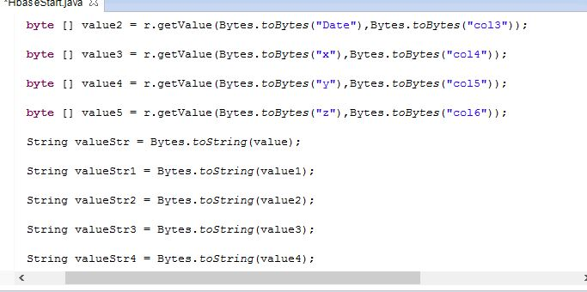

The code looks like the above.

The table created, with the five different columns latitude, longitude, x, y and Z looks as followsL

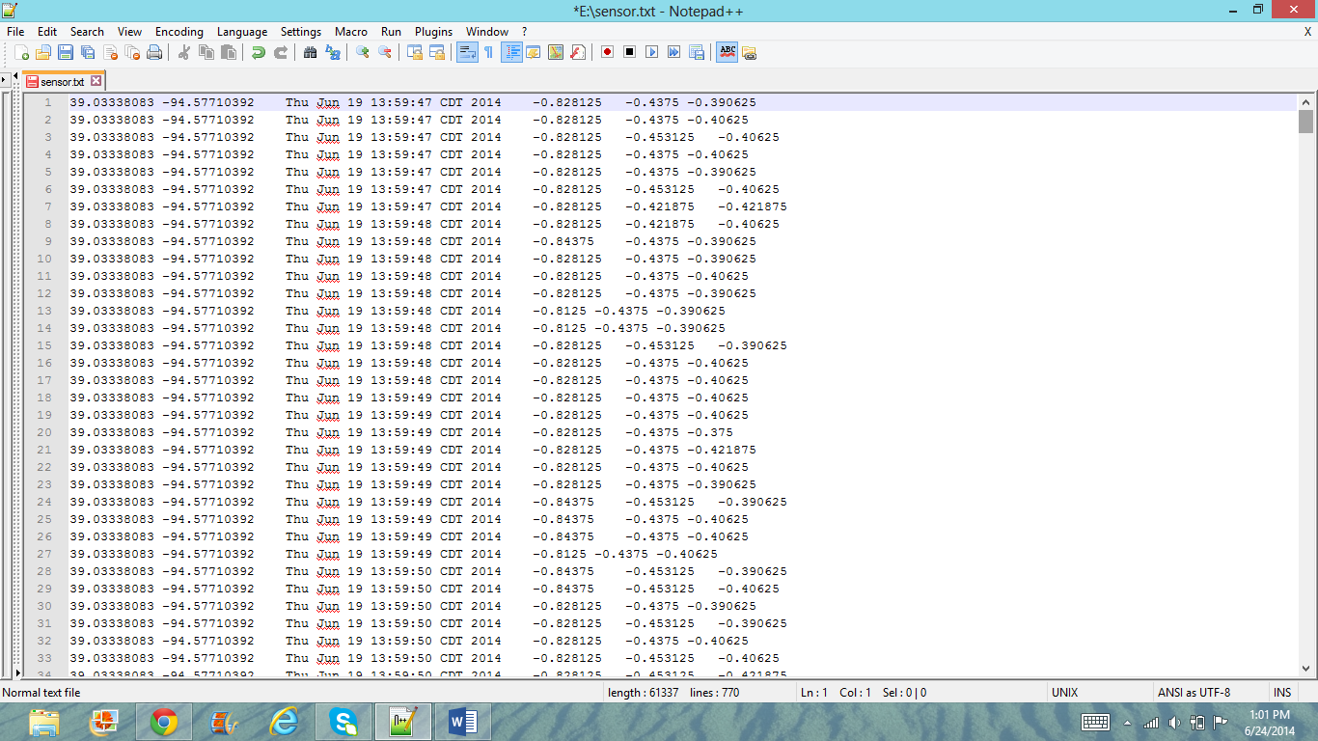

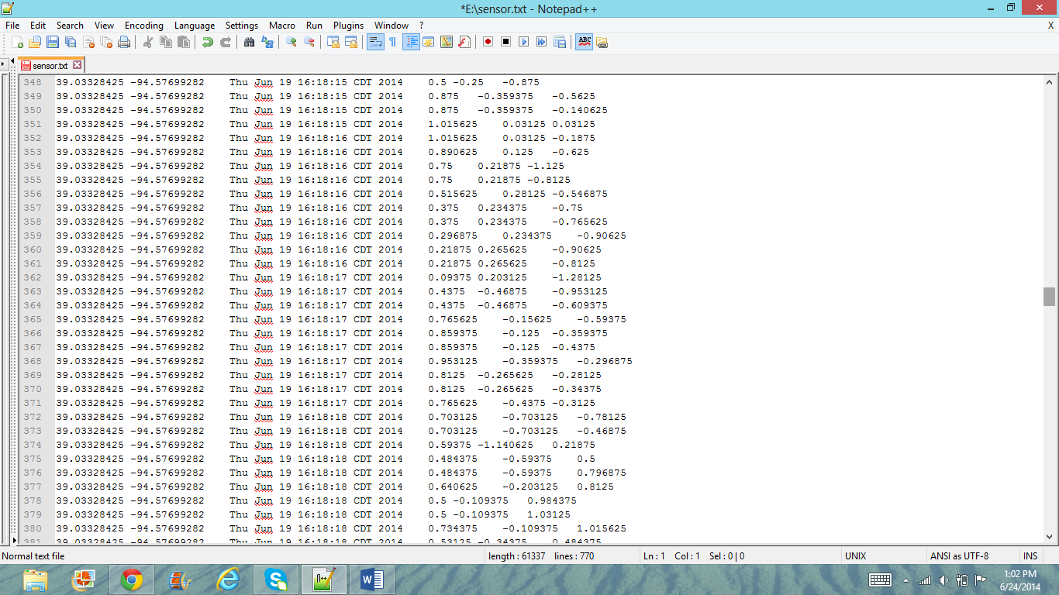

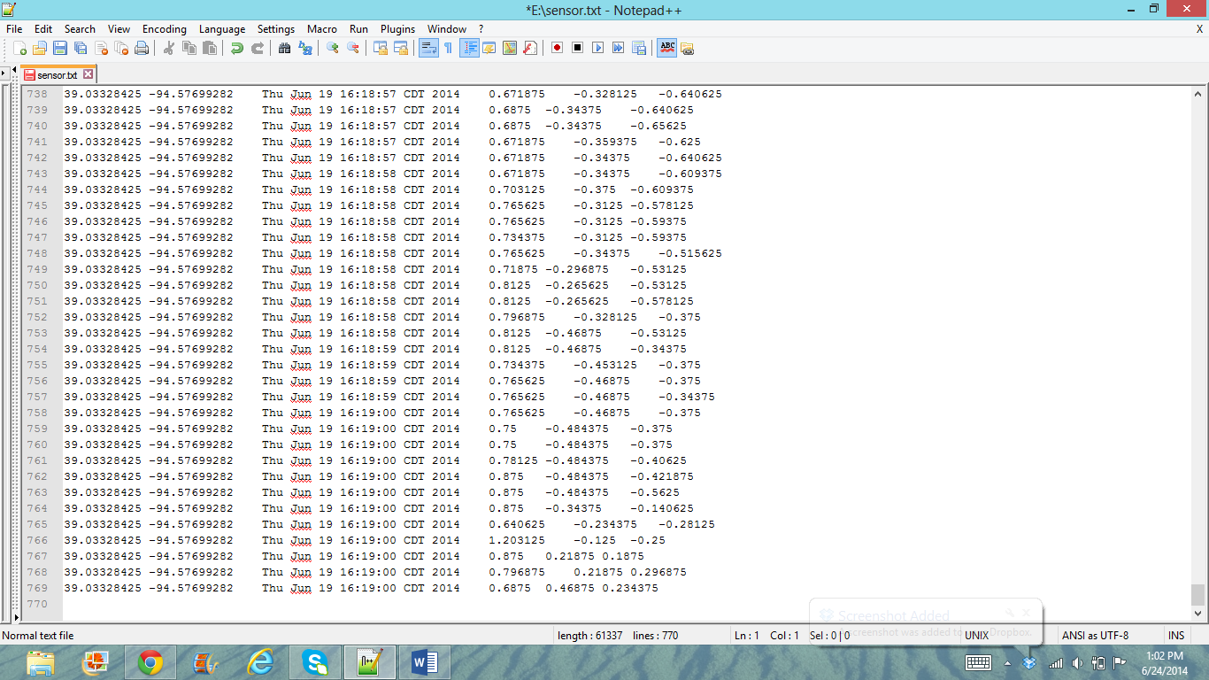

Importing the code and running locally is the key and connecting via UMKC Vpn in order to run via Hbase. Import the code and run on the local machine.The insertion of table, with the table name The command which is used to Get all row and count was : Getallrow() and the entire file system using Getalltable() command.

In order to retrieve,

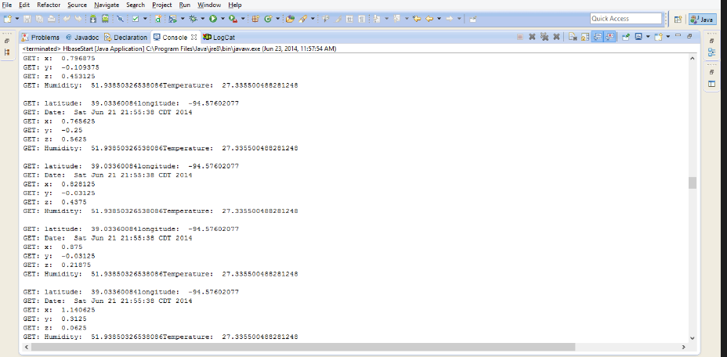

Retrieveall() command

This is how the table is created, inserted and retrieved.