# *Task1: Provide a Save File option once you invoke the HBASE Retrieval operation*

In order to create a table with the table name provided,

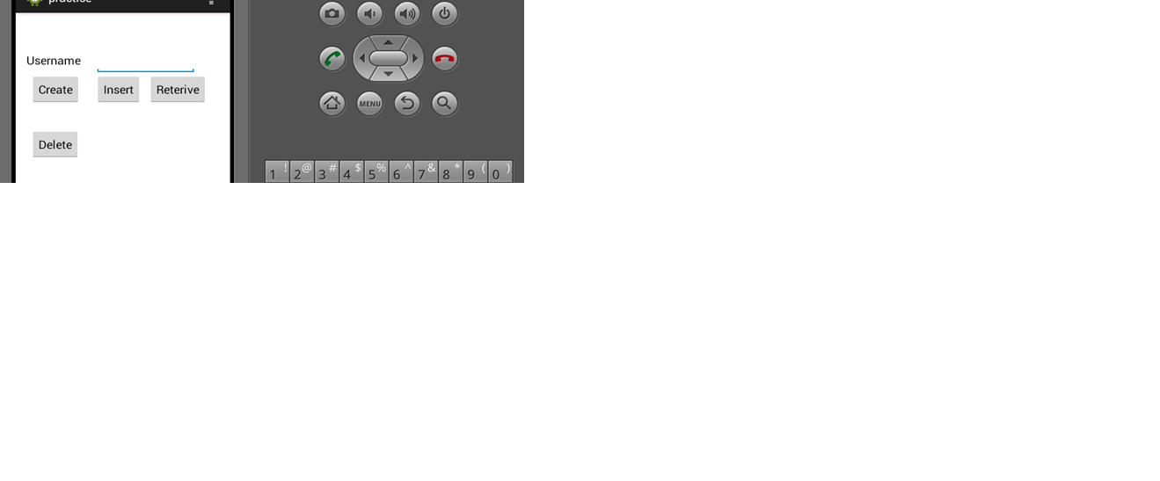

Create the table with the username provided and click on retrieve in order to retrieve, Created four training files and saved to our device. Upon creation of the local files, Saving the files on the cloudera would be the next step. Conversion of files into sequence files from the text file would be the next step [http://134.193.136.147:8080/HMMWS/jaxrs/generic/TrainFileOperation/-home-group6-LeftToRightJ.txt/-home-group6-leftrightj.seq](http://134.193.136.147:8080/HMMWS/jaxrs/generic/TrainFileOperation/-home-group6-LeftToRightJ.txt/-home-group6-leftrightj.seq%20%20)

Left to Right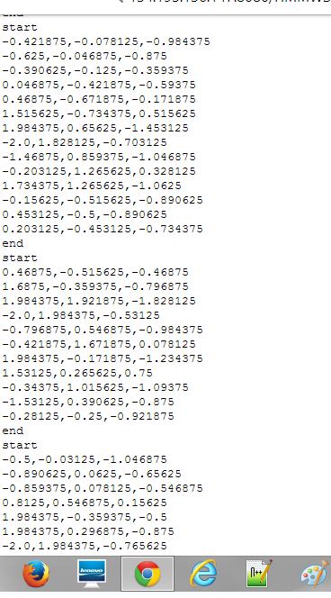

Right to Left



Bottom up

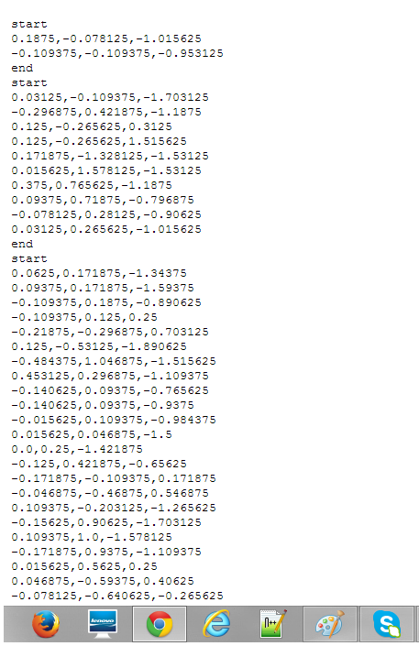

Test file Sequence

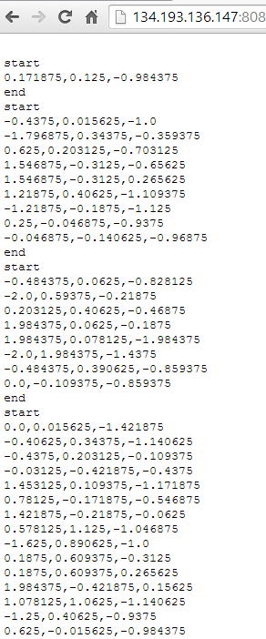

*Training and testing for activity recognition*

As we have set of sequence files for training and testing, now we have to run below service using our generated sequence files to identify whether training got success and generates motions. The further conclusions would be ensemble.

[http://134.193.136.127:8080/HMMWS/jaxrs/generic/HMMTrainingTest/-home-group6-leftrightj.seq/-home-group6-RightToLeft.seq/-home-group6-BTPJ.seq/-home-group6-TestFilej.seq](http://134.193.136.127:8080/HMMWS/jaxrs/generic/HMMTrainingTest/-home-group6-leftrightj.seq/-home-group6-RightToLeft.seq/-home-group6-BTPJ.seq/-home-group6-TestFilej.seq%20%20)