LinkedList vs Array

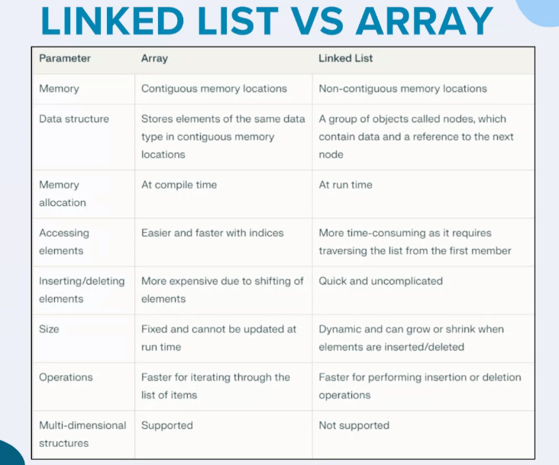

// RESOURCES

https://youtu.be/R9PTBwOzceo?si=yYyp-hLYakXft281

https://youtu.be/58YbpRDc4yw?si=g4ANNN6rfNVZoq21

https://youtu.be/N6dOwBde7-M?si=4RFsG83XiWLf_iVS

https://www.javatpoint.com/java-linkedlist

https://docs.oracle.com/javase/8/docs/api/java/util/LinkedList.html

// CODE

// Online Java Compiler

// Use this editor to write, compile and run your Java code online

public class Main {

public static void main(String[] args) {

Node first = new Node(1);

Node second = new Node(5);

Node third = new Node(0);

Node fourth = new Node(2);

Node fifth = new Node(4);

Node sixth = new Node(16);

first.next = second;

second.next = third;

third.next = fourth;

fourth.next = fifth;

fifth.next = sixth;

traverse(first);

System.out.println();

System.out.println("Middle node is: "+ middle(first).data );

}

static void traverse(Node first){

Node head=first;

while(head!=null){

System.out.print(head.data + "->");

head=head.next;

}

}

// Q1. Print the middle of a given linked list

static Node middle(Node head){

Node turtle = head;

Node rabit = head;

while(rabit.next!=null && rabit.next.next!=null){

rabit = rabit.next; // 1st Step

rabit = rabit.next; // 2nd Step

turtle = turtle.next;

}

return turtle;

}

}

class Node{

int data;

Node next;

Node(int d){

data = d;

}

}