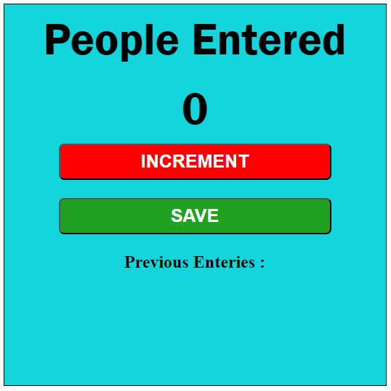

**Topic Covered:-**

* Script tag
* Variables
* Numbers
* Strings
* Functions
* The DOM
* getElementById()
* innerText and textContent
* innerHTML
* TASK

{

H1 : {

innerText : 6

}

}