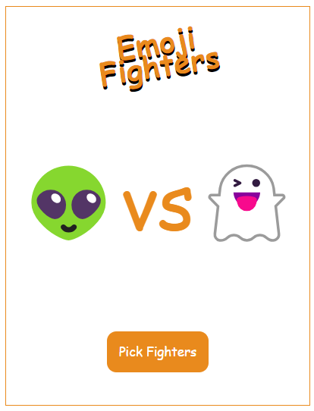

**Topic Covered:-**

* Arrays
* Math Object
* Time Events(setTimeout,cleartimeout,setInterval,clearInterval)
* Array maps and ForEach
* Stop watch

Css properties:-

font-family: 'Permanent Marker', cursive;

color: #e98a1d;

Arrays elements:-

[

'💀','☠️','👻','👽','😹','😸','🦒','🐭','🐨','🦄','🐒','🦬','🐘'

];