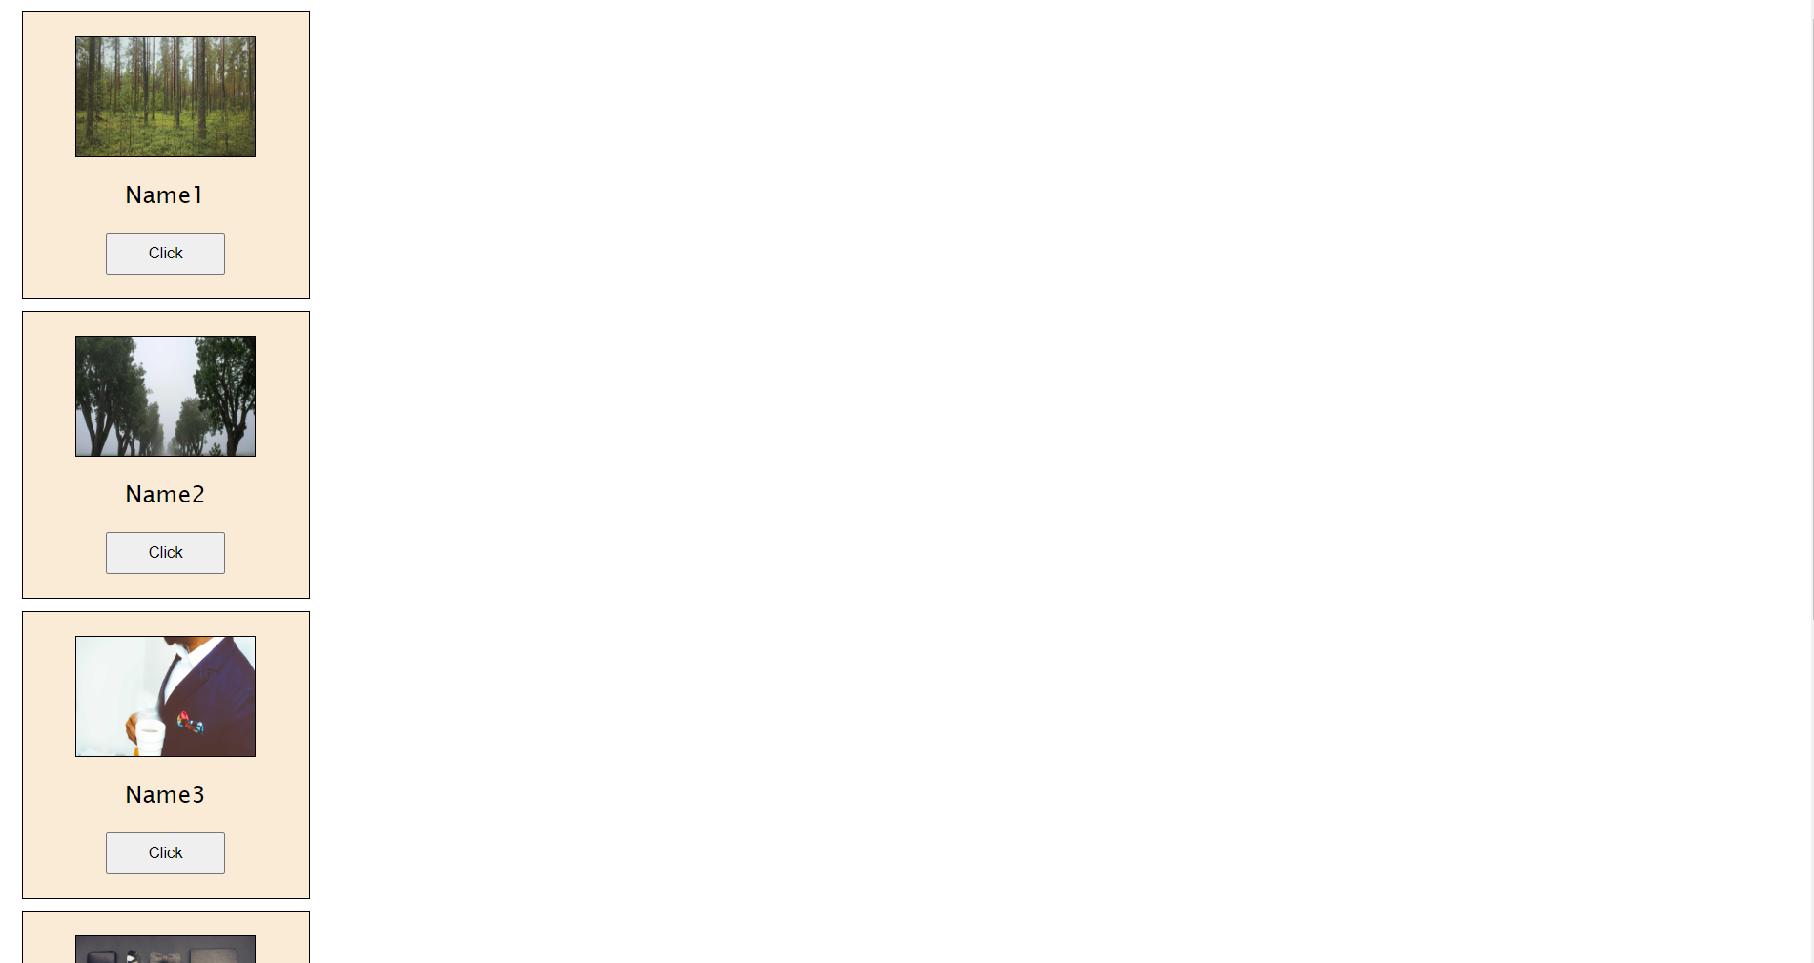

**Topic Covered:-**

* Objects
* Array of Objects
* InnerHTML
* Dynamic changes