|  |  |
| --- | --- |
| EXNO:1 | **OPENCV INSTALLATION - PYTHON** |
| DATE: |

**AIM**:

To install a opencv in python platform and working with python.

**PROCEDURE**

Step1: Open the Command line(search for cmd in the Run dialog( + R). Now run the following

command: python --version

If Python is already installed, it will generate a message with the Python version available.

Step2: Next, check if PIP is already installed on your system, just go to the command line and execute the

following command: pip -V

Step3: OpenCV can be directly downloaded and installed with the use of pip (package manager). To install

OpenCV, just go to the command-line and type the following command: pip install opencv-python

Step4: Type the command in the Terminal and proceed

Step5: pip install opencv-python

Step6: Collecting Information and downloading data:

Step7: Installing Packages

Step8: Finished Installation

Step9: To check if OpenCV is correctly installed, just run the following commands to perform a version

check: Python

import cv2

print(cv2.__version__)

**OUTPUT:**

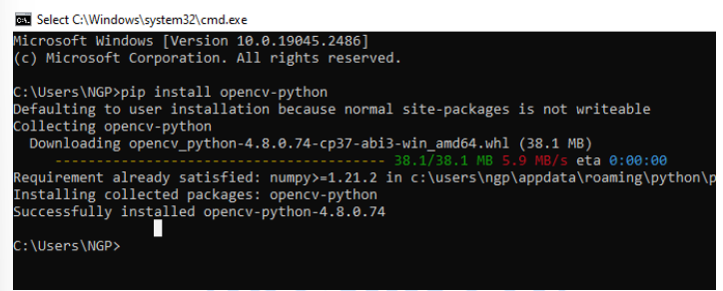

**RESULT**:

Thus, the installation of opencv in python platform and working with python was executed and output is verified successfully.

|  |  |
| --- | --- |
| EX NO: 2 | **Basic Image processing ,loading image ,cropping ,resizing, thresholding contour analysis ,blob detection** |
| DATE : |

**Aim:**

To write a python code to perform basic image processing such as loading image , cropping resizing , thresholding contour analysis ,blob detection.

**Algorithm:**

Step1: Import Necessary packages.

Step2:Load the image using cv2.imread()

Step3:Using plt.imshow() print the original image

Step4:By defining width and height crop the image and display the cropped image.

Step5:Using resize() print ‘Half’,’Bigger’,’Interpolation Nearest’ views to original image.

Step6:Print the Threshold analysis of the image

Step4:Print the contour analysis view of the image.

Step5:Load an image of different shapes for Blob detection.

Step6:Using SimpleBlobDetector_create() find the number of circles in the image and print the count.

**Program**:

import cv2

import matplotlib.pyplot as plt

import numpy as np

image = cv2.imread('image.jpg')

image2 = cv2.imread('image4.png')

image3=cv2.imread('images2.jpg')

**Load The Image:-**

plt.imshow(cv2.cvtColor(image, cv2.COLOR_BGR2RGB))

plt.axis('on')

plt.show()

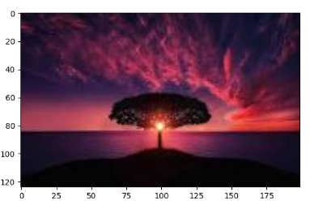

**Cropped Image**:

x = 40

y = 75

width = 200

height = 200

cropped_image = image[y:y+height, x:x+width]

plt.imshow(cv2.cvtColor(cropped_image, cv2.COLOR_BGR2RGB))

plt.axis('on')

plt.show()

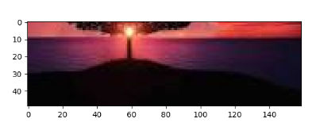

**Resized Image:**

new_width = 300

new_height = 300

resized_image = cv2.resize(image, (new_width, new_height))

plt.imshow(cv2.cvtColor(resized_image, cv2.COLOR_BGR2RGB))

plt.axis('on')

plt.show()

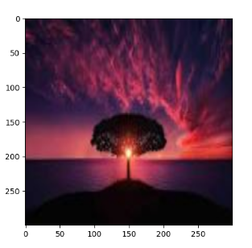

**Thresholding and contour analysis:**

gray_image = cv2.cvtColor(image3, cv2.COLOR_BGR2GRAY)

_, thresholded_image = cv2.threshold(gray_image, 127, 255, cv2.THRESH_BINARY)

plt.imshow(thresholded_image, cmap='gray')

plt.axis('off')

plt.show()

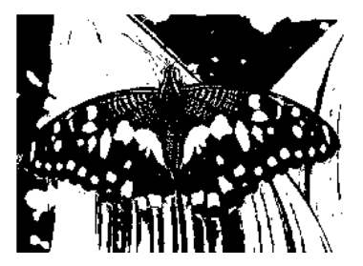

**Contour analysis:-**

contours, _ = cv2.findContours(thresholded_image, cv2.RETR_EXTERNAL, cv2.CHAIN_APPROX_SIMPLE)

cv2.drawContours(image3, contours, -1, (0, 255, 0), 2)

plt.imshow(cv2.cvtColor(image3, cv2.COLOR_BGR2RGB))

plt.axis('on')

plt.show()

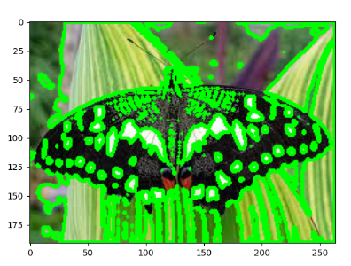

**Blob Detection:**

params = cv2.SimpleBlobDetector_Params()

blob_detector = cv2.SimpleBlobDetector_create(params)

keypoints = blob_detector.detect(image2)

blob_image = cv2.drawKeypoints(image2, keypoints, np.array([]), (0, 0, 255), cv2.DRAW_MATCHES_FLAGS_DRAW_RICH_KEYPOINTS)

plt.imshow(cv2.cvtColor(blob_image, cv2.COLOR_BGR2RGB))

plt.axis('on')

plt.show()

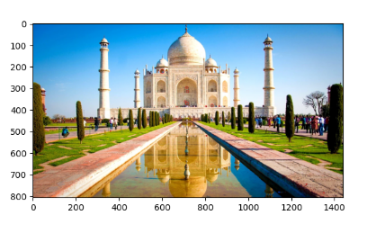

**Result:**

Thus the python program to perform various operations on image using open-CV was verified and executed successfully.

|  |  |
| --- | --- |
| EX NO: 3 | **Image Annotation – Drawing lines, text circles, rectangle, ellipse on image** |
| DATE : |

**Aim:**

To write a python code to perform a image annotation in drawing lines, text circle, rectangle, ellipse on image.

**Algorithm:**

Step1: Start the program.

Step2: Load the image using in read() function

Step3: Using the line in the image by line (image line, point A, point B)

Step4: Draw the circle in the image

Step5: Draw the rectangle in the image using rectangle function

Step6: Draw the eclipse in the image

Step7: Stop the program

**Program**:

import cv2

import matplotlib.pyplot as plt

# Read the original image

img = cv2.imread("images.jpeg")

**# Display the original image**

plt.imshow(cv2.cvtColor(img, cv2.COLOR_BGR2RGB))

plt.axis('off')

plt.title("Original Image")

plt.show()

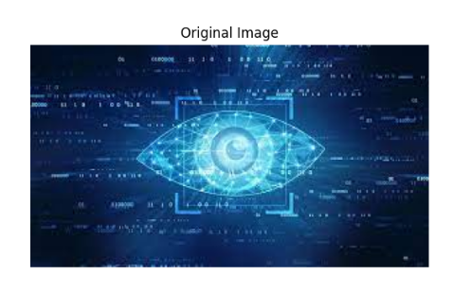

**# Line Image:**

imageLine = img.copy()

pointA = (50, 50)

pointB = (100, 50)

cv2.line(imageLine, pointA, pointB, (255, 255, 0), thickness=3)

# Display the line image

plt.imshow(cv2.cvtColor(imageLine, cv2.COLOR_BGR2RGB))

plt.axis('off')

plt.title("Line Image")

plt.show()

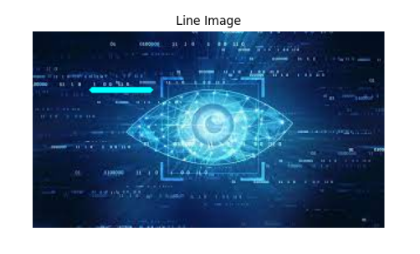

**# Circle Image:**

imageCircle = img.copy()

circle_center = (50, 50)

radius = 50

cv2.circle(imageCircle, circle_center, radius, (0, 0, 255), thickness=3, lineType=cv2.LINE_AA)

# Display the circle image

plt.imshow(cv2.cvtColor(imageCircle, cv2.COLOR_BGR2RGB))

plt.axis('off')

plt.title("Circle Image")

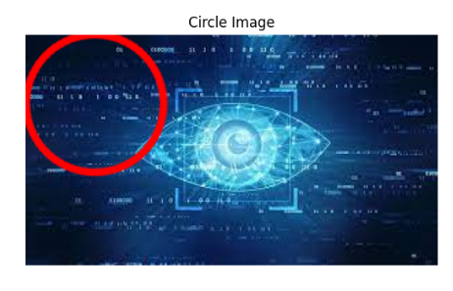plt.show()

**# Rectangle Image:**

height, width, _ = img.shape

rect_width = 100

rect_height = 50

x = (width - rect_width) // 2

y = (height - rect_height) // 2

start_point = (x, y)

end_point = (x + rect_width, y + rect_height)

color = (0, 0, 255)

thickness = 2

annotated_image = cv2.rectangle(img.copy(), start_point, end_point, color, thickness)

# Display the rectangle image

plt.imshow(cv2.cvtColor(annotated_image, cv2.COLOR_BGR2RGB))

plt.axis('off')

plt.title("Rectangle Image")

plt.show()

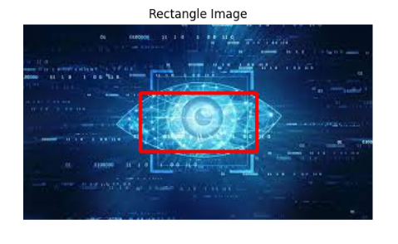

**# Ellipse Image:**

center_x = width // 2

center_y = height // 2

axis1_length = 100

axis2_length = 50

color = (0, 0, 255)

thickness = 2

annotated_image = cv2.ellipse(img.copy(), (center_x, center_y), (axis1_length, axis2_length), 0, 0, 360, color, thickness)

# Display the ellipse image

plt.imshow(cv2.cvtColor(annotated_image, cv2.COLOR_BGR2RGB))

plt.axis('off')

plt.title("Ellipse Image")

plt.show()

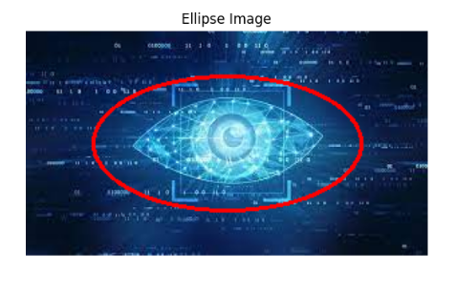

**Result:**

Thus the python program to perform various operations on image using open-CV was verified and executed successfully.

|  |  |
| --- | --- |
| EX NO: 4 | **Image Enhancement - Understanding Color spaces, color space**  **conversion, Histogram equalization, Convolution, Image**  **smoothing, Gradients, Edge Detection** |
| DATE : |

**Aim:**

To write a python code to perform Image Enhancement - Understanding Color spaces, color space Conversion , Histogram equalization, Convolution, Image smoothing, Gradients, Edge Detection.

**Algorithm:**

Step1: Import Necessary packages.

Step2: Load the image using cv2.imread()

Step3: Convert image to grayscale.

Step4: Convert image to HSV.

Step5: Perform histogram equalization.

Step6: Perform Convolution (Edge Detection).

Step7: Perform Image Smoothing.

Step8: Perform Gradients and Edge Detection.

Step9: display all the images.

Step10: Stop the program.

**Program**:

import cv2

from google.colab.patches import cv2_imshow

import numpy as np

# Load the image

image = cv2.imread('/content/drive/MyDrive/Images/ball.jpg')

# Convert the image to grayscale

gray_image = cv2.cvtColor(image, cv2.COLOR_BGR2GRAY)

# Convert the image to HSV color space

hsv_image = cv2.cvtColor(image, cv2.COLOR_BGR2HSV)

# Apply histogram equalization to the grayscale image

equalized_image = cv2.equalizeHist(gray_image)

# Define a kernel for convolution

kernel = np.array([[0, -1, 0], [-1, 4, -1], [0, -1, 0]])

# Apply convolution using the defined kernel

convolved_image = cv2.filter2D(image, -1, kernel)

# Apply Gaussian blur to the image

blurred_image = cv2.GaussianBlur(image, (5, 5), 0)

# Apply Sobel edge detection in the x and y directions

sobel_x = cv2.Sobel(gray_image, cv2.CV_64F, 1, 0, ksize=3)

sobel_y = cv2.Sobel(gray_image, cv2.CV_64F, 0, 1, ksize=3)

# Calculate gradient magnitude using Sobel derivatives

gradient_magnitude = cv2.magnitude(sobel_x, sobel_y)

# Apply Canny edge detection

canny_edges = cv2.Canny(gray_image, threshold1=100, threshold2=200)

# Display the results

print("Original Image")

cv2_imshow(image)

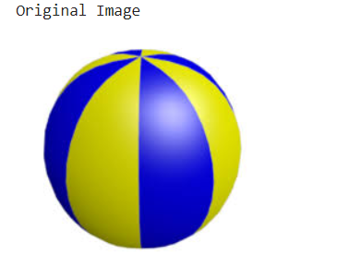

print("Grayscale Image")

cv2_imshow(gray_image)

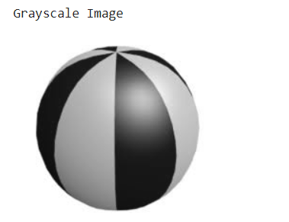

print("HSV Image")

cv2_imshow(hsv_image)

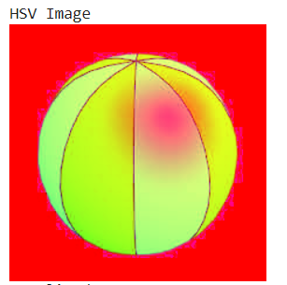

print("Equalized Image")

cv2_imshow(equalized_image)

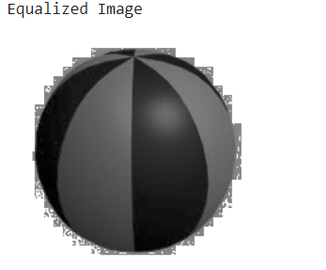

print("Convolved Image")

cv2_imshow(convolved_image)

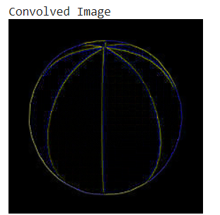

print("Blurred Image")

cv2_imshow(blurred_image)

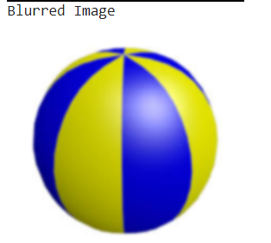

print("Gradient Magnitude")

cv2_imshow(gradient_magnitude)

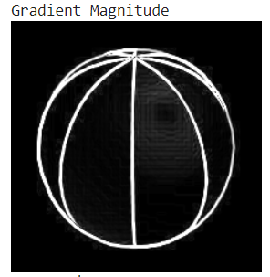

print("Canny Edges")

cv2_imshow(canny_edges)

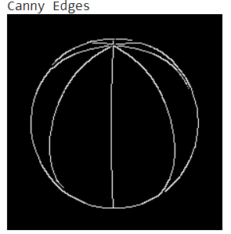

# Wait for a key event and close all windows

cv2.waitKey(0)

cv2.destroyAllWindows()

**Result:**

Thus, the python program to perform Image Enhancement - Understanding Color spaces, color space Conversion , Histogram equalization, Convolution, Image smoothing, Gradients, Edge Detection was verified and executed successfully.

|  |  |
| --- | --- |
| EX NO: 5 | **IMAGE FEATURES AND IMAGE**  **ALIGNMENT** |
| DATE : |

**Aim:**

To perform image features and image alignment image transformation fourier, hough, extract ORB image features ,features matching ,cloning ,feature matching based on image alignment.

**Algorithm:**

Step1:Start the program

Step2:import cv2 and matplotlib

Step3:Load the image

Step4:Display the fourierbimagebof the image

Step5:Display the hough edged image

Step6:Display the ORB matching images using matplotlib

Step7:Display the cloned image

Step8:display the featured image

Step9:Stop the program

**Program**:

import cv2

import numpy as np

from google.colab.patches import cv2_imshow

# Load the image

image = cv2.imread("/content/drive/MyDrive/Images/ball.jpg")

# Display the original image

print('\nOriginal Image')

cv2_imshow(image)

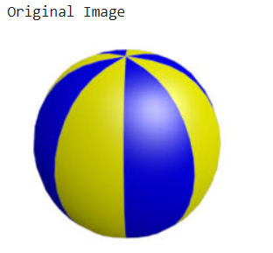

# Convert the image to grayscale

gray = cv2.cvtColor(image, cv2.COLOR_BGR2GRAY)

# Compute the Fourier Transform

f_transform = np.fft.fft2(gray)

f_shift = np.fft.fftshift(f_transform)

magnitude_spectrum = 20 * np.log(np.abs(f_shift))

# Display the Fourier Transform magnitude spectrum

print('\nFourier Image')

cv2_imshow(magnitude_spectrum)

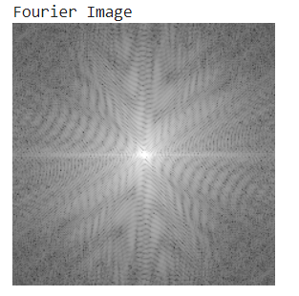

# Apply Canny edge detection

edges = cv2.Canny(gray, 50, 150, apertureSize=3)

# Display the Canny edge image

print('\nCanny edge image')

cv2_imshow(edges)

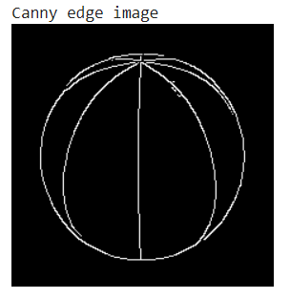

# Create an ORB detector

orb = cv2.ORB_create()

# Detect keypoints and compute descriptors

keypoints, descriptors = orb.detectAndCompute(gray, None)

# Draw keypoints on the image

keypoint_image = cv2.drawKeypoints(image, keypoints, None)

# Display the ORB keypoints image

print('\nORB Image')

cv2_imshow(keypoint_image)

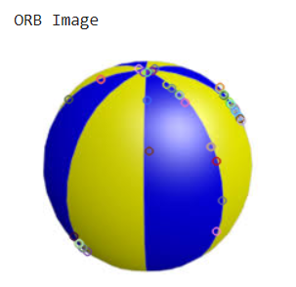

# Create a Brute-Force Matcher

bf = cv2.BFMatcher(cv2.NORM_HAMMING, crossCheck=True)

# Match descriptors

matches = bf.match(descriptors, descriptors)

matches = sorted(matches, key=lambda x: x.distance)

# Draw matched features

matched_image = cv2.drawMatches(image, keypoints, image, keypoints, matches[:10], None,

flags=cv2.DrawMatchesFlags_NOT_DRAW_SINGLE_POINTS)

# Display the matched feature image

print('\nMatched feature image')

cv2_imshow(matched_image)

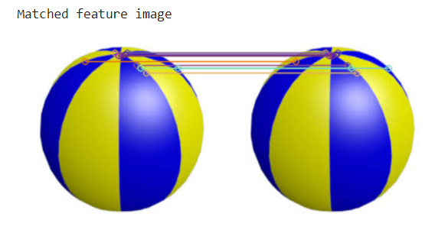

# Create a clone of the original image

cloned_image = image.copy()

# Display the cloned image

print('\nCloned image')

cv2_imshow(cloned_image)

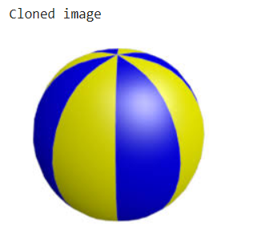

**Result:**

Thus the program for image features and image alignment was executed and the output

verified successfully

|  |  |
| --- | --- |
| EXNO:6 | **Image segmentation using Graph Cut and Grab Cut method** |
| DATE: |

**AIM**:

To write a python code to perform image segmentation using graph cut and grab cut

method.

# ALGORITHM:

Step1:Strat the program.

Step2:Import necessary packages and Load the image. Step3: Create a graph .Add nodes for each pixel

Step4: Set unary potentials (data term) based on pixel intensities Step5: Define neighborhood structure (4-connectivity)

Step6: Set pairwise potentials (smoothness term) based on pixel similarity.Compute the maximum flow.

Step7: Get the segmentation result. Convert the result to a binary mask. Display the segmentation result.

Step8: Create a mask initialized with zeros, and two arrays for the background and foreground models.

Step9: Define a rectangle around the object you want to segment (initial bounding box). Step10: Initialize GrabCut with the rectangle as the initial region

Step11: Create a mask where all the probable foreground pixels are labeled as 3, others as 0 Step12: Multiply the original image with the mask to get the segmented object

Step13: Display the segmented image> Step14:Stop the program.

# PROGRAM:

import numpy as np

import cv2

from matplotlib import pyplot as plt

# Load the image

image_path = '/content/drive/MyDrive/Images/Apple.jpg'

image = cv2.imread(image_path)

image = cv2.cvtColor(image, cv2.COLOR_BGR2RGB)

# Create a mask for the foreground and background

mask = np.zeros(image.shape[:2], np.uint8)

# Define the rectangle enclosing the object of interest

rect = (25, 25, image.shape[1] - 20, image.shape[0] - 20)

# Initialize the foreground and background models

bgdModel = np.zeros((1, 65), np.float64)

fgdModel = np.zeros((1, 65), np.float64)

# Apply GraphCut algorithm

cv2.grabCut(image, mask, rect, bgdModel, fgdModel, 5, cv2.GC_INIT_WITH_RECT)

# Modify the mask to create a binary mask for the foreground and background

graphcut_mask = np.where((mask == 2) | (mask == 0), 0, 1).astype('uint8')

# Apply the mask to the original image

graphcut_segmented = image * graphcut_mask[:, :, np.newaxis]

# Reset the mask for GrabCut

mask.fill(0)

mask[graphcut_mask == 1] = cv2.GC_PR_FGD # Set probable foreground for GrabCut

# Apply GrabCut algorithm

cv2.grabCut(image, mask, None, bgdModel, fgdModel, 5, cv2.GC_INIT_WITH_MASK)

# Modify the mask to create a binary mask for the foreground and background

grabcut_mask = np.where((mask == 2) | (mask == 0), 0, 1).astype('uint8')

# Apply the mask to the original image

grabcut_segmented = image * grabcut_mask[:, :, np.newaxis]

# Display the original image, GraphCut segmented image, and GrabCut segmented image

plt.figure(figsize=(18, 6))

plt.subplot(131)

plt.imshow(image)

plt.title('Original Image')

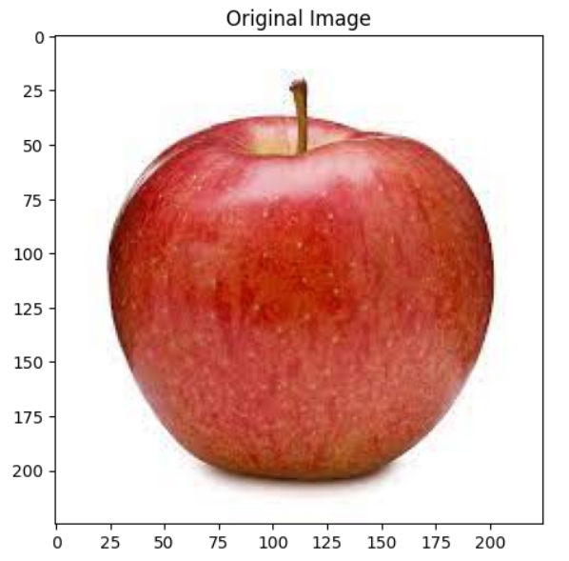

plt.subplot(132)

plt.imshow(graphcut_segmented)

plt.title('GraphCut Segmented Image')

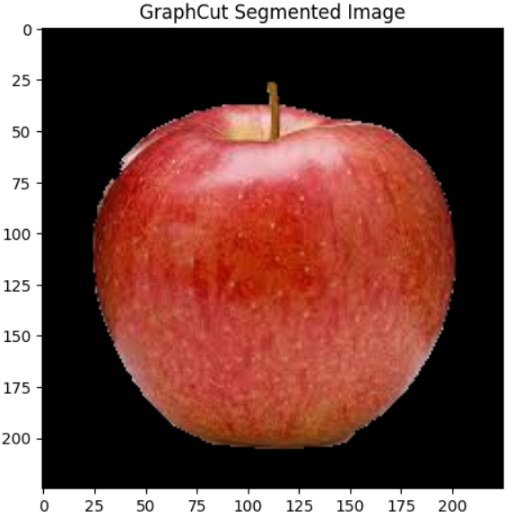

plt.subplot(133)

plt.imshow(grabcut_segmented)

plt.title('GrabCut Segmented Image')

plt.show()

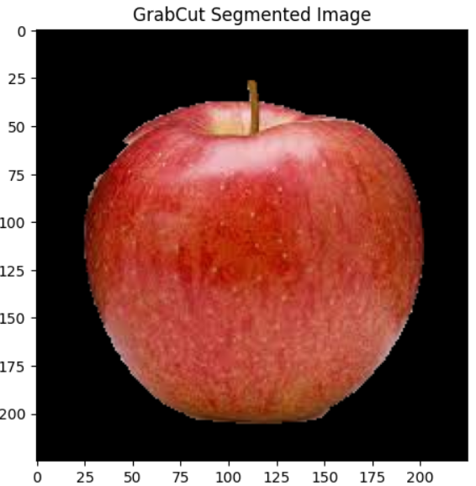

RESULT:

Thus the above python program to perform image segmentation using graph cut and grab cut method was verified and executed successfully.

|  |  |
| --- | --- |
| EXNO:7 | **Camera Calibration with circular grid** |
| DATE |

**AIM**:

To write a python program to perform camera calibration with circular grid.

# ALGORITHM:

Step1:Start the program.

Step2:Import the necessary pacakages.

Step3: Define the number of grid corners in the calibration pattern.( Number of rows in the grid, Number of columns in the grid)

Step4: Load the input image.

Step5: Convert the image to grayscale.

Step6: Generate the grid points in the real world (assuming a square grid) Step7: Find the circular grid corners

Step8: If corners are found, add them to the object and image points lists Step9: Perform camera calibration.

Step10: Save the calibration parameters to a file (you can use them later) Step11: Print the camera matrix and distortion coefficients.

Step12: Draw circles at the detected corner positions. Step13: Display the input image with detected corners. Step14:Stop the program.

# PROGRAM:

import cv2

import numpy as np num_rows = 6

num_cols = 9 input_image_path = 'chess.png'

image = cv2.imread(input_image_path)

gray = cv2.cvtColor(image, cv2.COLOR_BGR2GRAY)

grid_size = 1.0 # Size of each square in your calibration grid (e.g., 1 inch)

objp = np.zeros((num_rows * num_cols, 3), np.float32)

objp[:, :2] = np.mgrid[0:num_cols, 0:num_rows].T.reshape(-1, 2) * grid_size

ret, corners = cv2.findCirclesGrid(

gray, (num_cols, num_rows), None, cv2.CALIB_CB_SYMMETRIC_GRID

)

if ret:

obj_points = [objp] img_points = [corners]

ret, mtx, dist, rvecs, tvecs = cv2.calibrateCamera(obj_points, img_points, gray.shape[::-1], None, None)

calibration_data = { "camera_matrix": mtx, "distortion_coefficients": dist,

}

np.save("camera_calibration.npy", calibration_data) print("Camera Matrix:")

print(mtx)

print("\nDistortion Coefficients:") print(dist)

for corner in corners:

cv2.circle(image, (int(corner[0][0]), int(corner[0][1])), 3, (0, 0, 255), -1) cv2.imshow("Calibration Image", image)

cv2.waitKey(0) cv2.destroyAllWindows()

else:

print("Corners not found. Calibration failed.")

# OUTPUT:

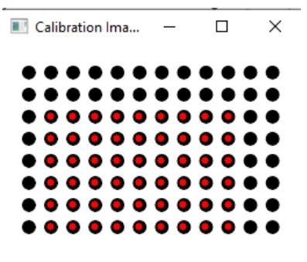

**RESULT**:

Thus the above program to perform camera calibration using circular grid was verified and executed successfully.