Java Colletioctions:-
Collection in Java , is a Framework to reresent it in asingle entity
In General:-
In java,It Considered as root interface of collection framework
Collection interface defines the most general method which are applicable for any collection objects

Collections:-

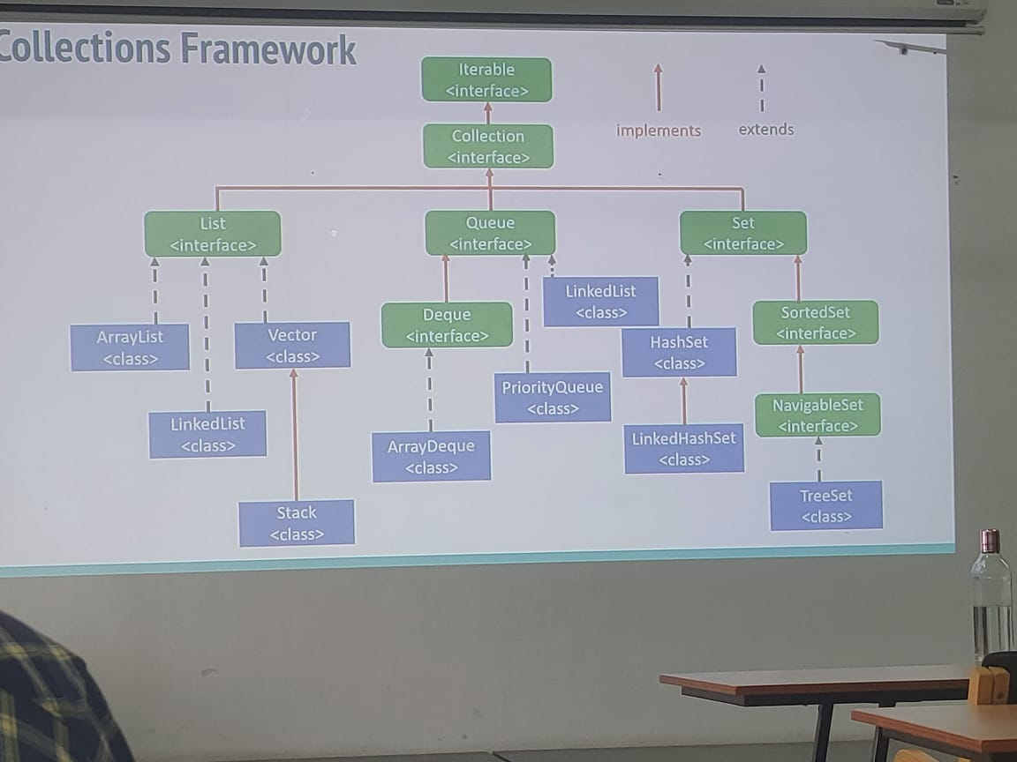
Green – Interfaces
Blue – Classes
Maps:-

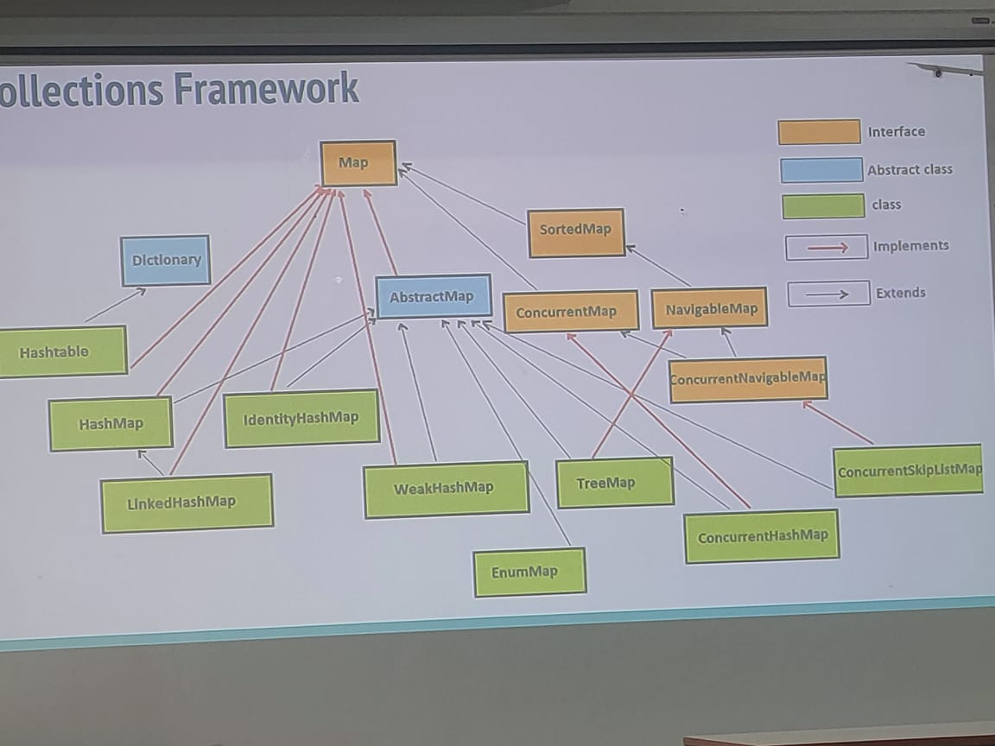

Difference between Collection Interface and Collections class:-
Collection is an interface which can be used to represent a group of indivtaul ibject as an single entity
collections is a utility class present in java.util package to define several utilty methods for collections object
There is no concrete class which implemets collection interface directly

Difference between Arrays and Collections:-

Functionality | Arrays | Collections
Sizing | Fixed Size cannont be resized | Dynamically resizable
Add or Remove Element | Need Manual Shifting | Easily add or remove elements
Type Safety | Lacks type with Generics | Collection is Strong type safety with Generics
Iterable | Not Inherently Iterable | Can be used in Enhanced for loop
Sorting | Arrays.sort() for primitives | Collections.sort() for object
Memory Management | More Memory Efficient for primitives | More Memory Overhead due to extra features
Inheritance | Doesn’t inherites from any Class | Collections interface  Extends Iterable
Polymorphism | Not polymorphic | Polymorphic due to interfaces like list set etc..,
Length retrival | Array.Length | Size method

List:-

