**NUTRITION ASSISTANT**

# A MINI-PROJECT REPORT

***Submitted by***

|  |  |
| --- | --- |
| **AAKASH S** | **710721205001** |
| **BALAJI C** | **710721205007** |
| **YASWANTH KUMAR A** | **710721205063** |

***in partial fulfillment for the award of the degree***

***of***

**BACHELOR OF TECHNOLOGY**

# IN INFORMATION TECHNOLOGY

**Dr. N. G. P. INSTITUTE OF TECHNOLOGY, COIMBATORE - 641048 (AN AUTONOMOUS INSTITUTION)**

**NUTRITION ASSISTANT**

# A MINI-PROJECT REPORT

***Submitted by***

|  |  |
| --- | --- |
| **AAKASH S** | **710721205001** |
| **BALAJI C** | **710721205007** |
| **YASWANTH KUMAR A** | **710721205063** |

***in partial fulfillment for the award of the degree***

***of***

**BACHELOR OF TECHNOLOGY**

# IN INFORMATION TECHNOLOGY

**Dr. N. G. P. INSTITUTE OF TECHNOLOGY, COIMBATORE - 641048 (AN AUTONOMOUS INSTITUTION)**

**ANNA UNIVERSITY: CHENNAI 600 025**

**BONAFIDE CERTIFICATE**

Certified that this project report **“NUTRITION ASSISTANT”** is the Bonafide work of **AAKASH S (710721205001), BALAJI C (710721205007), YASWANTH KUMAR A (710721205063)”** who carried out the project work under my supervision.

|  |  |
| --- | --- |
| **SIGNATURE** | **SIGNATURE** |
| **Dr. M. KRISHNAMOORTHI M.E., Ph.D.,** | **Mr.T.VIJAYAKUMAR M.E.,(Ph.D).,** |
| **HEAD OF THE DEPARTMENT** | **ASSISTANT PROFESSOR (SG)** |
| Department of Information Technology, | Department of Information Technology, |
| Dr. N. G. P Institute of Technology, | Dr. N.G.P Institute of Technology, |
| Kalapatti Road, | Kalapatti Road, |
| Coimbatore-641 048. | Coimbatore-641 048. |

Submitted for the End Semester Project Viva-Voce held on

# _ _ _ _ _ _ _ _ _ _ _ _ _ _ _ _ _ _ _ _ _ _ _ _ _

**INTERNAL EXAMINER EXTERNAL EXAMINER**

# ACKNOWLEDGEMENT

We extend our heartiest thanks to **Dr. NALLA G. PALANISWAMI**, Chairman, KMCH & Dr. N.G.P. Educational Institutions for providing us the necessary infrastructure to do our project work.

We express our gratitude to **Dr. THAVAMANI D. PALANISWAMI**, Secretary, Dr. N.G.P. Institute of Technology, for providing us the facilities to do our project work.

We would like to express our hearty thanks and gratitude to **Dr. S.U. PRABHA, M.E., Ph.D.,** Principal, Dr. N.G.P. Institute of Technology, for her earnest encouragement.

We extend our deep sense of gratitude to **Dr. M. KRISHNAMOORTHI, M.E., Ph.D.,** Head of the Department, Department of Information Technology, for his valuable guidance and constructive suggestion at all stages of our project from inception to completion.

We express our hearty thanks to our project guide **Mr. T. VIJAYAKUMAR, M.E,(Ph.D).,** Assistant Professor (SG), Department of Information Technology, for his valuable guidance and timely help for completing our project.

We express our sincere thanks to our mini project coordinator

**Dr. D. PAVITHRA M.E.,M.B.A.., Ph.D.,** Assistant Professor (SG), Department of Information Technology, for her support in developing our project.

We would also like to express our gratitude to the faculty members of Department Information Technology and also to our family for their kind patronage.

# ABSTRACT

This mobile application helps patients manage their nutrition after being discharged from medical treatment. Users can scan their medical reports to extract health conditions. The app then suggests personalized food habits and meal plans based on the user's health profile. Real-time food scanning identifies meals and ingredients using image recognition technology. It provides nutritional information and diet tips tailored to the patient's needs. The goal is to assist recovering patients in following optimal diets by analyzing their unique medical data and food intake. Key features include health report processing, customized diet recommendation, and real-time food image recognition. Target users are patients lacking nutrition knowledge or support after hospital discharge. Expected benefits are improved nutrition, recovery, and wellbeing through personalized and timely feedback. This app aims to leverage AI techniques like computer vision and predictive analytics to provide data-driven, tailored nutrition guidance to patients transitioning from hospital to home.

**KEYWORDS**: Computer vision, Predictive analytics, Personalized nutrition, Food tracking, Post-discharge care, Health and wellness.

|  |  |  |
| --- | --- | --- |
| **CHAPTER NO** | **TITLE** | **PAGE NO** |
|  | **ABSTRATCT** | **v** |
|  | **LIST OF FIGURES** | **ix** |
|  | **LIST OF ABBREVIATIONS** | **x** |
| **1** | **INTRODUCTION** | **11** |
|  | 1.1 OBJECTIVE | 11 |
|  | 1.2 SCOPE OF THE PROJECT | 12 |
| 1.3 PROBLEM STATEMENT | 12 |
| 1.4 FLOW DIAGRAM | 13 |
| **2** | **LITERATURE SURVEY** | **14** |
|  | 2.1 INTRODUCTION | 14 |
|  | 2.2 LITERATURE REVIEW | 14 |
| **3** | **EXISTING SYSTEM** | **17** |
|  | 3.1 EXISTING SYSTEM | 17 |
|  | 3.2 DRAWBACKS OF EXISTING SYSTEM | 17 |
| **4** | **SOFTWARE SPECIFICATIONS** | **18** |
|  | 4.1 HARDWARE SPECIFICATIONS | 18 |
|  | 4.2 SOFTWARE SPECIFICATIONS | 18 |

|  |  |  |
| --- | --- | --- |
|  | * + 1. TECHNOLOGY AND TOOLS     2. DRAWBACKS OF EXISTING SYSTEM     3. SOFTWARE DESCRIPTION | 19  19  21 |
| **5** | **PROPOSED SYSTEM**  5.1 PROPOSED SYSTEM  4.2 PROPOSED ARCHITECTURE | **22**  22  22 |
| **6** | **TESTING** | **23** |
|  | 6.1 TESTING INTRODUCTION | 23 |
|  | 6.1.1 STRATEGIC APPROACH | 23 |
|  | TO SOFTWARE TESTING |  |
|  | 6.1.1.1. UNIT TESTING | 24 |
|  | 6.1.1.2. FUNCTIONAL TESTING | 24 |
| 6.1.1.3. CONDITIONAL TESTING | 24 |
| 6.1.1.4. PERFORMANCE TESTING | 24 |
| 6.1.1.5. SECURITY TESTING | 25 |
| 6.1.1.6. SYSTEM TESTING | 25 |
| **7** | **DEPLOYMENT** | **26** |
|  | 7.1 DEPLOYMENT DETAILS | 26 |

|  |  |  |
| --- | --- | --- |
| **8** | **RESULT AND DISCUSSION** | **27** |
|  | 8.1 OUTPUT AND DISPLAY | 27 |
| **9** | **CONCLUSION** | **31** |
|  | 9.1 CONCLUSION | 31 |
| **10** | **APPENDIX** | **32** |
|  | 10.1 READ ME FILE | 32 |
|  | 10.1 ABOUT THE APPLICATION | 32 |
|  | 10.2 DEVLEOPERS | 32 |
| **11** | **SOURCE CODE** | **33** |
|  | 11.1 DASHBOARD | 33 |
|  | 11.2 ADMIN | 35 |
|  | 11.3 BACKEND | 36 |
|  | 11.4 STUDENT JSP | 37 |
| **12** | **REFERENCES** | **40** |

# LIST OF FIGURES:

|  |  |  |
| --- | --- | --- |
| **FIGURE NO** | **FIGURE NAME** | **PAGE NO** |
| 1 | Flow Diagram | 13 |
| 2 | Block Diagram | 22 |
| 3 | Main Module page | 27 |
| 4 | Admin Login page | 28 |
| 5  6  7  8  9 | Admin Dashboard Student/Staff Login page Student/staff Dashboard Book Issue  Book Issue Result | 28  29  29  30  30 |

**LIST OF ABBREVIATIONS**

0

|  |  |
| --- | --- |
| HTML | Hyper Text Markup Language |
| CSS | Cascading Style Sheet |
| JS | Java Script |
| JSP | Java Servlet Page |
| DB | Data Base |
| IDE | Integrated Development Environment |
| LMS | Library Management System |
| RAM | Random Access System |
| GPU | Graphical User Interface |
| CPU | Central Processing Unit |
| SQL | Structured Query Language |
| JDBC | Java Data Base Connectivity |

# CHAPTER – 1 INTRODUCTION

The transition from hospital to home can be challenging for recovering patients, especially regarding diet and nutrition. This application employs innovative technology to provide personalized nutritional guidance tailored to individual health needs. The core functionality involves scanning medical reports to extract health conditions using optical character recognition and natural language processing. This data fuels a proprietary AI engine that analyzes medical history alongside diagnostic markers to generate customized dietary plans promoting wellness. A machine vision system identifies food items in real-time and cross-references nutritional databases to display contextual information aligned with the patient’s diet. The system combines computer vision, data mining, and predictive analytics to promote optimal nutrition by assessing meals, ingredients, and portions consumed. Key differentiators are personalization driven by automated health data analysis and near real-time feedback enabled by food image recognition. Target users are patients recently discharged after medical treatment lacking nutritional knowledge or family support. Expected outcomes include improved nutrition, reduced complications, and enhanced patient engagement. Future work will focus on extending capabilities across more health conditions, user testing for usability, and partnerships with care providers. This innovative application of AI techniques aims to provide data-driven, personalized nutrition guidance to patients recovering from illness and medical interventions by intelligently analyzing their unique health profile and real-world food choices.

# OBJECTIVE

The main objective of the project is to develop a mobile application that uses AI techniques to provide data-driven, tailored nutrition guidance to patients transitioning from hospital to home.

The specific objectives of the project are to:

* Develop a health report processing module that can extract health conditions from medical reports.
* Develop a personalized diet recommendation module that can generate personalized food habits and meal plans based on the user's health profile.
* Develop a real-time food image recognition module that can identify meals and ingredients in real time and provide nutritional information and diet tips tailored to the patient's needs.
* Integrate the three modules into a mobile application that is easy to use and accessible to patients.
* Evaluate the effectiveness of the mobile application in improving nutrition, recovery, and well-being in patients discharged from medical treatment.

The project is expected to have a significant impact on the health and well-being of patients discharged from medical treatment. By providing personalized nutrition guidance, the app can help patients to recover more quickly and improve their overall health outcomes. The app is also expected to reduce malnutrition rates and healthcare costs.

* 1. **SCOPE OF PROJECT:**

The scope of the project to develop a mobile application that uses AI techniques to provide data-driven, tailored nutrition guidance to patients transitioning from hospital to home. The app will allow users to scan their medical reports to extract health conditions and provide personalized food habits and meal plans based on the user's health profile. It will also use computer vision to identify meals and ingredients in real time and provide nutritional information and diet tips tailored to the patient's needs.

# PROBLEM STATEMENT:

Patients discharged from medical treatment often lack the nutrition knowledge and support they need to follow optimal diets. This can lead to malnutrition, which can delay recovery, worsen health outcomes, and increase healthcare costs. Additionally, malnutrition can increase the risk of readmission to the hospital, further impacting patients' quality of life and well-being.

# 1.4 FLOW DIAGRAM:

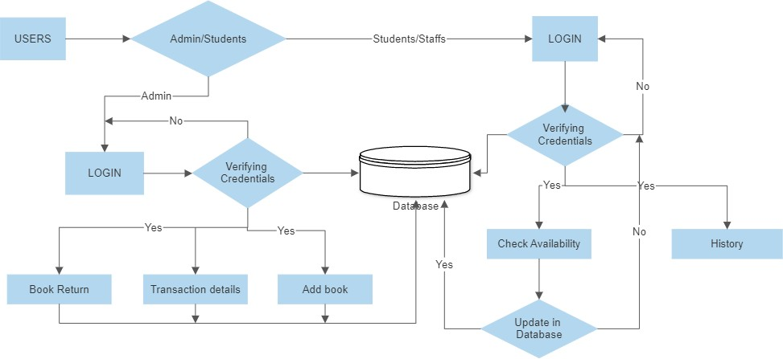

**Fig. 1 FLOW DIAGRAM**

# CHAPTER – 2 LITERATURE SURVEY

**2.1. INTRODUCTION**

The innovative ideas and concepts which helped for the proposal of this system were taken from the following references. This has helped in gaining information regarding the works and procedures of the existing systems. Encapsulating the advantages and disadvantages of various existing systems henceforth helped in modifying the project.

# 2.2 LITERATURE REVIEW

The Comparative Analysis of Teknolib Library Information System [1] (Library Management System) with SLiMS (Senayan Library Management System) Based on ISO 9126 Kholifa Artikatama, Rosihan Ari Yuana, Dwi Maryono. ISSN 2746-7813 which is published on Feburary,2019(Online). Technology is rapidly develop in various aspects of life, especially in the field of education In the world of education, technological developments are applied to the use of library information systems.

Privacy practices in academic libraries in Ghana: Insight into three top universities Bright

K. Avuglah [2] <https://doi.org/10.1177/0340035220966605> and it is published on October,2020.This research contributes to knowledge on privacy practices in academic libraries, by comparing survey data of librarians.

Designing Web-based Library Management System [3] October 2020 [International](https://www.researchgate.net/journal/International-Journal-of-Engineering-and-Technical-Research-2278-0181) [Journal of Engineering and Technical Research](https://www.researchgate.net/journal/International-Journal-of-Engineering-and-Technical-Research-2278-0181) V for the proposal of the library management system DOI:[10.17577/IJERTV9IS100131](http://dx.doi.org/10.17577/IJERTV9IS100131).Thus the author also describes the functionality to the end users for each and every dataset available in the paper.

Library Management System Article [4] in Xi'an Jianzhu Keji Daxue Xuebao/Journal of Xi'an University of Architecture & Technology December 2020. With the advancement of technology, it is imperative to exalt all the systems into a user-friendly manner. The Library Management system (LMS) acts as a tool to transform traditional libraries into digital libraries.

School Library Management: A Literature Review February 2021 DOI:[10.47191/ijcsrr/V4-i2-08](http://dx.doi.org/10.47191/ijcsrr/V4-i2-08) [Alifa Soraya Nuryadika](https://www.researchgate.net/scientific-contributions/Alifa-Soraya-Nuryadika-2190338394) [5].This paper is to develop an approach on advancement functions to maintain the user’s account . Thus this will be in such a way how to handle the multiple user’s account into a single organized system and could help in avoiding the duplication of same data into a database.

Key features of information management systems (IMSs) [6] for automation in university libraries: a view point of information professionals in Pakistan Shakeel Ahmad Khan, Ghulam Ayesha Library Hi Tech ISSN: 0737-8831 which is published on Feburary 2021.The purpose of this study is to investigate the key features of information management systems (IMSs) for automation in university libraries.

International Journal for research in Applied Science and Engineering Technology, Pratiksha D Dutonde [7] published on January 2022. In this paper it provides basis of knowledge system and net services to client model. Also detailed on client-server architecture of a web users. It is used to understand the basic functionality of a web browser.

Research on Library Book Information Resource Management Based on Artificial Intelligence and Sensors Chunyu Liu [8] published on April 2022. In order to explore the research on library book information resource management, the author proposes a method based on artificial intelligence and training.

Library Management System (LMS) [9] Using JAVA Bikash Shaw1 , Pritam Prajapati2 , Akash Ghosh3 , Bibrata Sarkar4 , Hemant Giri5 , Surajit Basak6 [1, 2, 3, 4, 5, 6] in April, 2022 [9] by the Department of Electronics and Communication Engineering, Guru Nanak Institute of Technology. It helps to maintain a database that is useful to enter new books and records of books borrowed by the members.

Library Management System Authors: Sourabh Sharma, Sunny Mishra, Shubham Gupta, Sachin Kumar [10] published on August 2022. A Library Management System is a project that tries to create an automated and computerised version for a library so that the daily work of a library can be managed and monitored easily and efficiently.

# CHAPTER-3 EXISTING SYSTEM

* 1. **EXISTING SYSTEM**

# EXISITNG SYSTEM

* + 1. **DRAWBACKS OF EXISTING SYSTEM**

Existing nutrition management solutions are often complex, expensive, and not tailored to the patient's unique needs. They may also have latency issues with food detection and require manual entry of medical data.

# CHAPTER-4 SYSTEM SPECIFICATION

* 1. **HARDWARE SPECIFICATION**

This section gives the details and specification of the hardware on which the system is expected to work.

|  |  |
| --- | --- |
| * RAM | : 4 GB or more |
| * CPU | : 2 GHz |
| * Minimum Core | : i-3 Processor , Ryzen 3 |
| * Hard Disk   **.2. SOFTWARE SPECIFICATIONS**  This section gives the details of the soft   * Front end   + HTML5   + CSS3   + Javascript   + JSP * Back end   + Java   + Javascript * Servlet   + Apache Tomcat 9 | : 40 GB  that are used for the devel |

# 4

opment.

* + - Servlet
      * Ubuntu Terminal / Windows Terminal
    - Database
      * MySQL

# TECHNOLOGY USED:

* + - * **TECHNOLOGIES:**
        + JAVA
        + JS
        + SERVLET
        + HTML & CSS
        + SQL
        + JSP

# TOOLS REQUIRED:

* + - * + Visual Studio Code
        + MySQL work bench
        + Eclipse JEE version

# TECHNOLOGY DESCRIPTION:

* + - * **HTML:**
        + HTML is the standard markup language for creating Web pages. HTML describes the structure of a Web page. HTML consists of a series of elements. HTML elements tell the browser how to display the content.HTML5 is commonly thought to be the fifth version or release of the Hyper Text Markup Language(HTML), a standardized descriptive language that specifies how to structure webpages.

19

# CSS:

* + - * + Cascading Style Sheets (CSS) is a style sheet language used for describing the presentation of a document written in a markup language such as HTML or XML (including XML dialects such as SVG, MathML or XHTML). CSS is a cornerstone technology of the World Wide Web, alongside HTML and JavaScript. It describes how a webpage should look: it prescribes colors, fonts, spacing, and much more. In short, you can make your website look however you want. CSS lets developers and designers define how it behaves, including how elements are positioned in the browser.

# JAVASCRIPT:

* + - * + JavaScript is the most popular lightweight, interpreted compiled programming language. It can be used for both Client-side as well as Server- side developments. JavaScript also known as a scripting language for web pages. JavaScript is used by many developers (65% of the total development community), and the number is increasing day by day. JavaScript is one such programming language that has more than 1444231 libraries and increasing rapidly. It is preferred over any other programming language by most developers

# JAVA:

* + - * + The SE stands for Java Standard Edition is a computing platform in which we can execute software, and it can be used for development and deployment of portable code for desktop and server environments. It has the Java programming language in use. It is part of Java software- platform family.

# SQL:

* Structured query language (SQL) is a programming language for storing and processing information in a relational database. A relational database stores information in tabular form, with rows and columns representing different data attributes and the various relationships between the data values

# JSP:

* + - Java Servlet Pages is a Java standard technology that developers use to write dynamic, data-driven web pages for Java web applications.

# SOFTWARE DESCRIPTION:

* + - * **VISUAL STUDIO CODE:**
* Visual Studio Code (famously known as VS Code) is a free open source text editor by Microsoft. VS Code is available for Windows, Linux, and macOS. Although the editor is relatively lightweight, it includes some powerful features that have made VS Code one of the most popular development environment tools in recent times.

# ECLIPSE JEE:

* + - * + Eclipse is an integrated development environment (IDE) used in computer programming. It contains a base workspace and an extensible plug-in system for customizing the environment.

# CHAPTER-5 PROPOSED SYSTEMS:

* 1. **PROPOSED SYSTEMS:**
     + To solve the inconveniences as mentioned in the existing system, Open source library system is proposed.
     + The proposed system contains the following features: -
       - Each user has their own login.
       - Consist of all the required information in a database.
       - Time consuming.
       - Accuracy.
       - Reliability can be improved with the help of security.

# PROPOSED ARCHITECTURE

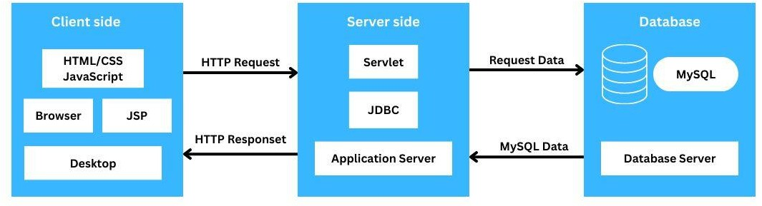

**Fig. 2 BLOCK DIAGRAM**

# CHAPTER-6 TESTING INTRODUCTION

**6.1. SYSTEM TESTING**

Software testing is a critical element of software quality assurance and represents the ultimate review of specification, design and coding. In fact, testing is the one step in the software engineering process that could be viewed as destructive rather than constructive. A strategy for software testing integrates software test case design methods into a well- planned series of steps that result in the successful construction of software. Testing is the set of activities that can be planned in advance and conducted systematically. The underlying motivation of program testing is to affirm software quality with methods that can economically and effectively apply to both strategic to both large and small- scalesystems.

# STRATEGIC APPROACH TO SOFTWARE TESTING

The software engineering process can be viewed as a spiral. Initially system

+engineering defines the role of software and leads to software requirement analysis where the information domain, functions, behavior, performance, constraints and validation criteria for software are established. Moving inward along the spiral, directs to designing and coding. To develop computer software, the spiral in along streamlines that decrease the level of abstraction on each turn.

* + - 1. Unit Testing
      2. Functional Testing
      3. Conditional Testing
      4. Performance Testing
      5. Security Testing
      6. System Testing

# UNIT TESTING

Test the entire code into separate blocks of unit coding. It checks each functionality of each unit code. Unit testing is a type of software testing that focuses on individual units or components of a software system. The purpose of

unit testing is to validate that each unit of the software works as intended and meets the requirements. It is performed by developers, and it is performed early in the development process before the code is integrated and tested as a whole system.

# FUNCTIONAL TESTING

Test the every functionality of the pages which includes:

* + - * + Get data from the user
        + Connecting it to the database
        + Fetching and retrieving the required data

Functional testing is a type of testing that seeks to establish whether each application feature works as per the software requirements.

# CONDITIONAL TESTING

Test each and every conditions that are given in it’s functionality. It should checks the valid and non-valid input for the program. The test case should be passed for each and every conditional aspects.

# PERFORMANCE TESTING

The performance testing is carried out to check the entire performance of the code that is developed. For very huge amount of meta data also the system should give the better performance. Performance testing is a non-functional software testing technique that determines how the stability, speed, scalability, and responsiveness of an application holds up under a given workload.

# SECURITY TESTING

The security testing is carried out in the way to check the authentication provided in the page. The unknown users are not allowed to access the page each user will have their own password authentication. Security testing is a process intended to reveal flaws in the security mechanisms of an information system that protect data and maintain functionality as intended.

# SYSTEM TESTING

The system testing is done to check whether there is a required specifications of the system. The process in which a quality assurance (QA) team evaluates how the various components of an application interact together in the full, integrated system or application.

# CHAPTER-7 DEPLOYMENT

**7.1. DEPLOYMENT DETAILS**

The deployment of the system is integrated into a specific system in the library. Access to the server is given through Tomcat server 9 and the data will be stored in JDBC which is fetched through queries in MySQL. The system should have the Eclipse IDE for enterprises Java and web developers 2022-12, along with this there should be Workbench for MySQL and MySQL for windows .The system should have the Windows OS to operate then it should integrate with the server.

# CHAPTER-8 RESULT AND DISCUSSION

**8.1. OUTPUT AND DISPLAY:**

The module page is as like shown below

# LOGIN PAGE:

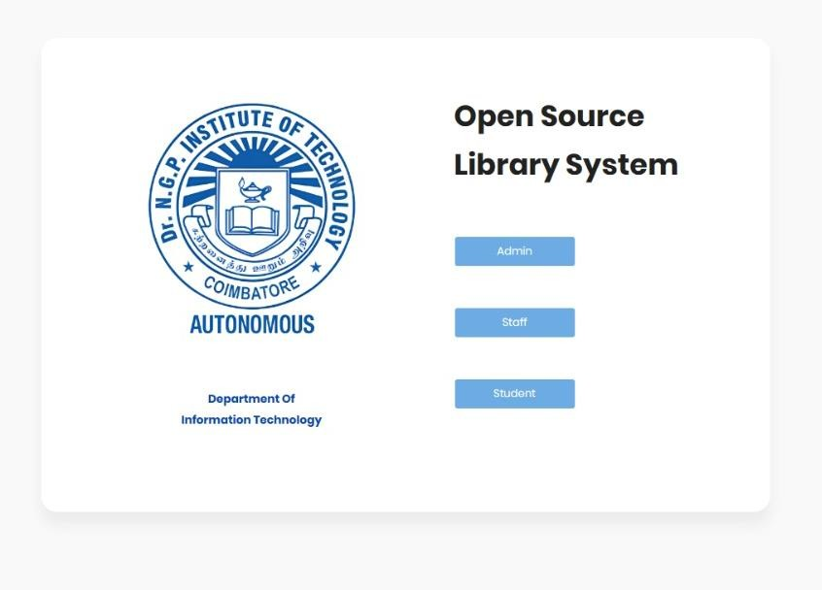

**Fig. 3 MAIN MODULE**

# ADMIN LOGIN PAGE:

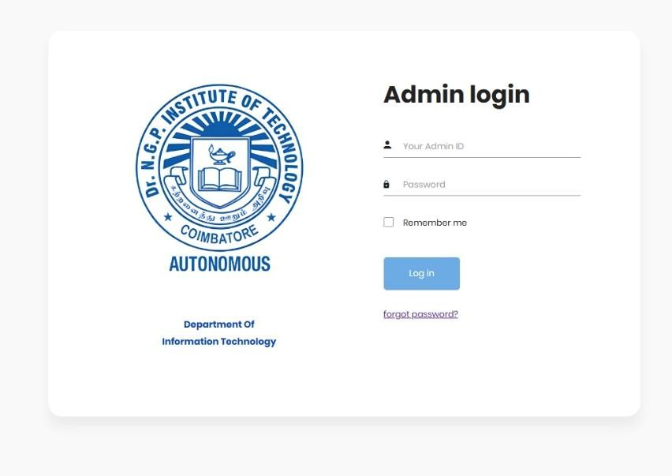

**Fig. 4 ADMIN LOGIN**

# ADMIN DASHBOARD:

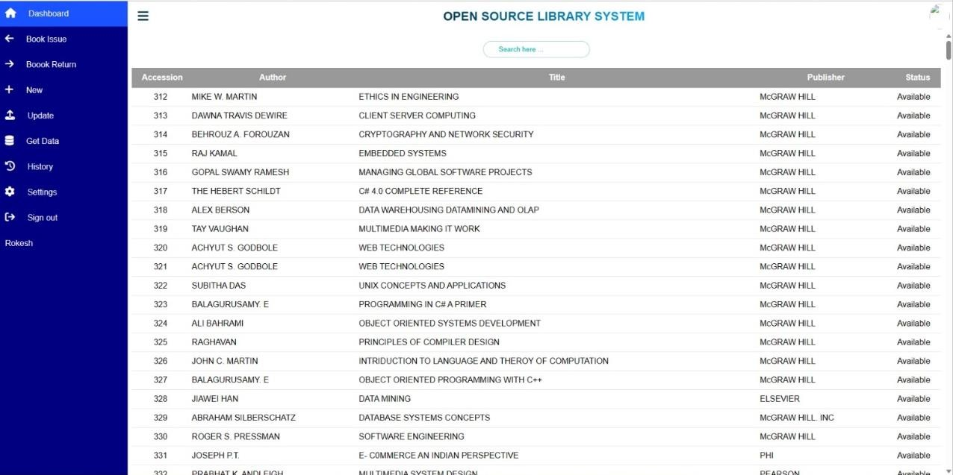

**Fig. 5 ADMIN DASHBOARD**

# STUDENT/STAFF LOGIN PAGE:

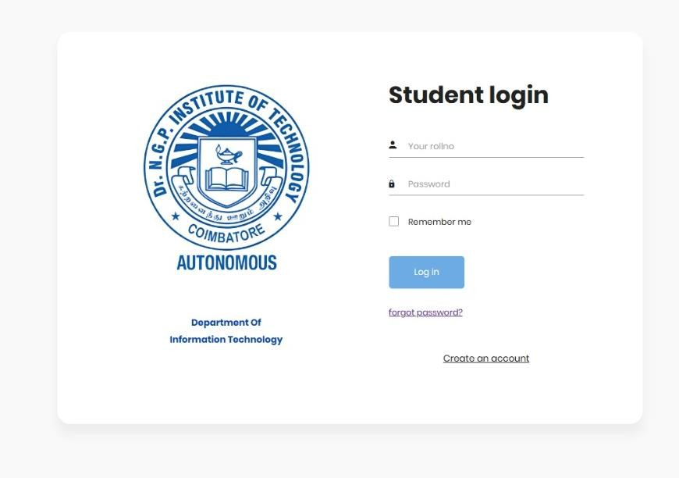

**Fig. 6 STUDENT/STAFF LOGIN**

# STUDENT/STAFF DASHBOARD:

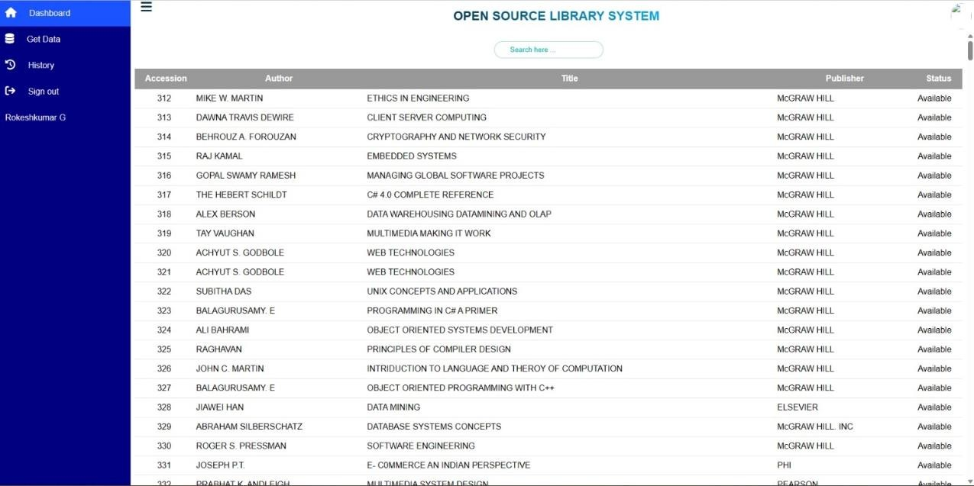

**Fig. 7 STUDENT/STAFF DASHBOARD**

# BOOK ISSUE:

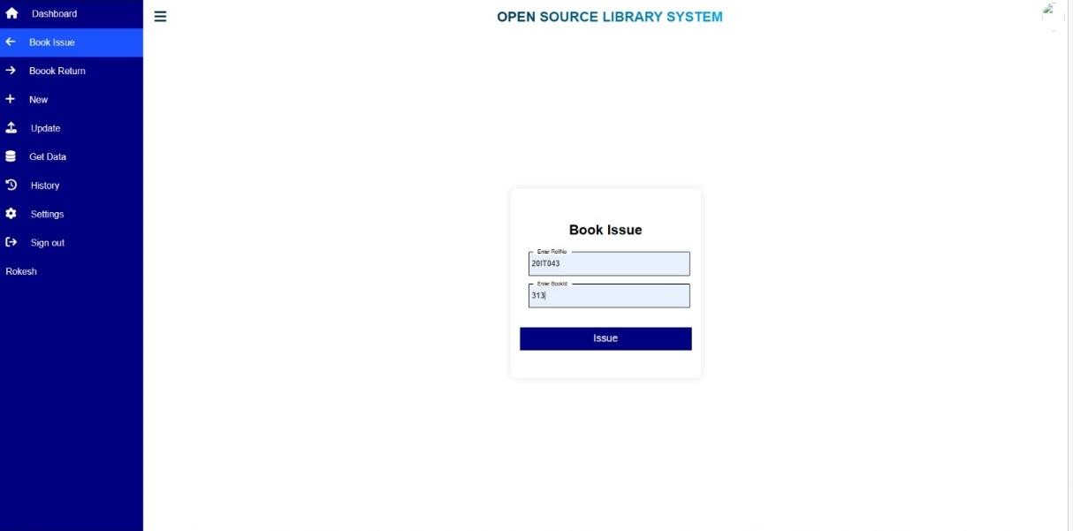

**Fig. 8 BOOK ISSUE**

# BOOK ISSUE RESULT:

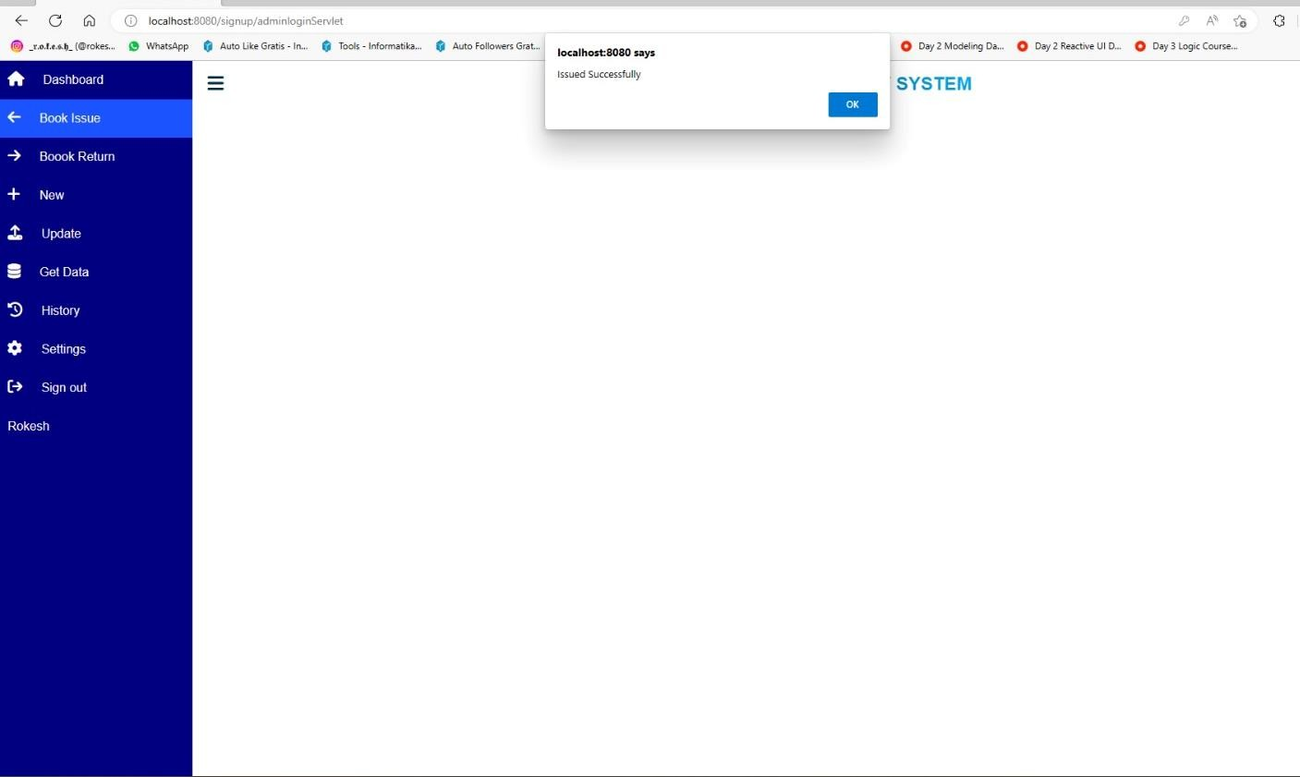

**Fig. 9 BOOK ISSUE RESULT**

# CHAPTER 9 CONCLUSION

**9.1. CONCLUSION**

* Enhanced Accessibility: A library management system improves accessibility by providing online cataloging, allowing users to search for books, journals, and other materials remotely. This promotes inclusivity and enables users to access library resources from anywhere, at any time.
* Efficient Resource Utilization: With a library management system, librarians can easily track inventory, identify misplaced or lost items, and streamline the procurement process. This leads to optimal resource utilization, cost savings, and a more efficient allocation of budgetary resources.
* Improved User Experience: The system facilitates self-checkout, online reservations, and personalized recommendations, enhancing the user experience. Users can access their accounts, renew items, and receive notifications, making interactions with the library more convenient and user-friendly.
* Secure Data Management: Library management systems ensure the security and privacy of patron data by implementing appropriate safeguards. User information, circulation records, and financial transactions are protected, maintaining confidentiality and compliance with data protection regulations.
* Scalability and Future-Readiness: A robust library management system is designed to scale with the growing needs of the library. It can accommodate increasing volumes of data, expanding collections, and evolving technology trends, ensuring the system remains relevant and adaptable over time.

# CHAPTER – 10 APPENDIX

* 1. **READ ME FILE**

# ABOUT THE APPLICATION

This method is proposed with reliable and robust method for the effective usage of the library.

# DEVELOPERS

MAGESHWARAN S [- mageshwaranbalaji25@gmail.com](mailto:-%20mageshwaranbalaji25@gmail.com) ROKESHKUMAR G - [rokeshkumar.it2020@gmail.com](mailto:rokeshkumar.it2020@gmail.com) SHELJIN SG - [sheljin2003sgs@gmail.com](mailto:sheljin2003sgs@gmail.com) SURYADHARSHINI G - [suryadharshinig@gmail.com](mailto:suryadharshinig@gmail.com)

# CHAPTER – 11 SOURCE CODE

* 1. **SOURCE CODE**

# DASHBOARD

package com.lms.DashboardServlet; import java.io.IOException;

import java.io.PrintWriter; import java.sql.Connection; import java.sql.DriverManager; import java.sql.ResultSet; import java.sql.Statement;

import javax.servlet.ServletException; import javax.servlet.annotation.WebServlet; import javax.servlet.http.HttpServlet;

import javax.servlet.http.HttpServletRequest; import javax.servlet.http.HttpServletResponse; @WebServlet("/DashboardServlet")

public class DashboardServlet extends HttpServlet { private static final long serialVersionUID = 1L;

protected void doPost(HttpServletRequest request, HttpServletResponse response) throws ServletException, IOException {

System.out.println("Method call successfully "); try {

Class.forName("com.mysql.jdbc.Driver"); Connection con=

DriverManager.getConnection("jdbc:mysql://localhost:3306/library","root","Eshwa ran@123");

Statement st = con.createStatement();

ResultSet rs = st.executeQuery("select * from bookDetails"); PrintWriter out = response.getWriter(); out.println("<html>");

out.println("<head>");

out.println("<LINKREL=\"StyleSheet\" HREF=\"dashboardStyle.css\" TYPE=\"text/css\"> ");

out.println("<linkrel=\"stylesheet\" href=\"https://cdnjs.cloudflare.com/ajax/libs/font-awesome/4.7.0/css/font- awesome.min.css\">\r\n"

+"<linkrel=\"stylesheet\" href=\"https://cdnjs.cloudflare.com/ajax/libs/font-

awesome/6.3.0/css/all.min.css\">");

out.println("</head>"); out.println("<body>");

out.println("<div class=\"container\">\r\n"

+ " <div class=\"search-bar\">\r\n"

+<input type=\"text\" class=\"searchbar\" placeholder=\"Search here ...\" name=\"search\" onkeyup=\"Check()\">\r\n"

+ " </div>\r\n"

+ " </div>"); out.println("<table>"); out.println("<tr>"); out.println("<th>Accession</th>"); out.println("<th>Author</th>"); out.println("<th>Title</th>"); out.println("<th>Publisher</th>"); out.println("<th>Status</th>"); out.println("</tr>"); while(rs.next()) {

out.println("<tr>"); out.println("<td

class=\"AccNo\">"+rs.getString("AccNo")+"</td>"); out.println("<td class=\"Author\">"+rs.getString("Author")+"</td>"); out.println("<td

class=\"Title\">"+rs.getString("Title")+"</td>");

out.println("<td sclass=\"Publisher\">"+rs.getString("Publisher")+"</td>");

out.println("<td class=\"Status\">Available</td>"); out.println("</tr>");

}

out.println("</table>"); out.println("</body>");

out.println("<script src=\"dashboard.js\"></script>");

# ADMIN:

<!DOCTYPE html>

<html lang="en">

<head>

<meta charset="UTF-8">

<meta http-equiv="X-UA-Compatible" content="IE=edge">

<!-- <meta name="viewport" content="width=device-width, initial- scale=1.0"> -->

<title>Stafflogin</title>

<link rel="stylesheet" href="Studentlogin.css">

</head>

<body>

<h1>Dr.N.G.P.Institute of Technology</h1>

<div id="cont1">

<form >

<h2>Admin Signin</h2>

<div class="input-box">

<input type="text" id="" placeholder="Admin ID" required>

</div>

<div class="input-box">

<input type="password" id="" placeholder="Password"

required>

</div>

<button type="submit" id=""

onclick="window.open('admin.jsp')">SignIn</button>

<!-- <p id="lab">Don't have an account?

<a href="Staffsignup.html">SignUp</a></p> -->

</form>

</div>

</body>

</html>

# BACKEND:

console.log("Hello world"); function Check(){

let input = document.querySelector('.searchbar').value.toLowerCase(); let AccNo=document.querySelectorAll('.AccNo');

let Title=document.querySelectorAll('.Title');

let Author=document.querySelectorAll('.Author');

let Publisher=document.querySelectorAll('.Publisher'); let Status=document.querySelectorAll('.Status');

let tot=AccNo.length;

for (let i = 0; i < tot; i++) { if(AccNo[i].innerHTML.toLowerCase().includes(input) ||

Title[i].innerHTML.toLowerCase().includes(input) || Author[i].innerHTML.toLowerCase().includes(input) || Publisher[i].innerHTML.toLowerCase().includes(input) || Status[i].innerHTML.toLowerCase().includes(input)){ AccNo[i].parentNode.style.display="" Author[i].parentNode.style.display="" Publisher[i].parentNode.style.display="" Status[i].parentNode.style.display="" Title[i].parentNode.style.display=""

}

else{

}

}

AccNo[i].parentNode.style.display="none"

console.log(book.length);

}

# 11.4 STUDENT JSP:

<!DOCTYPE html>

<html lang="en">

<head>

<meta charset="UTF-8">

<meta name="viewport" content="width=device-width, initial-scale=1.0">

<meta http-equiv="X-UA-Compatible" content="ie=edge">

<title>Student Login</title>

<!-- Font Icon -->

<link rel="stylesheet"

href="fonts/material-icon/css/material-design-iconic-font.min.css">

<!-- Main css -->

<link rel="stylesheet" href="css/style.css">

</head>

<body>

<input type="hidden" id="status" value="<%= request.getAttribute("status")

%>">

<div class="main">

<!-- Sing in Form -->

<section class="sign-in">

<div class="container">

<div class="signin-content">

<div class="signin-image">

<figure>

<img src="images/collagelogo.png" alt="sing up image">

</figure>

<a href="Studentsignup.jsp" class="signup-image- link">Create an account</a>

</div>

<div class="signin-form">

<h2 class="form-title">Student login</h2>

<form method="post" action="StudentloginServlet" class="register-form" id="login-form">

<div class="form-group">

<label for="rollno">

<i class="zmdi zmdi- account material-icons-me"></i>

</label>

<input type="text" name="rollno" id="rollno" placeholder="Your rollno" required/>

</div>

<div class="form-group">

<label for="password"><i class="zmdi zmdi- lock">

</i>

</label>

<input type="password" name="pswd" id="pswd" placeholder="Password" required/>

</div>

<div class="form-group">

<input type="checkbox" name="remember-me" id="remember-me"

class="agree-term" /> <label for="remember-me" class="label-agree-term”

<span>

</span>

</span>Remember me</label>

</div>

<div class="form-group form-button">

<input type="submit" name="signin" id="signin”

class="form-submit" value="Log in"

/>

</div>

<div>

<a href="forgot.jsp">forgot password?</a>

</div>

</form>

</div>

</div>

</div>

</section>

</div>

<script src="https://unpkg.com/sweetalert/dist/sweetalert.min.js"></script>

<script type="text/javascript">

var status = document.getElementById("status").value; if(status == "failed"){

swal("sorry","Wrong Username or Password","error");

}

else if(status == "invalidrollno"){ swal("sorry","please Enter the Rollno","error");

}

else if(status == "invalidpswd"){

swal("sorry","please Enter the Password","error");

}

</script>

</body>

</html>

# CHAPTER - 12 REFERENCES

1. The Comparative Analysis of Teknolib Library Information System(Library Management System) with SLiMS (Senayan Library Management System) Based on ISO 9126 Kholifa Artikatama, Rosihan Ari Yuana, Dwi Maryono. ISSN 2746-7813 which is published on Feburary,2019(Online).
2. Privacy practices in academic libraries in Ghana: Insight into three top universities Bright K.Avuglah <https://doi.org/10.1177/0340035220966605>and it is published on October,2020.
3. Designing Web-based Library Management System October 2020 [International](https://www.researchgate.net/journal/International-Journal-of-Engineering-and-Technical-Research-2278-0181) [Journal of Engineering and Technical Research](https://www.researchgate.net/journal/International-Journal-of-Engineering-and-Technical-Research-2278-0181) V for the proposal of the library management system DOI:[10.17577/IJERTV9IS100131](http://dx.doi.org/10.17577/IJERTV9IS100131).
4. Library Management System Article in Xi'an Jianzhu Keji Daxue Xuebao/Journal of Xi'an University of Architecture & Technology December 2020.
5. School Library Management: A Literature Review February 2021 DOI:[10.47191/ijcsrr/V4-i2-08](http://dx.doi.org/10.47191/ijcsrr/V4-i2-08) [Alifa Soraya Nuryadika](https://www.researchgate.net/scientific-contributions/Alifa-Soraya-Nuryadika-2190338394).
6. Key features of information management systems (IMSs) for automation in university libraries: a view point of information professionals in Pakistan Shakeel Ahmad Khan, Ghulam Ayesha Library Hi Tech ISSN: 0737-8831 which is published on Feburary 2021.
7. International Journal for research in Applied Science and Engineering Technology, Pratiksha D Dutonde published on January 2022.
8. Research on Library Book Information Resource Management Based on Artificial Intelligence and Sensors Chunyu Liu published on April 2022.
9. Library Management System (LMS) Using JAVA Bikash Shaw1 , Pritam Prajapati2 , Akash Ghosh3 , Bibrata Sarkar4 , Hemant Giri5 , Surajit Basak6 [1, 2, 3, 4, 5, 6] in April, 2022.
10. Library Management System Authors: Sourabh Sharma, Sunny Mishra, Shubham Gupta, Sachin Kumar published on August 2022.